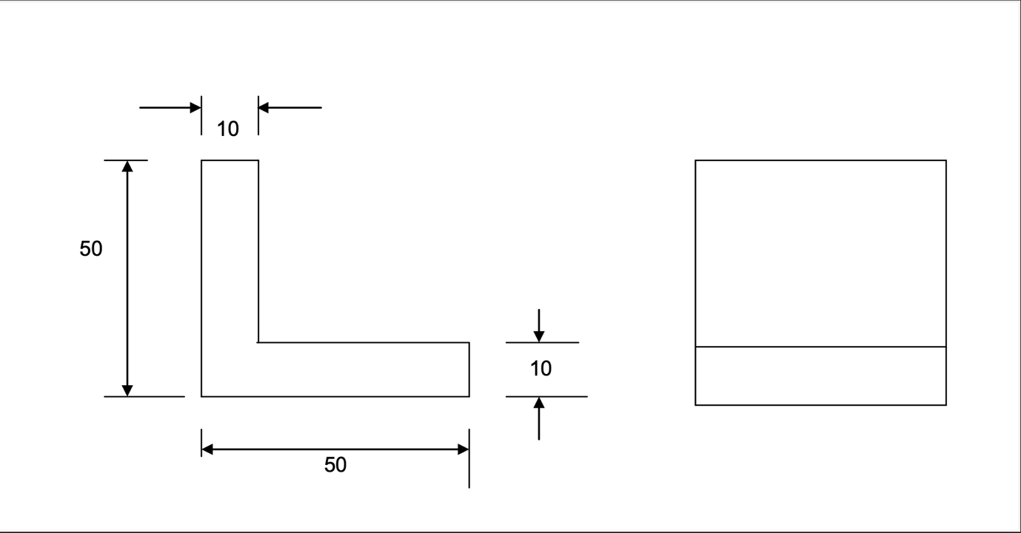

**SIDE VIEW TOP VIEW**

|  |  |
| --- | --- |
| **Part name:** Angle | |
| **Quantity:** 4 | **Scale:** 1:1 |
| **Material Required:** Metal | |