Table Design
The schema consists of five primary tables:
- Keywords
  - Purpose: Maps words to unique Word IDs for efficient storage and lookup.
  - Attribute:[keyword_id, keyword]
    - keyword_id (Primary Key): A unique identifier for each keyword
    - keyword: The actual filtered and stemmed word
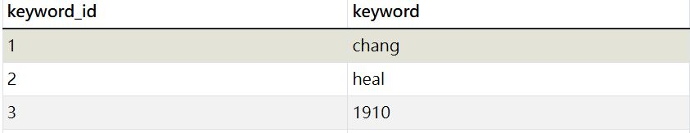
- links
  - Purpose: Stores metadata for each crawled URL, including its unique Page ID.
  - Attribute: [id, title, stem_title, url, last_mod_date, size]
    - id (Primary Key): A unique identifier for each page (Page ID)
    - title: The title of the page
    - stem_title: The stemmed title of the page
    - url: The actual URL of the page
    - last_mod_date: The last modification date of the page
    - size: The size of the page in bytes
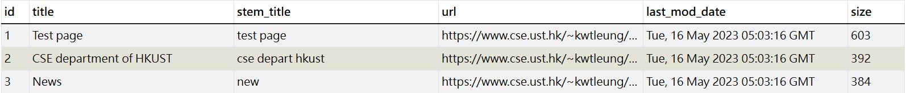
- child_links
  - Purpose: Tracks the child links (URLs) for each parent link.
  - Attribute: [child_id, parent_group, url]
    - child_id(Primary Key): A unique identifier for each child link
    - parent_group: Represents which parent link the child URL originates from
    - url: The URL of the child link.
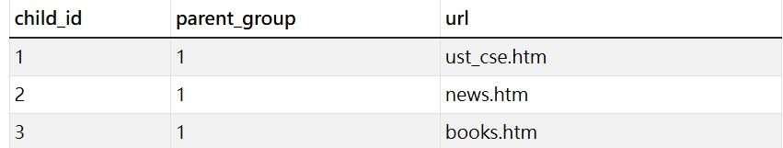
- keywords_freq
  - Purpose: Tracks the frequency of each keyword for a given parent link (Page ID).
  - Attribute: [freq_id, keyword, parent_group,frequency]
    - freq_id(Primary Key): A unique identifier for the keyword frequency entry
    - keyword:The keyword (linked to the Keywords table).
    - parent_group:The Page ID of the parent link where the keyword appears.
    - frequency:The frequency of the keyword on the page.
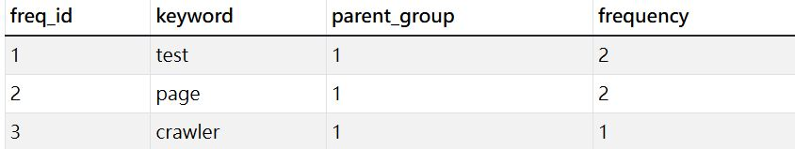
- parent_links
  - Purpose: Tracks parent links for each group of child links.
  - Attribute: [parent_id, parent_group, url]
    - parent_id(Primary Key): A unique identifier for each parent link
    - parent_group: Identifies the group of child links originating from this parent link
    - url:The URL of the parent link
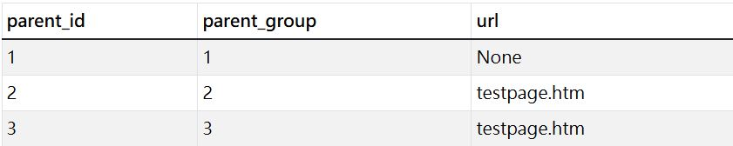

ER diagram

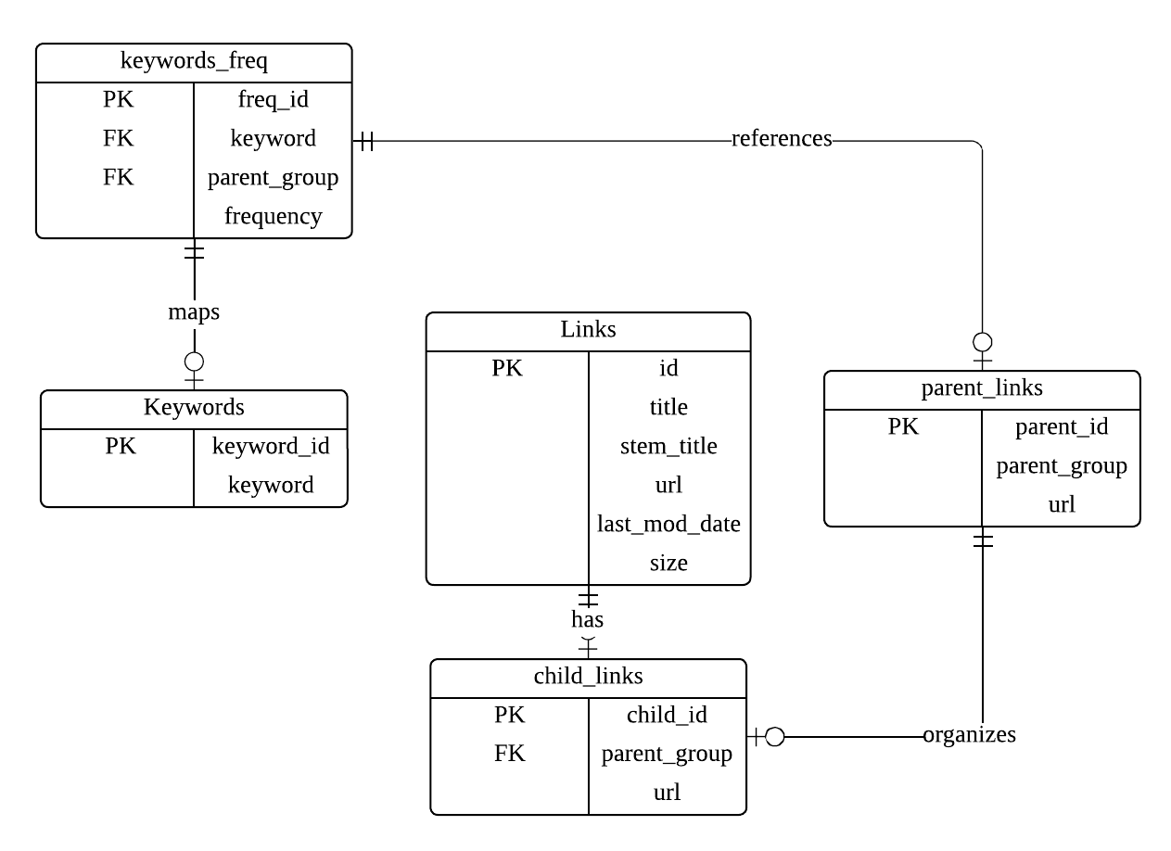

Explanation of the Design
Forward Index:
- The forward index is implemented using the Links and Keywords Frequency tables:
  - The Links table stores metadata about each page (Page ID, title, URL, etc.).
  - The Keywords Frequency table records the keywords and their frequencies for each page (linked by parent_group to the Page ID in the Links table).
Inverted Index:
- The inverted index is implemented using the Keywords and Keywords Frequency tables:
  - The Keywords table maps each word to a unique Word ID.
  - The Keywords Frequency table links keywords to the Page IDs where they appear, along with their frequencies.
Mapping Tables:
- URL ↔ Page ID:
  - The Links table serves as the mapping table between URLs and Page IDs.
- Word ↔ Word ID:
  - The Keywords table serves as the mapping table between words and Word IDs.
Child and Parent Links:
- The Child Links and Parent Links tables track the relationships between parent and child links:
  - The Parent Links table identifies the parent link for each group of child links.
  - The Child Links table stores the child URLs for each parent link.

