Table

* keywords
* links
* child_links
* keywords_freq
* parent_links

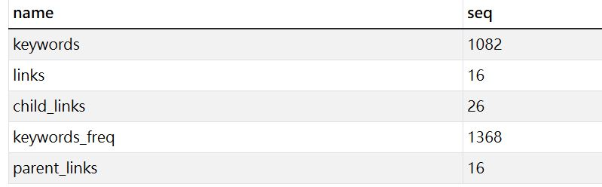

1. Keywords
   * Attribute:[**keyword_id, keyword**]
     1. **keyword_id**: primary key
     2. **keyword**: filtered word

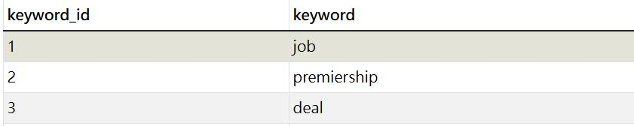

1. links
   * Attribute: [**id, title, url, last_mod_date, size**]
     1. **id**: primary key
     2. **title:** store page title
     3. **url**: store url
     4. **last_mod_date**: store last modification date
     5. **size**: store size of page

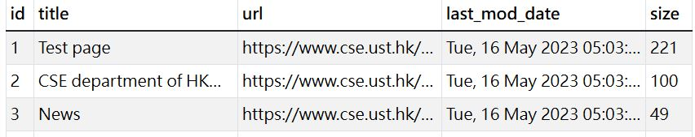

1. child_links
   * Attribute: [**child_id, parent_group, url**]
     1. **child_id:**primary key
     2. **parent_group**:represents the keyword come from which parent link
     3. **url:** store child url

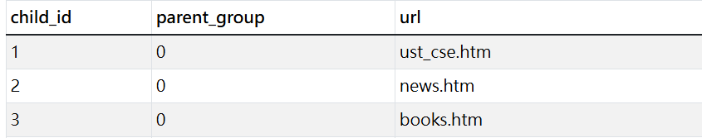

1. keywords_freq
   * Attribute: [**freq_id, keyword, parent_group,frequency**]
     1. **freq_id:**primary key
     2. **keyword:**store keyword
     3. **parent_group**:represents the keyword come from which parent link
     4. **frequency:**represents the frequency of keyword

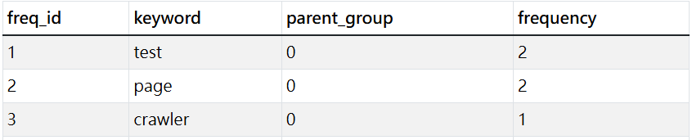

1. Parent_links
   * Attribute: [**parent_id, parent_group, url**]
     1. **parent_id:**primary key
     2. **parent_group**:represents the keyword come from which parent link
     3. **url:**store parent url

