HW01 – Part 1. Display Cube using simple \* characters.

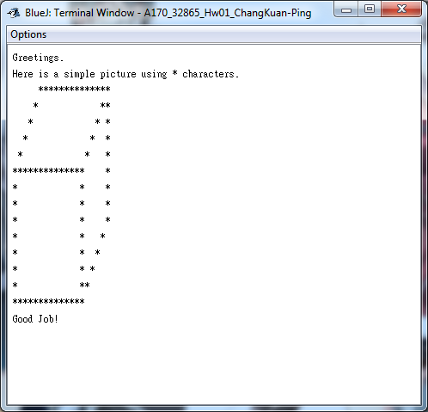

HW01 – Part 2. Number Range Class: Display the number of integers that lie between them.

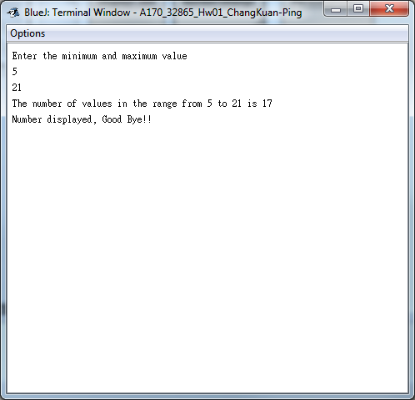

HW01 – Part 3. Create a Applet with a snow man drawn.

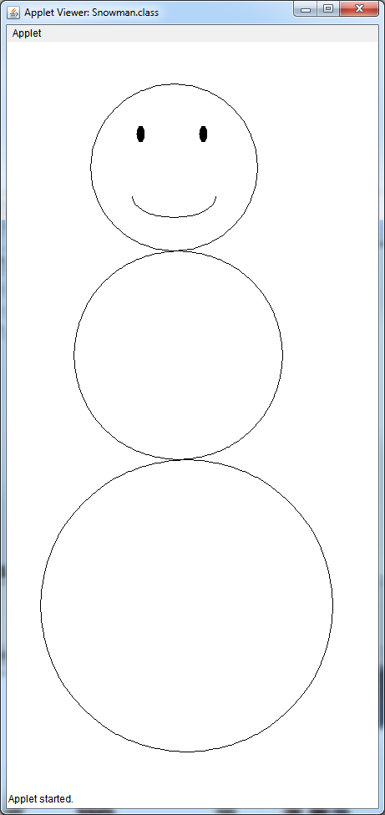

Lab 1. Personal Hello. Write a simple Hello World Statement

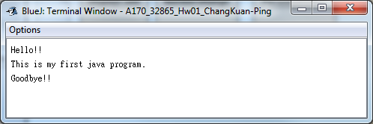

Lab 2. Write another personal hello. This time asks for user input and display greetings.

