HW03 – CH2. Basic computing

Part 1. Mortgage Calculator 1 - show integer result

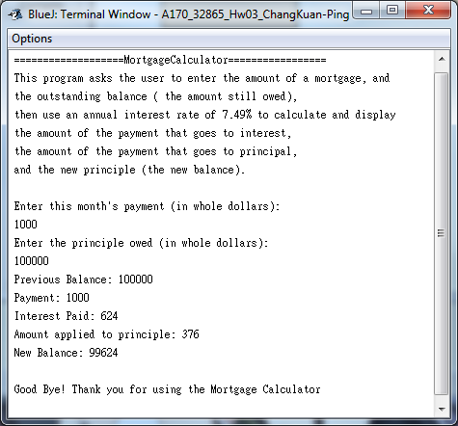

Part 2. Mortgage Calculator 2 – modified to show double result and enable rate input

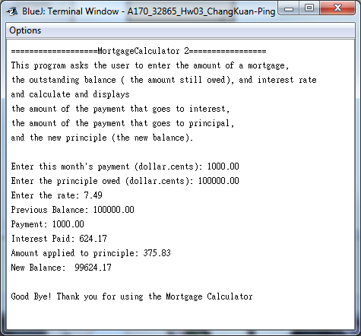

Part. 3 LoveHate – replace the word ‘hate’ with ‘love’

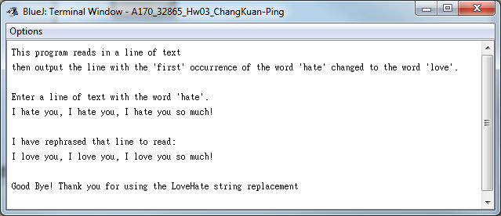

Lab 05 - Pseudo code: Algorithms, variables, and expressions  
The program will square an integer for you.  
Ask for user input: Please enter the integer value you wish to square.  
X = User Input  
X2 = X \* X  
Show result: The square of X is X^2  
Good Bye!

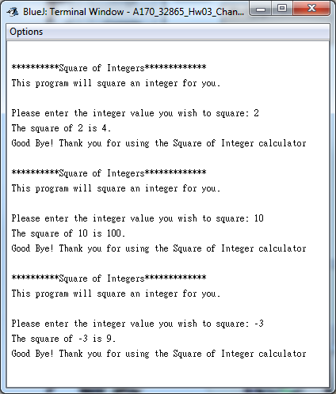

Lab 06 -

Pseudo Codes:

Enter a string containing no space: ABCDEFGHIJK  
The string entered is: ABCDEFGHIJK  
The string length is: 11

Request to enter another string this time containing spaces: A B C D E F G H I J K  
The string entered is: A B C D E F G H I J K   
The string length is: 21

Variable is String userInput

Using method length () to count

