HW02 – Basic Computation and I/O

CH02: Part 1. Simple Calculation (AverageOf4Int)

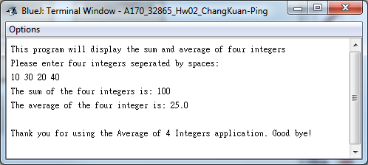

Part 2. Modified Calculations (AverageOf4Double class)

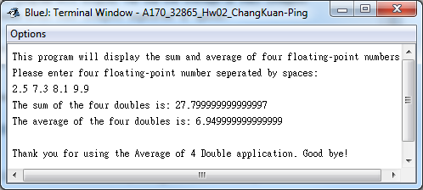

Part 3. Draw without graphics (MyName class)

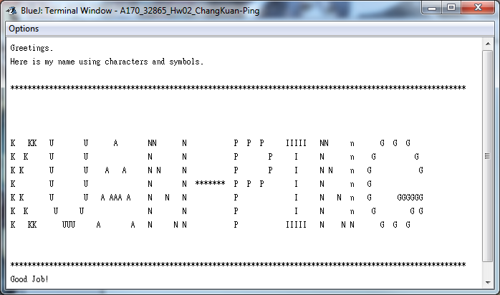

Lab 03 - Digit manipulation (DigitsInOrder)

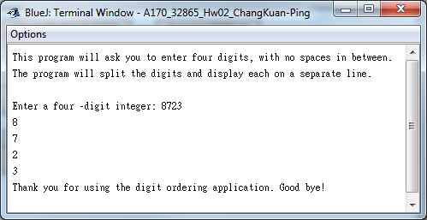

Lab 03 – US Flag (USFlag)

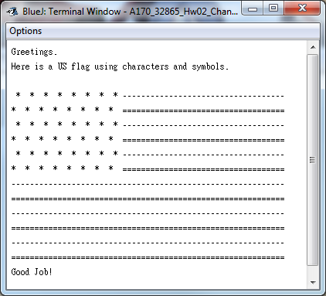

Lab 04 – Simple Math Calculator (SimpleMath)

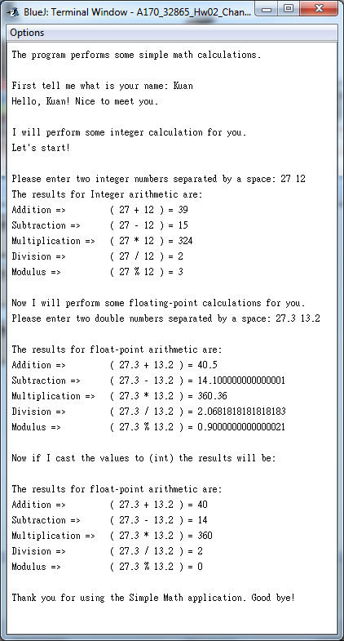

Lab 04 – Metric conversions (MeterConversion)

