Game: State of Mind

By: John Luke Saake, Devin Merritt, & Kuanping Chang (12-S)

Description:

The goal of this game is raise awareness about Schizophrenia, a mental disorder. Currently there is no cure, though medication can help reduce symptoms. Schizophrenia causes the victim to experience hallucinations including seeing things that contradict reality. Many also experience hearing noises that are not there. Our goal was to put the player in the shoes of a young child with Schizophrenia as they try to manage their “stress level.” As they explore, their stress level will increase gradually, while also being influenced by other factors from the environment. In order to manage their stress level, the player must pick up medication throughout the map to help lower their stress level. If their stress level reaches 100, they faint and have to replay the game. The player is trying to find keys located throughout the map to unlock their parent’s door at the end of the hallway. Once they do so, the game will end with a dialogue box detailing the effects and seriousness of Schizophrenia.

Images: 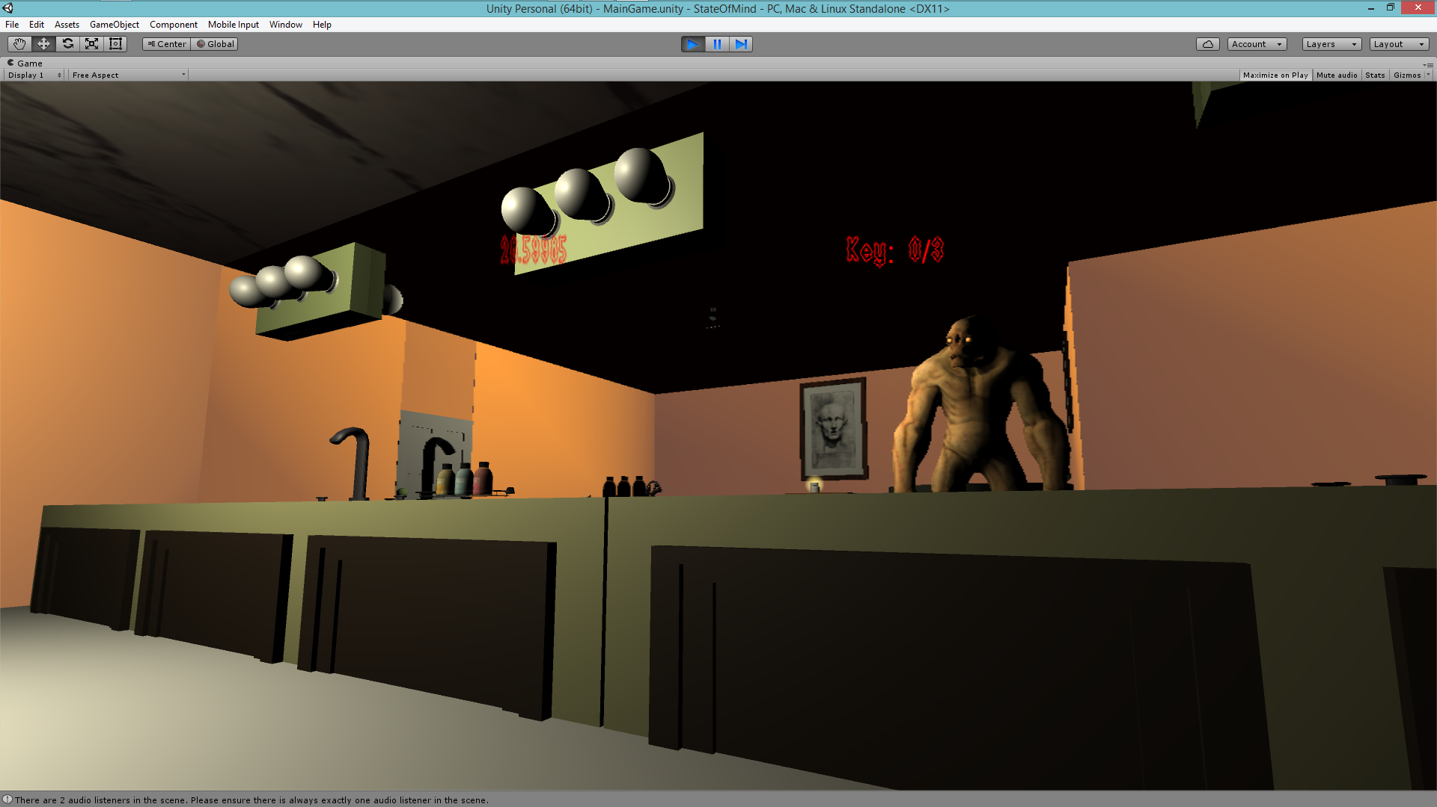

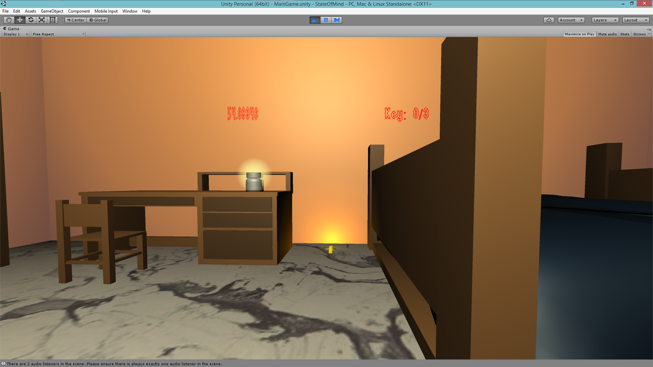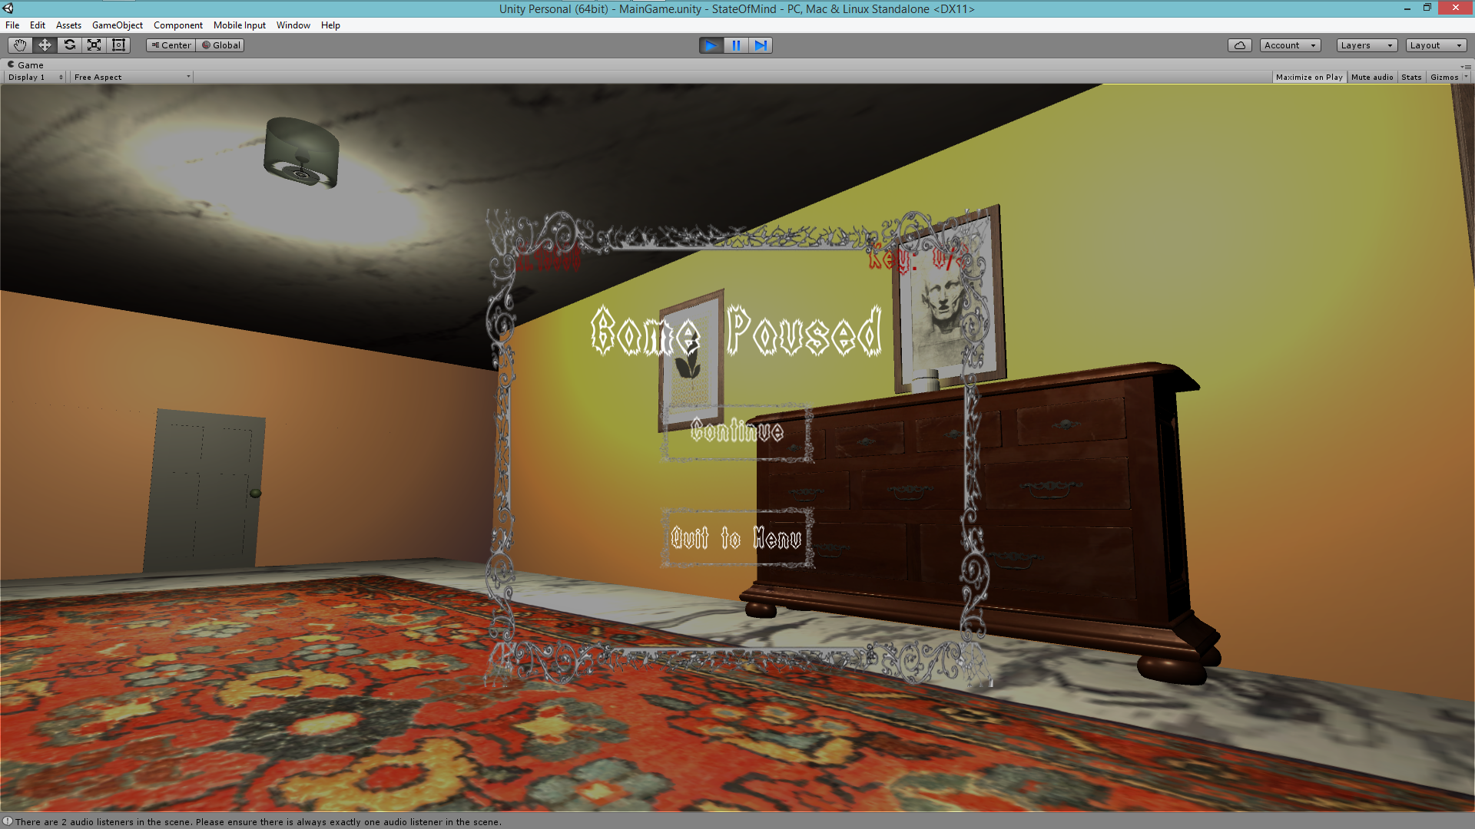

Asset List:

First Person Shooter Script: Asset Store

Mirror Script: Unity Wiki

Teddy Bear Model: Copied from Youtube tutorial by tutor4u (without hair textures)

Flooring Textures: Asset Store

Paintings: Asset Store

Bathroom (Toilet, Bathtub, Jacuzzi, Toilet Paper Roll, Soap Bottlesl): Asset Store

Monster: Asset Store

Rug: Asset Store

Chest (hallway): Asset Store

Floor Texture: Asset Store