CSE370

Database Systems

Lab Homework-1

Name: Azwad Aziz

ID: 21301027

Section: 06

Answer of question 1:

create table Developers

-> (

-> member_id int,

-> name varchar(30),

-> email varchar(30),

-> influence_count int,

-> Joining_date date,

-> multiplier int

-> );

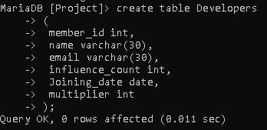

Answer of question 1:

MariaDB [project]> Insert into developers values

-> (1,'Taylor Otwell','otwell@laravel.com',739360,'2020-6-10',10),

-> (2,'Ryan Dahl','ryan@nodejs.org',633632,'2020-04-22',10),

-> (3,'Brendan Eich','eich@javascript.com',939570,'2020-05-07',8),

-> (5,'Evan You','you@vuejs.org',982630,'2020-06-11',7),

-> (6,'Rasmus Lerdorf','lerdorf@php.net',937927,'2020-06-3',8),

-> (7,'Guido van Rossum','guido@python.org',968827,'2020-07-18',19),

-> (8,'Adrian Holovaty','adrian@djangoproject.com',570724,'2020-05-07',5),

-> (9,'Simon Willison','simon@djangoproject.com',864615,'2020-04-30',4),

-> (10,'James Gosling','james@java.com',719491,'2020-05-18',5),

-> (11,'Rod Johnson','rod@spring.io',601744,'2020-05-18',7),

-> (12,'Satoshi Nakamoto','nakamoto@blockchain.com',630488,'2020-05-10',10);

Answer of question 2:

MariaDB [project]> alter table developers CHANGE influence_count followers int;



Answer of question 3:

MariaDB [project]> update developers set followers = followers+10;

Answer of question 4:

MariaDB [project]> select name,email,followers from developers;



Answer of question 5:

MariaDB [project]> select name, (((followers*100)/1000000)*((multiplier*100)/20))/100 as efficiency from developers;



