CSE370

Database Systems

Lab Homework-2

Name: Azwad Aziz

ID: 21301027

Section: 06

Answer of question 1:

MariaDB [project]> select joining_date from developers group by joining_date order by joining_date;



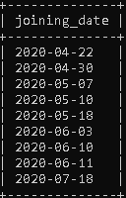

Answer of question 2:

MariaDB [project]> select name,email from developers order by followers DESC limit 0,5;



Answer of question 3:

MariaDB [project]> select multiplier,count(*) as members from developers group by multiplier;



Answer of question 4:

MariaDB [project]> select name from developers where followers<700000 and multiplier = (select max(multiplier) from developers where followers<700000);



Answer of question 5:

MariaDB [project]> select avg(followers) from developers where joining_date<'2020-06-11';



Answer of question 6:

MariaDB [project]> select member_id,name,email from developers where email like '%.com' or email like '%.net';



