CSE370

Database Systems

Lab Homework-3

Name: Azwad Aziz

ID: 21301027

Section: 06

MariaDB [project]> create table Employees

-> (

-> employee_id char(10),

-> first_name varchar(20),

-> last_name varchar(20),

-> email varchar(60),

-> phone_number char(14),

-> hire_date date,

-> job_id char(10),

-> salary int,

-> commission_pct decimal(5,3),

-> manager_id char(10),

-> department_id char(10)

-> );

MariaDB [project]> INSERT INTO Employees VALUES

-> ("EMP001", "Michael", "Scott", "scott@gmail.com", "01565637846782", "1999-09-20","JOB001", 100000,12.678,"MNG001","DPT001"),

-> ("EMP002", "Jim", "Harper","harper@gmail.com", "01945637846782", "2004-09-30","JOB002", 6000,13.898,"MNG002" ,"DPT002"),

-> ("EMP003", "Pam", "Beesly","pam@gmail.com", "01789657846782", "2005-09-28","JOB003", 250,15.163,"MNG003" ,"DPT003"),

-> ("EMP004", "Angela", "Martin","martin@gmail.com", "04589637846782", "2004-09-28","JOB004",6500,17.231,"MNG004" ,"DPT004"),

-> ("EMP005", "Dwight", "Shrute","Shrute@gmail.com", "01945637846782", "2003-09-30","JOB001", 600,18.929,"MNG005" ,"DPT005"),

-> ("EMP006", "Kelly", "Kapoor","Kelly@gmail.com", "01945637567782", "2003-09-30" , "JOB001", 45000,17.636,"MNG006" ,"DPT006"),

-> ("EMP007", "Andrew", "Bernard","Andrew@gmail.com", "01945637846782", "2007-05-10","JOB002",500,13.585,"MNG007","DPT007"),

-> ("EMP008", "Kevin", "Malone","Kevin@gmail.com", "01789637846782", "2004-10-30","JOB003", 65000,13.585,"MNG003" ,"DPT003"),

-> ("EMP009", "Toby", "Flender","Toby@gmail.com", "019456378464567", "2004-09-30" , "JOB004",70,15.163,"MNG009","DPT002"),

-> ("EMP010", "Phyllis", "Vance","Vance@gmail.com", "01945645646782", "1999-09-20","JOB005", 61000,18.216,"MNG004","DPT001");

**Answer of question 1:**

MariaDB [project]> select first_name, last_name, email, phone_number, hire_date, department_id from employees where hire_date=(select max(hire_date) from employees);



**Answer of question 2:**

MariaDB [project]> select first_name, last_name, employee_id, phone_number, salary, department_id from employees where salary in (select min(salary) from employees group by department_id);



**Answer of question 3:**

MariaDB [project]> select first_name, last_name, employee_id, commission_pct, department_id from employees where department_id="DPT007" and commission_pct< (select max(commission_pct) from employees where department_id="DPT005");



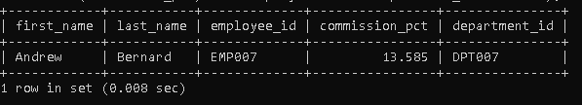

**Answer of question 4:**

MariaDB [project]> select distinct department_id from employees where salary in (select max(salary) from employees group by department_id) and salary<30000;



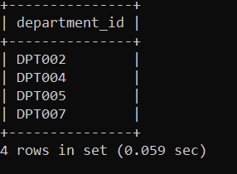

Answer of question 5:

MariaDB [project]> select department_id, job_id, commission_pct from

-> employees L1 where exists(select * from employees L2 where

-> L1.department_id=L2.department_id and L1.job_id!=L2.job_id and

-> L1.commission_pct < L2.commission_pct)group by department_id;

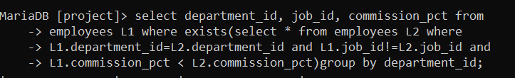

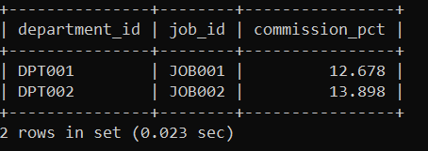

**Answer of question 6**

MariaDB [project]> select distinct manager_id from employees where salary>3500;



**Answer of Question 7:**

MariaDB [project]> select first_name, last_name, employee_id, email, salary, department_id , commission_pct

-> from employees where (manager_id,commission_pct) in (select manager_id,min(commission_pct) from employees group

-> by manager_id);



