**Methods**

*Vertebrate diversity surveys*

Don is writing

*Acoustic indices*

Acoustic indices were generated from the audio for the entire 7 days (12pm on day of first spotlighting survey – 12pm on the day of last bird survey) at a 1-min resolution using Kaleidoscope Pro (Wildlife Acoustics; version 5.4.1). Ten acoustic indices were calculated: the acoustic complexity index (ACI), the acoustic diversity index (ADI), the acoustic evenness index (AEI), the normalised difference soundscape index (NDSI), the bioacoustic Index (BI), events per second (EVN), spectral entropy (SH), low-frequency cover (LFC), mid-frequency cover (MFC), and high frequency cover (HFC). The settings used for each acoustic index are in SuppInfo.

For comparison with the on-ground biodiversity data, each acoustic index was aggregated into a weekly value by taking the average of all 1-minute values for certain taxa-specific time periods. For birds, indices were averaged for the morning (6am-9am), afternoon (3pm-6pm), and daytime (6am-6pm). For frogs, indices were averaged for the evening (6pm-9pm) and night (6pm-6am). For total vertebrate biodiversity and non-avian biodiversity, indices were averaged for the entire 7-day dataset.

*Statistical analyses*

Bootstrap correlation values were calculated for each acoustic index and biodiversity measure (richness, Shannon’s diversity, count).

To determine how well multiple acoustic indices predict vertebrate biodiversity random forest models were fit to each biodiversity measure using all acoustic indices as predictors. Random forest models were fit using 1000 trees and 10 x 3 cross validation to estimate predictive performance (randomForest ver xx.x; caret ver xx.x).

**Results**

*Acoustic index correlations*

XX index correlated …

*Random forest models*

Random forest models performed …

Scatter index for frogs …



Figure . Mean (±SE) performance of random forest models predicting richness, Shannon’s diversity, and total count of all vertebrates, non-avian vertebrates, birds, and frogs. Performance measured with 10 x 3 cross-validation.

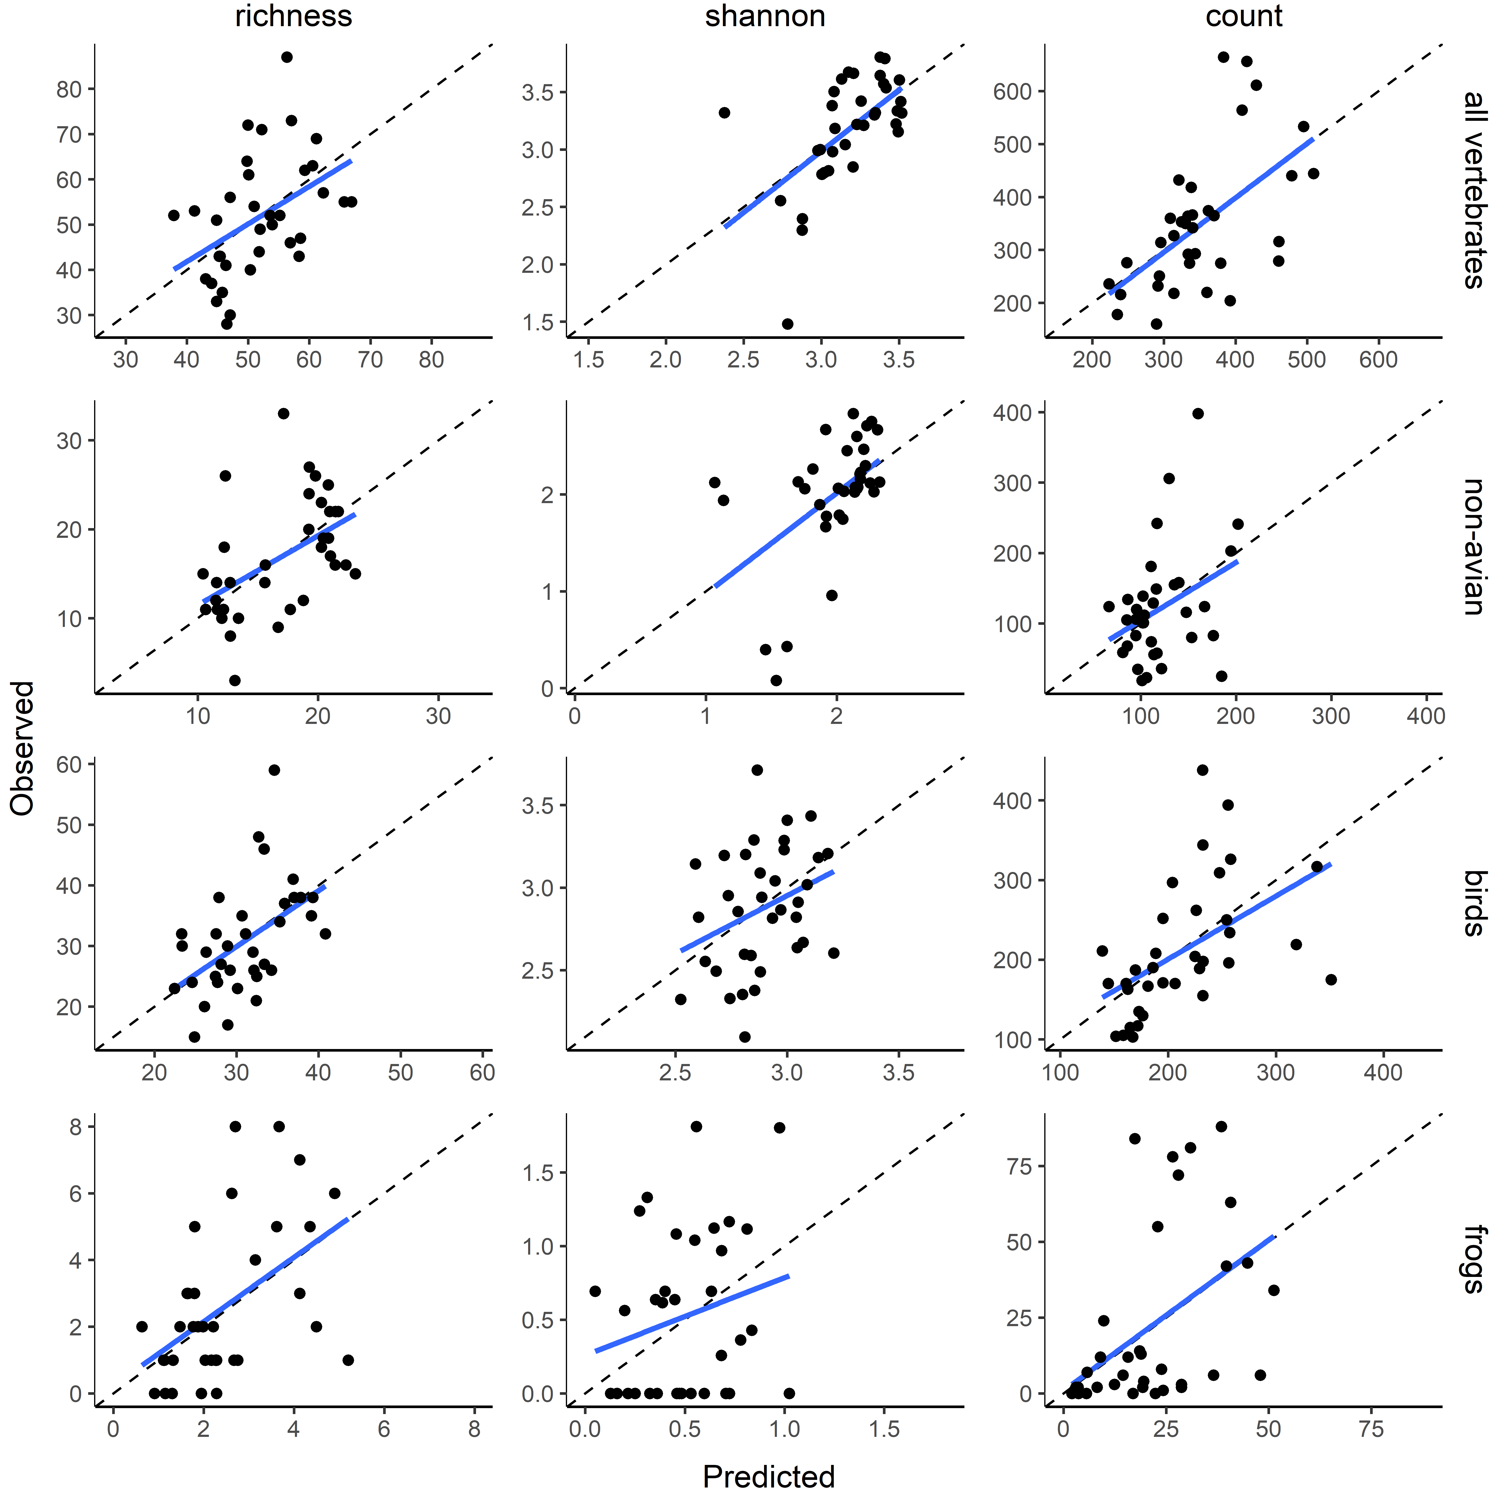

Figure . Comparison of observed and out-of-bag predicted values for random forest models