Web Programming CA – Project Functionality

Oisin Murphy D00191700

* Displays all artists on index to be picked from.
* Once chosen, the selected artist profile will load, displaying their details and unique styling (profile picture, background, and header images) as well as 3 pieces of their art.
* You can edit the artist’s details and featured art via an artist’s page, as well as the art’s name and date.
* You can access the Home page, add artist page, remove artist page, remove art page, and view all page on the navbar.
* You can add and remove artists and art from the database.
* You can view all art sorted by artist, by art name and by date added via the view all page.

ER Diagram

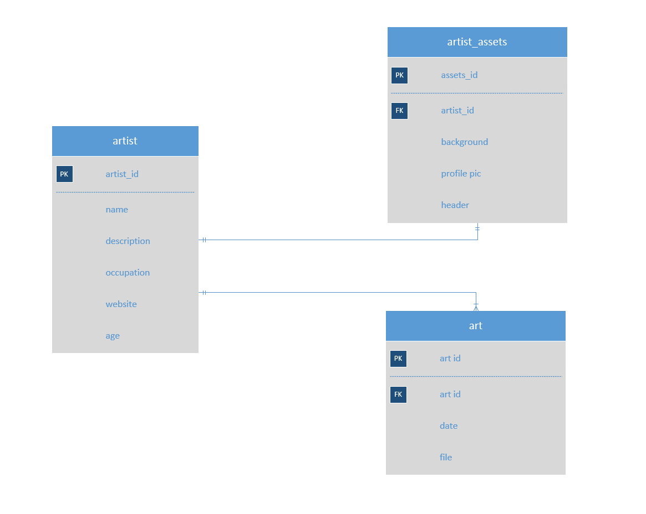

Screencast

<https://www.youtube.com/watch?v=Vv_rhgWPkFk&feature=youtu.be>