**Projectile Assignment –Patricia Bere & Oisin Murphy**

In our first test we decied to go with the following parameters:

t = 5s

Position = (2, -3, 6)m

Velocity = (-5, 14, 2)m/s

Rotation = (1, 2, 3)m/s

W = (-1, 1, 0)m/s

Ball density = 140

Liquid = water (1000kg/m^3)

radius = 0.05

duration of simulation = 0.1s

Below you can see the results both on paper and as produced by our program.

Paper results:

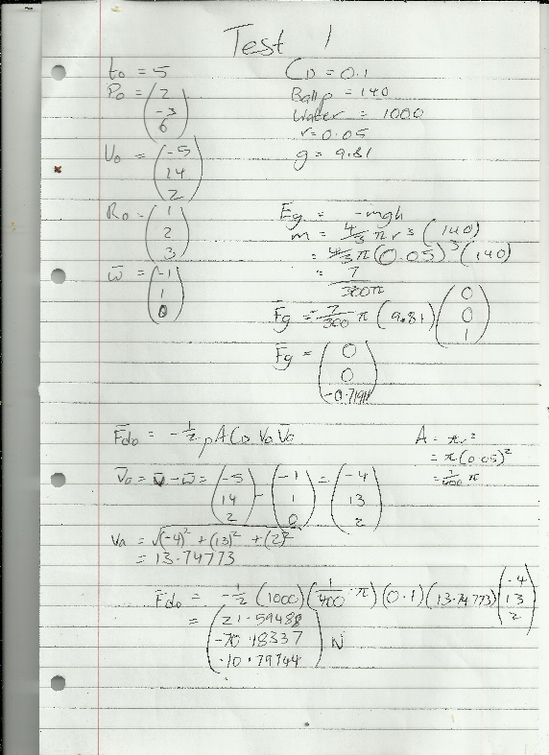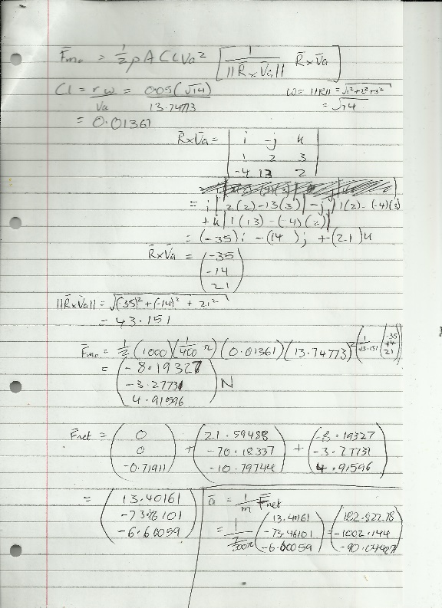

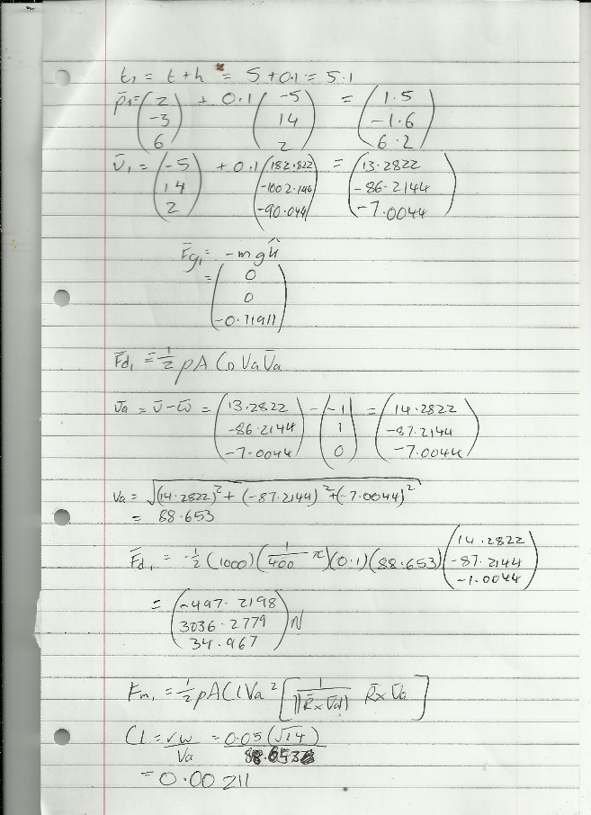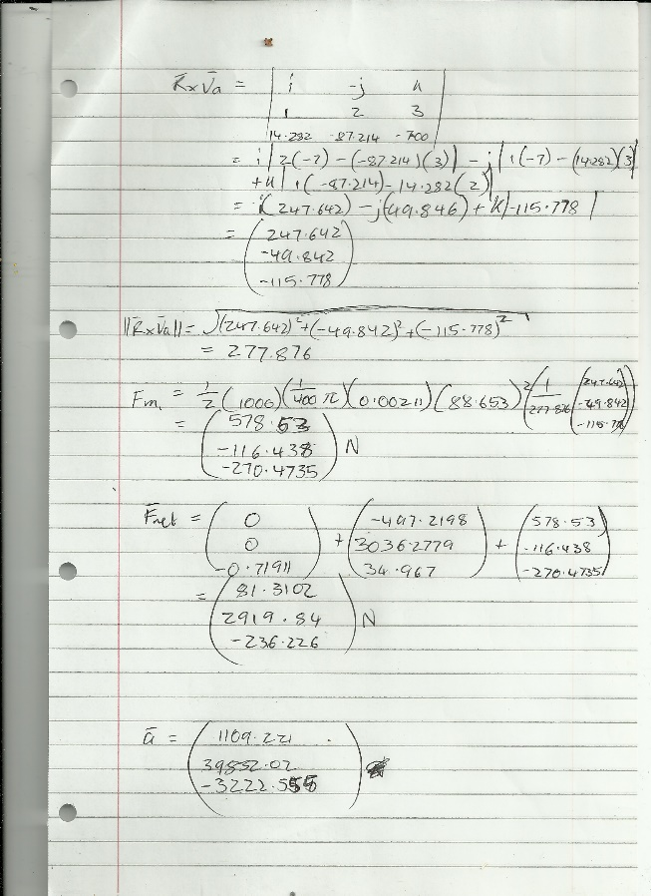

Program results:

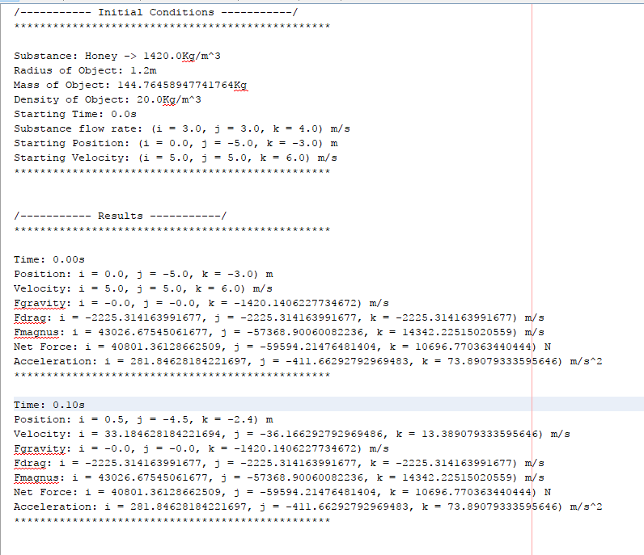

In our second test we decied to go with the following parameters:

t = 0s

Position = (0, -5, -3)m

Velocity = (5, 5, 6)m/s

Rotation = (-1, -2, -5)m/s

W = (3, 3, 4)m/s

Ball density = 20

Liquid = honey (1420 kg/m^3)

radius = 1.2

duration of simulation = 0.2s

Paper results:

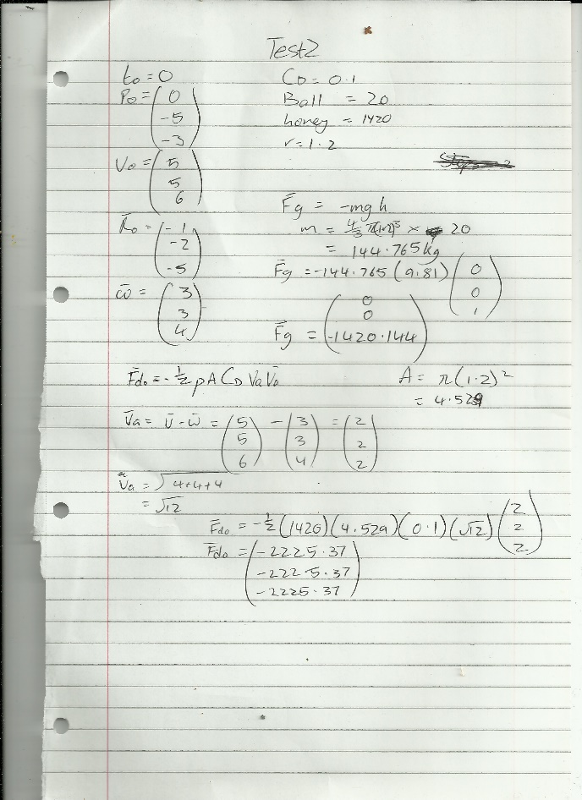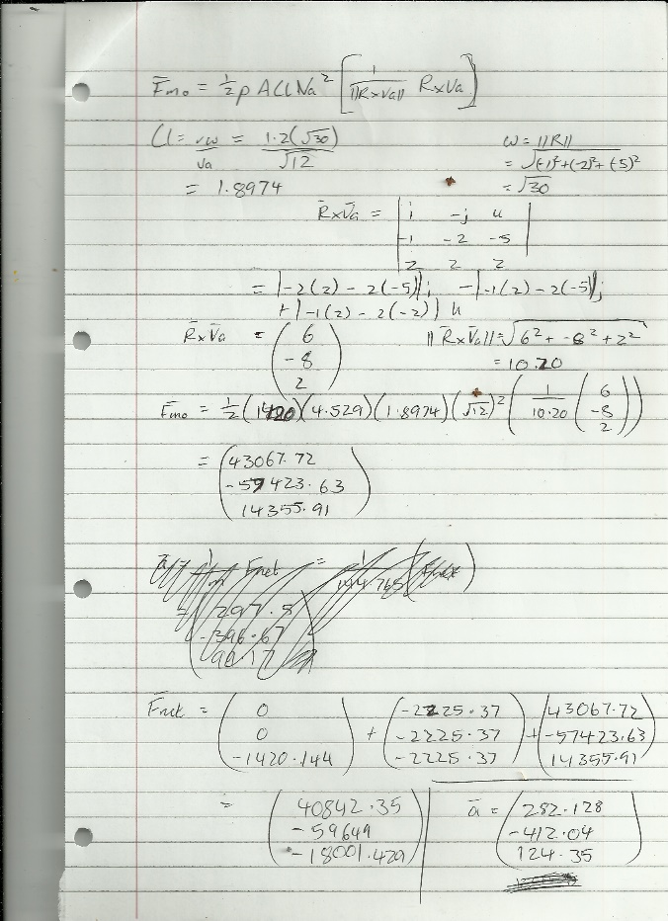

Program results:

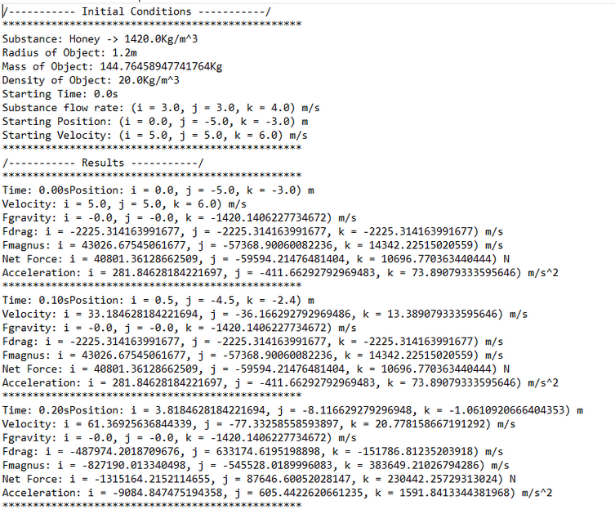

In our third test we decied to go with the following parameters:

t = 3.2s

Position = (1, 3, -1.4)m

Velocity = (-5, 17.6, 7.2)m/s

Rotation = (2.4, -1.3, 2)m/s

W = (7, 6, 4)m/s

Ball density = 1246

Liquid = hydrogen (0.082kg/m^3)

radius = 0.52

duration of simulation = 0.3s

Paper results:

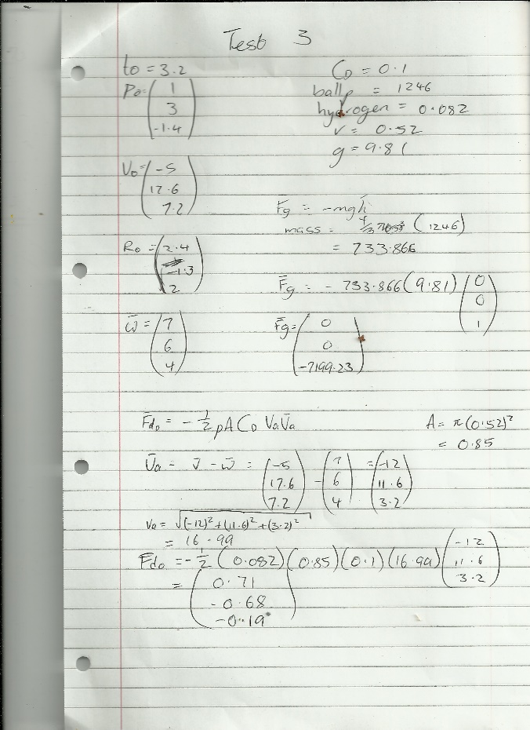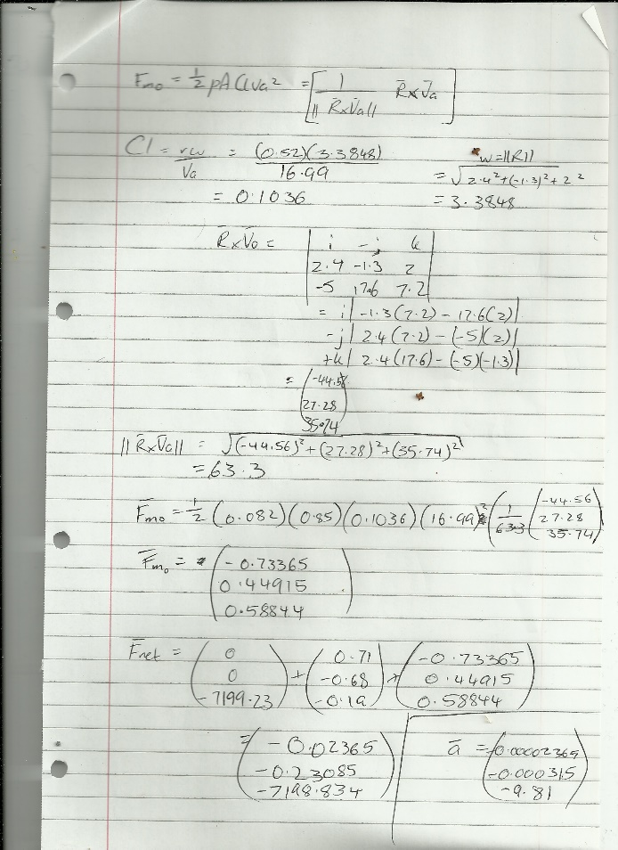

Program results:

