**Physics CA2 – Sliding  
Oisin Murphy, Patricia Bere**

**Test 1**

**Initial Conditions:**Radius: 0.07m  
Density: 3800kg/m^3  
Mass: 5.472kg  
Mu Static: 0.8  
Mu Kinetic: 0.7  
Normal Vector: (7, -9, 10)

**Paper Test**

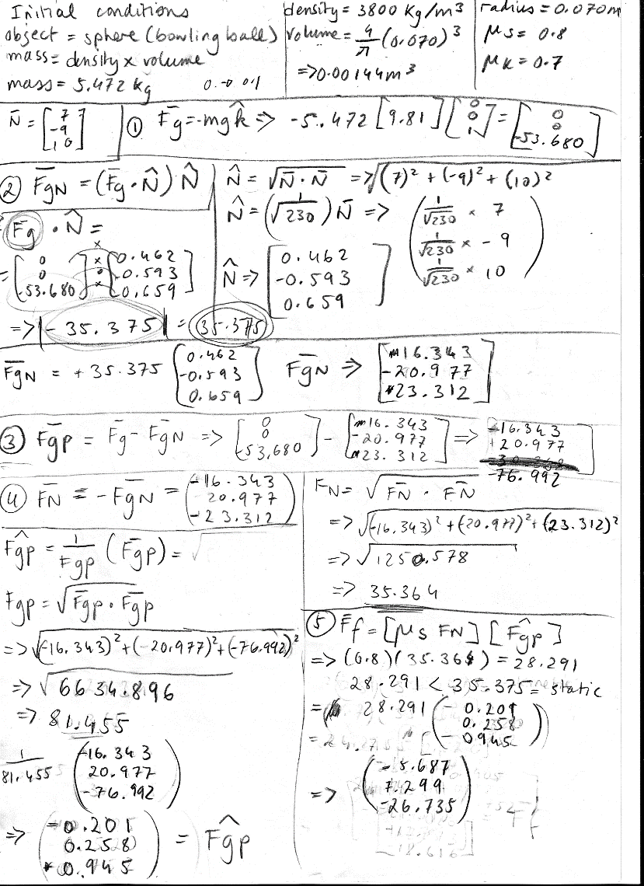

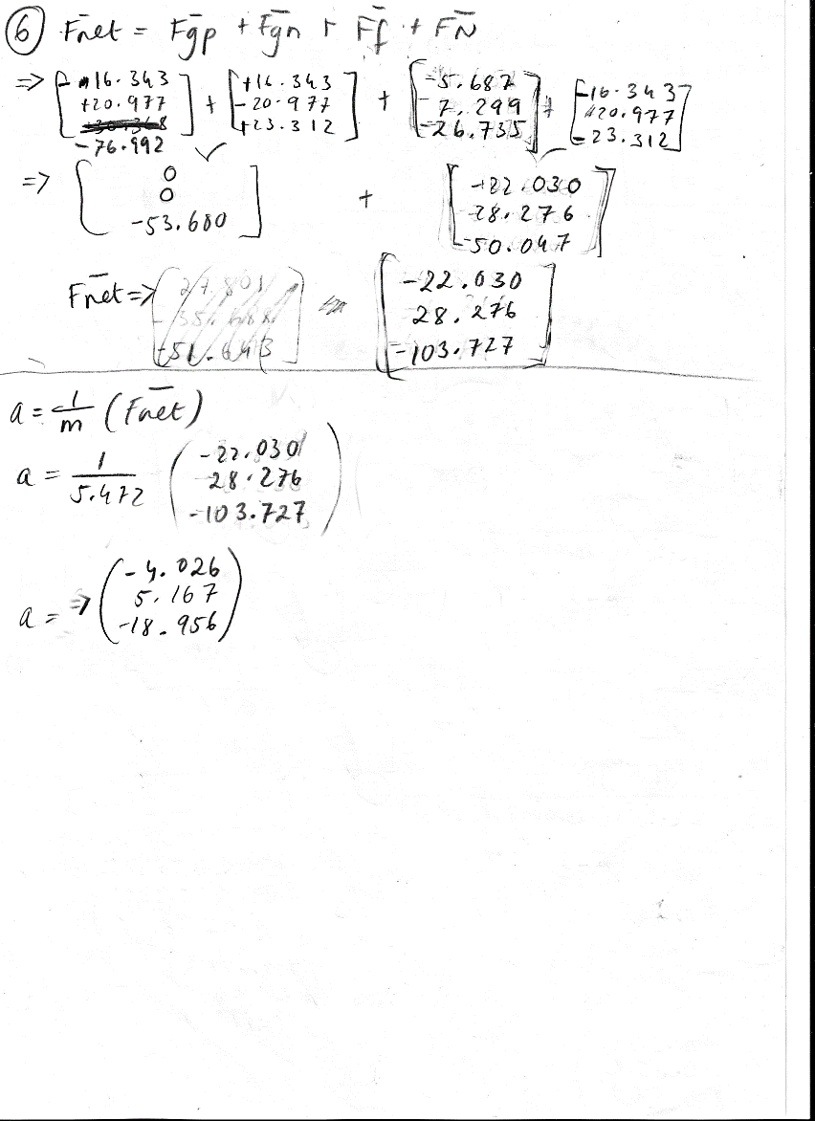

**Software Test**

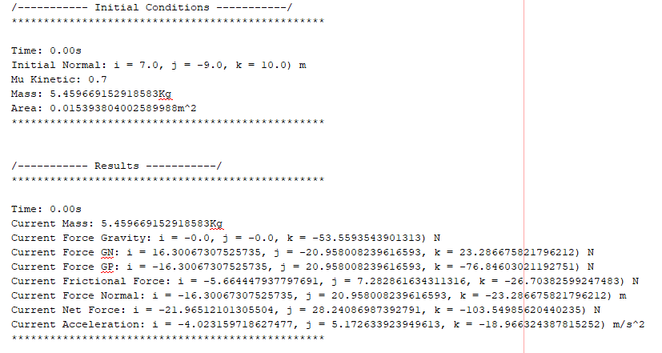

**Test 2**

**Initial Conditions:**Radius: 0.015m  
Density: 2100kg/m^3  
Mass: 0.009kg  
Mu Static: 0.9  
Mu Kinetic: 0.4  
Normal Vector: (-13, 6, -12)

**Paper Test**

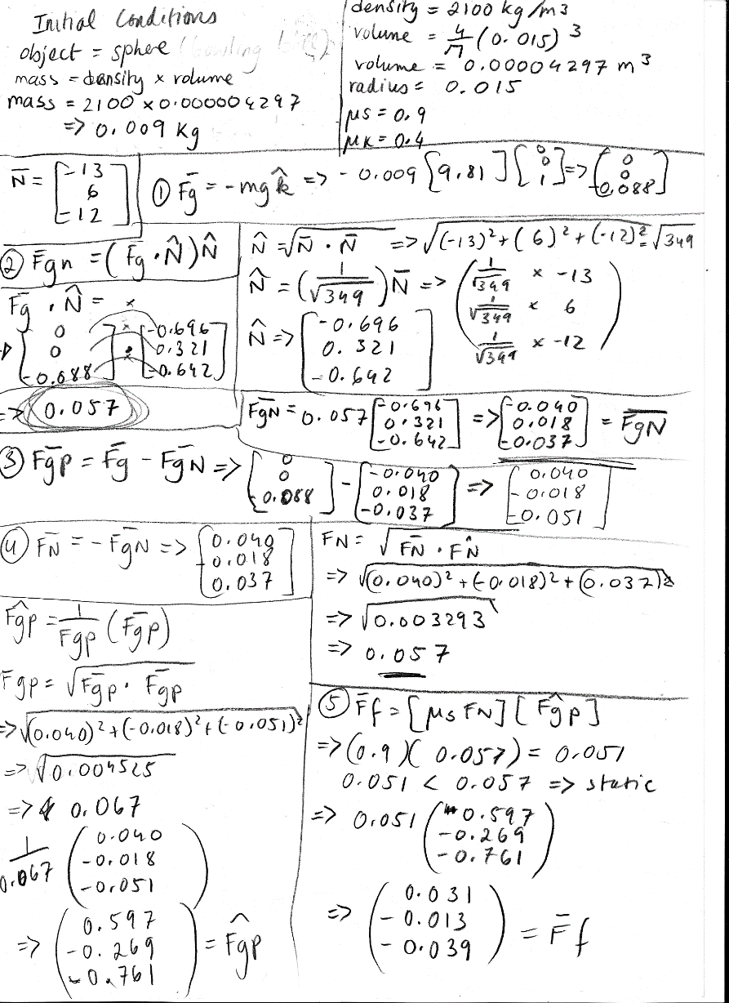

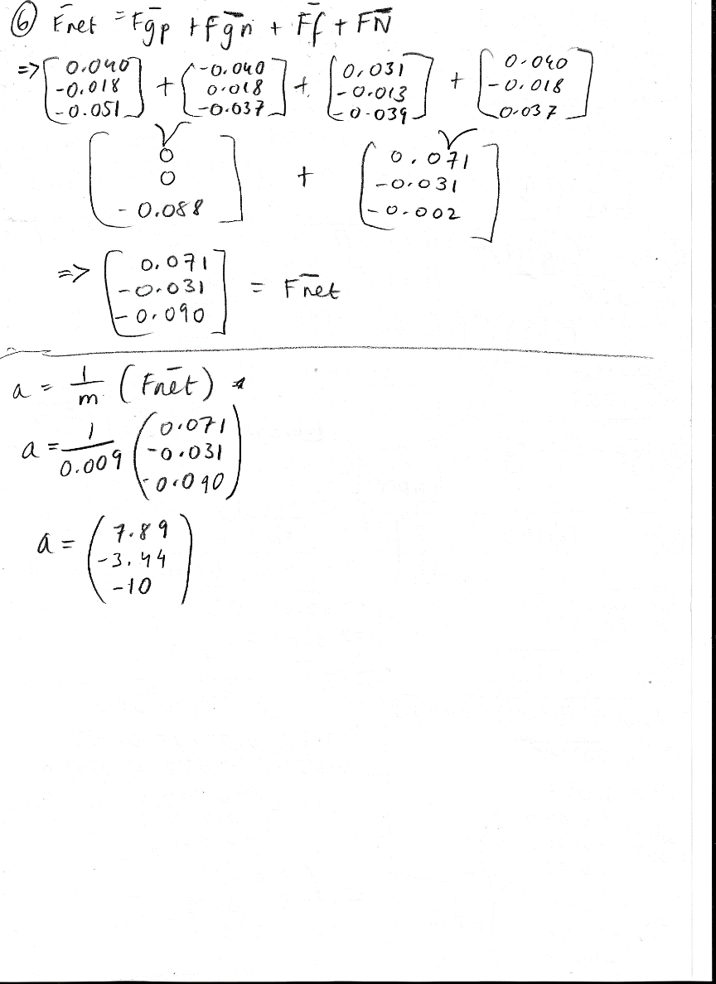

**Software Test**

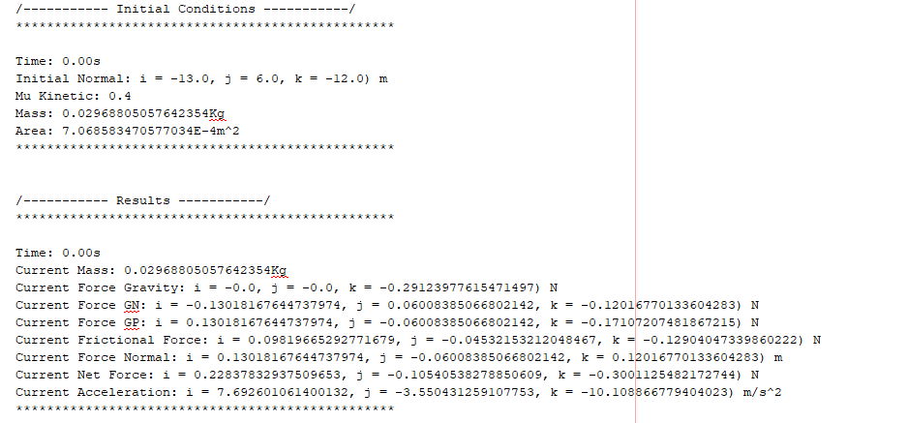

**Test 3**

**Initial Conditions:**Radius: 0.095m  
Density: 4200kg/m^3  
Mass: 4.585kg  
Mu Static: 0.3  
Mu Kinetic: 0.1  
Normal Vector: (11, -8, -4)

**Paper Test**

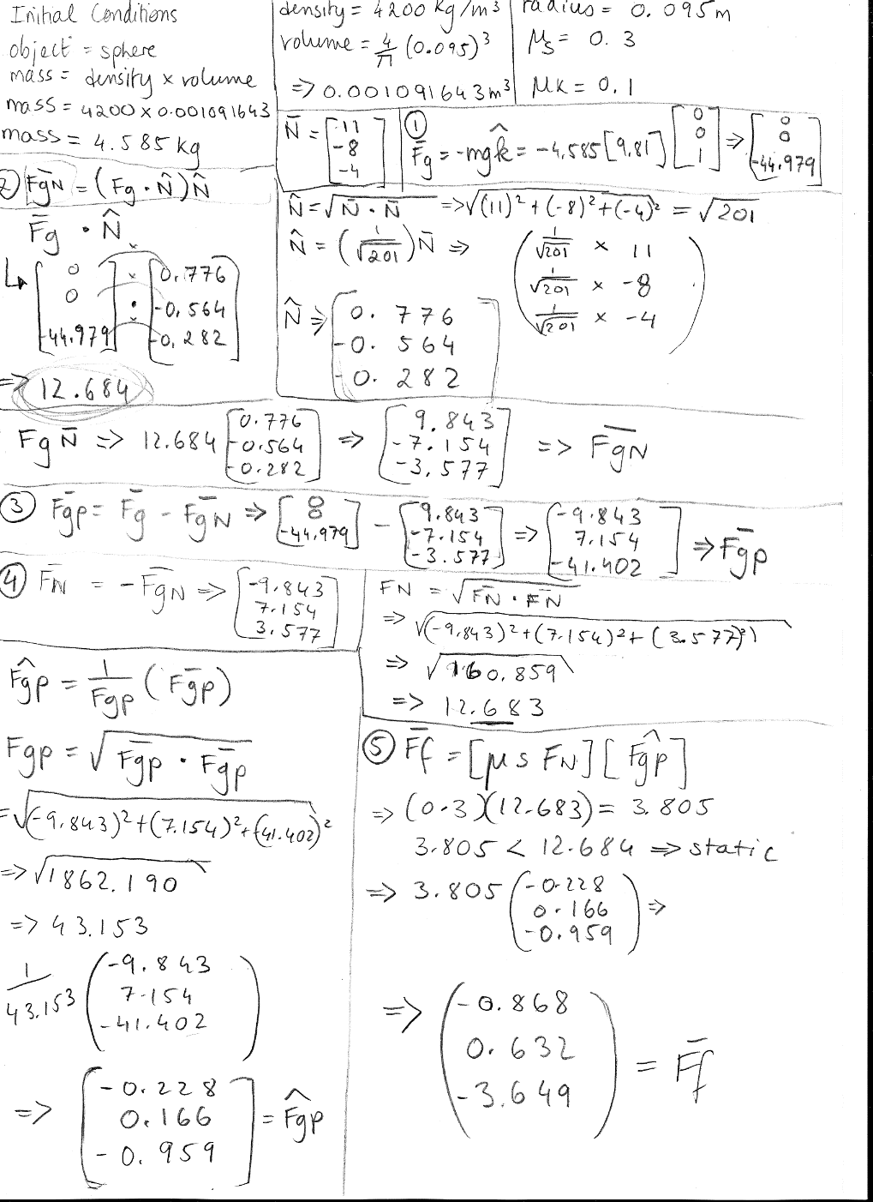

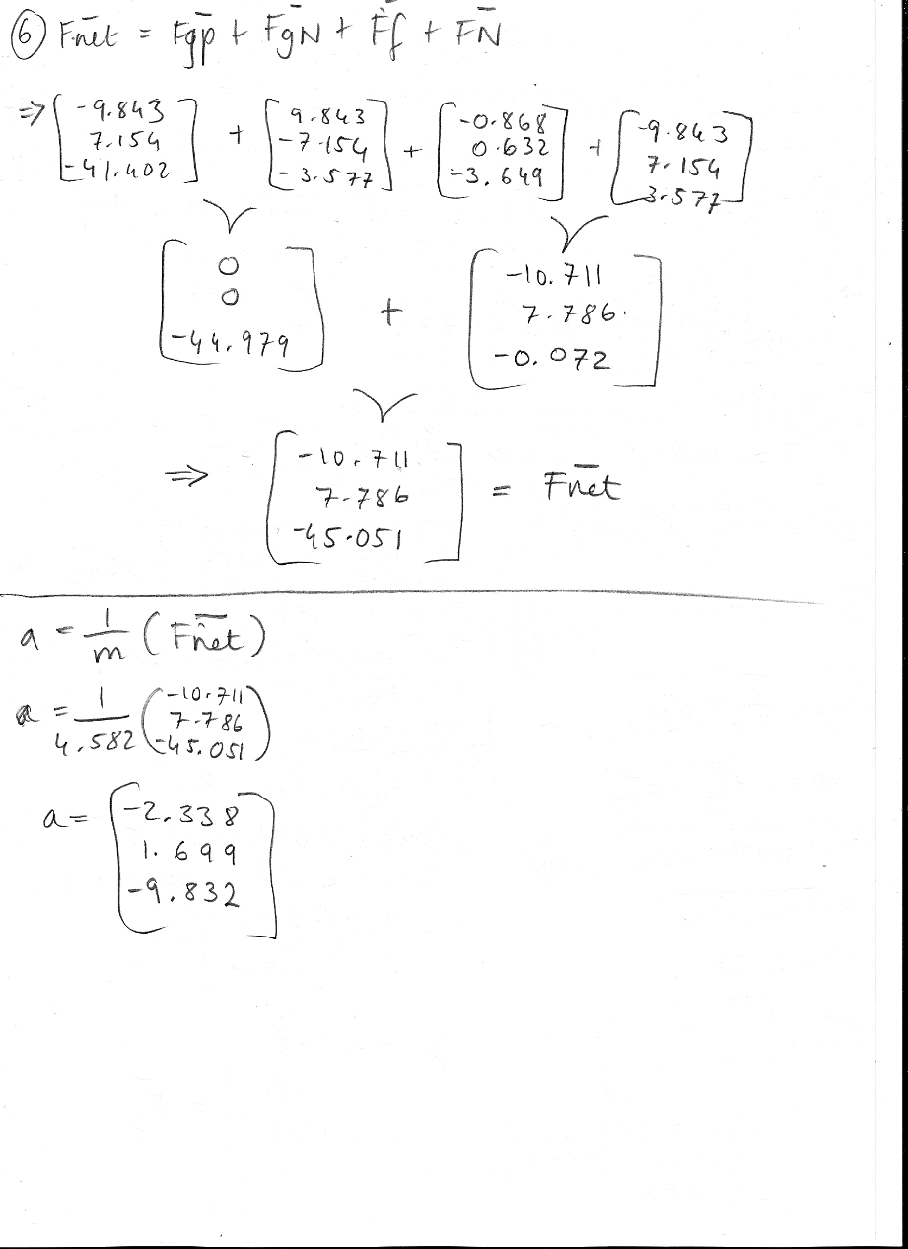

**Software Test**

