**Use Case Analysis**

Document the use case descriptions and draw a use case diagram for the chosen problem.

Pick/ get pet - Kerrie Callaghan

Care for pet - Oisin Murphy

Buy items - Patricia Bere

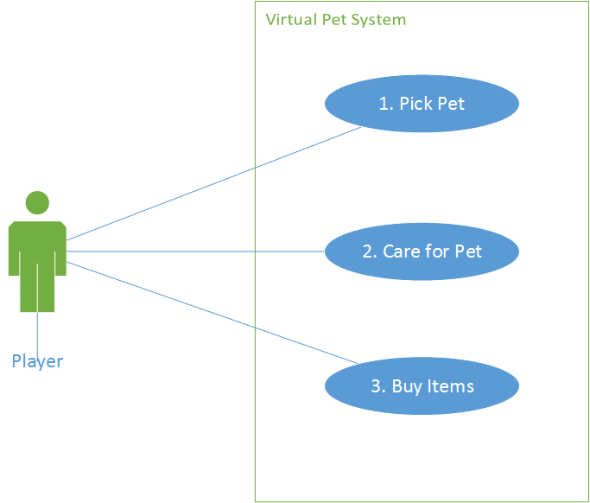

1. Title: UC1, Pick Pet.

Description: Player chooses the type of pet they would like to care for.

Actor: Player.

Trigger: Player begins a new game.

Pre-Condition: Player does not own a pet.

Post-Condition: Player owns a pet.

Normal Steps:

1. Select type of pet.
2. Select gender.
3. Enter name.

2. Title: UC2, Care for Pet

Description: Various pet interaction activities to keep it alive & healthy.

Actor(s): Player, game.

Trigger: Player input - choice.

Pre-Condition: Player chooses to interact with their pet.

Post-Condition: Player has interacted with pet, pet is now happier & its needs are mostly if not all met.

Normal Steps:

1. Enter the pet interaction menus
2. Pick an activity - food button, wash button, toy button, or bed button.

Feed Pet

3) Choose food type from inventory.

4) Give pet food.

Wash Pet

3) Choose bath or shower.

4) Choose shampoo to use.

5) Choose soap to use.

6) Choose duration of wash.

7) Note pet reaction(s).

Play w/ pet

3) Choose toy from inventory.

4) Choose playing option (i.e throw the ball/stick or jingle the bells)

5) Note pet reaction(s).

6) Change toy.

7) Play More.

Put pet to sleep

3) Choose bed for it to sleep in.  
 4) Choose if a toy will be used.

5) Choose toy.

3. Title : UC3, Buy Items

Description : The ability to buy items from the shop using currency in-game.

Actor : game

Trigger : player

Pre-Condition : Have enough money to buy what you want.

Post-Condition : Bought items.

Steps

1. Open shop from menu.
2. Select item(s).
3. Select quantity.
4. Buy item(s).