Paxos based directory updates for geo-replicated cloud storage

1. Introduction
   1. Geo-Replicated Cloud Storage
      * With the recent trend of moving services to the cloud, it’s not surprising that with the services, the data too has moved to the cloud.
      * Cloud applications can be classified into various classes based on their purposes.
      * Some, such as interactive web applications face stringent requirements on latency and availability.
      * Applications like banking or online trading whilst being sensitive to latency and availability too, have a stricter requirement in consistency. These are typically the online transactional applications.
      * The user bases of these applications are geographically distributed and the applications are expected to scale to hundreds of thousands of such users.
      * In response to these challenges, a number of systems that replicate data across geographically distributed data-centers have emerged in recent years.
      * Geo-replication has the double benefit of:
        + Placing data closer to the user base to minimize access latency
        + Adding a redundancy later for availability in case of failures – alleviating the single point of failure problem
      * Geo-replication comes with the added cost of the replication process itself which could be asynchronous or synchronous (and hence on the critical path of write operations). The consistency (or staleness) requirements coupled with the latency requirements have a role to play in the choice of either.
      * Thus we are left with the problem of customizing replication policies in cloud datastores to application workloads.
      * Some datastores like Cassandra and Dynamo are based on consistent hashing which limits their flexibility in placing data in replicas. Hashes however are fast to compute and the lookup time to determine the data location is just the compute time of the hash.
      * Other datastores like COPS(?) assume that all data is replicated everywhere, which may be prohibitively expensive for large applications.
      * To motivate the need for flexibility in data placement, consider an interactive web application that involves reads and writes by geographically distributed users while requiring consistent updates on the replicated/distributed replicas.
      * An example of such an application would be Facebook timelines or collaborative editing.
      * This requires us to carefully choose the number of replicas maintained, which datacenters contain what data and the underlying consistency parameters (e.g., quorum size in quorum based systems).
      * The requirement of placing data in the right datacenter is key to achieveing low read and write latencies in the cloud datastore.
      * This placement requires a directory scheme to manage the current location of data.
      * The directory is subject to the standard set of CRUD operations to reflect the current spread of data.
      * As a part of this thesis, we implement a system which manages these directory updates in a consistent fashion.
      * To do this, we use a Java based implementation of the Paxos protocol called JPaxos.
      * Alongside the implementation of this system, we also deploy this implementation in a simulated WAN setting to observe the behavior of Paxos.
2. Background
   1. Paxos

* An algorithm for implementing fault-tolerant distributed systems.
* The heart is a consensus algorithm – how do we get multiple processes that are each trying to assert/propose a value to agree upon and stick with a single value?
* The safety requirements:
  + Only a single value that has been proposed may be chosen
  + Processes learn about values if and only if they have been chosen
* The protocol does not specify any liveness/convergence requirements.
* There are 3 classes of “agents” that take part in the protocol:
  + Proposers – They propose values to be chosen
  + Acceptors – They choose to or not to accept proposed values
  + Learners – They learn the final, single proposed value that was accepted by the acceptors (not all, just a majority, see below)
  + There are no strict requirements on the mappings between the given processes and these roles
* A proposed value can be considered accepted once a majority of acceptors have accepted it.
* The cornerstone of the algorithm lies in determining how and which value must be accepted.
* From a bird’s eye perspective, the acceptors control the proposers and their proposed values – so the working of the algorithm is driven by acceptors forcing the proposers to propose acceptable values, whilst the design of the algorithm revolves around setting down rules for how to accept values.
* The design considerations for accepting values are as follows (revised as new requirements emerge:
  + 1. An acceptor must accept the first proposal it receives – we must begin somewhere
  + Only a single value must be accepted => we’ll turn this around and instead put the responsibility on the proposers and say – only that value may be proposed repeatedly
  + As a proposer, I can see what values have been accepted while proposing, but I cannot predict what values might be accepted in the future. To this end, I somehow seek to control the future acceptances by extracting promises from acceptors regarding the nature of the same
    - Proposals now have a proposal number. To avoid confusions, different proposals must have different numbers, a global ordering of sort – the implementation left open ended. A suggestion would be to just have proposers choose the numbers from non-overlapping sequences and store the last used number in stable storage.
    - Promise to me, the proposer that you, the acceptor will not accept a proposal with a number lower than mine
    - If you have already accepted a proposal, let me know.
  + Due to this extracted promise, we need to change acceptance rule 1 to: 1a. Acceptors can and must only accept proposals that do not violate promises it has made => accept proposals which have numbers > numbers of proposals to which promises have been made
  + 2. If a proposal with value ‘v’ is chosen, then every higher numbered proposal that is chosen by any acceptor has value ‘v’ – this follows from the requirement that only a single value be chosen in a round of Paxos.
  + This is where the implementation of the algorithm is driven backwards – to ensure that no proposal with a value other than ‘v’ with a proposal number higher than the highest accepted proposal number (with value ‘v’) is accepted, the acceptors force the proposer to only issue proposals with value ‘v’. Hence:   
    2a. If a proposal with value ‘v’ is chosen, then every higher-numbered proposal issued by any proposer has value ‘v’.
  + Now we relax constraint 2a by moving to a majority instead of every acceptor. Hence:   
    2b. For any proposal numbered ‘n’ with value ‘v’ issued, there exists a set ‘S’ consisting of a majority of acceptors such that either:
    - a) no acceptor in S has accepted any proposal numbered less than ‘n’, or
    - b) ‘v’ is the value of the highest numbered proposal among all proposals numbered less than ‘n’ accepted by acceptors in ‘S’
* Putting all this together, the algorithm for a single ‘round’ of Paxos sums up to such:   
  Phase 1.   
  (a) A proposer selects a globally exclusive proposal number ‘n’ and sends a prepare request to a majority of acceptors (it could be all acceptors in the implementation) – this is called a ‘prepare’ request.  
  (b) If an acceptor receives a ‘prepare’ request with number ‘n’ greater than any ‘prepare’ request to which it has already responded, it responds to the request with a promise not to accept any more proposals with number less than ‘n’, and the number ‘n’ and value ‘v’ of the highest number proposal it has accepted (if any).  
  Phase 2.  
  (a) If the proposer receives a response to its prepare request numbered ‘n’ from a majority of acceptors, then it sends an ‘accept’ request to each of those acceptors for a proposal numbered ‘n’ with either the value of the highest numbered proposal it received from the acceptors in response to its prepare request, or if no such value exists, then any value of its choosing.  
  (b) If an acceptor receives an accept request for a proposal numbered ‘n’ >= highest prepare request number it has responded to, then it accepts the proposal.
* A few things to note:
  + There is no direct correlation between Phases 1 and 2 in terms of a Phase 1 being sufficient for Phase 2. That is, a proposer ‘P1’ could elicit a response to its prepare request but it might end up racing with another proposer ‘P2’ in that acceptors could end up rejecting P1’s accept requests after accepting its prepare requests because P2 is racing P1 and keeps issuing prepare requests with numbers succeeding P1’s prepare requests.
  + A decision is implicitly reached when a majority of the acceptors accept the same value ‘v’ – because using induction and the property of there being at least one common acceptor in the intersection of 2 majorities of acceptors, we can show that the acceptors will force any future proposers into re-proposing the same accepted value.
  + There is no limit on the number of proposals that can be made – proposers can abandon proposals mid-flight and reissue proposals of higher numbers if they want.
  + There is no guarantee of convergence – the protocol is correct, but may never converge.
* To learn a chosen value, the learners must find out that a majority set of acceptors have accepted a single value. There are multiple ways to do this, the most straightforward of which would be to have every acceptor ack acceptances it makes to every learner.
* Optimizations:
  + The first obvious optimization would be some step to alleviate the non-convergence problem. We could have a “distinguished proposer”, a leader who would be the only one trying to issue proposals, circumventing the race problem.
  + Similarly, we could have a distinguished learner, or a set of them to reduce the number of acks that the acceptors would have to send out once they accept a value.
  1. JPaxos

1. Design and Implementation
   1. Dexter and DTunes?
   2. The Migration Service
      * The part of the DTunes project that we decided to implement was the directory service.
      * This service needed to be a fault tolerant service which keeps track of object migrations initiated by the compute client.
      * What we are guaranteeing here overall is that once a migration request has been saved by the Paxos members, they will eventually complete the migration.
      * We separate the migration process into 4 main concerns:
        + A directory service that implements the Paxos service interface fronted by the JPaxos code
        + A migration protocol that takes care of the actual migration process
        + Directories that store the current location of a given object
        + Migration Agents that perform the actual process of copying the object from the source to the destination location.
   3. The Directory Service
      * The Directory Service implements the service wrapper that JPaxos fronts.
      * This means, apart from the actual execution of decided Paxos requests themselves, it also handles concerns like snapshotting and restoration from snapshots.
      * What we had to be cognizant of in the design of the service is that there is no single replica that can be in charge of the migration of even just a single object.
      * Reason for this being we can have failures and leader changes mid-migration.
      * When a new object migration is received (and decided upon), a record is created in the database to represent the migration request.
      * This record represents all the state information associated with the object.
      * The fields stored in the record are:
        + ObjectId: The ID of the object being migrated
        + Old Replica Set: Where the object is currently being stored
        + New Replica Set: Where the object will be stored after the migration
        + Directory Acks: Directories that know about the new location of the object
        + Migration Progress Acks: Migration agents that have ACK’d back, having completed their share of the object movement
        + Creation Time: Time of creation of the record
        + Completion Time: Time the migration was completed
        + Last Updated Time: Time this last record was last serviced (read/updated). This is meant to be a mechanic to avoid starvation.
        + Migration Started Timestamp: Time the Migration Agents were informed about the required object movement.
        + Migrated: Boolean state of whether the object has been moved from its old replica set to the new one.
        + Migration Complete: Boolean state of whether the whole migration process has been completed for this object.
      * These fields are updated as the object moves through the migration process, and are also used to make decisions about what must be done next to complete the migration for the object.
      * Since we are implementing a fault-tolerant service, we can see that all write operations (insert and update) made on the record must be Paxos operations.
      * The first thing we had to consider while implementing the service was that the way the Paxos protocol as implemented recovers from a failure is by replaying batches of requests.
      * Depending on the crash recovery model we use, the strategy of recovery changes.
      * The EpochSS recovery model that we used replays all requests from the last saved Epoch, not just saved requests.
      * This means that decided requests that the crashed replica played before crashing will now be replayed.
      * JPaxos has been designed to replicate services that have no state surviving  
        crash.
      * However, what JPaxos does give us is a sequence number for every request that has the following properties:
        + It is monotonically increasing
        + It is consistent amongst replicas (the same request will have the same sequence number for every replica)
        + There are no gaps between 2 numbers
      * Using this primitive, we can design a stateful replication service.
      * We save the sequence number of the last executed request in the database and when we replay requests, we skip all requests up till the last executed one.
      * One important thing to note here is that the saving of the last executed request’s sequence number and the effect of the last executed request itself (in terms of any database operations) must be one single atomic operation.
      * Now that we have a stateful replicated system, the next thing to discuss would be the operations that the service supports:
        + Insert: creates a migration record in the database. By design, only one outstanding migration is allowed for an object. This design choice has tight correlation with the design choice of optimizing local database reads as opposed to Paxos reads in the migration protocol.
        + Update operations: updates on the above listed fields of the migration record. In the directory service, updates are triggered by either the protocol process or a migration agent.
        + Read: reads and serves the current migration state for the given object id
        + Delete: deletes the migration record for the given object from the database
        + Register operations: register directories/migration agents that are bootstrapping
      * To implement snapshotting, instead of restoring from a snapshot by replaying all requests contained in the snapshotted period, we snapshot the state of the database itself.
      * This makes the implementation straightforward and in some cases we end up with fewer database operations this way.
      * An example of such a case would be a snapshot of a single completed migration’s database record – if we maintained a traditional transaction based log, we would have about 8 database write transactions to reach completion. If on the other hand we just snapshotted the finished database state, we would achieve the same effect, in a single insert statement.
      * When restoring from a snapshot, the restoring replica wipes its database state clean and completely restores the state received.
   4. The Migration Protocol
      * The protocol is a process that runs co-hosted with all the replicas
      * The only protocol process that can make any decisions and take actions is the one co-hosted with the leader process.
      * Reason for this being, the protocol process co-hosted with the leader makes DB local reads (as an optimization instead of making Paxos reads)
      * When a leader change occurs, the process co-hosted with the new leader seamlessly picks up from where the old one left off.
      * To do this, we have a polling mechanism set up between the replica and protocol processes.
      * Since we want the protocol processes to be able to function in this seamless fashion without any communication between them on failure, the main design consideration was statelessness.
      * The protocol process is essentially a state machine. It picks up a few objects which still have been slated for migration and are in different stages of their migration and pushes them to completion.
      * The process is not currently threaded – that is it only performs one migration at a time.

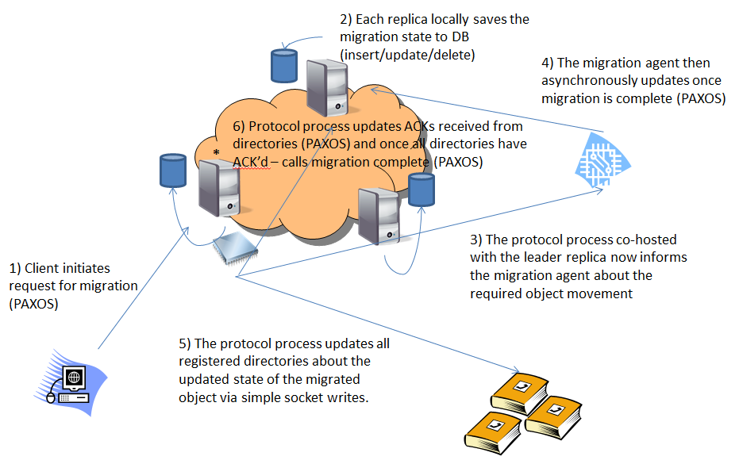

A step-by-step progress of the migration process

* + - As discussed before, the progress of any object’s migration is reflected in its state in the database.
    - The protocol process reads in the full state of the object from the database and then through a series of conditionals that represent the state machine, determines where along the process the object currently is and what the next step should be.
    - An example to illustrate the statelessness and seamlessness of the protocol processes:
      * Consider an object “object-id:1” that currently resides in some set of replicas {A,B,C} and needs to migrated to {B,F}.
      * A client process (that we refer to as the migration initiator) connects to the Paxos cluster and requests that this migration be performed.
      * The leader process accepts the request and queues it for proposing.
      * At this point, a failure of the leader process would not preserve the request and it would be lost. But also note, we have not responded to the client yet confirming that we have registered the migration request and it is now fault-proof.
      * The leader eventually (based on parameters such as the number of outstanding proposals, poll time, batching factor) drains the client request for the migration and proposes it.
      * Once the proposal is accepted by a majority of other replicas (including the leader), the leader replica proceeds to “Decide” the request.
      * Now note that each replica (by implementation in JPaxos) “Decide”s requests independently of each other. That is “Accept” requests from the follower replicas are multicast to all other replicas in the protocol, and once any replica in the cluster locally sees a majority, it goes ahead and “Decide”s the request.
      * Once a request has been decided, the request is then processed – that is, each individual replica gives control to the underlying implemented service to process the request byte stream.
      * This is where the previously discussed Directory Service would create a migration record for the Object in the database.
      * At this point, the migration request is considered resilient as it has been replicated in a majority of replicas.
      * Now the leader replica responds back to the client saying that the request has been persisted in the database and will eventually completed.
      * Meanwhile, the protocol process co-hosted with the leader is constantly polling the database for any outstanding migrations that need to performed.
      * It finds the new migration request in the database and starts off by initiating the actual movement of the object.
      * It does this by informing all registered migration agents of the object move by opening up connections to the IP/port they are listening on. It only does this for processes that have not already completed their part of the move and ACK’d back that they are done.
      * The ACKing from the migration agents is an asynchronous operation. The protocol process does not block on its execution path for this move to happen. It simply informs the agents about the required move and updates a timestamp on the migration record to reflect when it last informed the migration agents about the requisite move.
      * The timestamp helps handle failures of migration agents. If the protocol process informs them about the move and they fail before they can complete it, the process retries if it sees that all agents haven’t ACKed after a specified time interval from when it last updated them.
      * When migration agents ACK, it is another Paxos operation (as it is an update operation on the migration record’s state)
      * Once the protocol process sees that all registered agents have ACKed for the requested object move, it proceeds to the next step which is informing the registered directories about the new location of the object.
      * To do this, it runs over each registered directory and communicates the new replica set for the object over a connection to the IP/port the directory has been registered with. Once the directory (synchronously) ACKs back that it has received the information, the process makes a Paxos update to reflect the updated states of directories that have been informed about the new state of the object.
      * The reason for doing these updates on a per-directory basis is to keep our protocol stateless – this way, even if one protocol process fails midway, another can take over and continue where the old one left off.
      * We assume that the directories store the information in stable storage, so the information they hold is resilient to failures.
      * Once all directories have been informed, the protocol process then calls the migration complete and proceeds to look for more migrations to perform.
      * We note that all operations performed by the protocol process are just enactments of the state machine logic. It does not locally store any state about the progress of the migration. Any progress made is replicated and stored as state in the database, thus keeping everyone updated about the progress of every migration and achieving the seamless transitions between protocol processes in failure scenarios.
    - Maybe a detailed state machine diagram of the protocol process?
  1. Directories
     + Directories are processes that maintain a lookup table of mappings between objects and the set of replicas that currently hold them.
     + When directories bootstrap, they must register with the
  2. Migration Agents
  3. Logging Framework
     + The above sections discussed the implemented Directory Service for fault-tolerant object migrations.
     + But one of our main aims was detailed instrumentation of the Paxos protocol and to observe its performance in a WAN setting.
     + To achieve this we needed a non-invasive, detailed logging framework.
     + If we logged the progress of every request as it passed through checkpoints we setup in the system, we could collate the results to understand how the time is being divided on a part-by-part per request basis. The salient required features:
       - Per request granularity of logging: We need to able to identify individual requests so any discrepancies can be tied back to the originating request for analysis.
       - Non-Invasive: The logging framework cannot interfere with the actual execution of the code itself. It must be as decoupled from the code as possible. This translates to an asynchronous, threaded setup with queues.
       - Aggregated: We are tracking the progress of the request as it proceeds through multiple processes/machines in a distributed systems setting. We have the ability to track a single request across systems using its request number. We use the same to aggregate log data from multiple checkpoints across multiple machines into the log of the progress of the same request. We still maintain the source of the data – that is 2 checkpoints for the same request that are hit on 2 different machines will not overwrite each other; instead they will result in 2 numbers for the same checkpoint, for the same request under different replica numbers.
       - Analyzable: Instead of complicating the post-processing of logs to derive metrics, we do the work up front before persisting the logs. We use a relational database to store our data. This gives us a rich log format to store data under. This also gives us a very rich query interface to run analytics on the logged data.
       - Detailed: We wanted to log the data in as much detail as possible as we could always choose to process it at a coarser granularity. To this end, we have about 20 logging checkpoints setup per machine. However, some of these checkpoints will not be hit on all machines as they are parts of the code only the leader for the round will execute.

1. Experimental Methodology and Results
   1. Aim
      * The high level aim of the experiments was to get a deeper understanding of the Paxos algorithm in an actual implementation.
      * This effort can be broadly classified into 2 steps:
        + Understanding the implementation and it’s departures from the algorithm in terms of optimizations and details generally left open to implementation.
        + Instrumenting the implementation to piece-wise analyze the different component times in the algorithm.
      * Coupling this with different delays simulated between replicas would give us an example of an instrumented Paxos system deployed in a WAN.
      * The Directory Protocol gives us a working state machine system built around the Paxos core to drive the experiments.
   2. Setup  
      The experimental is as shown below:  
        
      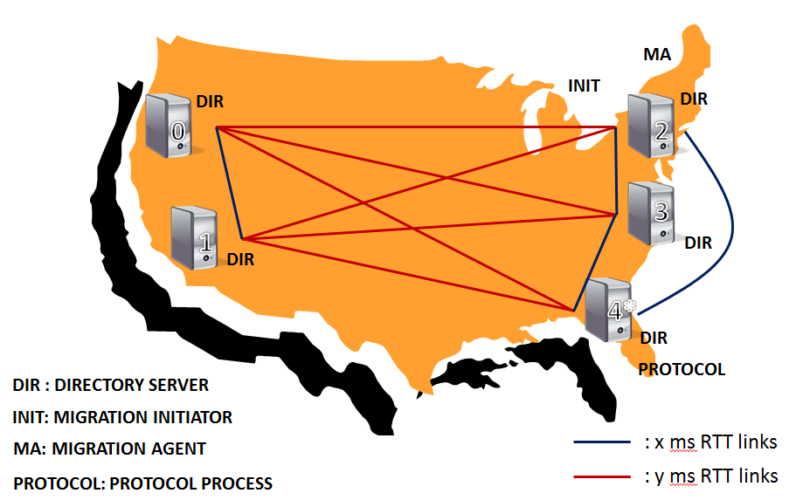

* We used a 5 replica cluster.
* The cluster was split into 2 sub-clusters. Depending on the inter and intra cluster delays this allowed us to model different geographical setups.
* Each replica runs its own directory server
* The Migration Initiator is co-located with the Migration Agent on one of the replicas. We did not want to end up needing a lot of the machines to conduct these experiments. Also since all 3 processes are rather lightweight, there would be limited overhead/contention between them.
* The Protocol Process runs on every machine, but since for the purpose of these experiments we are not simulating any failures, all processes apart from the one co-located with the leader replica are of no consequence as they would be unable to take any action.
* Since the focus here is on latency and not throughput measurements, we set the parameters to have high polling frequencies, and low critical path latencies.
  + CrashModel – EpochSS
  + WindowSize – 2 (the migrations are serial for the purpose of these experiments)
  + MaxBatchDelay – 0 (do not batch, push proposals instantly on arrival)
* The implementation had been modified to force any Paxos client to always connect to the leader process (directly, no redirections) and the same replica (#4) is elected leader for all experiments. This forces uniformity between runs so we can set strong expectations for our experiments.
  1. Experiments
     + The experiments are each run for 10 key migrations – each key migration involves 5 Paxos stages, namely:
       - Migration Initiation
       - Directory Acks – 1 per agent (5 in our implementation)
       - Updating Timestamp after informing Migration Agent about object move
       - Migration Agent Acks – 1 per agent (1 in our implementation)
       - Updating migration record to complete
     + All graphs are plotted on the basis of above mentioned Paxos rounds.
     + We ran our experiments for 3 different network configurations. Discussed below are each configuration and associated expectations and results.
     + No DummyNet:
       - These set of experiments are running on the PRObE testbed’s Infiniband fabric directly.
       - The link delays between nodes i.e. x = y = ~0.1ms.
       - Expectations:
         1. The Paxos latencies as measured from the enqueued phase to decide phase measured at the leader (as that is the only replica which has to power to queue and propose) should be of the order of a few milliseconds (~1 RTT). This is heavily dominated mainly by 2 factors:

Code execution time and threading overhead.

Queuing latencies between the multiple asynchronous parts of the application

* + - * 1. The client end to end latencies should be dominated by the service time of the request. The link latencies are almost negligible and the Paxos part of the request servicing should only come out to a few milliseconds. The service time again can be splits into 2 dominant factors:

Code execution time of the state machine itself

Database access times

* + - * Results:

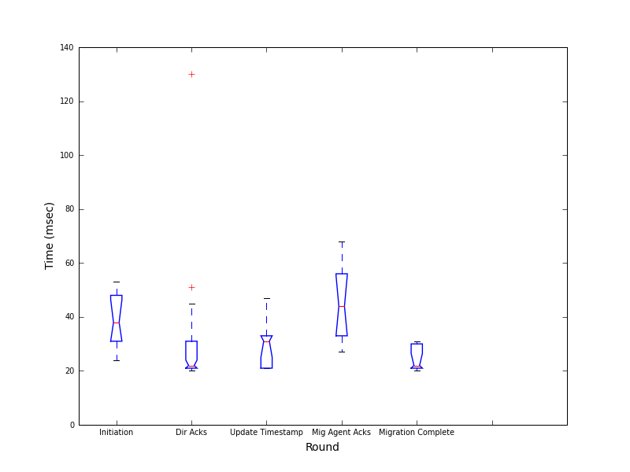

Paxos client end to end latency

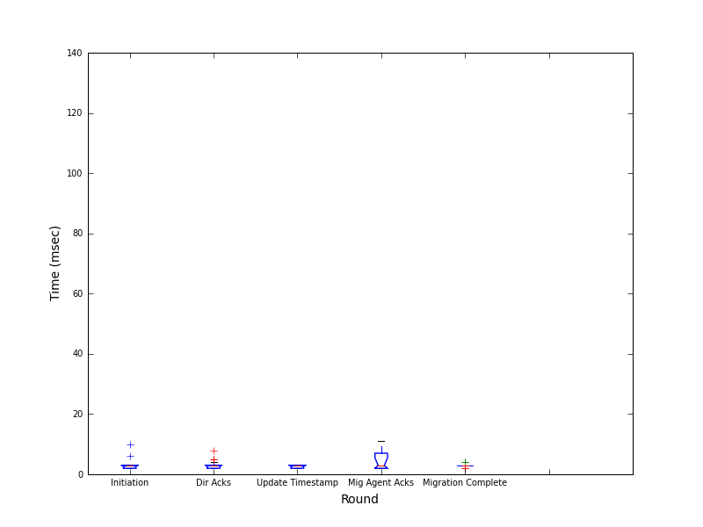

Paxos leader latency

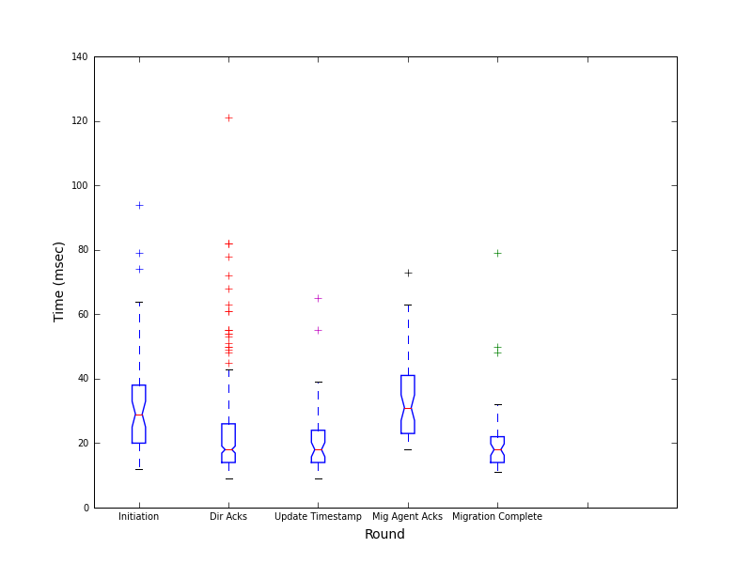

Directory service time

* While we have some deviation from the expected case, if we round-wise sum the service times and Paxos leader latencies, they line up with the Client end to end latencies.
* The client end to end latencies may not be uniform because of the different natures of the Paxos clients:
  1. Migration Initiator and Migration Agent processes run on different machines from the leader process, and will hence experience link delays.
  2. The Paxos client for the other rounds is the Protocol process which is running co-hosted with the leader replica, and will only experience inter-process communication delay.
* The possible mismatches could be due to a few reasons such as:
  1. The client end to end latency includes a round trip from the paxos client to the leader replica and whilst on inifniband this link latency itself is a small value, there is a finite queuing time involved in the transmission of the message within the application itself.
  2. + DummyNet with 0ms delay
       - DummyNet introduces a finite amount of overhead. If we configure DummyNet to emulate link delays to be 0ms, there is still a finite ping time between nodes.
       - This time was roughly observed to be around 5ms.
       - Plotting this case will now give us a benchmark for an overhead over our pure inifniband case.
       - The expectations here are the same as the no dummynet case and any observed deviation will be treated as the dummynet overhead.
       - Results:

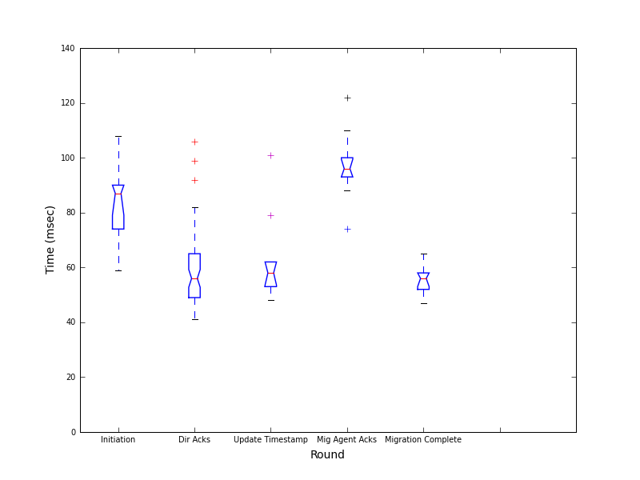

Client end to end latency

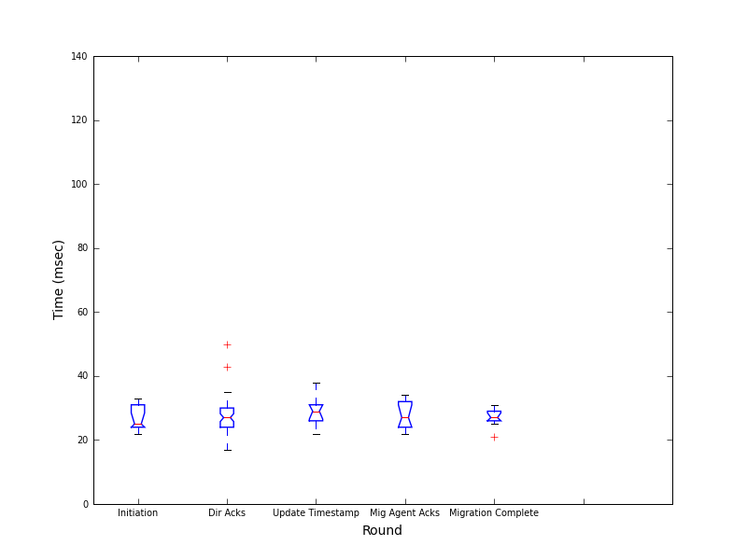

Paxos leader latency

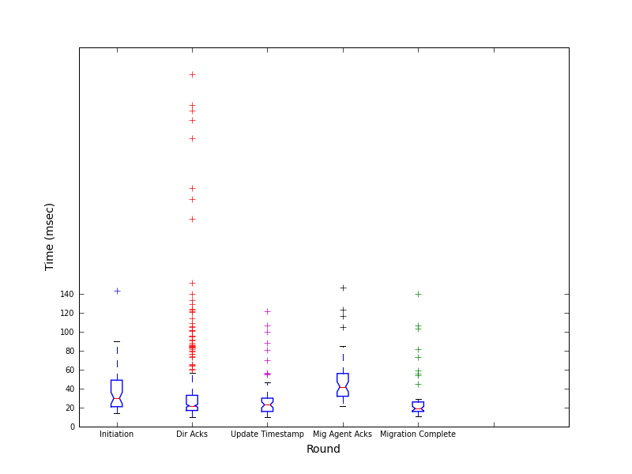

Directory service time

* Now we notice that we have a large deviation from the expected case (which would be that these graphs be very similar to the no dummynet graphs)
* Since there has been no change between these 2 experiments apart from dummynet being introduced to model 0ms delay, all of the deviation can be attributed to dummynet overhead.
* Now as the Paxos leader latency times represent ~ 1 RTT of link delay, we can use the overhead in that graph to fit and verify our earlier proposed explanation to the mismatch between the round-wise sum of the Directory service times + Paxos leader latencies and the Client end to end latency
  1. The client end to end latency includes a round trip from the paxos client to the leader replica.
  2. The earlier explanation attributed the extra time to message queuing delays in the application, but with this new overhead we are seeing due to dummynet for the Paxos leader times (~1 RTT) would now make the round trip from the client to the leader replica significant and in fact the dominant factor.
  3. Accounting for this, our observations line up as expected – Paxos leader latencies + Directory service times + Paxos leader latencies representing client-leader roundtrip ~= Client end to end latencies.  
       
     + Dummynet with uniform 20ms (RTT) latency
       - Now we simulate the 5 nodes being at equal link delays of 20ms from each other.
       - i.e. x = y =20ms
       - Expectations:
         1. The convergence time of a single Paxos round measured at the leader would now be composed of 3 factors:

Code execution time and threading overhead.

Queuing latencies between the multiple asynchronous parts of the application

Since all replicas are 20ms (RTT) away from the leader, ~1 RTT convergence time for the Paxos round would also now be expected to kick in.

* + - * 1. Since in our baseline pure Infiniband only experiment we saw Paxos leader times of ~3-5ms which account for i. and ii., overall we would expect to see a 20 + 3-5ms delay.
        2. But we also note that in our 0ms dummynet experiment that we saw a ~20ms overhead in our Paxos leader latencies.
        3. So while we would ideally expect to see a 25ms Paxos leader latency graph, it would be offset by the overhead, moving up our expectations to around 45ms.
        4. The client end to end latencies can be split into dominant factors:

The client-leader RTTs for the initiation and migration agent ack rounds – ~20ms

The service time for the request – DB + code execution time

The Paxos time itself - ~20ms (1 RTT)

* + - * 1. Hence we expect a 20ms (for initiation and migration agent acks) + 20ms + 3-5ms (baseline Paxos) + 20ms dummynet overhead + DB + code execution time.
      * Results:

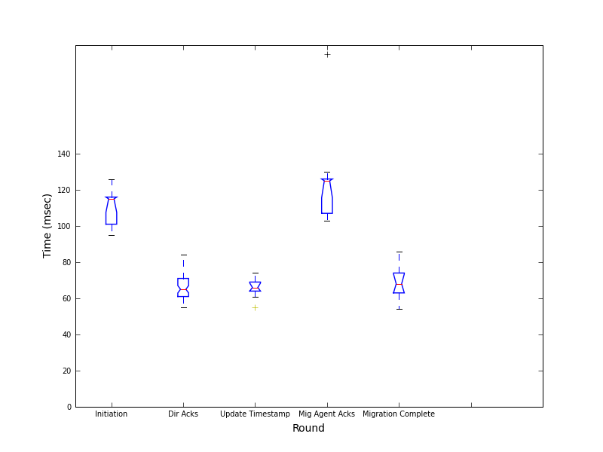

Client end to end latency

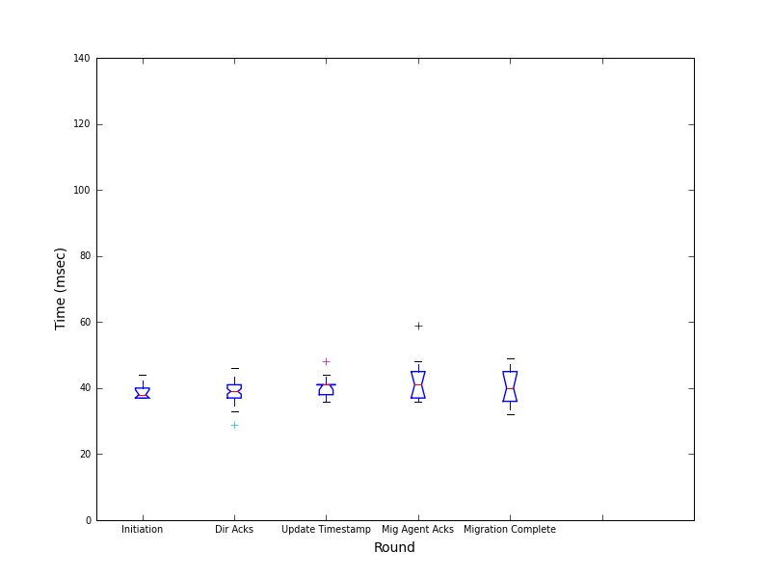

Paxos leader latency

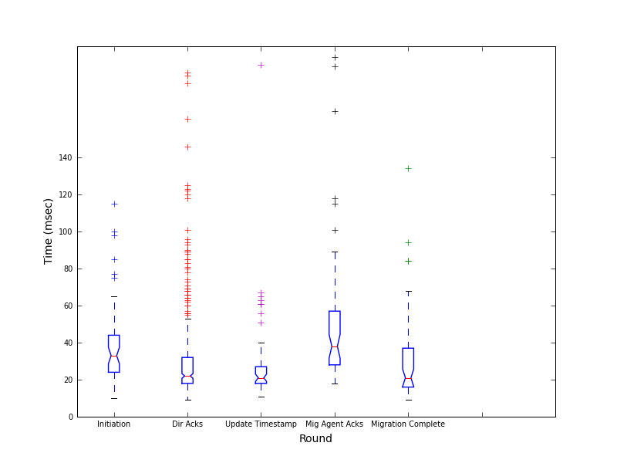

Directory service time

* We notice that most of our expectations were right.  
  + - Dummynet with 20 and 80ms delays
      * We simulate a setup with 3 machines on the east coast and 2 on the west coast.
      * x = 20ms, y = 80ms.
      * Expectations:
        1. The convergence time of a single Paxos round measured at the leader would now be composed of 3 factors:

Code execution time and threading overhead.

Queuing latencies between the multiple asynchronous parts of the application

The convergence time for a single Paxos round would still be expected to be around 20ms as the leader replica has the ability to form a majority with the 2 other east coast replicas.

* + - * 1. Other expectations remaining the same as the previous case, we would still ideally expect to see a 25ms Paxos leader latency graph, it would be offset by the overhead, moving up our expectations to around 45ms.
        2. The client end to end latencies can be split into dominant factors:

The client-leader RTTs for the initiation and migration agent ack rounds – ~20ms

The service time for the request – DB + code execution time

The Paxos time itself - ~20ms (1 RTT)

* + - * Hence we expect a 20ms (for initiation and migration agent acks) + 20ms + 3-5ms (baseline Paxos) + 20ms dummynet overhead + DB + code execution time.
      * Results:

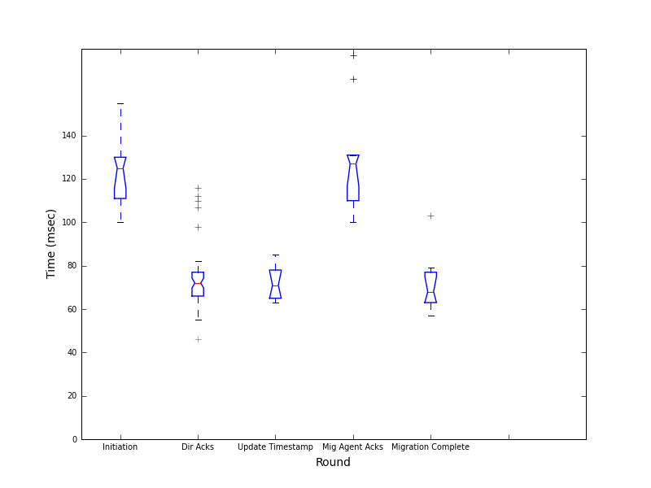

Client end to end latency

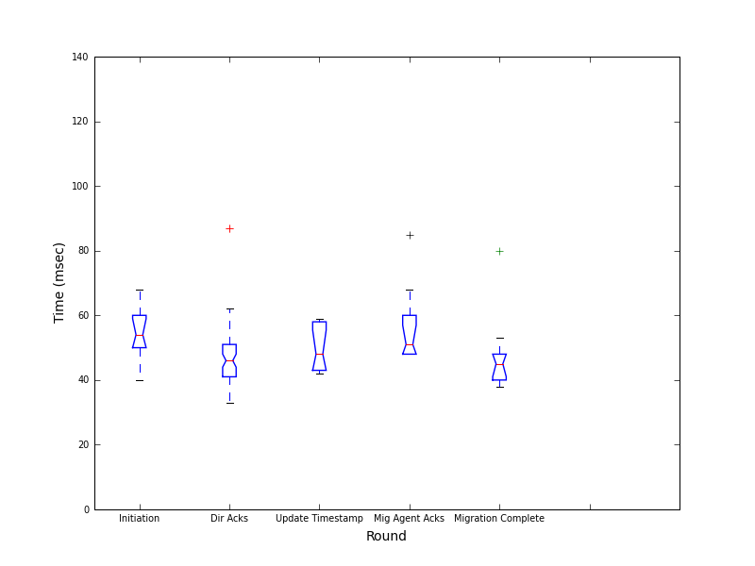

Paxos leader latency

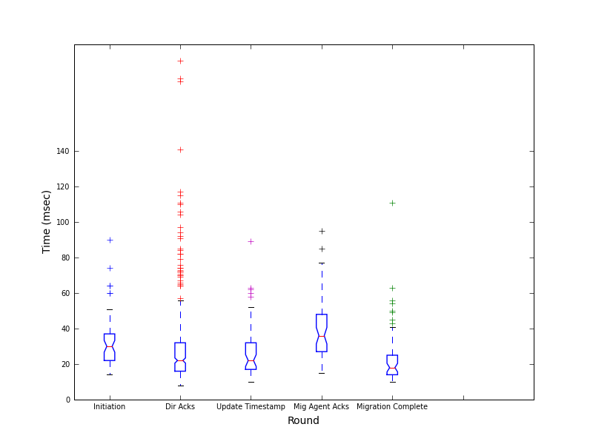

Directory service time

* Our Paxos leader times as expected are still around the 45ms mark – validates our claim about the east coast majority causing consensus.
  + - * Other results match up as expected.
    - Something that we observe across the service time results above is that the initiation and migration agent acks times seem to be consistently higher than the other 3. This can be attributed to the following reasons:
      * Database – Initiation is an insert operation. The other operations are all update operations. This leads us to believe that the DB optimizer somehow seems to favor performance of one over the other.
      * Migration Agent Acks by design is a 3 step database operation due to its asynchronous nature.
        1. First the migration agent acking is identified through its IP and port information.
        2. Then the current migration progress for the object being migrated is looked up.
        3. Finally, if this is an ack from an agent that hasn’t already acked, the entry is recorded.

1. Conclusion