PAXOS BASED DIRECTORY UPDATES FOR GEO-REPLICATED CLOUD STORAGE

A Thesis

Submitted to the Faculty

of

Purdue University

by

Srivathsava Rangarajan

In Partial Fulfillment of the

Requirements for the Degree

of

Master of Science in Electrical and Computer Engineering

August 2014

Purdue University,

West Lafayette, Indiana

This thesis is dedicated to my parents who instilled in me the importance of education and to my friends for making grad school appear easy.

ACKNOWLEDGEMENTS

I would like to thank Dr. Sanjay Rao for the opportunity he offered me to work along with him on this project. Learning to set my own goals and expectations has been a liberating experience, one that has introduced me to the lifestyle that is research.

I would like to take the opportunity to commend the authors of JPaxos for writing and maintaining a clean, understandable codebase. I would especially like to thank Jan Kończak for corresponding with me and patiently answering the slew of questions regarding both implementation details in JPaxos and Paxos in general. His guidance on many issues was vital to making progress towards the implementation of this system.

To my colleagues, I wish to extend my gratitude for giving me support and advice when I needed it. Every interaction and meeting I learnt something new and I find myself all that much wiser for having asked the most fundamental of questions.

TABLE OF CONTENTS

Page

LIST OF TABLES vi

LIST OF FIGURES vii

ABSTRACT ix

1. INTRODUCTION 6

1.1 Goal of the Thesis 8

1.2 Thesis Contribution 8

1.3 Organization of the Thesis 8

2. BACKGROUND 9

2.1 Paxos 9

2.2 JPaxos 9

2.2.1 Brief introduction 13

2.2.2 MultiPaxos 13

2.2.3 JPaxos architecture 15

2.2.4 Optimizations 16

2.2.5 Replica catchup mechanisms 17

2.2.6 Recovery 17

2.3 PostgreSQL 19

3. DESIGN AND IMPLEMENTATION 20

3.1 Motivation 20

3.2 The Migration Service 21

3.2.1 The directory service 21

3.2.2 The migration protocol 23

3.2.3 Directories 25

3.2.4 Migration agents 25

3.2.5 Logging framework 26

4. EXPERIMENTAL METHODOLOGY AND RESULTS 27

4.1 Aim 27

4.2 Setup 27

4.3 PRObE 28

4.4 Breaking Down Latencies Involved In The Migration Process 29

4.5 Results and Discussion 29

4.5.1 No DummyNet 29

4.5.2 DummyNet with x=y=0ms 31

4.5.3 DummyNet with x=y=20ms 33

4.5.4 DummyNet with x=20ms, y=80ms 36

4.5.4 Net Migration Times 36

4.6 Overhead When DummyNet Is Introduced 19

5. CONCLUSION 39

5.1 Summary of Thesis Contributions 27

5.2 Key Results 27

5.3 Limitations and Future Work 28

LIST OF REFERENCES

LIST OF TABLES

Table Page

4.1Times involved in the migration process 7

4.2 Expected times for each operation 11

LIST OF FIGURES

Figure Page

1.1 Object migration between replicas 7

2.1 Paxos: Round successful 11

2.2 Paxos: A single failed acceptor, majority still ensures progress 11

2.3 Paxos: Failed proposer 11

2.4 Paxos: Livelock without distinguished proposer 12

2.5 The message patterns of single (optimized) and multi Paxos 14

2.6 A service replicated in three replicas accessed by several clients. 15

2.7 Request handling, when client is connected directly to the leader 15

3.1 A step-by-step progress of the migration process 23

4.1 Experimental Setup 27

4.2 Paxos client end to end latency (No DummyNet) 30

4.3 Paxos round convergence time (No DummyNet) 30

4.4 Directory service time (No DummyNet) 31

4.5 Paxos client end to end latency (DummyNet with x=y=0ms) 32

4.6 Paxos round convergence time (DummyNet with x=y=0ms) 32

4.7 Directory service time (DummyNet with x=y=0ms) 33

4.8 Paxos client end to end latency (DummyNet with x=y=20ms) 34

4.9 Paxos round convergence time (DummyNet with x=y=20ms) 35

4.10 Directory service time (DummyNet with x=y=20ms) 35

Figure Page

4.11 Paxos client end to end latency (DummyNet with x=20ms, y=80ms) 36

4.12 Paxos round convergence time (DummyNet with x=20ms, y=80ms) 37

4.13 Directory service time (DummyNet with x=20ms, y=80ms) 37

4.14 Net Migration Time for a migration

4.15 Net Migration Time (without object movement time) for a migration

4.16 Delay Observed vs. Delay Emulated for ping test 50

ABSTRACT

Rangarajan, Srivathsava. M.S.E.C.E., Purdue University, August, 2014. Paxos Based Directory Updates for Geo-Replicated Cloud Storage. Major Professor: Sanjay G. Rao.

Modern cloud data stores (e.g., Spanner, Cassandra) replicate data across geographically distributed data centers for availability, redundancy and optimized latencies.

An important class of cloud data stores involves the use of directories to track the location of individual data objects. Directory-based datastores allow flexible data placement, and the ability to adapt placement in response to changing workload dynamics. However, a key challenge is maintaining and updating the directory state when replica placement changes.

In this thesis, we present the design and implementation of a system to address the problem of correctly updating these directories. Our system is built around JPaxos, an open-sourced implementation of the Paxos consensus protocol. Using a Paxos cluster ensures our system is tolerant to failures that may occur during the update process compared to approaches that involve a single centralized coordinator.

We instrument and evaluate our implementation on PRObE, a large scale research testbed, using DummyNet to emulate wide-area network latencies. Our results show that latencies of directory update with our system are acceptable in WAN environments.

Our contributions include (i) the design, implementation and evaluation of a system for updating directories of geo-replicated cloud datastores; (ii) implementation experience with JPaxos; and (iii) experience with the PRObE testbed.

**1. INTRODUCTION**

With the recent trend of moving services to the cloud, it’s not surprising that with the services, data too has moved to the cloud. Cloud applications can be classified into various classes based on their purposes. Some, such as interactive web applications face stringent requirements on latency and availability. An example of such an application would be social media applications such as Facebook or Twitter. When we post updates/tweets, we expect the application to be more responsive than absolutely correct in its general ordering of news feed.

Applications like banking or online trading whilst being sensitive to latency and availability too, have a stricter requirement in consistency; typically these are the online transactional applications. We expect transactions to be absolutely right even if it takes a few seconds longer to process.

The user bases of these applications are geographically distributed and the applications are expected to scale to hundreds of thousands of such users. In response to these challenges, a number of systems that replicate data across geographically distributed data-centers have emerged in recent years.

Geo-replication has the double benefit of:

1. Placing data closer to the user base to minimize access latency
2. Adding a redundancy later for availability in case of failures – alleviating the single point of failure problem

Geo-replication comes with the added cost of the replication process itself which could be asynchronous or synchronous (and hence on the critical path of read or write operations). The consistency (or staleness) requirements coupled with the latency requirements have a role to play in the choice of either. Thus we are left with the

problem of customizing replication policies in cloud datastores to application workloads.

Some datastores like Cassandra and Dynamo are based on consistent hashing which limits their flexibility in placing data in replicas. Hashes however are fast to compute and the lookup time to determine the data location is just the compute time of the hash. Other datastores like COPS(?) assume that all data is replicated everywhere, which may be prohibitively expensive for large applications.

To motivate the need for flexibility in data placement, consider an interactive web application that involves reads and writes by geographically distributed users. An example of such an application would be Facebook timelines or collaborative editing. This requires us to carefully choose the number of replicas maintained, which datacenters contain what data and the underlying consistency parameters (e.g., quorum size in quorum based systems). The requirement of placing data in the right datacenter is key to achieveing low read and write latencies in the cloud datastore.

This placement requires some sort of directory scheme to manage the current location of data. A directory scheme as the name suggests involves a collection of directories (typically one co-located with every replica) which serves as a lookup table for objects to determine their current locations. As the directory lookup now becomes a key step in object fetching, it is important to keep these directories updated. Thus, the directory is subject to the standard set of Create, Update and Delete (CRUD) operations to reflect the current spread of data.

The importance of having consistent directory updates is to ensure correctness. If we have different directories holding different states for objects, one of them by definition is bound to be wrong. To illustrate this, consider Figure 1.1.

Figure 1.1 depicts a scenario where a directory update can fail leaving directories in an inconsistent state. We see that Object-1 has been migrated from one replica to another, but the updates made to the directories about the new location of the object are inconsistent. Dir-1 still believes that the object resides in Replica-1 and when the client asks the directory for the object’s location, it replies with the wrong replica. When the client tries to search for the object at this location, it will fail.

One way to address this problem would be to invalidate (make un-resolvable) the object’s location when under migration, and consider the migration complete only when all directories have been consistently updated about the object’s new location.

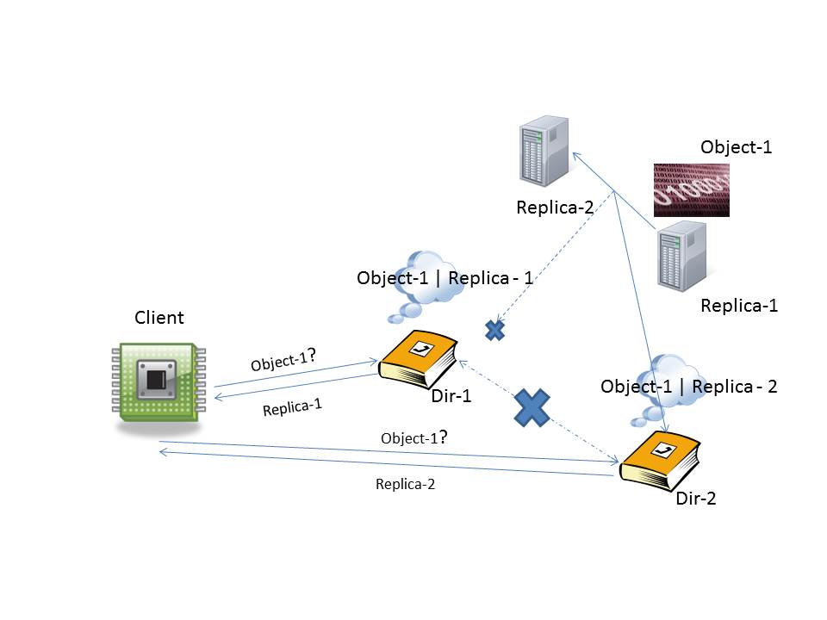

Fig. 1.1 Object migration between replicas

Our system entertains requests for migrations of objects (updates of object location state) and asynchronously manages this process. The actual object movement itself is considered blackboxed by the system.

* 1. **Goals of the Thesis**

As a part of this thesis, we seek to implement a system which manages directory updates in a fault tolerant fashion. We make careful distinction in using the term fault tolerant over consistent. Our aim was to implement a part of a larger system that can manage consistent updates of directories. The larger system has to account for things such as invalidation of directory entries while the object movement is in progress (we discuss this in greater detail in Chapter 5). Thus, to make continued progress, a consistent directory update system would require a fault-tolerant core similar to the one we want to implement. Consistency is a widely studied topic and there exist many protocols such as Quorum and Paxos. There is contemporary research work regarding key and object placement strategies for consistent, high-availability, low latency applications (DTunes, SpanStore?). This thesis seeks to deal with the practical aspects of the proposed flexible key and object placement schemes by implementing parts of the proposed systems.

There have been a lot of papers explaining the workings of the Paxos protocol, and research works that propose optimizations and improvements to the same. However, we found that the number of actual implementations of the protocol were scarce. That also explains the lack of data and results about the performance of the Paxos protocol in a distributed WAN setting. There are large scale systems such as Spanner than use the protocol but there have been no official reports about the performance of the protocol. Our instrumentation of the consensus protocol is aimed at verifying common theories about convergence times of the Paxos protocol.

* 1. **Thesis Contribution**

We present our implementation of the fault tolerant directory updates system built around a Paxos core. We have built a service around an open sourced Java based implementation of the Paxos protocol called JPaxos. Our system coordinates communication between the clients seeking to migrate or fetch object state, the Paxos cluster which maintains and updates the migration state and a state-machine process which performs the migration. The system exposes a CRUD-like API service for developers building services requiring consistent directory updates.

Alongside the implementation of this system, we instrument and deploy it in a simulated WAN setting (using the PRObE testbed) to observe the behavior of Paxos. The instrumentation results will be used to validate expectations of consensus system behavior we expect in different WAN settings.

* 1. **Organization of the Thesis**

The rest of the thesis is organized as follows: Chapter 2 presents an overview of the Paxos protocol and the JPaxos implementation including details about the salient features of the implementation and deviations and optimizations of the implementation from the standard protocol. Chapter 3 details the design and implementation of the directory updates system, challenges involved, decisions made and a description of the logging service. Chapter 4 presents our evaluation goals and methodology, a brief description about the PRObE public testbed used to run the experiments and then details the results along with discussions about the same. Chapter 5 concludes the thesis.

**2. BACKGROUND**

**2.1 Paxos**

Paxos is an algorithm for implementing fault-tolerant distributed systems. At the heart of the Paxos algorithm/protocol is a consensus algorithm – how do we get multiple processes that are each trying to assert/propose a value to agree upon and stick with a single value?

The safety requirements of such a consensus algorithm required to achieve consistency are as follows:

* Only a single value that has been proposed may be chosen
* Processes learn about values if and only if they have been chosen

Note here that the safety requirements do not specify any liveness/convergence requirements. That is, all we’re focusing on here is correctness, not practical concerns such as progress. There are 3 classes of “agents” that take part in the protocol:

* Proposers – They propose values to be chosen
* Acceptors – They choose to or not to accept proposed values
* Learners – They learn the final, single proposed value that was accepted by the acceptors (not all, just a majority, see below)
* There are no strict requirements on the mappings between the given processes and these roles

A value proposed by a proposer can be considered accepted once a majority of acceptors have accepted it. The cornerstone of the algorithm lies in determining how and which value must be accepted. From a bird’s eye perspective, the acceptors control the proposers and their proposed values – so the working of the algorithm is driven by acceptors forcing the proposers to propose acceptable values, whilst the

design of the algorithm revolves around setting down rules for how to accept values. The design considerations for accepting values are as follows (revised as new requirements emerge):

* 1. An acceptor must accept the first proposal it receives – we must begin somewhere
* Only a single value must be accepted => we’ll turn this around and instead put the responsibility on the proposers and say – only that value may be proposed repeatedly
* The proposer can see what values have been accepted while proposing, but cannot predict what values might be accepted in the future. To this end, the proposer somehow seeks to control the future acceptances by extracting promises from acceptors regarding the nature of the same
  + Proposals now have a proposal number. To avoid confusions, different proposals must have different numbers, a global ordering of sort – the implementation left open ended. A suggestion would be to just have proposers choose the numbers from non-overlapping sequences and store the last used number in stable storage.
  + A promise that the acceptor will not accept a proposal with a number lower than mine
  + If a proposal has already been accepted, let the proposer know.
* Due to this extracted promise, we need to change acceptance rule 1 to: 1a. Acceptors can and must only accept proposals that do not violate promises it has made => accept proposals which have numbers > numbers of proposals to which promises have been made
* 2. If a proposal with value ‘v’ is chosen, then every higher numbered proposal that is chosen by any acceptor has value ‘v’ – this follows from the requirement that only a single value be chosen in a round of Paxos.
* This is where the implementation of the algorithm is driven backwards – to ensure that no proposal with a value other than ‘v’ with a proposal number higher than the highest accepted proposal number (with value ‘v’) is accepted, the acceptors force the proposer to only issue proposals with value ‘v’. Hence:   
  2a. If a proposal with value ‘v’ is chosen, then every higher-numbered proposal issued by any proposer has value ‘v’.
* Now we relax constraint 2a by moving to a majority instead of every acceptor. Hence:   
  2b. For any proposal numbered ‘n’ with value ‘v’ issued, there exists a set ‘S’ consisting of a majority of acceptors such that either:
  + a) no acceptor in S has accepted any proposal numbered less than ‘n’, or
  + b) ‘v’ is the value of the highest numbered proposal among all proposals numbered less than ‘n’ accepted by acceptors in ‘S’

Putting all this together, the algorithm for a single ‘round’ of Paxos sums up to such:

Phase1.   
(a) A proposer selects a globally exclusive proposal number ‘n’ and sends a prepare request to a majority of acceptors (it could be all acceptors in the implementation) – this is called a ‘prepare’ request.  
(b) If an acceptor receives a ‘prepare’ request with number ‘n’ greater than any ‘prepare’ request to which it has already responded, it responds to the request with a promise not to accept any more proposals with number less than ‘n’, and the number ‘n’ and value ‘v’ of the highest number proposal it has accepted (if any).

Phase2.  
(a) If the proposer receives a response to its prepare request numbered ‘n’ from a majority of acceptors, then it sends an ‘accept’ request to each of those acceptors for a proposal numbered ‘n’ with either the value of the highest numbered proposal it received from the acceptors in response to its prepare request, or if no such value exists, then any value of its choosing.  
(b) If an acceptor receives an accept request for a proposal numbered ‘n’ >= highest prepare request number it has responded to, then it accepts the proposal.

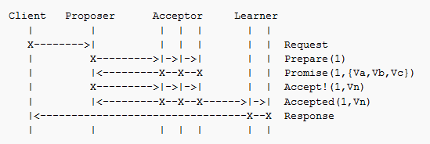

Fig. 2.1 Paxos: Round successful[1]

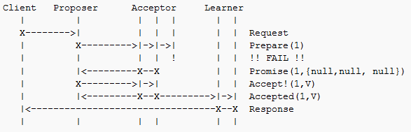

Fig. 2.2 Paxos: A single failed acceptor, majority still ensures progress1

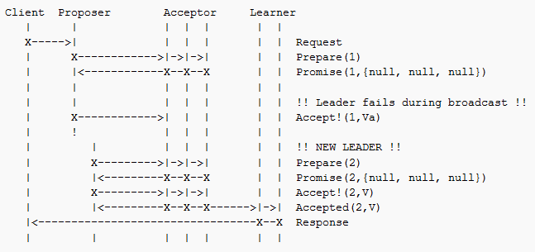

Fig. 2.3 Paxos: Failed proposer

Figures 2.1 - 2.4 depict the functioning of the Paxos algorithm under some basic scenarios using time-space diagrams.

A few things to note:

There is no direct correlation between Phases 1 and 2 in terms of a Phase 1 being sufficient for Phase 2. That is, a proposer ‘P1’ could elicit a response to its prepare request but it might end up racing with another proposer ‘P2’ in that acceptors could end up rejecting P1’s accept requests after accepting its prepare requests because P2 is racing P1 and keeps issuing prepare requests with numbers succeeding P1’s prepare requests.

A decision is implicitly reached when a majority of the acceptors accept the same value ‘v’ – because using induction and the property of there being at least one common acceptor in the intersection of 2 majorities of acceptors, we can show that the acceptors will force any future proposers into re-proposing the same accepted value.

There is no limit on the number of proposals that can be made – proposers can abandon proposals mid-flight and reissue proposals of higher numbers if they want.

There is no guarantee of convergence – the protocol is correct, but may never converge.

To learn a chosen value, the learners must find out that a majority set of acceptors have accepted a single value. There are multiple ways to do this, the most straightforward of which would be to have every acceptor acknowledge acceptances it makes to every learner.

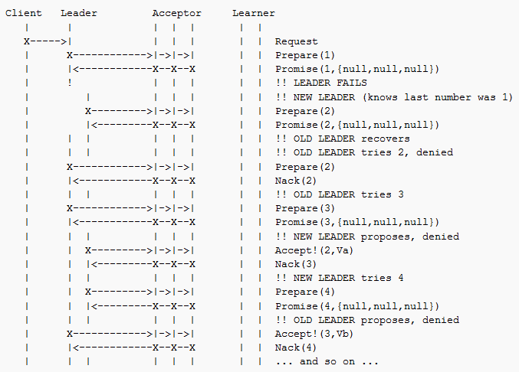

Fig. 2.4 Paxos: Livelock without distinguished proposer[2]

A few optimizations to the protocol:

* The first obvious optimization would be some step to alleviate the non-convergence problem. We could have a “distinguished proposer”, a leader who would be the only one trying to issue proposals, circumventing the race problem.
* Similarly, we could have a distinguished learner, or a set of them to reduce the number of acks that the acceptors would have to send out once they accept a value.

**2.2 JPaxos**

**2.2.1 Brief introduction**

JPaxos is a full-fledged, high-performance Java implementation of state machine replication based on Paxos. It is an open-source contribution maintained at github.com/JPaxos. The focus of the implementation is on:

* Batching and parallelizing rounds of Paxos to maximize performance
* Different crash recovery mechanisms for systems with and without stable storage
* Scalability with processing parallelism

To deal with replicas/processes who are members of the Paxos protocol crashing, JPaxos uses 2 crash models:

* Crash stop: If a member of the protocol crashes, it cannot recover from the crash.
* Crash recovery: A member can resume execution of the algorithm after crashing. There are multiple implementations of this model to trade off critical path execution time with state storage in stable vs. volatile storage. This consequently leads to recovery from different periods before the crash.

**2.2.2 MultiPaxos**

Now we present a brief discussion of MultiPaxos state machine replication.

The Paxos protocol by itself only describes the necessary conditions to achieve consensus for a single round of execution. To extend this to a sequence of rounds of consensus in deterministic order is closely related to the atomic broadcast problem, as both share the same core problem of ordering a sequence of values.

Figure 2.5 shows the difference between a single Paxos ballot and ballots in a MultiPaxos setting.

Though it would possible to use a sequence of independent Paxos instances with absolute ordering to implement MultiPaxos, it would be inefficient. MultiPaxos achieves better performance by “merging” execution phases of several instances. In MultiPaxos the system advances through a series of views, which play a similar role as ballots in single instance Paxos.

JPaxos uses a concept of a view. A view plays a similar role as a ballot of a single instance of Paxos. The leader of each view is determined by a rotating coordinator scheme, that is, the leader of view ‘v’ is the process v mod n where n is the number of replicas in the cluster.

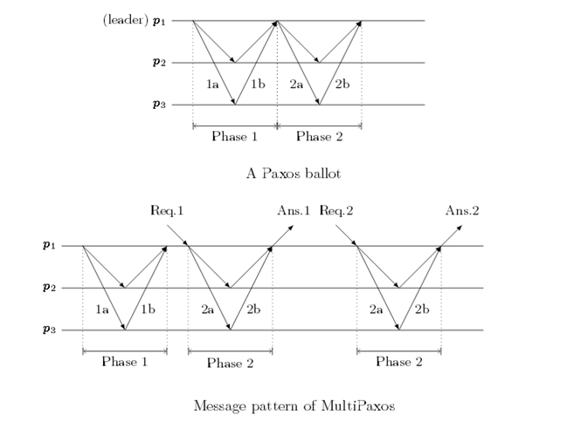

Fig. 2.5 The message patterns of single (optimized) and multi Paxos.

Once a process ‘p’ is elected leader (by some external leader oracle module), it advances to the next view number ‘v’ such that p is the coordinator for that view (v mod n = p), and ‘v’ is higher than any view previously observed by p. Process p then executes Phase 1 for all instances that according to the local knowledge of p were not yet decided by sending a <Prepare, v, i> message where ‘i’ is the number of the first instance that p thinks is undecided. The acceptors answer with a message containing the Phase 1b message for every instance of consensus higher than i. The acceptors send the last value they accepted (or null if they accepted no value). Once Phase 1 is complete, the proposer can then execute Phase 2 for every instance >= i. In state machine replication, when the leader receives new requests from clients, it executes only Phase 2 of a new instance.

**2.2.3 JPaxos architecture**

JPaxos consists of two main modules: Replica and Client. The Replica module executes the service as a replicated state machine, while the Client module is a library that is used by client applications to access the service. Figure 2.6 shows the architecture of a system built around JPaxos. Figure 2.7 shows how a request is handled within the JPaxos system when a client is directly connected to the leader.

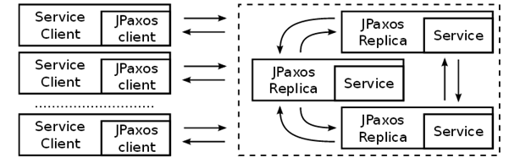

Fig. 2.6 A service replicated in three replicas accessed by several clients. Arrows indicate communication flows.

A Paxos log is a data structure that is actually replicated consistently among replicas. Each replica has its own copy of the log. The log reflects a series of rounds of Paxos with relevant information for each such as whether the round has been decided yet, what value was decided upon, when it was decided and the replicas that formed the majority for the decision. One of the details of MultiPaxos which is open to implementation that we will discuss here is the generation of unique request identifiers.

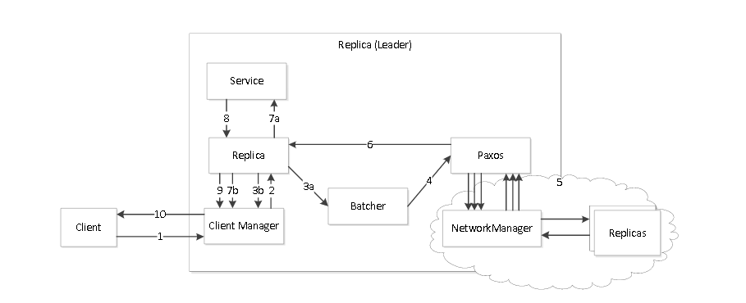

Fig. 2.7 Request handling, when client is connected directly to the leader. 1) Client sends request, 2) request read and forwarded to Replica modules, 3a) request added to batch queue (new request) or 3b) send cached answer (repeated request), 4) propose request as part of a batch, 5) order batch using MultiPaxos, 6) after being ordered, batch is given to Replica for execution, 7a) Replica executes request in service if the request is new, or 7b) answers with cached reply if request is repeated, 8), 9) and 10) answer is sent back to the client.

Each request must have a unique identifier in order to be distinguished from the others. A commonly used method is by using a <clientID, sequenceNumber> pair. While sequences can be monotonically maintained within a system, the main challenge arises with allocating unique clientIDs. JPaxos makes replicas responsible for granting IDs to clients. When the client first establishes a connection to the replica, a unique ID will be supplied using 2 policies:

* # of replicas: A modulo scheme based on number of replicas. Replica i of 0…n will grant “k mod n = i” integers as IDs.
* Time based: IDs granted are of the form (t+localId), (t+localId+n), (t+localId+2n) where t is the time the Replica was started, localId the identifier of the replica and n the number of replicas in the protocol.

MultiPaxos requires both a leader election oracle and a mechanism to assign to each process an infinite number of exclusive proposal numbers, both of which are left as implementation details. JPaxos uses view numbers to implement both leader election and to generate proposal numbers. The ordering protocol is organized as a sequence of views with increasing numbers. Processes keep track of their current view v (which would ideally be the same across processes unless one of them is recovering from a crash) and tag all their messages with the number of the view when they were sent. Messages from lower views are ignored and receiving a messages from a higher view forces the process to advance to the higher view immediately. As discussed before, the process v mod n is pre-assigned to be the leader of view v. Proposal numbers are generated by using the view number and adding a sequence number internal to that view. The leader of view v uses <v,i> as a proposal number where I is the sequence number generated by the leader. Ordering among proposals is defined first by view number then, in the case of a tie, by the sequence number. Leader election is implemented by advancing view whenever the leader of the current view is suspected to have failed. When a process suspects that the current leader has failed, it tries to become the new leader by advancing to the next view where it can be leader and sends out Prepare messages to everyone. If multiple processes suspect a leader crash and race to become leader, the one with the highest view number will win. Failure detection happens using a simple heartbeat based scheme – the leader sends out “Alive” messages as a heartbeat to inform other replicas that it’s still up. A configurable number of missed Alive messages in a configurable time interval will result in the process suspecting the leader of having crashed.

**2.2.4 Optimizations**

JPaxos uses several optimizations to reduce the number of messages sent. Many of these are possible because in JPaxos every process is at once Propose, Acceptor and Learner – so all processes share the exact same replicated log (outside of crashes).

Sending to self: In traditional Paxos, the Proposer has to send the Phase 1a and Phase 2a messages to all Accptors. As the leader plays both roles, it can suppress the message to itself, and directly updates its state. A similar optimization can be applied when the Acceptor sends 2b to all Learners.

Merging Phase 2a and 2b of the leader: In Phase 2, the leader has to send, as the Proposer a Phase 2a message to all, and immediately after, as an Acceptor, a Phase 2b message also to all. Since the leader implicitly accepts its own 2a message, it only sends out a 2a message to all other processes, which is understood to be a combined 2a + 2b message. This reduces the number of messages sent by leader in Phase 2 by 50%.

Minimizing count of messages carrying the value: Most descriptions of Paxos state that both the Propose and Accept messages carry the value being agreed upon, which in our case are client requests. The size of the requests is contingent on the service being implemented and could get large. JPaxos ensures that the message is only sent once per round by omitting it from the Accept messages and relying on the Propose message of the leader to distribute the value to all replicas (which then store it in their local storage). To preserve correctness, the protocol of the Acceptor must be modified slightly: if the Acceptor receives an Accept before the corresponding Propose, it must wait before sending its own Accept.

**2.2.5 Replica Catchup Mechanisms**

MultiPaxos must guarantee that all learners eventually learn the decision of every instance. This is important because a gap in the sequence of requests to be executed will block the process from executing future requests because of the properties of a state machine replicated log.

The leader keeps retransmitting the Propose message until it receives a majority of Accepts, but in a lossy network this does not guarantee that all processes will receive enough messages to decide.

For these situations, JPaxos includes a catch-up mechanism based on the following observation: if the leader is correct (heartbeats) and a process knows of an instance that started some time ago but has not yet been decided, then it’s likely that the value has already been decided and the process should contact some other process to learn the decision. There are 2 possible catch-up schemes that could be used:

* Log-based: The replica only copies the missing decisions from other replicas and then executes them locally.
* State-based: The replica copies the missing decisions and the resulting state from other replicas and just directly applies them as a patch without moving through the state machine.

The more intricate details of triggers to start and stop catchup, and the different catchup and recovery algorithms are not discussed here.

2.2.6 Recovery

Recovery is the process of a crashed replica coming back up and rejoining the Paxos cluster, taking part in the decision process of new requests after making up for any requests that it might have missed while it was down. When reasoning about crash-recovery, it is usual to assume that processes have access to volatile and stable storage. Any data stored in volatile memory is lost during a crash, while data on stable storage is preserved.

There are 3 recovery models that JPaxos uses to support different types of recovery (excluding the trivial CrashStop recovery model wherein crashed replicas simply cannot recover). They differ in how they log checkpoints to recover upon a crash.

Find below a brief description of each recovery process:

Crash Recovery with stable storage:

This algorithm saves enough information to stable storage so that upon recovery, it can restore its state using only information stored on local storage, and rejoin the protocol without executing any additional recovery protocol involving the other replicas. With this algorithm, processes write to stable storage often, once per instance of the ordering protocol which is a significant overhead.

Effectively what this model does is save every executed instance and the respective decided value in stable storage upon decision. Thus when a replica recovers, it can replay all requests necessary to rejoin the protocol just using the locally saved information.

Using this model enables the cluster to tolerate catastrophic failure (that is, possibly all replicas fail), but as noted comes with the additional overhead of making synchronous writes to stable storage on every decision.

Epoch-based recovery:

This algorithm only makes one synchronous write to stable storage on process startup, but the recovery phase is more complicated than the previous algorithm.

The algorithm is not described in detail here, but a high level view would be that it uses an epoch vector describing the last epoch number written to stable storage, where the epoch number is updated on every recovery after a crash. The algorithm uses this epoch vector alongside replies of epoch vectors from other replicas, and the catch-up module of JPaxos to restore lost state to the crashed replica.

This algorithm however requires a majority of replicas to be up at any given point to work, but is almost as fast as the trivial CrashStop model which has no synchronous writes to stable storage.

View-based Recovery:

Like Epoch-based recovery, View-based recovery requires a majority of processes to be up at all times, just that instead of using epoch numbers, the view number is written to stable storage on every change (while the epoch number was a number that was incremented on every recovery from a crash).

Similar to Epoch-based recovery, View-based recovery uses the collective knowledge of instances from other live replicas to restore state it has missed.

The performance of this algorithm too is almost as fast as the trivial CrashStop model, but is contingent on the number of view changes (synonymous with leader changes), as more view changes trigger more synchronous writes to stable storage.

**2.3 PostgreSQL**

The database used for saving all migration requests and tracking changes/updates to them is PostgreSQL. This is also the database used to log the instrumentation data from the logging framework.

PostgeSQL is a powerful, open source object-relational database system. It has been in active development for 15 years and runs on most major operating systems.

Apart from being having a very rich set of features, Postgres is a database that is very commonly used in the industry today as a relational store. Its high performance, customizability, and most importantly open-source nature make it a top choice for this purpose.

It is for this reason that we chose to use Postgres as the database of our choice for tracking migration data. It’s very rich and performant query optimizer and interface also made it an ideal choice for logging instrumentation data to run analytics on the same.

**3. DESIGN AND IMPLEMENTATION**

**3.1 Motivation**

At the outset, we talked about flexible data placement schemes for interactive, latency sensitive web applications. We now briefly further motivate the problem by providing context about one of the direct applications of the implemented system – key migrations. To elucidate further about this and give an example of the necessity to adjust data locations, consider the read and write latency sensitivity dimension of the design space.

Consider a Twitter user in India with majority of his/her friends and followers in India. It would make the most sense to save his tweet data in data centers in Asia close to India. Now consider the scenario of said person moving to the U.S. and making a lot of new friends in the U.S. who are interested in following him/her on Twitter. The placement of data in the Asia data center would no longer be optimal because his friends in the U.S. would see much longer latencies in retrieving his tweet data as compared to his friends in India. Also, all his new Tweets (writes) would now have to be pushed all the way to the Asian data center which also is sub-optimal. This problem can easily be made more involved by bringing in weights as a design consideration:

* Read latency weight vs. Write latency weight (prioritizing one over the other)
* # reads or writes from a given geographical region
* # of users in given geographical region
* Storage cost of the data in replicated geographical regions

Finally, we must realize that this computation will not result in a static placement of data. Once these parameters change by a large enough factor, they will necessitate a migration of data to a placement optimal to the new parameters. This makes a solid

use-case for the system we’re designing. We have talked about consistent updates, and the need for a fault-tolerant subsystem to make progress, but we haven’t discussed this need. The use of Paxos makes the system fault tolerant, alleviating the problem of a single point of failure. To illustrate this, consider the following scenario:

Consider a single node migration “cluster”. That is, one node that manages the whole migration process. Clients connect to this single node to initiate migrations and that node manages the whole migration process and eventually drives migrations to completions.

What happens if this node fails? Not only can we not entertain any new migration, but all the migrations that the node had underway are also stalled at this point. So we have a single point of failure.

What if we set up a master-slave replication scheme instead? This could be implemented one of 2 ways:

* Synchronous updates – this would slow down writes because every write would now incur n (number of slaves) write costs + interconnecting link transmission costs to keep all replicas up to date.
* Asynchronous updates – this would cause correctness issues as a failed master would result in a slave that could possibly be out of date (if not all updates have been propagated). This would cause the slave to make wrong decisions regarding the migration process

**3.2 The Migration Service**

The migration service is the CRUD wrapper around the Directory Service. It guarantees that once a migration request has been persisted (Paxos-ly), the system will eventually drive the migration to completion. We separate the migration process into four main concerns which we shall discuss in detail:

* A directory service that implements the Paxos service interface fronted by the JPaxos code
* A migration protocol that takes care of the actual migration process
* Directories that store the current location of a given object
* Migration Agents that perform the actual process of copying the object from the source to the destination location.

**3.2.1 The Directory Service**

The Directory Service implements the service wrapper that JPaxos fronts. This means, apart from the actual execution of decided Paxos requests themselves, it also handles concerns like snapshotting and restoration from snapshots. The design considers that there is no single replica that can be in charge of the migration of even just a single object. The justification for this is that we can have failures and leader changes mid-migration too.

When a new object migration is received (and decided upon), a record is created in the database to represent the migration request. This record represents all the state information associated with the respective object’s migration. The fields stored in the record are:

* ObjectId: The ID of the object being migrated
* Old Replica Set: Where the object is currently being stored
* New Replica Set: Where the object will be stored after the migration
* Directory Acks: Directories that know about the new location of the object
* Migration Progress Acks: Migration agents that have ACK’d back, having completed their share of the object movement
* Creation Time: Time of creation of the record
* Completion Time: Time the migration was completed
* Last Updated Time: Time this last record was last serviced (read/updated). This is meant to be a mechanic to avoid starvation.
* Migration Started Timestamp: Time the Migration Agents were informed about the required object movement.
* Migrated: Boolean state of whether the object has been moved from its old replica set to the new one.
* Migration Complete: Boolean state of whether the whole migration process has been completed for this object.

These fields are updated as the object moves through the migration process, and are also used to make decisions about what must be done next to complete the migration for the object.

Since we are implementing a fault-tolerant service, we can see that all write operations (insert and update) made on the record must be Paxos operations. The justification for this is simple – if any operation is performed non-Paxosly, it would lead to some state being saved local to a replica or a subset of replicas not honoring the Paxos safety concerns. This would lead to that single write/update being inconsistent (in that not every replica is now seeing this operation and thus the state being maintained is no longer the same across replicas) and correctness being an all or nothing concept would break down.

The first thing we had to consider while implementing the service was that the way the Paxos protocol as implemented recovers from a failure is by replaying batches of requests. Depending on the crash recovery model we use, the strategy of recovery changes. For our implementation we only used the EpochSS recovery model. The EpochSS recovery model replays all requests from the last saved Epoch, not just saved requests. This means that decided requests that the crashed replica played before crashing will now be replayed. The model has been designed to replicate services that have no state surviving crash. However, JPaxos gives us a sequence number for every request that has the following properties:

* It is monotonically increasing
* It is consistent amongst replicas (the same request will have the same sequence number for every replica)
* There are no gaps between 2 numbers

Using this primitive, we can design a stateful replication service. To do this ,we save the sequence number of the last executed request in the database and when we replay requests, we skip all requests up till the last executed one. One important thing to note here is that the saving of the last executed request’s sequence number and the effect of the last executed request itself (in terms of any database operations) must be one single atomic operation.

Now that we have a stateful replicated system, the next thing to discuss would be the operations that the service supports:

* Insert: creates a migration record in the database. By design, only one outstanding migration is allowed for an object. This design choice has tight correlation with the design choice of optimizing local database reads as opposed to Paxos reads in the migration protocol.
* Update operations: updates on the above listed fields of the migration record. In the directory service, updates are triggered by either the protocol process or a migration agent.
* Read: reads and serves the current migration state for the given object id
* Delete: deletes the migration record for the given object from the database
* Register operations: register directories/migration agents that are bootstrapping

To implement snapshotting, instead of restoring from a snapshot by replaying all requests contained in the snapshotted period, we snapshot the state of the database itself. This makes the implementation straightforward and in some cases we end up with fewer database operations this way. An example of such a case would be a snapshot of a single completed migration’s database record – if we maintained a traditional transaction based log, we would have about 8 database write transactions to reach completion. If on the other hand we just snapshotted the finished database state, we would achieve the same effect, in a single insert statement. When restoring from a snapshot, the restoring replica wipes its database state clean and completely restores the state received.

**3.2.2 The Migration Protocol**

The protocol is a process that runs co-hosted with all the replicas. The only protocol process that can make any decisions and take actions is the one co-hosted with the leader process. Reason for this being, the protocol process co-hosted with the leader makes DB local reads (as an optimization instead of making Paxos reads). When a leader change occurs, the process co-hosted with the new leader seamlessly picks up from where the old one left off. To do this, we have a polling mechanism set up between the replica and protocol processes. Since we want the protocol processes to be able to function in this seamless fashion without any communication between them on failure, the main design consideration was statelessness.

Figure 3.1 gives an overview of the steps involved in making progress during the migration process. The protocol process is essentially a state machine. It picks up a few objects which still have been slated for migration and are in different stages of their migration and pushes them to completion. In the implementation, the process is not threaded – that is it only performs one migration at a time.

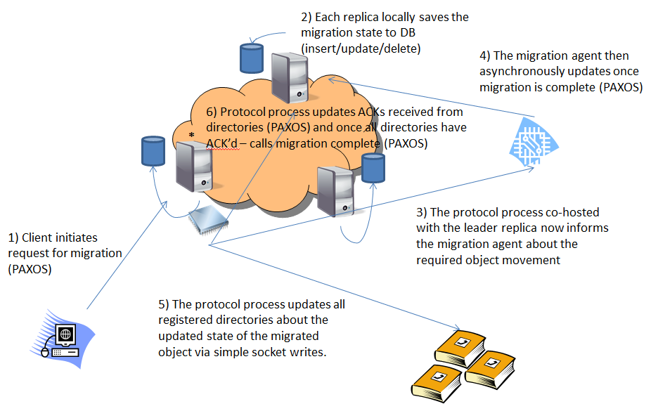

Fig. 3.1 A step-by-step progress of the migration process

As discussed before, the progress of any object’s migration is reflected in its state in the database. The protocol process reads in the full state of the object from the database and then through a series of conditionals that represent the state machine, determines where along the process the object currently is and what the next step should be. We now present a detailed step-by-step example to illustrate the statelessness, seamlessness and working of the protocol processes:

* Consider an object “object-id:1” that currently resides in some set of replicas {A,B,C} and needs to migrated to {B,F}.
* A client process (that we refer to as the migration initiator) connects to the Paxos cluster and requests that this migration be performed.
* The leader process accepts the request and queues it for proposing.
* At this point, a failure of the leader process would not preserve the request and it would be lost. But also note, we have not responded to the client yet confirming that we have registered the migration request and it is now fault-proof.
* The leader eventually (based on parameters such as the number of outstanding proposals, poll time, batching factor) drains the client request for the migration and proposes it.
* Once the proposal is accepted by a majority of other replicas (including the leader), the leader replica proceeds to “Decide” the request.
* Now note that each replica (by implementation in JPaxos) “Decide”s requests independently of each other. That is “Accept” requests from the follower replicas are multicast to all other replicas in the protocol, and once any replica in the cluster locally sees a majority, it goes ahead and “Decide”s the request.
* Once a request has been decided, the request is then processed – that is, each individual replica gives control to the underlying implemented service to process the request byte stream.
* This is where the previously discussed Directory Service would create a migration record for the Object in the database.
* At this point, the migration request is considered resilient as it has been replicated in a majority of replicas.
* Now the leader replica responds back to the client saying that the request has been persisted in the database and will eventually completed.
* Meanwhile, the protocol process co-hosted with the leader is constantly polling the database for any outstanding migrations that need to performed.
* It finds the new migration request in the database and starts off by initiating the actual movement of the object.
* It does this by informing all registered migration agents of the object move by opening up connections to the IP/port they are listening on. It only does this for processes that have not already completed their part of the move and ACK’d back that they are done.
* The ACKing from the migration agents is an asynchronous operation. The protocol process does not block on its execution path for this move to happen. It simply informs the agents about the required move and updates a timestamp on the migration record to reflect when it last informed the migration agents about the requisite move.
* The timestamp helps handle failures of migration agents. If the protocol process informs them about the move and they fail before they can complete it, the process retries if it sees that all agents haven’t ACKed after a specified time interval from when it last updated them.
* When migration agents ACK, it is another Paxos operation (as it is an update operation on the migration record’s state)
* Once the protocol process sees that all registered agents have ACKed for the requested object move, it proceeds to the next step which is informing the registered directories about the new location of the object.
* To do this, it runs over each registered directory and communicates the new replica set for the object over a connection to the IP/port the directory has been registered with. Once the directory (synchronously) ACKs back that it has received the information, the process makes a Paxos update to reflect the updated states of directories that have been informed about the new state of the object.
* The reason for doing these updates on a per-directory basis is to keep our protocol stateless – this way, even if one protocol process fails midway, another can take over and continue where the old one left off.
* We assume that the directories store the information in stable storage, so the information they hold is resilient to failures.
* Once all directories have been informed, the protocol process then calls the migration complete and proceeds to look for more migrations to perform.
* We note that all operations performed by the protocol process are just enactments of the state machine logic. It does not locally store any state about the progress of the migration. Any progress made is replicated and stored as state in the database, thus keeping everyone updated about the progress of every migration and achieving the seamless transitions between protocol processes in failure scenarios.

**3.2.3 Directories**

Directories are processes that maintain a lookup table of mappings between objects and the set of replicas that currently hold them. When directories bootstrap, they must register with the Paxos cluster using the IP and port they are listening on. The protocol processes and any other interested clients lookup directory listings in the database to contact them.

**3.2.4 Migration Agents**

Migration Agents are processes that blackbox the migration process. In the implementation, they wait for a fixed time interval before ACKing back to the Paxos cluster to signify the completion of object move. This process as discussed is asynchronous – so their ACKs include details about the object which was moved. Similar to directories, when migration agents are bootstrapped, they too must register with the Paxos cluster using the IP and port they are listening on and the listing is looked up by the protocol processes to contact them.

**3.2.5 Logging Framework**

The above sections discussed the implemented Directory Service for fault-tolerant object migrations. Another one of our main aims was detailed instrumentation of the Paxos protocol and to observe its performance in a WAN setting. To achieve this we needed a non-invasive, detailed logging framework.

* If we logged the progress of every request as it passed through checkpoints we setup in the system, we could collate the results to understand how the time is being divided on a part-by-part per request basis. The salient required features: Per request granularity of logging: We need to able to identify individual requests so any discrepancies can be tied back to the originating request for analysis.
* Non-Invasive: The logging framework cannot interfere with the actual execution of the code itself. It must be as decoupled from the code as possible. This translates to an asynchronous, threaded setup with queues.
* Aggregated: We are tracking the progress of the request as it proceeds through multiple processes/machines in a distributed systems setting. We have the ability to track a single request across systems using its request number. We use the same to aggregate log data from multiple checkpoints across multiple machines into the log of the progress of the same request. We still maintain the source of the data – that is 2 checkpoints for the same request that are hit on 2 different machines will not overwrite each other; instead they will result in 2 numbers for the same checkpoint, for the same request under different replica numbers.
* Analyzable: Instead of complicating the post-processing of logs to derive metrics, we do the work up front before persisting the logs. We use a relational database to store our data. This gives us a rich log format to store data under. This also gives us a very rich query interface to run analytics on the logged data.
* Detailed: We wanted to log the data in as much detail as possible as we could always choose to process it at a coarser granularity. To this end, we have about 20 logging checkpoints setup per machine. However, some of these checkpoints will not be hit on all machines as they are parts of the code only the leader for the round will execute.

**4. EXPERIMENTAL METHODOLOGY AND RESULTS**

**4.1 Aim**

The high level aim of the experiments was to get a deeper understanding of the Paxos algorithm in an actual implementation. This effort can be broadly classified into 2 steps:

* Understanding the implementation and it’s departures from the algorithm in terms of optimizations and details generally left open to implementation.
* Instrumenting the implementation to piece-wise analyze the different component times in the algorithm.

Coupling this with different delays simulated between replicas would give us an example of an instrumented Paxos system deployed in a WAN. The Directory Protocol gives us a working state machine system built around the Paxos core to drive the experiments.

**4.2 Setup**

The experimental setup is as shown below in Figure 4.1. We used a five replica cluster. Figure 4.1 shows that the cluster was split into 2 sub-clusters (say maybe one on the east coast and one on the west coast). Depending on the inter and intra cluster delays, this allowed us to model different geographical setups. Each replica runs its own directory server. Note from Figure 4.1 that the Migration Initiator is co-located with the Migration Agent on one of the replicas. Since all 3 processes are rather lightweight, there would be limited overhead/contention between them.

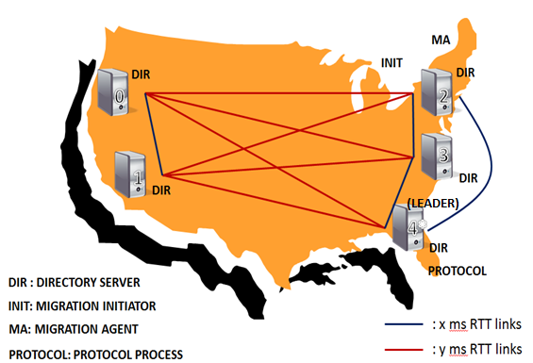

Fig. 4.1 Experimental Setup

As we can see from Figure 4.1, the Protocol Process runs on every machine, but since for the purpose of these experiments we are not simulating any failures, all processes apart from the one co-located with the leader replica are of no consequence as they would be unable to take any action. Since the focus here is on latency and not throughput measurements, we set the parameters to have high polling frequencies, and low critical path latencies. The parameters settings to effect this high polling frequency, low critical path latency setup are:

* CrashModel – EpochSS
* WindowSize – 2 (the migrations are serial for the purpose of these experiments)
* MaxBatchDelay – 0 (do not batch, push proposals instantly on arrival)

The implementation had been modified to force any Paxos client to always connect to the leader process (directly, no redirections) and the same replica (#4) is elected leader for all experiments. This forces uniformity between runs enabling us to set strong expectations for the experiments.

**4.3 PRObE**

The experiments were run on the NMC’s (New Mexico Consortium) PRObE test bed.

PRObE’s Kodiak cluster is an excellent, well-provisioned large scale compute resource that runs on an Inifiniband backend. At the time these experiments were being conducted on PRObE, they had upwards of 700 free nodes at any given point.

To create an experiment, a NS (network simulator) formatted file describing the topology for the experiment is expected to be supplied. This allows the user to setup whole network topologies including the bandwidth and latency of interconnects. However, for the purposes of these experiments, a very basic NS file that just spawned the required number nodes on the default Infiniband network was used.

PRObE also gives its users the ability to snapshot images of their node’s disks. This proves to be extremely useful when it comes to bootstrapping nodes with a custom OS and software packages necessary. This enables having a cluster of nodes up and running from scratch in a very short time period. As PRObE has a limit on the maximum duration an experiment can stay active, it necessitates the need to snapshot disk images. Once the nodes were swapped in (become active), since we have an extremely fast network fabric for a primitive, we use DummyNet to shape the link delays to emulate network configurations that we want.

The Kodiak cluster’s nodes are not accessible from the internet. Management of the nodes (including access) happens through an ops node. Consequently data is also shuttled in and out of the nodes through the ops node. The ops node also controls other functions of nodes such as rebooting and reloading a new disk image amongst other things.

**4.4 Breaking Down Latencies Involved In The Migration Process**

Table 4.1 shows a list of the various times involved in the migration process and the notation used for the same in the text.

Table 4.1

Times involved in the migration process

|  |  |
| --- | --- |
| **Time** | **Notation** |
| Inter-coast delay | x |
| Intra-coast delay | y |
| Paxos round convergence time | PRCT = x |
| Database update time | DBu |
| Database insert time | DBi |
| Database read time | DBr |

We define Paxos round convergence time to be the time taken to successfully complete one Paxos round. Recall that with an elected leader, once we receive a majority of accepts after sending out the propose message, the Paxos round can be decided which is when it can be considered complete. At the leader replica, this would be time taken to send a propose message to the second closest replica and receive back an accept message (as messages are sent and received in parallel, by this time a message would also have been sent to the closest replica and the corresponding accept would have been received). In our setup the replicas 2, 3 and 4 can form this majority and thus we expect the convergence time to be x (as x is always less than or equal to y).

Each key migration involves 5 steps/operations which each involve a Paxos round resulting in either a database insert/update. The graphs are plotted on the basis of these rounds. Below is a description of the rounds detailing the steps involved and times being measured in each round:

* Migration Initiation: This is the time from when the Migration Agent starts to send a message to the leader replica to when it receives back a message indicating that a database record has been created to start the migration process. This time can be split into three components:
  1. A round trip between the Migration Agent and the leader
  2. The Paxos round convergence time
  3. The database record creation time

In summary we expect the end to end time of Migration Initiation (without queuing) step to be x + PRCT + DBi.

* Updating Timestamp: Once the record has been created, the protocol process which is polling the database picks up the record and initiates the object movement by contacting the Migration Agent (and receives an ACK). This is the time from when the protocol process starts sending a message to the leader indicating the time the object movement was started to when it receives back a message indicating that the migration record has been updated with the information. This can be split into 3 components:
  1. A round trip between the protocol process and the leader (which can be ignored as these are co-hosted)
  2. The Paxos round convergence time
  3. The database record update time

In summary we expect the end to end time of the Update Timestamp (without queueing) step to be PRCT + DBu.

* Migration Agent Acks: Once the object movement is complete, the Migration Agent intimates the leader about the same. This is the time from when the Migration Agent starts sending that message to the leader to when it receives back a message from the leader indicating that the migration record has been updated to reflect the same. This can be split into:
  1. A round trip between the Migration Agent and the leader
  2. The Paxos round convergence time
  3. The database record update time. The Migration Agent’s id needs to be looked up and care must be taken to not record the same update twice.

Thus, we expect the end to end time of the Migration Agents Acks (without queuing) step to be x + PRCT + 2DBr + DBu. Note that there can be multiple Migration Agents, while we only have one in our implementation.

* Directory Acks: Once the object movement is complete, the protocol process starts updating directories about the new location of the object (and receives ACKs). This is the time from when the protocol process starts sending a message to the leader indicating that a specific directory has been updated to when it receives back a message from the leader indicating that the database record has been updated to reflect the same. Similar to step two above, we expect the end to end time of the Directory Acks (without queuing) step to be PRCT + DBu.
* Migration Complete: Once all directories have been updated, the protocol process sends a message to the leader to indicate that the migration is now complete. This is the time from when the protocol process starts sending that message to when it receives back a message from the leader indicating that the database record has been updated to reflect the same. Similar to steps two and four above, we expect the end to end time of the Migration Complete (without queuing) step to be PRCT + DBu.

Table 4.2 lists the expected times for the above mentioned operations.

Table 4.2

Expected times for each operation

|  |  |
| --- | --- |
| **Operation** | **Expected Time** |
| Migration Initiation | x + PRCT + DBi |
| Directory (Dir) Acks | PRCT + DBu |
| Update Timestamp | PRCT + DBu |
| Migration (Mig) Agent Acks | x + PRCT + 2DBr + DBu |
| Migration Complete | PRCT + DBu |

**4.5 Results and Discussion**

The experiments are run 4 different network configurations, each involving the migration of 10 keys/objects. Discussed below are each configuration and associated expectations and results.

**4.5.1 No DummyNet**

These set of experiments are running on the PRObE testbed’s Infiniband fabric directly. The link delays between nodes i.e. x = y = ~0.1ms. Since in the no DummyNet case the experiments are running directly on the underlying Infiniband fabric, they serve as a baseline as all the delays are related to processing.

Our expectations from the results of the experiment:

* PRCT should be roughly 0ms as x=y=~0.1ms
* The client end to end latencies should be dominated by the service time of the request. As the link latencies are almost negligible (Infiniband) the Paxos part of the request servicing should only be a few milliseconds. The service time is split into:
  + Code execution time of the state machine itself
  + Database access times – typically this would be expected to dominate

Results:

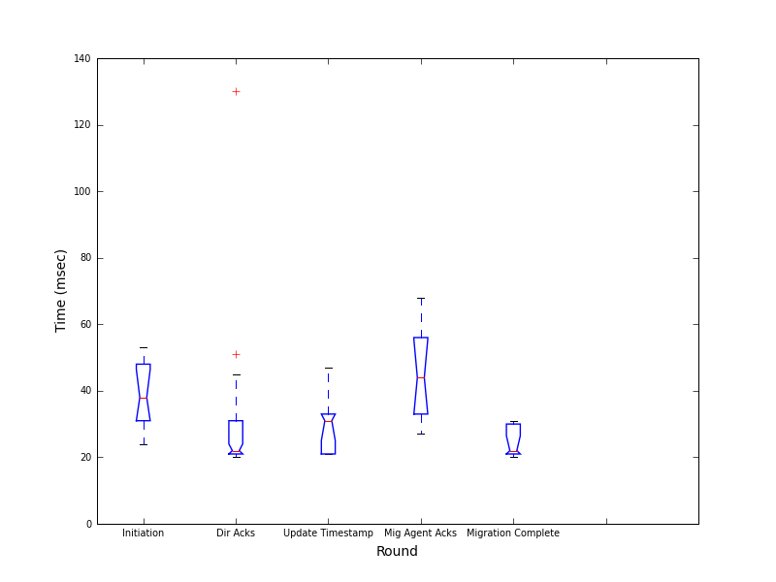  
Fig. 4.2 Paxos client end to end latency (No DummyNet)

Figure 4.2 shows the client end to end latencies for the no DummyNet case. We can see that for the Directory Acks, Update Timestamp and Migration Complete rounds, the latency is around 25ms, while the Initiation and Migration Agent Acks rounds are higher around 40ms. This is as expected from Table 1.2. Note that as x is a very small value (Infiniband), the higher times for Initiation and Mig Agent Acks are due to the database access times. Now we present the Paxos convergence times (at the leader) and the Directory Service times to decompose the end to end latency into those two components.

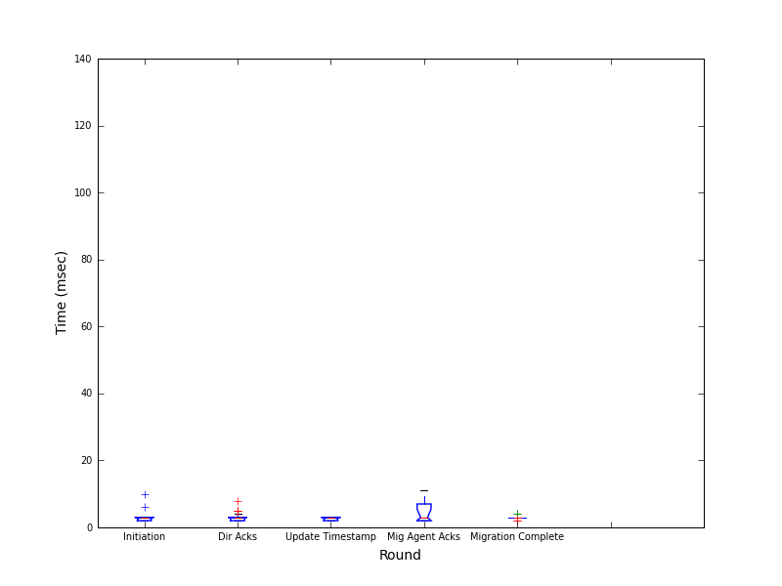

Fig. 4.3 Paxos round convergence time (No DummyNet)

Figure 4.3 shows the Paxos convergence times at the leader. We expected this latency to be negligible. From the graph we can see that this is indeed the case with all latencies of the order of a few milliseconds. The milliseconds of latency are being contributed by the execution of the Paxos code and queuing latencies between multiple asynchronous parts of the application.

Figure 4.4 shows the Directory service times for the no DummyNet case. Typically (based on choice of database) we expect this to be dominated by the database access times, with the other component being the state machine code execution time itself. With the choice of Postgres (heavy in terms of access times) we can assume that the directory service times are dominated by database access times. From Figure 4.4 we can see that the service times for the Directory Acks, Update Timestamp and Migration Complete rounds is about 20ms and for the Initiation and Migration Agent Acks rounds it’s about 30-35ms. Initiation is an insert operation (while the other rounds are all updates) and we suspect the query optimizer optimizes updates over inserts. As discussed before since Mig Agent Acks involves multiple database access due to the asynchronous nature, it is higher than the others.

Now, if we round-wise sum the service times and Paxos leader latencies, we can see that they roughly line up with the Client end to end latencies. Any errors/mismatches can be written off to the finite queuing/polling times involved in the transmission of the messages within the application.

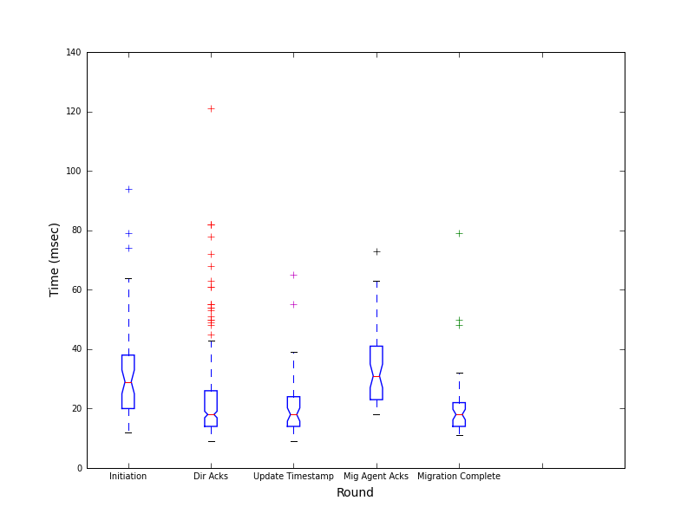

Fig. 4.4 Directory service time (No DummyNet)

**4.5.2 DummyNet with x=y=0ms**

This experiment was designed to evince the presence of any overhead of introducing DummyNet. We enable DummyNet but set it to simulate 0ms latencies between the replicas.

The expectations here are the same as the no DummyNet case and any observed deviation will be treated as the DummyNet overhead.

Results:

Figure 4.5 shows the client end to end latencies for the DummyNet with 0ms delay case. We see that for the Directory Acks, Update Timestamp and Migration Complete rounds, the latency seems to be around 60ms while the Initiation and Migration Agent Acks rounds are higher around 90-100ms. Once again we decompose the end to end latency into the Paxos convergence times (at the leader) and the Directory Service times.

Figure 4.6 shows the Paxos convergence times at the leader. The 2nd closest replica to the leader is still effectively 0ms away. From the graph we can see that this is not the case. All the convergence latencies are around 25-30ms. Now if we compare this to the no DummyNet case, we see an overhead of roughly 20ms.

Figure 4.7 shows the Directory service times for the no DummyNet case. Apart from the long tail for the Directory Acks round (artifact of the database query optimizer), the database access times are the same as the no DummyNet case. This is as expected because introducing DummyNet only has bearing on the link latencies if at all.

Now if we try to sum up the service time (database access times) and the Paxos convergence times to compare it against the end to end latencies, everything except the Initiation and Migration Agent Acks rounds roughly add up. Those two rounds seem to have an extra 20ms in the end to end that isn’t accounted for in the decomposition. We suspect the reasoning for this is that the paxos client to leader RTT (the 2x factor in the expected times) also experiences the 20ms DummyNet overhead.

Thus, the overhead can be translated to DummyNet adding 20ms everytime there is a network roundtrip. In other words x becomes x + 20ms when DummyNet is in use.

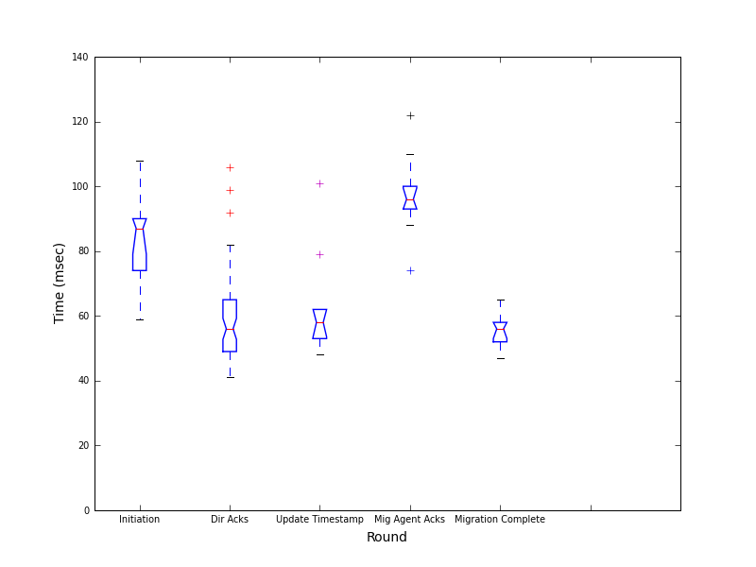

Fig. 4.5 Client end to end latency (DummyNet with x=y=0ms)

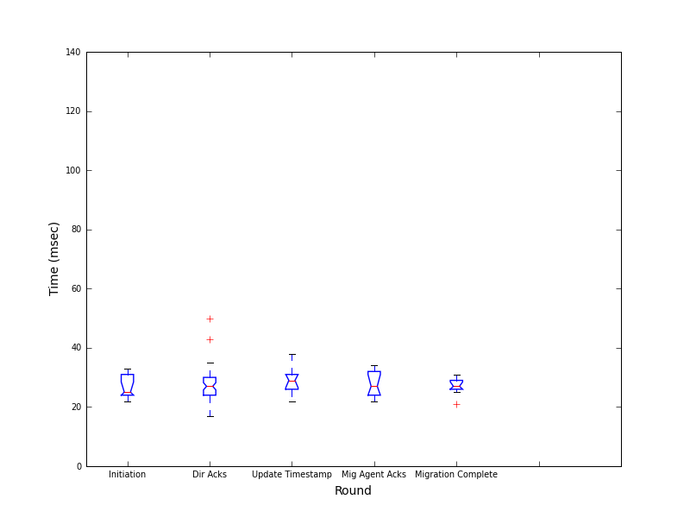

Fig. 4.6 Paxos leader latency (DummyNet with x=y=0ms)

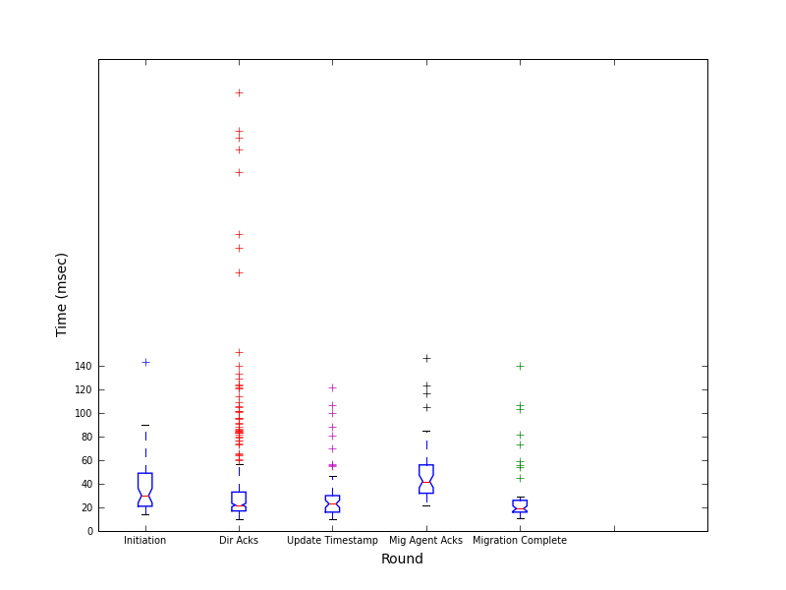

Fig. 4.7 Directory service time (DummyNet with x=y=0ms)

**4.5.3 DummyNet with x=y=20ms**

Now we simulate the 5 nodes being at equal link delays of 20ms from each other. i.e. x = y =20ms. This experiment was a step towards more realistic network conditions.

Expectations:

* PRCT should be 20ms + 3-5ms code execution time/queuing delays within the application.
* With the DummyNet overhead, PRCT = 20ms + 3-5ms + 20ms.
* The Directory service times (database access times) are expected to remain the same.

Results:

Figure 4.8 shows the client end to end latencies. Latencies for the Directory Acks, Update Timestamp and Migration Complete rounds, seem to be around 65ms while those for the Initiation and Migration Agent Acks rounds are higher around 120ms. Decomposing the end to end latency into the Paxos convergence times (at the leader) and the Directory Service times, we have:

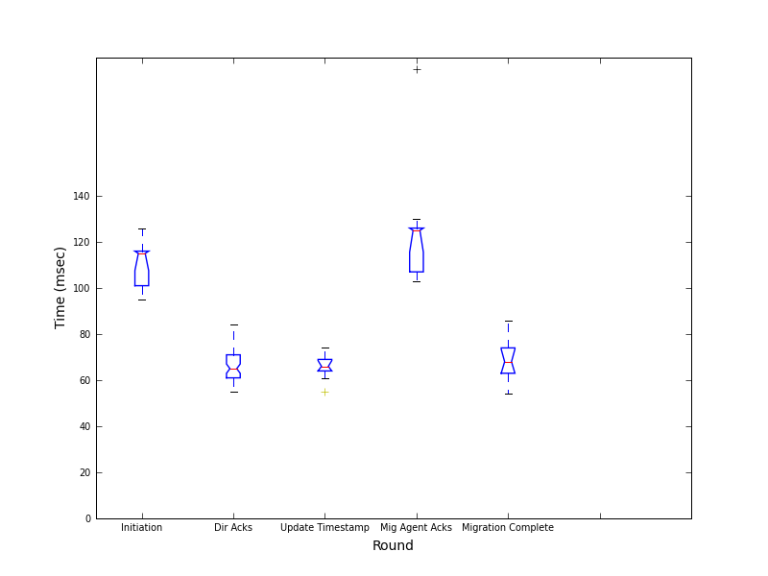

Fig. 4.8 Client end to end latency (DummyNet with x=y=20ms)

Figure 4.9 shows the Paxos convergence times at the leader. The 2nd closest replica to the leader is 20ms away (as they are all 20ms away). With the DummyNet overhead, we expect the convergence time to be around 45ms which is the case as we can see in Figure 4.9.

Figure 4.10 shows the Directory service times. Once again, apart from the long tail for the Directory Acks round (artifact of the database query optimizer), the database access times are the same as the ones from other experiments. This is as expected as changing link latencies should have no effect on the database access times.

Now, if we add up the service times for the rounds with the corresponding Paxos convergence times, we see that with room for queuing delay and some minor deviations, we get the client end to end latencies.

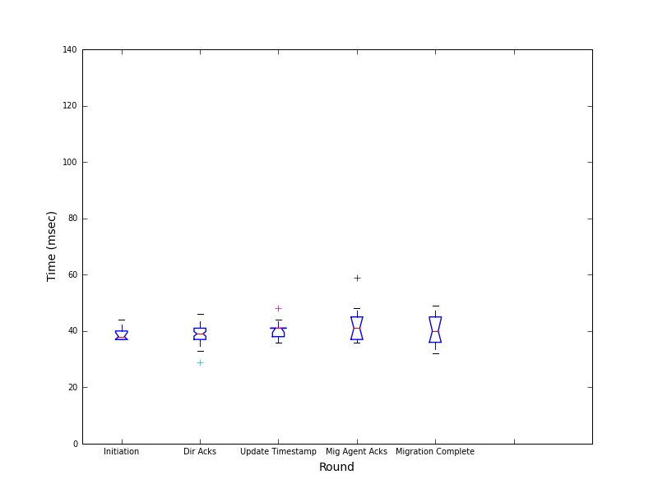

Fig. 4.9 Paxos leader latency (DummyNet with x=y=20ms)

**4.5.4 DummyNet with x=20ms, y=80ms**

As the final step towards emulating realistic network conditions and setups, we simulate a setup with 3 machines on the east coast and 2 on the west coast. x = 20ms, y = 80ms.

Expectations:

* PRCT should still be 20ms + 3-5ms as the 3 replicas on the east coast can form a majority between themselves.
* Again, with the DummyNet overhead, PRCT = 20ms + 3-5ms + 20ms.
* Note that these expectations are exactly the same as the case with x=y=20ms.

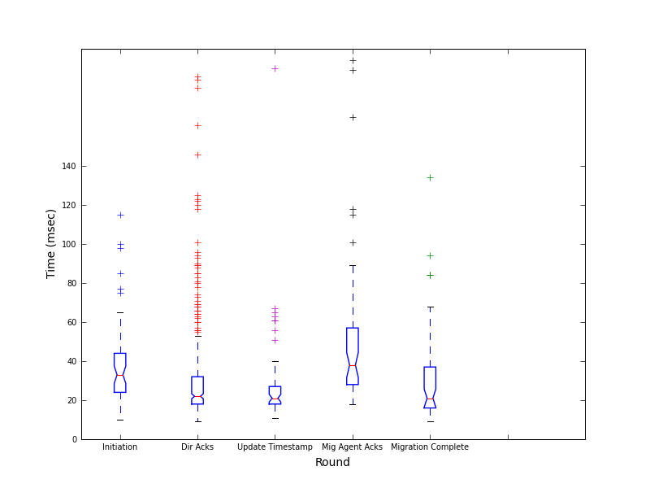

Fig. 4.10 Directory service time (DummyNet with x=y=20ms)

Results:

Figure 4.11 shows the client end to end latencies. We can see that for the Directory Acks, Update Timestamp and Migration Complete rounds, the latency seems to be around 70ms while the initiation and migration agent acks rounds are higher around 120ms.

Figure 4.12 shows the Paxos convergence times at the leader. The 2nd closest replica to the leader is 20ms away (on the east coast). With the DummyNet overhead, we expect the convergence time to be around 45ms which is the case as we can see in Figure 4.12.

Figure 4.13 shows the Directory service times. Once again, apart from the long tail for the Directory Acks round (artifact of the database query optimizer), the database access times are the same as the ones from other experiments. This is as expected as changing link latencies should have no effect on the database access times.

Once again, if we add up the service times for the rounds with the corresponding Paxos convergence times, we see that with room for queuing delay and some minor deviations, we get the client end to end latencies.

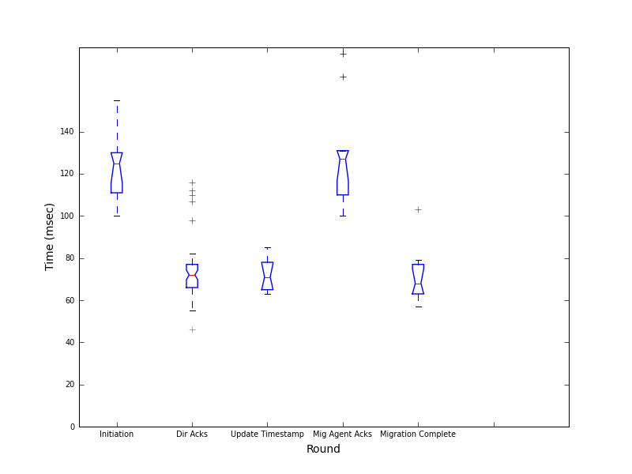

Fig. 4.11 Client end to end latency (DummyNet with x=20ms, y=80ms)

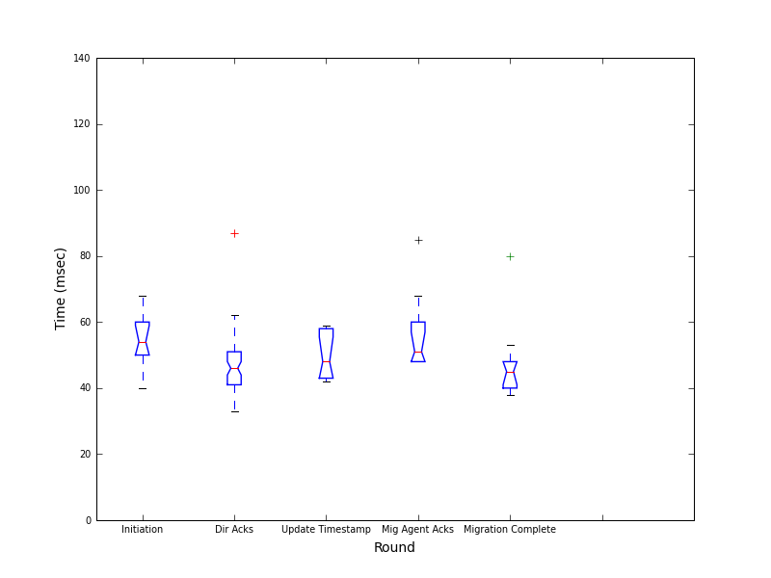

Fig. 4.12 Paxos leader latency (DummyNet with x=20ms, y=80ms)

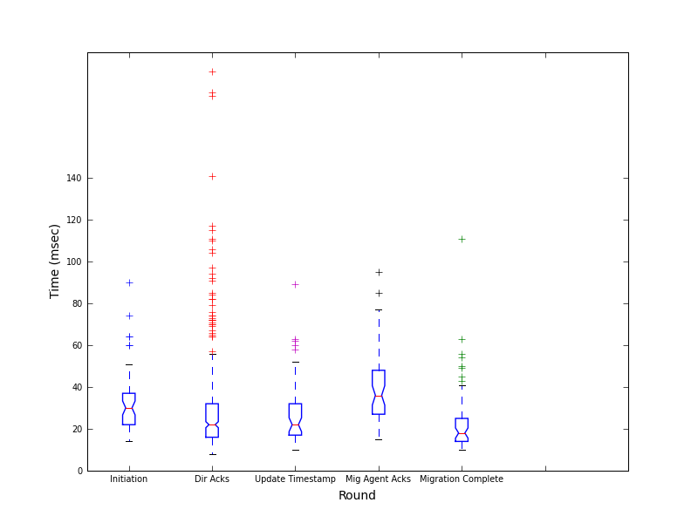

Fig. 4.13 Directory service time (DummyNet with x=20ms, y=80ms)

**4.5.5 Net Migration Times**

Thus far we have presented and discussed results that a step/operation wise break up of the migration process. We now present our results of the net end to end migration time for a migration.

Figure 4.14 shows a box plot of the migration times for a single migration. The x-axis indicates which of the above four cases (4.5.1 – 4.5.4) the migration time represents. We can see that all the migration times are roughly around 6seconds. Note that in our implementation, we have blackboxed the actual object movement itself and made it a constant 5seconds.

Figure 4.15 shows the same result of net migrations times for each of the above four cases without the object movement time. This represents the net time it takes for all the necessary steps (except the actual object movement) in the migration process to be completed – in essence all the Paxos round and the protocol processing time. We see that this time is roughly around 1 second.

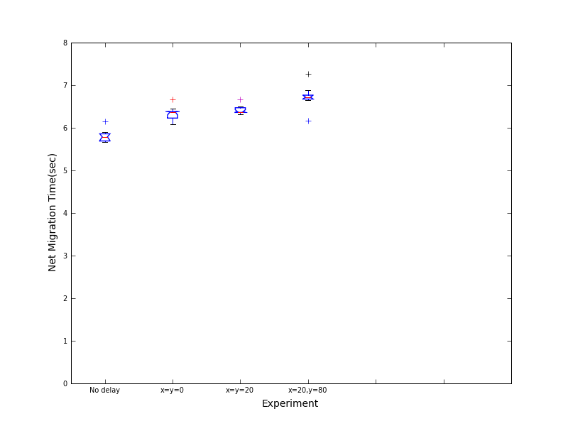

Fig. 4.14 Net Migration Time for a migration

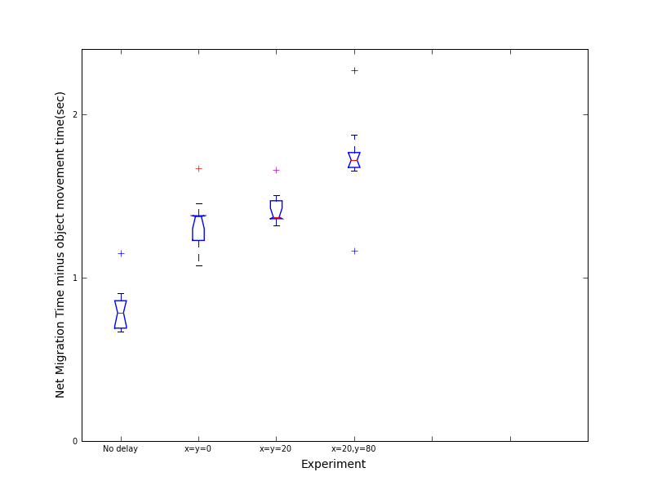

Fig 4.15 Net Migration Time (without object movement time) for a migration

**4.6 Overhead When DummyNet Is Introduced**

In Chapter 4, we saw that when we introduced DummyNet, we observed an overhead of about 20ms for all RTTs between replicas. We wanted to investigate this further to try to pinpoint the source of the overhead.

The first step was to see if this is a per-packet overhead being introduced by using DummyNet itself. To do this, we setup an experiment wherein we configured DummyNet pipes between two machines on PRObE, varied the delay and measured the ping times between the machines. We then plotted a boxplot of the Observed vs Emulated Delays.

The first step was to see if this is a per-packet overhead being introduced by using DummyNet itself. To do this, we setup an experiment wherein we configured DummyNet pipes between two machines on PRObE, varied the delay and measured the ping times between the machines. We then plotted a boxplot of the Observed vs Emulated Delays.

From Figure A.1 we can see that the observed delay is a few milliseconds within the emulated delay. If DummyNet was introducing a per-packet overhead of 20ms, then the ICMP packets (ping packets) would also have experienced this delay and the observed delay should have also seen a 20ms overhead. Hence we can rule out this being a DummyNet problem.

Additionally, we suspected that the frequency of the CPU timer interrupts might have some interaction with the scheduling of packets to be sent out on the Network Interface Card. The Linux kernel has parameters that can be configured at compile time to alter this frequency. We suspected that if an option called “CONFIG_HZ_100” was set, then the timer interrupt frequency would be set to 100Hz implying that the timer ticks would happen every 10ms. Then it might be possible that the kernel is unable to schedule events with the precision we want it to, so it might end up rounding the time an event fires to the closest 10th ms tick (thus causing the 20ms overhead).

On investigation, we found out that the Linux kernel we were using had the frequency configured to “CONFIG_HZ_250” thus setting the interrupt frequency to 250Hz. Thus the maximum overhead due to scheduling we could be seeing would be +/- 4ms, which is lesser than our 20ms overhead.

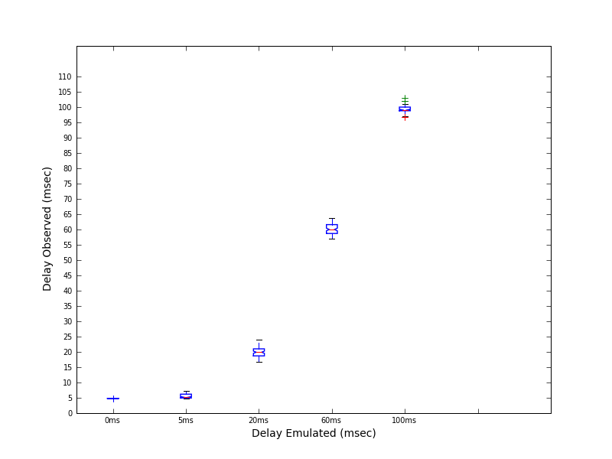

Fig. 4.16 Delay Observed vs. Delay Emulated for ping test

**5. CONCLUSION**

In this thesis we have presented our experience implementing a Paxos based directory updates scheme for geo-replicated cloud storage. We have conducted detailed evaluation of the system on the PRObE testbed under simulated wide area network environments. Many replica placement systems today such as SPANStore, DTunes take for granted the availability of a distributed, correct directory and its updates. While there are systems such as Google Spanner which do implement such a scheme, there is no available open source implementation of the same. This open source implementation and it’s evaluation in simulated WAN settings forms the highlight of this work.

**5.1 Summary of Thesis Contributions**

Below is a summary of our thesis contributions:

* We implemented Paxos based directory updates scheme for geo-replicated cloud storage systems and have open sourced our implementation.
* We instrumented and evaluated the implementation in simulated WAN environments on the public research testbed PRObE.
* From our experience we have extracted key lessons that could benefit researchers in this field since we provide detailed instrumentation data of a Paxos based system evaluated in WAN environments.

**5.2 Key Results**

We present our learnings from developing and testing this directory updates system:

* Latencies of operation in wide area settings were acceptable with each Paxos round converging predictably in the time it takes for the 3 closest replicas to communicate.
* With an east coast – west coast like setup, the database access times form a large portion of the end to end latencies.The total number of Paxos rounds involved in a single migration depend on the implementation (with rounds like timestamp updates being implementation specific)
* In implementations of systems like replicated state machines built around the Paxos protocol, once a leader election system is in place, the protocol simplifies to a majority based, quorum-like one.

**5.3 Limitations and Future Work**

Finally, we list some limitations of this work and directions we could take to improve these issues.

* Multithreading: The protocol process is a single threaded process. This means that at any given point, since only one protocol process is active, only one thread is executing migration requests. This means that only one leg of a single migration request is being serviced at any given point of time. To address this we can have a thread pool from which each thread can have a mutually exclusive migration in progress. The reason we need the threads to work on mutually exclusive requests is not only to avoid duplicate work being done, but also to avoid transient inconsistencies from parallel threads trying to update the state of the same migration request. To implement such a mutex system, we propose that the unique key constraint feature of the database by having threads “fight and claim” migrations by registering it with the thread’s name in the database in a table where the primary key (unique) is the object name. This way we can let the database engine arbitrate contentions.
* Database abstraction: While the logging framework has been abstracted to an extent from the data store, the state machine implementation of the migration process is tightly tied to the chosen PostgreSQL database. There can be use cases made for switching out Postgres for a non-relational store such as Cassandra or MongoDB. This would require significant rewriting of the migration code. A better implementation would be to abstract away the database layer so that it can be switched out without requiring rewriting of the migration protocol itself.
* Evaluations under cases of failure: While we did sanity tests to ensure that the replicas are capable of recovering from failure and that the system can tolerate failed replicas (the number of them being contingent on the crash model being used), we did not evaluate the process in terms of factors such as recovery time and compression ratio of the truncated log versus individual log records. A comprehensive evaluation of these factors under different scenarios (failures at different points in the Paxos protocol and the update protocol) is worth looking into. These scenarios would also subsume the cases of leader change due to failure which can be an expensive operation if the new leader is also recovering from a crash or is still catching up.
* Consistent updates: We alluded to this in Section 1.1. The implemented system is fault tolerant – in case of failures, the state has been replicated using Paxos and there is another replica that can take over and carry forward the migration process. But this system is only a part of a larger system that can actually claim to be able to perform consistent updates. Below we briefly describe the extensions required by one such possible implementation. First off we would need a way to invalidate directory entries while the object is being moved. A simple way to implement this would be to set bits against the directory entries of the object being moved before the migration process is actually started. Having this bit set indicates that the object is under migration and there is a chance that the object will not be found at the location until the directory is updated and the bit is unset. We unset the bits once the object has moved and all directories have been updated. The setting and unsetting of the bit are not atomic operations, but that is acceptable as the clients are aware that the bit represents a pending migration. The other issue that has to be addressed is whether or not reads and writes should be allowed while the object is under movement. Allowing reads is acceptable as the migration process can take some time and blocking all access to the object can be expensive. Allowing writes at the replica from which the object is being copied while the object is under movement is a trickier problem which we will not be going into here. So we need to set markers at the replicas from which we are moving the object out of to indicate that said object is going to be under migration soon and writes must be disallowed. Once we get a sufficient number of acknowledgements (based on the consistency parameters of the system) from replicas where the object is currently placed, we can begin the migration process. As clean up, once the entire migration process is complete, the object can be deleted from the old set of replicas and the markers can be done away with as at this point the directories have the information about the new location of the object.

LIST OF REFERENCES

LIST OF REFERENCES

[1] Kończak, Jan, et al. "JPaxos: State machine replication based on the Paxos protocol." *Faculté Informatique et Communications, EPFL, Tech. Rep* 167765 (2011).

[2] Lamport, Leslie. "Paxos made simple." *ACM Sigact News* 32.4 (2001): 18-25.

[3] Lamport, Leslie. "The part-time parliament." *ACM Transactions on Computer Systems (TOCS)* 16.2 (1998): 133-169.

[4] Shankarnarayanan, P.N., Ashiwan Sivakumar, Sanjay Rao and Mohit Tawarmalani. “Performance sensitive replication in geo-distributed cloud datastores.” *Proceedings of the Annual IEEE/IFIP International Conference on Dependable Systems and Networks (DSN),* 2014.

[5] Wu, Zhe, et al. "Spanstore: Cost-effective geo-replicated storage spanning multiple cloud services." *Proceedings of the Twenty-Fourth ACM Symposium on Operating Systems Principles*. ACM, 2013.

[6] Corbett, James C., et al. "Spanner: Google’s globally distributed database." *ACM Transactions on Computer Systems (TOCS)* 31.3 (2013): 8.

[7] Ongaro, Diego, and John Ousterhout. "In search of an understandable consensus algorithm." *Draft of October* 7 (2013).

[8] Lloyd, Wyatt, et al. "Don't settle for eventual: scalable causal consistency for wide-area storage with COPS." *Proceedings of the Twenty-Third ACM Symposium on Operating Systems Principles*. ACM, 2011.

[9] Dynamo. http://aws.amazon.com/dynamodb/.

[10] Cassandra. <http://cassandra.apache.org/>.

[11] Chandra, Tushar D., Robert Griesemer, and Joshua Redstone. "Paxos made live: an engineering perspective." *Proceedings of the twenty-sixth annual ACM symposium on Principles of distributed computing*. ACM, 2007.

1. Figures courtesy Wikipedia page on Paxos: http://en.wikipedia.org/wiki/Paxos_%28computer_science%29
2. Figure courtesy Wikipedia page on Paxos: http://en.wikipedia.org/wiki/Paxos_%28computer_science%29