# 2014-06-24 Ambari Install failed

Failed to install/start the services.

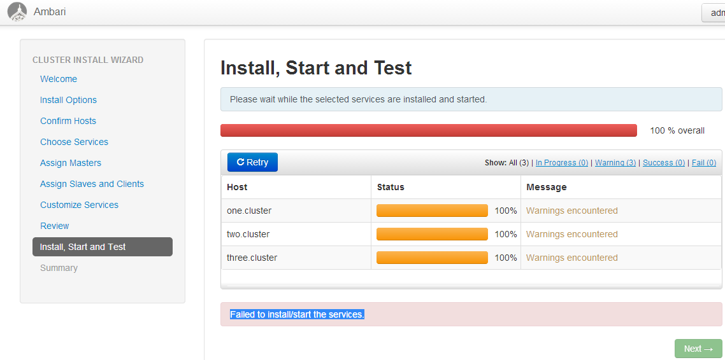

## One

### [NameNode install](http://192.168.66.101:8080/)

stderr:

stdout:

notice: /Stage[1]/Hdp::Create_smoke_user/File[/tmp/changeUid.sh]/ensure: defined content as '{md5}5fed97154685622eeb89f4fe21ebe356'

notice: /Stage[1]/Hdp::Snappy::Package/Hdp::Package[snappy]/Hdp::Package::Process_pkg[snappy]/Package[snappy]/ensure: created

notice: /Stage[1]/Hdp::Snmp/Hdp::Package[snmp]/Hdp::Package::Process_pkg[snmp]/Package[net-snmp-utils]/ensure: created

notice: /Stage[1]/Hdp::Snmp/Hdp::Package[snmp]/Hdp::Package::Process_pkg[snmp]/Package[net-snmp]/ensure: created

notice: /Stage[1]/Hdp::Snmp/Hdp::Package[snmp]/Hdp::Package::Process_pkg[snmp]/Hdp::Java::Package[snmp]/Exec[mkdir -p /tmp/HDP-artifacts/ ; curl -f --retry 10 http://one.cluster:8080/resources//jdk-6u31-linux-x64.bin -o /tmp/HDP-artifacts//jdk-6u31-linux-x64.bin snmp]/returns: executed successfully

notice: /Stage[1]/Hdp::Snmp/Hdp::Package[snmp]/Hdp::Package::Process_pkg[snmp]/Hdp::Java::Package[snmp]/Exec[mkdir -p /usr/jdk ; chmod +x /tmp/HDP-artifacts//jdk-6u31-linux-x64.bin; cd /usr/jdk ; echo A | /tmp/HDP-artifacts//jdk-6u31-linux-x64.bin -noregister > /dev/null 2>&1 snmp]/returns: executed successfully

notice: /Stage[1]/Hdp::Snmp/Hdp::Package[snmp]/Hdp::Package::Process_pkg[snmp]/Hdp::Java::Package[snmp]/File[/usr/jdk/jdk1.6.0_31/bin/java snmp]/ensure: created

notice: /Stage[1]/Hdp::Snmp/Hdp::Snmp-configfile[snmpd.conf]/Hdp::Configfile[/etc/snmp//snmpd.conf]/File[/etc/snmp//snmpd.conf]/content: content changed '{md5}8307434bc8ed4e2a7df4928fb4232778' to '{md5}f786955c0c36f7f5a4f375e3fe93c959'

notice: /Stage[1]/Hdp::Snmp/Service[snmpd]/ensure: ensure changed 'stopped' to 'running'

notice: /Stage[1]/Hdp::Snmp/Service[snmpd]: Triggered 'refresh' from 1 events

## Two

### SNameNode install

stderr:

stdout:

warning: Dynamic lookup of $service_state at /var/lib/ambari-agent/puppet/modules/hdp-hadoop/manifests/init.pp:223 is deprecated. Support will be removed in Puppet 2.8. Use a fully-qualified variable name (e.g., $classname::variable) or parameterized classes.

warning: Dynamic lookup of $service_state at /var/lib/ambari-agent/puppet/modules/hdp-hadoop/manifests/service.pp:76 is deprecated. Support will be removed in Puppet 2.8. Use a fully-qualified variable name (e.g., $classname::variable) or parameterized classes.

warning: Dynamic lookup of $service_state at /var/lib/ambari-agent/puppet/modules/hdp-hadoop/manifests/service.pp:85 is deprecated. Support will be removed in Puppet 2.8. Use a fully-qualified variable name (e.g., $classname::variable) or parameterized classes.

warning: Dynamic lookup of $configuration is deprecated. Support will be removed in Puppet 2.8. Use a fully-qualified variable name (e.g., $classname::variable) or parameterized classes.

warning: Dynamic lookup of $mapred-site is deprecated. Support will be removed in Puppet 2.8. Use a fully-qualified variable name (e.g., $classname::variable) or parameterized classes.

warning: Dynamic lookup of $ambari_db_rca_url is deprecated. Support will be removed in Puppet 2.8. Use a fully-qualified variable name (e.g., $classname::variable) or parameterized classes.

warning: Dynamic lookup of $ambari_db_rca_driver is deprecated. Support will be removed in Puppet 2.8. Use a fully-qualified variable name (e.g., $classname::variable) or parameterized classes.

warning: Dynamic lookup of $ambari_db_rca_username is deprecated. Support will be removed in Puppet 2.8. Use a fully-qualified variable name (e.g., $classname::variable) or parameterized classes.

warning: Dynamic lookup of $ambari_db_rca_password is deprecated. Support will be removed in Puppet 2.8. Use a fully-qualified variable name (e.g., $classname::variable) or parameterized classes.

notice: /Stage[1]/Hdp::Create_smoke_user/File[/tmp/changeUid.sh]/ensure: defined content as '{md5}5fed97154685622eeb89f4fe21ebe356'

## Three

### [DataNode install](http://192.168.66.101:8080/)

stderr:

stdout:

warning: Dynamic lookup of $service_state at /var/lib/ambari-agent/puppet/modules/hdp-hadoop/manifests/init.pp:223 is deprecated. Support will be removed in Puppet 2.8. Use a fully-qualified variable name (e.g., $classname::variable) or parameterized classes.

warning: Dynamic lookup of $service_state at /var/lib/ambari-agent/puppet/modules/hdp-hadoop/manifests/service.pp:76 is deprecated. Support will be removed in Puppet 2.8. Use a fully-qualified variable name (e.g., $classname::variable) or parameterized classes.

warning: Dynamic lookup of $service_state at /var/lib/ambari-agent/puppet/modules/hdp-hadoop/manifests/service.pp:85 is deprecated. Support will be removed in Puppet 2.8. Use a fully-qualified variable name (e.g., $classname::variable) or parameterized classes.

warning: Dynamic lookup of $configuration is deprecated. Support will be removed in Puppet 2.8. Use a fully-qualified variable name (e.g., $classname::variable) or parameterized classes.

warning: Dynamic lookup of $mapred-site is deprecated. Support will be removed in Puppet 2.8. Use a fully-qualified variable name (e.g., $classname::variable) or parameterized classes.

warning: Dynamic lookup of $ambari_db_rca_url is deprecated. Support will be removed in Puppet 2.8. Use a fully-qualified variable name (e.g., $classname::variable) or parameterized classes.

warning: Dynamic lookup of $ambari_db_rca_driver is deprecated. Support will be removed in Puppet 2.8. Use a fully-qualified variable name (e.g., $classname::variable) or parameterized classes.

warning: Dynamic lookup of $ambari_db_rca_username is deprecated. Support will be removed in Puppet 2.8. Use a fully-qualified variable name (e.g., $classname::variable) or parameterized classes.

warning: Dynamic lookup of $ambari_db_rca_password is deprecated. Support will be removed in Puppet 2.8. Use a fully-qualified variable name (e.g., $classname::variable) or parameterized classes.

notice: /Stage[1]/Hdp::Create_smoke_user/File[/tmp/changeUid.sh]/ensure: defined content as '{md5}5fed97154685622eeb89f4fe21ebe356'

### [HDFS Client install](http://192.168.66.101:8080/)

stderr:

stdout:

## Lösungsversuche

