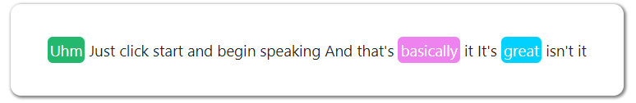

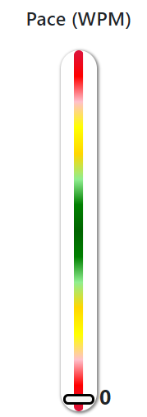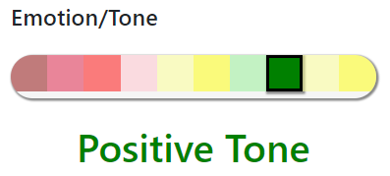

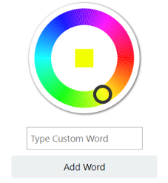

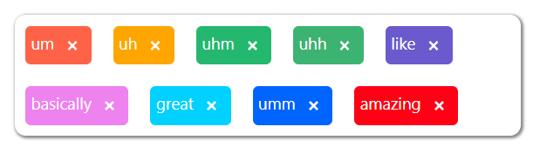

BUGS TO FIX BEFORE LAUNCH

save transcript button

sidenav length

active effect on nav buttons

footer

user profile

help (remove or create)

add custom words tab and ability to hide in freestyle

logout on firefox

general errors and warnings

main nav links

contact page

cookies indication

multiple insert in usage graph

forgot password

signup/signin box

google search / site map

sidenav cut off

stop record immediately after click stop

UI

Remove Console.logs

Policies

Positive spelling on main page