**大数据平台部署与运维**

|  |  |  |  |
| --- | --- | --- | --- |
| 文档更新记录 | | | |
| 日期 | 作者 | 版本 | 备注说明 |
| 2016-05-20 | 吴钢奇 | 1.0 | Rsyslog+kafka+fleuntd+elastic+hadoop部署 |
|  |  |  |  |
|  |  |  |  |

目录

一、大数据平台架构图 3

二、rsyslog 3

1、安装 3

2、配置 4

3、维护 5

三、kafka 5

1、安装 5

2、配置 6

3、维护 7

四、fleuntd 7

1、安装 7

2、配置 8

3、维护 13

五、elastic 14

1、安装 14

2、配置 15

3、维护 18

六、hadoop 19

1、安装 19

2、配置 21

3、维护 22

4、数据输出 22

# 一、大数据平台架构图

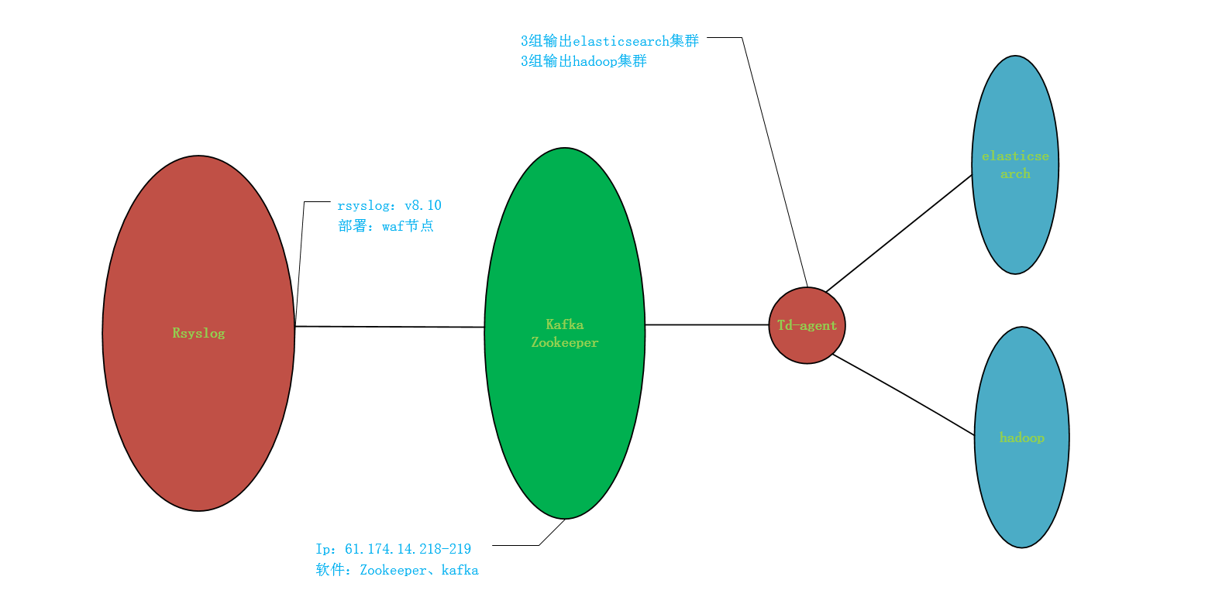

# 二、rsyslog

## 1、安装

[root@CNC-TJ-005-045 ~]# cd /etc/yum.repos.d/

[root@CNC-TJ-005-045 yum.repos.d]# ls

CentOS-Base.repo epel.repo epel-testing.repo rsyslogall.repo

[root@CNC-TJ-005-045 yum.repos.d]# cat rsyslogall.repo

[rsyslog-v8-stable]

name=Adiscon Rsyslog v8-stable for CentOS-$releasever-$basearch

baseurl=http://rpms.adiscon.com/v8-stable/epel-$releasever/$basearch

enabled=1

gpgcheck=0

protect=1

[root@CNC-TJ-005-045 yum.repos.d]#

[root@CNC-TJ-005-045 yum.repos.d]# yum -y install rsyslog rsyslog-kafka

[root@CNC-TJ-005-045 yum.repos.d]# rpm -qa |grep rsyslog

rsyslog-8.18.0-1.el6.x86_64

rsyslog-kafka-8.18.0-1.el6.x86_64

## 2、配置

[root@CNC-TJ-005-045 yum.repos.d]# cat /etc/rsyslog.conf |grep -vE "^#|^$"

$MaxMessageSize 20k

$ModLoad imuxsock # provides support for local system logging (e.g. via logger command)

$ModLoad imklog # provides kernel logging support (previously done by rklogd)

module(load="omkafka")

$ActionFileDefaultTemplate RSYSLOG_TraditionalFileFormat

$IncludeConfig /etc/rsyslog.d/*.conf

kern.* @61.174.9.68:61200

authpriv.* /var/log/secure

mail.* -/var/log/maillog

cron.* /var/log/cron

uucp,news.crit /var/log/spooler

local7.* /var/log/boot.log

$template strtpl,"%TIMESTAMP:::date-pgsql% %msg%\n"

local6.info /var/log/history;strtpl

local6.info @ops.cdn.syslog.secure.anquan.io:5140

authpriv.* @ops.cdn.syslog.secure.anquan.io:5656

$WorkDirectory /var/spool/rsyslog

module(load="imfile" mode="inotify")

input(type="imfile"

file="/cache/logs/201*_user_access.log"

Tag="nginx-access:"

Facility="local5"

Severity="err"

PersistStateInterval="200")

$template FormatNginx,"%msg%\n"

local5.err action(type="omkafka" topic="nginx-access" broker=["120.92.245.58:9092","120.92.245.59:9092","120.92.245.60:9092","120.92.245.59:9092","120.92.245.60:9092","120.92.245.58:9092","120.92.245.60:9092","120.92.245.59:9092","120.92.245.58:9092"] partitions.number="9" errorFile="/cache/logs/rsyslog/kafkaerr.log" template="FormatNginx" confParam=["compression.codec=snappy","socket.timeout.ms=5000","socket.keepalive.enable=true"] queue.spoolDirectory="/cache/logs/rsyslog" queue.type="LinkedList" queue.size="16777216" queue.filename="toKafka" queue.highwatermark="10066330" queue.lowwatermark="5033165" queue.maxdiskspace="20g" queue.maxfilesize="1g" queue.dequeuebatchsize="500" queue.saveonshutdown="on" queue.workerThreads="4" queue.discardseverity="8" queue.discardmark="16000000" queue.timeoutenqueue="5000")

if $programname == 'nginx-access' then stop

*.info;mail.none;authpriv.none;cron.none;local6.none /var/log/messages

## 3、维护

[root@CNC-TJ-005-045 ~]# service rsyslog start

[root@CNC-TJ-005-045 ~]# service rsyslog stop

# 三、kafka

## 1、安装

[root@ctl-zj-61-174-14-218 ~]# wget -c http://download.oracle.com/otn-pub/java/jdk/8u65-b17/jdk-8u65-linux-x64.tar.gz?AuthParam=1446451514_9a4acfee12c17886366e74da5d6cdef9

[root@ctl-zj-61-174-14-218 ~]# cat /etc/profile

export JAVA_HOME=/usr/local/jdk1.8.0_65

export CLASSPATH=.:$JAVA_HOME/lib/dt.jar:$JAVA_HOME/lib/tools.jar

export LIBJLI_PATH=/usr/local/jdk1.8.0_65/jre/lib/amd64/jli

export PATH=/usr/local/bin:$PATH:$JAVA_HOME/bin:$HOME/bin:$LIBJLI_PATH:/usr/local/kafka/bin:/usr/local/zookeeper/bin

[root@ctl-zj-61-174-14-218 ~]# ls /usr/local/zookeeper/

bin CHANGES.txt contrib docs ivy.xml LICENSE.txt README_packaging.txt recipes zookeeper-3.4.6.jar zookeeper-3.4.6.jar.md5

build.xml conf dist-maven ivysettings.xml lib NOTICE.txt README.txt src zookeeper-3.4.6.jar.asc zookeeper-3.4.6.jar.sha1

[root@ctl-zj-61-174-14-218 ~]#

[root@ctl-zj-61-174-14-218 ~]# ls /usr/local/kafka/

bin config libs LICENSE logs NOTICE version

## 2、配置

[root@ctl-zj-61-174-14-218 ~]# cat /usr/local/zookeeper/conf/zoo.cfg

tickTime=2000

initLimit=10

syncLimit=5

clientPort=2181

server.0=61.174.14.218:2888:3888

server.1=61.174.14.219:2888:3888

server.2=61.174.14.220:2888:3888

dataLogDir=/data01/zookeeper/logs

dataDir=/data01/zookeeper/data

autopurge.purgeInterval=6

autopurge.snapRetainCount=72

[root@ctl-zj-61-174-14-218 ~]#

[root@ctl-zj-61-174-14-218 ~]# cat /usr/local/kafka/config/server.properties

broker.id=0

port=9092

advertised.host.name=61.174.14.218

num.network.threads=16

num.io.threads=32

socket.send.buffer.bytes=102400

socket.receive.buffer.bytes=102400

socket.request.max.bytes=1083741824

log.dirs=/data02/kafka,/data03/kafka,/data04/kafka,/data05/kafka,/data06/kafka,/data07/kafka,/data08/kafka,/data09/kafka,/data10/kafka,/data11/kafka,/data12/kafka,/data13/kafka

num.partitions=8

num.recovery.threads.per.data.dir=1

log.segment.bytes=1073741824

log.retention.check.interval.ms=300000

log.cleaner.enable=false

zookeeper.connect=61.174.14.218:2181,61.174.14.219:2181,61.174.14.220:2181

zookeeper.connection.timeout.ms=6000

delete.topic.enable=true

log.flush.interval.messages=100000

log.flush.interval.ms=1000

log.retention.hours=720

queued.max.requests=2000

[root@ctl-zj-61-174-14-218 ~]#

## 3、维护

/usr/local/zookeeper/bin/zkServer.sh start

/usr/local/zookeeper/bin/zkServer.sh stop

/usr/local/kafka/bin/kafka-server-start.sh /usr/local/kafka/config/server.properties &

/usr/local/kafka/bin/kafka-server-stop.sh

# 四、fleuntd

## 1、安装

[root@ctl-zj-61-174-14-218 ~]# cd /etc/yum.repos.d

[root@ctl-zj-61-174-14-218 yum.repos.d]# ll

total 32

-rw-r--r-- 1 root root 2572 May 15 2015 CentOS-Base.repo

-rw-r--r-- 1 root root 954 Jul 6 2015 epel.repo

-rw-r--r-- 1 root root 1056 Nov 5 2012 epel-testing.repo

-rw-r--r-- 1 root root 174 Nov 4 2015 td.repo

-rw-r--r-- 1 root root 401 Nov 12 2013 zabbix.repo

[root@ctl-zj-61-174-14-218 yum.repos.d]# cat td.repo

[treasuredata]

name=TreasureData

baseurl=http://packages.treasuredata.com/2/redhat/$releasever/$basearch

gpgcheck=1

gpgkey=https://packages.treasuredata.com/GPG-KEY-td-agent

[root@ctl-zj-61-174-14-218 yum.repos.d]#

[root@ctl-zj-61-174-14-218 yum.repos.d]# yum -y install td-agent

## 2、配置

[root@ctl-zj-61-174-14-218 ~]# cat /etc/td-agent/td-agent.conf

<source>

type kafka

topics nginx-access

hosts 61.174.14.218,61.174.14.219,61.174.14.220

port 9092

#format text

format json

client_id elasticsearch-1

partition 1

max_bytes 52428800

max_wait_ms 5000

min_bytes 1024

socket_timeout_ms 50000

add_prefix abc

</source>

<match abc.nginx-access>

type record_modifier

char_encoding gbk:utf-8

tag a.apache.access

</match>

<match a.apache.access>

type api

add_prefix api

</match>

<match api.a.apache.access>

type copy

<store>

type forward

heartbeat_type tcp

send_timeout 60s

recover_wait 10s

heartbeat_interval 20s

phi_threshold 16

hard_timeout 60s

buffer_type file

buffer_path /data01/fluentd/buffer/myapp.*.buffer

buffer_queue_limit 500

buffer_chunk_limit 2m

num_threads 50

<server>

host 61.174.14.221

port 10086

</server>

<secondary>

type file

path /data01/fluentd/buffer/forward-failed

</secondary>

</store>

<store>

type rewrite_tag_filter

rewriterule1 blockid ^[-1-7]\d*$ attack.log

rewriterule2 domain 81\.cn$ jfzb.log1

rewriterule3 domain chinamil\.com\.cn$ jfzb.log2

rewriterule4 domain 81rc\.mil\.cn$ jfzb.log3

rewriterule5 domain mod\.gov\.cn$ jfzb.log4

</store>

<store>

type elasticsearch

hosts 61.174.14.194:9200,61.174.14.195:9200,61.174.14.196:9200

logstash_format true

flush_interval 20s

logstash_prefix access

index_name access

utc_index false

reload_connections false

buffer_type file

buffer_path /data01/fluentd/buffer/nginx.access.buffer

buffer_chunk_limit 14M

buffer_queue_limit 2048

request_timeout 30

</store>

</match>

<match attack.log>

type elasticsearch

hosts 61.174.14.194:9200,61.174.14.195:9200,61.174.14.196:9200

logstash_format true

flush_interval 20s

logstash_prefix waf

index_name waf

utc_index false

reload_connections false

buffer_type file

buffer_path /data01/fluentd/buffer/attack.buffer

buffer_chunk_limit 12M

buffer_queue_limit 1024

request_timeout 30

</match>

<match jfzb.log*>

type elasticsearch

hosts 61.174.14.194:9200,61.174.14.195:9200,61.174.14.196:9200

logstash_format true

flush_interval 20s

logstash_prefix mod

index_name mod

utc_index false

reload_connections false

buffer_type file

buffer_path /data01/fluentd/buffer/jfzb.log.buffer

buffer_chunk_limit 12M

buffer_queue_limit 2048

request_timeout 30

</match>

[root@ctl-zj-61-174-14-218 ~]# cat /etc/td-agent/td-agenthadoop1.conf

<source>

type kafka

topics nginx-access

hosts 61.174.14.218,61.174.14.219,61.174.14.220

port 9092

#format text

format json

client_id td-agent-input-hadoop1

partition 1

max_bytes 52428800

max_wait_ms 5000

min_bytes 1024

socket_timeout_ms 50000

add_prefix abc

</source>

<match abc.nginx-access>

type record_modifier

char_encoding gbk:utf-8

tag a.apache.access

</match>

<match a.apache.access>

type api

add_prefix api

</match>

<match api.a.apache.access>

type copy

<store>

type webhdfs

namenode 172.26.100.12:50070

standby_namenode 172.26.100.11:50070

path /weblog/temp_table/day=%Y%m%d/ht=%H/${hostname}_%H.log

username hdfs

localtime true

retry_known_errors yes

field_separator SOH

output_include_time true

output_include_tag false

time_format %Y-%m-%d %H:%M:%S

output_data_type attr:clientip,method,domain,request,status,size,referer,agent,hit_status,ruleid,prov,country,blockid,searchbot,p_status,hackerid

flush_interval 5s

buffer_type file

buffer_path /data01/fluentd/buffer/webhdfs2.buffer

buffer_chunk_limit 12M

buffer_queue_limit 2048

#retry_times 10

#retry_interval 3

</store>

<store>

type webhdfs

namenode 172.26.100.12:50070

standby_namenode 172.26.100.11:50070

path /weblog/web_source/day=%Y%m%d/${hostname}_%H.log

username hdfs

localtime true

retry_known_errors yes

field_separator SOH

output_include_time false

output_include_tag false

time_format %Y-%m-%d %H:%M:%S

output_data_type attr:domain,referer,blockid

flush_interval 5s

buffer_type file

buffer_path /data01/fluentd/buffer/webhdfs3.buffer

buffer_chunk_limit 12M

buffer_queue_limit 2048

#retry_times 10

#retry_interval 3

</store>

<store>

type webhdfs

namenode 172.26.100.12:50070

standby_namenode 172.26.100.11:50070

path /weblog/top10_url/day=%Y%m%d/${hostname}_%H.log

username hdfs

localtime true

retry_known_errors yes

field_separator SOH

output_include_time false

output_include_tag false

time_format %Y-%m-%d %H:%M:%S

output_data_type attr:domain,request

flush_interval 5s

buffer_type file

buffer_path /data01/fluentd/buffer/webhdfs4.buffer

buffer_chunk_limit 12M

buffer_queue_limit 2048

#retry_times 10

#retry_interval 3

</store>

<store>

type webhdfs

namenode 172.26.100.12:50070

standby_namenode 172.26.100.11:50070

path /weblog/top5_hacker/day=%Y%m%d/${hostname}_%H.log

username hdfs

localtime true

retry_known_errors yes

field_separator SOH

output_include_time false

output_include_tag false

time_format %Y-%m-%d %H:%M:%S

output_data_type attr:domain,clientip,prov,hackerid

flush_interval 5s

buffer_type file

buffer_path /data01/fluentd/buffer/webhdfs5.buffer

buffer_chunk_limit 12M

buffer_queue_limit 2048

#retry_times 10

#retry_interval 3

</store>

</match>

[root@ctl-zj-61-174-14-218 ~]#

## 3、维护

/etc/init.d/td-agent restart

kill `ps -ef |grep td-agent2 | grep -v grep |awk '{print $2}'`

kill `ps -ef |grep td-agent2 | grep -v grep |awk '{print $2}'`

kill `ps -ef |grep td-agent2 | grep -v grep |awk '{print $2}'`

sleep 30

/opt/td-agent/embedded/bin/ruby /usr/sbin/td-agent2 --group td-agent --log /var/log/td-agent/td-agent2.log --use-v1-config --daemon /var/run/td-agent/td-agent2.pid

kill `ps -ef |grep td-agent3 | grep -v grep |awk '{print $2}'`

kill `ps -ef |grep td-agent3 | grep -v grep |awk '{print $2}'`

kill `ps -ef |grep td-agent3 | grep -v grep |awk '{print $2}'`

sleep 30

/opt/td-agent/embedded/bin/ruby /usr/sbin/td-agent3 --group td-agent --log /var/log/td-agent/td-agent3.log --use-v1-config --daemon /var/run/td-agent/td-agent3.pid

kill `ps -ef |grep td-agenthadoop1 | grep -v grep |awk '{print $2}'`

kill `ps -ef |grep td-agenthadoop1 | grep -v grep |awk '{print $2}'`

kill `ps -ef |grep td-agenthadoop1 | grep -v grep |awk '{print $2}'`

sleep 30

/opt/td-agent/embedded/bin/ruby /usr/sbin/td-agenthadoop1 --group td-agent --log /var/log/td-agent/td-agenthadoop1.log --use-v1-config --daemon /var/run/td-agent/td-agenthadoop1.pid

kill `ps -ef |grep td-agenthadoop2 | grep -v grep |awk '{print $2}'`

kill `ps -ef |grep td-agenthadoop2 | grep -v grep |awk '{print $2}'`

kill `ps -ef |grep td-agenthadoop2 | grep -v grep |awk '{print $2}'`

sleep 30

/opt/td-agent/embedded/bin/ruby /usr/sbin/td-agenthadoop2 --group td-agent --log /var/log/td-agent/td-agenthadoop2.log --use-v1-config --daemon /var/run/td-agent/td-agenthadoop2.pid

kill `ps -ef |grep td-agenthadoop3 | grep -v grep |awk '{print $2}'`

kill `ps -ef |grep td-agenthadoop3 | grep -v grep |awk '{print $2}'`

kill `ps -ef |grep td-agenthadoop3 | grep -v grep |awk '{print $2}'`

sleep 30

/opt/td-agent/embedded/bin/ruby /usr/sbin/td-agenthadoop3 --group td-agent --log /var/log/td-agent/td-agenthadoop3.log --use-v1-config --daemon /var/run/td-agent/td-agenthadoop3.pid

# 五、elastic

## 1、安装

[root@ctl-zj-014-194 ~]# cd /etc/yum.repos.d/

[root@ctl-zj-014-194 yum.repos.d]# ls

abc CentOS-Base.repo elasticsearch.repo epel.repo epel-testing.repo kibana.repo nd.repo nodesource-el.repo

[root@ctl-zj-014-194 yum.repos.d]# cat elasticsearch.repo

[elasticsearch-2.x]

name=Elasticsearch repository for 2.x packages

baseurl=https://packages.elastic.co/elasticsearch/2.x/centos

gpgcheck=1

gpgkey=https://packages.elastic.co/GPG-KEY-elasticsearch

enabled=1

[root@ctl-zj-014-194 yum.repos.d]# cat kibana.repo

[kibana-4.5]

name=Kibana repository for 4.5.x packages

baseurl=http://packages.elastic.co/kibana/4.5/centos

gpgcheck=1

gpgkey=http://packages.elastic.co/GPG-KEY-elasticsearch

enabled=1

[root@ctl-zj-014-194 yum.repos.d]#

[root@ctl-zj-014-194 yum.repos.d]# yum install -y kibana

[root@ctl-zj-014-194 yum.repos.d]# yum install elasticsearch

[root@ctl-zj-014-194 yum.repos.d]# rpm -qa |grep elasticsearch

elasticsearch-2.3.2-1.noarch

[root@ctl-zj-014-194 yum.repos.d]# rpm -qa |grep kibana

kibana-4.5.0-1.x86_64

[root@ctl-zj-014-194 yum.repos.d]#

## 2、配置

[root@ctl-zj-014-194 ~]# cat /etc/elasticsearch/elasticsearch.yml

# ---------------------------------- Cluster -----------------------------------

cluster.name: "2dafb4bf52d4e8e0"

cluster.routing.allocation.node_initial_primaries_recoveries: 8

cluster.routing.allocation.node_concurrent_recoveries: 8

# ------------------------------------ Node ------------------------------------

#node.name: ${HOSTNAME}

node.name: "niudun_node194"

node.master: true

node.data: true

# ----------------------------------- Paths ------------------------------------

path.data: /log/02,/log/03,/log/04,/log/05,/log/06,/log/07,/log/08,/log/09,/log/10,/log/11,/log/12

path.repo: ["/backup"]

# ----------------------------------- Memory -----------------------------------

bootstrap.mlockall: true

# ---------------------------------- Network -----------------------------------

network.bind_host: 172.26.99.1

network.publish_host: 172.26.99.1

http.host: 61.174.14.194

network.tcp.keep_alive: true

# ---------------------------------- Gateway -----------------------------------

#gateway.type: local

gateway.recover_after_nodes: 6

gateway.recover_data_nodes: 9

gateway.recover_after_time: 5m

# ---------------------------------- Transport module -----------------------------------

transport.tcp.compress: true

# ---------------------------------- Http module -----------------------------------

http.enabled: true

http.tcp_keep_alive: true

http.max_content_length: 500mb

http.cors.allow-origin: "/.*/"

http.cors.enabled: true

# --------------------------------- Discovery ----------------------------------

discovery.zen.minimum_master_nodes: 1

discovery.zen.fd.ping_timeout: 120s

discovery.zen.fd.ping_retries: 6

discovery.zen.fd.ping_interval: 30s

discovery.zen.ping.timeout: 3s

discovery.zen.ping.unicast.hosts: ["172.26.99.1", "172.26.99.2", "172.26.99.3", "172.26.99.4", "172.26.99.5", "172.26.99.6", "172.26.99.7", "172.26.99.8", "172.26.99.9", "172.26.99.10"]

# ---------------------------------- Various -----------------------------------

node.max_local_storage_nodes: 1

action.destructive_requires_name: true

# ---------------------------------- Indices module -----------------------------------

# indices recovery

indices.recovery.max_bytes_per_sec: 100mb

indices.recovery.max_size_per_sec: 400mb

indices.recovery.concurrent_streams: 8

indices.recovery.compress: true

indices.recovery.translog_ops: 2000

# circuit breaker

indices.breaker.total.limit: 70%

indices.breaker.fielddata.limit: 60%

indices.breaker.request.limit: 40%

# fielddata

indices.fielddata.cache.size: 30%

# node query cache

indices.queries.cache.size: 10%

# indexing buffer

indices.memory.index_buffer_size: 15%

#indices.memory.max_index_buffer_size: 28gb

# shard request cache

indices.requests.cache.size: 2%

# basic

index.number_of_shards: 5

index.number_of_replicas: 1

index.refresh_interval: 5s

# translog settings

#index.translog.flush_threshold_ops: 50000

index.translog.flush_threshold_size: 4g

index.translog.flush_threshold_period: 30m

index.translog.interval: 5s

index.translog.sync_interval: 5s

# thread pool

threadpool.search.type: fixed

threadpool.search.size: 20

threadpool.search.queue_size: 400

threadpool.bulk.type: fixed

threadpool.bulk.size: 60

threadpool.bulk.queue_size: 300

threadpool.index.type: fixed

threadpool.index.size: 20

threadpool.index.queue_size: 100

# ---------------------------------- Slowlog module -----------------------------------

#index.search.slowlog.level: TRACE

#index.search.slowlog.threshold.query.warn: 10s

#index.search.slowlog.threshold.query.info: 5s

#index.search.slowlog.threshold.query.debug: 2s

#index.search.slowlog.threshold.query.trace: 500ms

#

#index.search.slowlog.threshold.fetch.warn: 1s

#index.search.slowlog.threshold.fetch.info: 800ms

#index.search.slowlog.threshold.fetch.debug: 500ms

#index.search.slowlog.threshold.fetch.trace: 200ms

#

#index.indexing.slowlog.threshold.index.warn: 10s

#index.indexing.slowlog.threshold.index.info: 5s

#index.indexing.slowlog.threshold.index.debug: 2s

#index.indexing.slowlog.threshold.index.trace: 500ms

## mavel

marvel.agent.exporters:

id1:

type: http

host: ["61.174.14.194:9200","61.174.14.195:9200","61.174.14.196:9200"]

[root@ctl-zj-014-194 ~]#

[root@ctl-zj-014-194 ~]# grep -vE "^#|^$" /opt/kibana/config/kibana.yml

server.port: 56123

server.host: "127.0.0.1"

server.basePath: ""

server.maxPayloadBytes: 1048576

elasticsearch.url: "http://61.174.14.194:9200"

elasticsearch.preserveHost: true

kibana.defaultAppId: "discover"

elasticsearch.pingTimeout: 1500

elasticsearch.requestTimeout: 300000

elasticsearch.shardTimeout: 0

elasticsearch.startupTimeout: 5000

pid.file: /var/run/kibana.pid

logging.dest: stdout

logging.silent: false

logging.quiet: false

logging.verbose: false

[root@ctl-zj-014-194 ~]#

## 3、维护

service elasticsearch start

/etc/init.d/kibana start

/usr/local/openresty/nginx/sbin/nginx

service elasticsearch stop

/etc/init.d/kibana stop

/usr/local/openresty/nginx/sbin/nginx –s stop

# 六、hadoop

## 1、安装

[root@master211 ~]# cat /etc/hosts

127.0.0.1 localhost localhost.localdomain localhost4 localhost4.localdomain4

::1 localhost localhost.localdomain localhost6 localhost6.localdomain6

172.26.100.1 slave201

172.26.100.2 slave202

172.26.100.3 slave203

172.26.100.4 slave204

172.26.100.5 slave205

172.26.100.6 slave206

172.26.100.7 slave207

172.26.100.8 slave208

172.26.100.9 slave209

172.26.100.10 slave210

172.26.100.13 slave211

172.26.100.14 slave212

172.26.100.15 slave213

172.26.100.16 slave214

172.26.100.17 slave215

172.26.100.11 master211

172.26.100.12 master212

[root@master211 ~]#

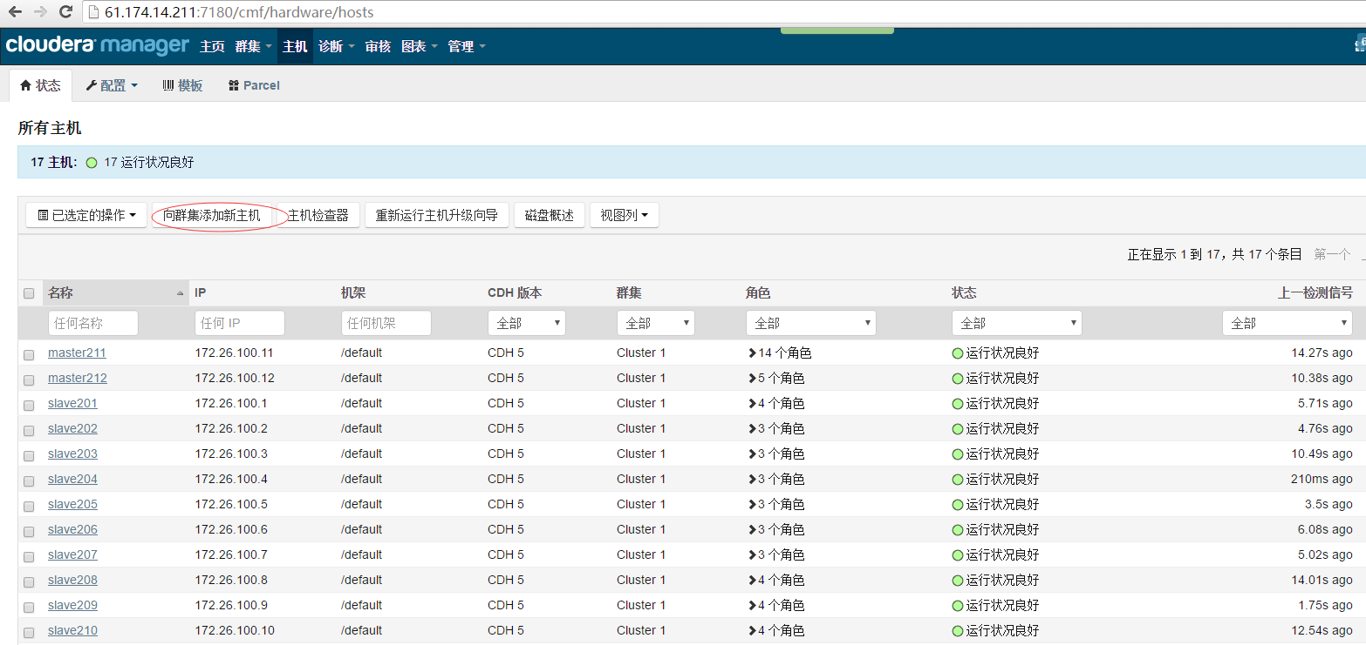

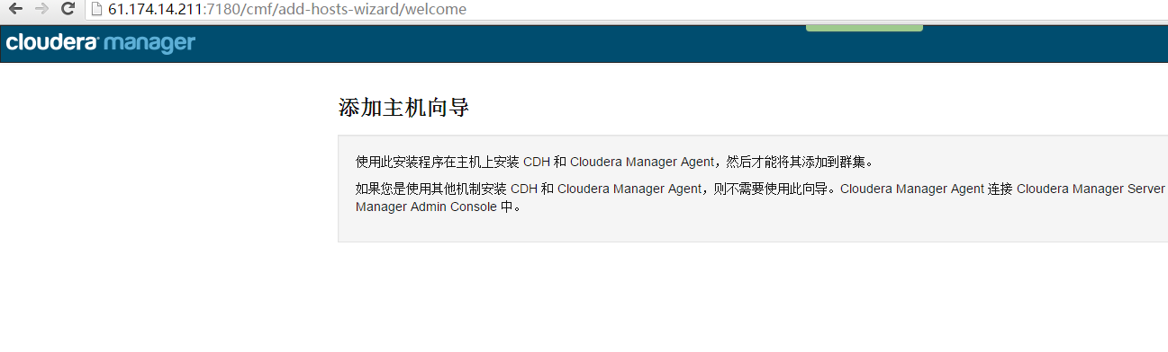

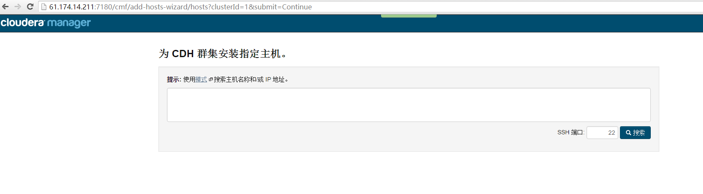

## 2、配置

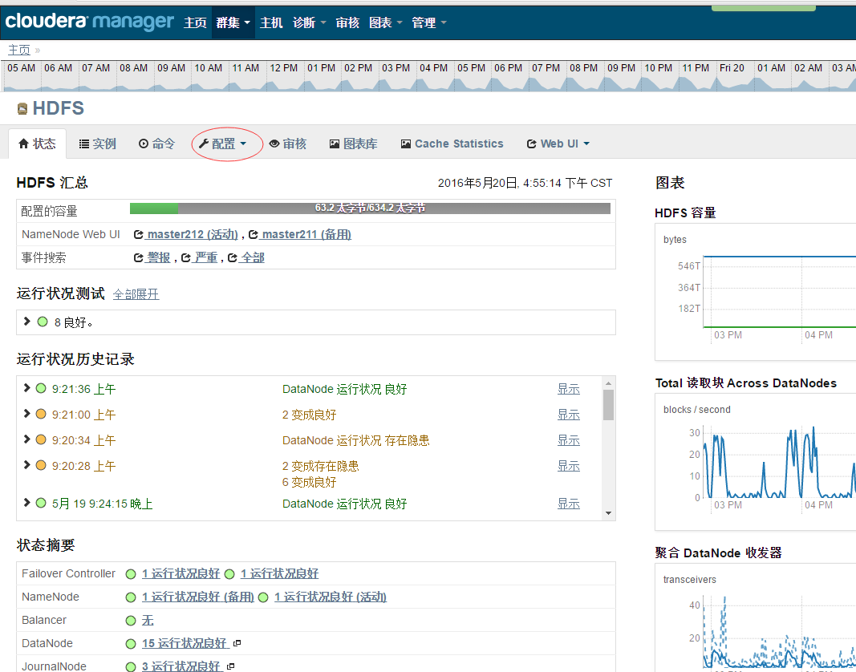

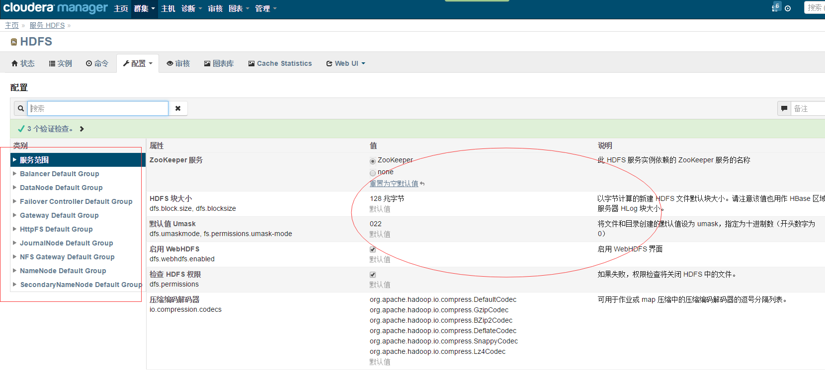

## 3、维护

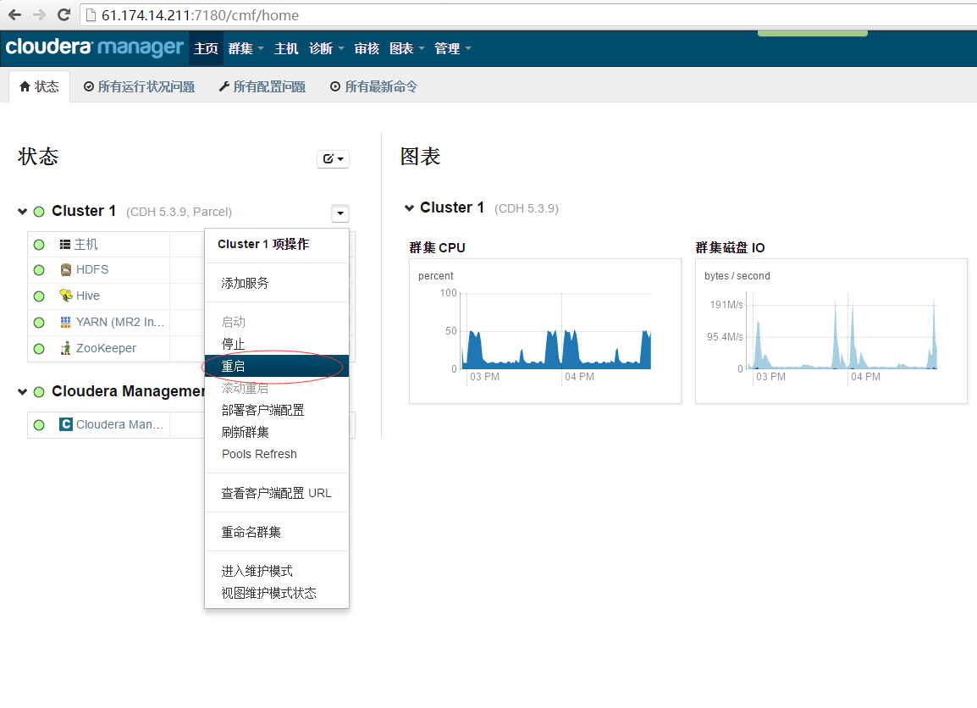

## 4、数据输出

[root@CTL_ZJ_014_200 ~]# /root/wugq 61.174.9.94

Last login: Thu May 19 15:23:19 2016 from 61.174.14.200

[root@ctl-zj-061-174-009-094 ~]# crontab -l

0 * * * * /usr/sbin/ntpdate ntp.api.bz;/usr/sbin/hwclock -w > /dev/null 2>&1

#15 7 * * * /var/lib/hadoop-hdfs/move_data.sh> /var/result/logs/move_data.sh.log 2>&1

#*/5 * * * * /bin/bash /opt/bin/restart.sh >> /var/result/logs/td_agent_restart.log 2>&1

[root@ctl-zj-061-174-009-094 ~]# su - hdfs

-bash: ulimit: open files: cannot modify limit: Operation not permitted

-bash-4.3$

-bash-4.3$ crontab -l

#*/15 * * * * /var/lib/hadoop-hdfs/jobs/total.sh >> /var/result/logs/total.log 2>&1

#*/6 * * * * /var/lib/hadoop-hdfs/jobs/hourliuliang.sh >> /var/result/logs/hourliuliang.log 2>&1

*/30 * * * * /var/lib/hadoop-hdfs/jobs/total.sh >> /var/result/logs/total.log 2>&1

*/7 * * * * /var/lib/hadoop-hdfs/jobs/hourliuliang.sh >> /var/result/logs/hourliuliang.log 2>&1

*/5 * * * * /var/lib/hadoop-hdfs/jobs/mod_new.sh >> /var/result/logs/mod.log 2>&1

*/49 * * * * /var/lib/hadoop-hdfs/jobs/domaintoday.sh >> /var/result/logs/domaintoday.log 2>&1

#10 0 * * * /var/lib/hadoop-hdfs/p.sh >> /var/result/logs/p.log 2>&1

5 0 * * * /var/lib/hadoop-hdfs/q.sh >> /var/result/logs/q.log 2>&1

7 * * * * /var/lib/hadoop-hdfs/analyze_table.sh >> /var/result/logs/analyze_table.log 2>&1

20 0 * * * /var/lib/hadoop-hdfs/analyze_table_day.sh >> /var/result/logs/analyze_table_day.log 2>&1

50 0 * * * /var/lib/hadoop-hdfs/jobs/domainyester.sh >> /var/result/logs/domainyester.log 2>&1

13 2 * * * /var/lib/hadoop-hdfs/jobs/domain7.sh >> /var/result/logs/domain7.log 2>&1

33 3 * * * /var/lib/hadoop-hdfs/jobs/domain30.sh >> /var/result/logs/domain30.log 2>&1

15 0 * * * /var/lib/hadoop-hdfs/jobs/liuliang.sh> /var/result/logs/liuliang.log 2>&1

#15 6 * * * /var/lib/hadoop-hdfs/move_data.sh> /var/result/logs/move_data.sh.log 2>&1

#15 6 * * * /var/lib/hadoop-hdfs/dk/dp.sh> /var/lib/hadoop-hdfs/dk/dump_error.log 2>&1

### migrate table from temp_table to new_accesslog2 ##

3 0 * * * /var/lib/hadoop-hdfs/jobs/migrate_table.sh >> /var/result/logs/migrate_table.log 2>&1

-bash-4.3$

#数据移动

-bash-4.3$ cat /var/lib/hadoop-hdfs/jobs/migrate_table.sh

#!/bin/bash

export PATH=/usr/local/bin:/usr/local/bin:/usr/lib64/qt-3.3/bin:/usr/local/bin:/bin:/usr/bin:/usr/local/sbin:/usr/sbin:/sbin:/usr/local/jdk1.8.0_66/bin:/var/lib/hadoop-hdfs/bin:/usr/local/jdk1.8.0_66/bin:/var/lib/hadoop-hdfs/bin

## 1. create hadoop dir ###

#hdfs dfs -mkdir /weblog/temp_table

## 2. create temp table ###

#hive -e "CREATE EXTERNAL TABLE `temp_table`(

# `time` string,

# `clientip` string,

# `method` string,

# `domain` string,

# `request` string,

# `status` string,

# `size` string,

# `referer` string,

# `agent` string,

# `hit_status` string,

# `ruleid` string,

# `prov` string,

# `country` string,

# `blockid` string,

# `searchbot` string,

# `p_status` string,

# `hackerid` int)

#PARTITIONED BY (

# `day` int,

# `ht` int)

#CLUSTERED BY (

# domain)

#INTO 10 BUCKETS

#ROW FORMAT SERDE

# 'org.apache.hadoop.hive.serde2.lazy.LazySimpleSerDe'

#STORED AS INPUTFORMAT

# 'org.apache.hadoop.mapred.TextInputFormat'

#OUTPUTFORMAT

# 'org.apache.hadoop.hive.ql.io.HiveIgnoreKeyTextOutputFormat'

#LOCATION

# 'hdfs://nameservice1/weblog/temp_table'; "

## 3. hdfs move data ###

echo "============================ `date '+%Y%m%d %H%M%S'` Start =========================================="

day=`date -d "2 day ago" +%Y%m%d`

hdfs dfs -mv /weblog/temp_table/day=$day /weblog/new_access2

echo "============================ `date '+%Y%m%d %H%M%S'` hdfs mv complete =========================================="

## 4. create partitions table on new_accesslog2 ###

echo "============================ `date '+%Y%m%d %H%M%S'` create partitions new_accesslog2 start =========================================="

for i in {00..23}

do

hive -e "ALTER TABLE new_accesslog2 ADD PARTITION(day=$day, ht=\"$i\");";

done

echo "============================ `date '+%Y%m%d %H%M%S'` create partitions new_accesslog2 complete =========================================="

## 5. rebuild index and analyze table on new_accesslog2

echo "============================ `date '+%Y%m%d %H%M%S'` rebuild index new_accesslog2 start =========================================="

for h in {00..23}

do

hive -e "alter index new_accesslog2_index on new_accesslog2 partition(day=$day, ht=\"$h\") rebuild;"

hive -e "analyze table new_accesslog2 partition(day=$day, ht=\"$h\") compute statistics;"

done

echo "============================ `date '+%Y%m%d %H%M%S'` rebuild index new_accesslog2 complete =========================================="

## 6. delete partition table and rebuild index on temp_table ###

echo "============================ `date '+%Y%m%d %H%M%S'` delete temp_table partitions start =========================================="

for i in {00..23}

do

hive -e "ALTER TABLE temp_table DROP IF EXISTS PARTITION(day=$day, ht=\"$i\");"

done

echo "============================ `date '+%Y%m%d %H%M%S'` delete temp_table partitions complete =========================================="

## 7. delete indexes and create indexes on temp_table ###

echo "============================ `date '+%Y%m%d %H%M%S'` delete temp_table index and create temp_table index start =========================================="

hive -e "drop index if exists temp_table_index on temp_table;"

hive -e "create index temp_table_index on table temp_table(domain,hackerid,blockid,hit_status,referer) as 'org.apache.hadoop.hive.ql.index.compact.CompactIndexHandler' with deferred rebuild;"

echo "============================ `date '+%Y%m%d %H%M%S'` delete temp_table index and create temp_table index complete =========================================="

## 8. rebuild index on temp_table

echo "============================ `date '+%Y%m%d %H%M%S'` rebuild temp_table index start =========================================="

day_ago=`date -d "1 day ago" +%Y%m%d`

for i in {00..23}

do

hive -e "alter index temp_table_index on temp_table partition(day=$day_ago, ht=\"$i\") rebuild;"

hive -e "analyze table temp_table partition(day=$day_ago, ht=\"$i\") compute statistics;"

done

echo "============================ `date '+%Y%m%d %H%M%S'` rebuild temp_table index complete =========================================="

echo "============================ **************************** Done!!! ***************************** =========================================="

-bash-4.3$

-bash-4.3$ ps -ef |grep td-agent

td-agent 11088 1 0 May13 ? 00:00:00 /opt/td-agent/embedded/bin/ruby /usr/sbin/td-agent --log /var/log/td-agent/td-agent.log --use-v1-config --group td-agent --daemon /var/run/td-agent/td-agent.pid

td-agent 11091 11088 10 May13 ? 16:54:53 /opt/td-agent/embedded/bin/ruby /usr/sbin/td-agent --log /var/log/td-agent/td-agent.log --use-v1-config --group td-agent --daemon /var/run/td-agent/td-agent.pid

root 11148 1 0 May13 ? 00:00:00 /opt/td-agent/embedded/bin/ruby /usr/sbin/td-agent2 --log /var/log/td-agent/td-agent2.log --use-v1-config --group td-agent --daemon /var/run/td-agent/td-agent2.pid

root 11151 11148 0 May13 ? 01:03:40 /opt/td-agent/embedded/bin/ruby /usr/sbin/td-agent2 --log /var/log/td-agent/td-agent2.log --use-v1-config --group td-agent --daemon /var/run/td-agent/td-agent2.pid

hdfs 30680 20578 0 17:03 pts/0 00:00:00 grep td-agent

-bash-4.3$

-bash-4.3$ cat /etc/td-agent/td-agent.conf

<source>

type tail

path /var/result/today/total

#pos_file /var/log/pos/today/total.pos

format /(?<count>[^ ]*)\t(?<type>[^ ]*)\t(?<date>[^ ]*)\t(?<flag>[^ ]*)/

tag total

</source>

<match total>

type bufferize

buffer_type file

buffer_path /var/result/fluentd/buffer/total.*.buffer

<config>

type http

endpoint_url http://www.anquan.io/api/totalData

http_method put

serializer json

</config>

</match>

<source>

type tail

path /var/result/domaintoday/mod

#pos_file /var/log/pos/today/total.pos

format /(?<count>[^ ]*)\t(?<liuliang>[^ ]*)\t(?<total_count>[^ ]*)\t(?<total_liuliang>[^ ]*)\t(?<domain>[^ ]*)\t(?<flag>[^ ]*)/

tag mod

</source>

<match mod>

type bufferize

buffer_type file

buffer_path /var/result/fluentd/buffer/mod.*.buffer

<config>

type http

endpoint_url http://www.anquan.io/api/mod

http_method put

serializer json

</config>

</match>

<source>

type tail

path /var/result/yesterday/liuliang

#pos_file /var/log/pos/yesterday/liuliang.pos

format /(?<count>[^ ]*)\t(?<domain>[^ ]*)\t(?<type>[^ ]*)\t(?<date>[^ ]*)\t(?<flag>[^ ]*)/

tag yt.liuliang

</source>

<match yt.liuliang>

type bufferize

buffer_type file

buffer_path /var/result/fluentd/buffer/yt.liuliang.*.buffer

<config>

type http

endpoint_url http://www.anquan.io/api/ytdTotalFlow

http_method put

serializer json

</config>

</match>

<source>

type tail

path /var/result/domaintoday/line

#pos_file /var/log/pos/domaintoday/line.pos

format /(?<count>[^ ]*)\t(?<domain>[^ ]*)\t(?<hour>[^ ]*)\t(?<type>[^ ]*)\t(?<flag>[^ ]*)\t(?<apiname>[^ ]*)/

tag domainline

</source>

<match domainline>

type redis_publish

host 61.174.14.199

port 6380

auth Qwe5sj32BSy9jpYC

db 0

buffer_type file

buffer_path /var/result/fluentd/buffer/domainline.buffer

buffer_chunk_limit 512m

buffer_queue_limit 500

flush_interval 3s

</match>

<source>

type tail

path /var/result/domaintoday/attack

#pos_file /var/log/pos/domaintoday/attack.pos

format /(?<count>[^ ]*)\t(?<type>[^ ]*)\t(?<domain>[^ ]*)\t(?<flag>[^ ]*)\t(?<apiname>[^ ]*)/

tag domainattack

</source>

<match domainattack>

type redis_publish

host 61.174.14.199

port 6380

auth Qwe5sj32BSy9jpYC

db 0

buffer_type file

buffer_path /var/result/fluentd/buffer/domainattack.buffer

buffer_chunk_limit 512m

buffer_queue_limit 500

flush_interval 3s

</match>

<source>

type tail

path /var/result/domaintoday/pie

#pos_file /var/log/pos/domaintoday/pie.pos

format /(?<count>[^ ]*)\t(?<domain>[^ ]*)\t(?<type>[^ ]*)\t(?<flag>[^ ]*)\t(?<apiname>[^ ]*)/

tag domainpie

</source>

<match domainpie>

type redis_publish

host 61.174.14.199

port 6380

auth Qwe5sj32BSy9jpYC

db 0

buffer_type file

buffer_path /var/result/fluentd/buffer/domainpie.buffer

buffer_chunk_limit 512m

buffer_queue_limit 500

flush_interval 3s

</match>

<source>

type tail

path /var/result/domaintoday/area

#pos_file /var/log/pos/domaintoday/area.pos

format /(?<count>[^ ]*)\t(?<prov>[^ ]*)\t(?<domain>[^ ]*)\t(?<type>[^ ]*)\t(?<flag>[^ ]*)\t(?<apiname>[^ ]*)/

tag domainarea

</source>

<match domainarea>

type redis_publish

host 61.174.14.199

port 6380

auth Qwe5sj32BSy9jpYC

db 0

buffer_type file

buffer_path /var/result/fluentd/buffer/domainarea.buffer

buffer_chunk_limit 512m

buffer_queue_limit 500

flush_interval 3s

</match>

<source>

type tail

path /var/result/domaintoday/sum

#pos_file /var/log/pos/domaintoday/sum.pos

format /(?<pv>[^ ]*)\t(?<ip>[^ ]*)\t(?<size>[^ ]*)\t(?<attack>[^ ]*)\t(?<domain>[^ ]*)\t(?<flag>[^ ]*)\t(?<apiname>[^ ]*)/

tag domainsum

</source>

<match domainsum>

type redis_publish

host 61.174.14.199

port 6380

auth Qwe5sj32BSy9jpYC

db 0

buffer_type file

buffer_path /var/result/fluentd/buffer/domainsum.buffer

buffer_chunk_limit 512m

buffer_queue_limit 500

flush_interval 3s

</match>

<source>

type tail

path /var/result/domaintoday/ref

#pos_file /var/log/pos/domaintoday/ref.pos

format /(?<count>[^ ]*)\t(?<ref>[^ ]*)\t(?<domain>[^ ]*)\t(?<flag>[^ ]*)\t(?<apiname>[^ ]*)/

tag domainref

</source>

<match domainref>

type redis_publish

host 61.174.14.199

port 6380

auth Qwe5sj32BSy9jpYC

db 0

buffer_type file

buffer_path /var/result/fluentd/buffer/domainref.buffer

buffer_chunk_limit 512m

buffer_queue_limit 500

flush_interval 3s

</match>

<source>

type tail

path /var/result/domaintoday/searchbot

#pos_file /var/log/pos/domaintoday/searchbot.pos

format /(?<day>[^ ]*)\t(?<searchbot>[^ ]*)\t(?<count>[^ ]*)\t(?<domain>[^ ]*)\t(?<flag>[^ ]*)\t(?<apiname>[^ ]*)/

tag domainsearchbot

</source>

<match domainsearchbot>

type redis_publish

host 61.174.14.199

port 6380

auth Qwe5sj32BSy9jpYC

db 0

buffer_type file

buffer_path /var/result/fluentd/buffer/domainsearchbot.buffer

buffer_chunk_limit 512m

buffer_queue_limit 500

flush_interval 3s

</match>

<source>

type tail

path /var/result/domaintoday/4xx_5xx

#pos_file /var/log/pos/domaintoday/4xx_5xx.pos

format /(?<count>[^ ]*)\t(?<type>[^ ]*)\t(?<domain>[^ ]*)\t(?<flag>[^ ]*)\t(?<apiname>[^ ]*)/

tag domain4xx_5xx

</source>

<match domain4xx_5xx>

type redis_publish

host 61.174.14.199

port 6380

auth Qwe5sj32BSy9jpYC

db 0

buffer_type file

buffer_path /var/result/fluentd/buffer/domain4xx_5xx.buffer

buffer_chunk_limit 512m

buffer_queue_limit 500

flush_interval 3s

</match>

<source>

type tail

path /var/result/domaintoday/top5_attack

#pos_file /var/log/pos/domaintoday/top5_attack.pos

format /(?<ip>[^ ]*)\t(?<prov>[^ ]*)\t(?<count>[^ ]*)\t(?<domain>[^ ]*)\t(?<flag>[^ ]*)\t(?<apiname>[^ ]*)/

tag domaintop5attack

</source>

<match domaintop5attack>

type redis_publish

host 61.174.14.199

port 6380

auth Qwe5sj32BSy9jpYC

db 0

buffer_type file

buffer_path /var/result/fluentd/buffer/domaintop5attack.buffer

buffer_chunk_limit 512m

buffer_queue_limit 500

flush_interval 3s

</match>

<source>

type tail

path /var/result/domaintoday/cc

#pos_file /var/log/pos/domaintoday/cc.pos

format /(?<count>[^ ]*)\t(?<domain>[^ ]*)\t(?<hour>[^ ]*)\t(?<type>[^ ]*)\t(?<flag>[^ ]*)\t(?<apiname>[^ ]*)/

tag domaincc

</source>

<match domaincc>

type redis_publish

host 61.174.14.199

port 6380

auth Qwe5sj32BSy9jpYC

db 0

buffer_type file

buffer_path /var/result/fluentd/buffer/domaincc.buffer

buffer_chunk_limit 512m

buffer_queue_limit 500

flush_interval 3s

</match>

<source>

type tail

path /var/result/domaintoday/jiasu

#pos_file /var/log/pos/domaintoday/jiasu.pos

format /(?<pv>[^ ]*)\t(?<liuliang>[^ ]*)\t(?<domain>[^ ]*)\t(?<flag>[^ ]*)\t(?<apiname>[^ ]*)/

tag domainjiasu

</source>

<match domainjiasu>

type redis_publish

host 61.174.14.199

port 6380

auth Qwe5sj32BSy9jpYC

db 0

buffer_type file

buffer_path /var/result/fluentd/buffer/domainjiasu.buffer

buffer_chunk_limit 512m

buffer_queue_limit 500

flush_interval 3s

</match>

<source>

type tail

path /var/result/domaintoday/top10_url

#pos_file /var/log/pos/domaintoday/top10_url.pos

format /(?<request>[^ ]*)\t(?<count>[^ ]*)\t(?<domain>[^ ]*)\t(?<rank>[^ ]*)\t(?<flag>[^ ]*)\t(?<apiname>[^ ]*)/

tag domaintop10_url

</source>

<match domaintop10_url>

type redis_publish

host 61.174.14.199

port 6380

auth Qwe5sj32BSy9jpYC

db 0

buffer_type file

buffer_path /var/result/fluentd/buffer/domaintop10_url.buffer

buffer_chunk_limit 512m

buffer_queue_limit 500

flush_interval 3s

</match>

<source>

type tail

path /var/result/day/7top5_attack

#pos_file /var/log/pos/day/7top5_attack.pos

format /(?<ip>[^ ]*)\t(?<prov>[^ ]*)\t(?<count>[^ ]*)\t(?<domain>[^ ]*)\t(?<flag>[^ ]*)\t(?<apiname>[^ ]*)/

tag 7top5_attack

</source>

<match 7top5_attack>

type redis_publish

host 61.174.14.199

port 6380

auth Qwe5sj32BSy9jpYC

db 0

buffer_type file

buffer_path /var/result/fluentd/buffer/7top5_attack.buffer

buffer_chunk_limit 512m

buffer_queue_limit 500

flush_interval 3s

</match>

<source>

type tail

path /var/result/day/30top5_attack

#pos_file /var/log/pos/day/30top5_attack.pos

format /(?<ip>[^ ]*)\t(?<prov>[^ ]*)\t(?<count>[^ ]*)\t(?<domain>[^ ]*)\t(?<flag>[^ ]*)\t(?<apiname>[^ ]*)/

tag 30top5_attack

</source>

<match 30top5_attack>

type redis_publish

host 61.174.14.199

port 6380

auth Qwe5sj32BSy9jpYC

db 0

buffer_type file

buffer_path /var/result/fluentd/buffer/30top5_attack.buffer

buffer_chunk_limit 512m

buffer_queue_limit 500

flush_interval 3s

</match>

<source>

type tail

path /var/result/day/7ref

#pos_file /var/log/pos/day/7ref.pos

format /(?<count>[^ ]*)\t(?<ref>[^ ]*)\t(?<domain>[^ ]*)\t(?<flag>[^ ]*)\t(?<apiname>[^ ]*)/

tag 7ref

</source>

<match 7ref>

type redis_publish

host 61.174.14.199

port 6380

auth Qwe5sj32BSy9jpYC

db 0

buffer_type file

buffer_path /var/result/fluentd/buffer/7ref.buffer

buffer_chunk_limit 512m

buffer_queue_limit 500

flush_interval 3s

</match>

<source>

type tail

path /var/result/day/30ref

#pos_file /var/log/pos/day/30ref.pos

format /(?<count>[^ ]*)\t(?<ref>[^ ]*)\t(?<domain>[^ ]*)\t(?<flag>[^ ]*)\t(?<apiname>[^ ]*)/

tag 30ref

</source>

<match 30ref>

type redis_publish

host 61.174.14.199

port 6380

auth Qwe5sj32BSy9jpYC

db 0

buffer_type file

buffer_path /var/result/fluentd/buffer/30ref.buffer

buffer_chunk_limit 512m

buffer_queue_limit 500

flush_interval 3s

</match>

<source>

type tail

path /var/result/day/7top10_url

#pos_file /var/log/pos/day/7top10_url.pos

format /(?<request>[^ ]*)\t(?<count>[^ ]*)\t(?<domain>[^ ]*)\t(?<rank>[^ ]*)\t(?<flag>[^ ]*)\t(?<apiname>[^ ]*)/

tag 7top10_url

</source>

<match 7top10_url>

type redis_publish

host 61.174.14.199

port 6380

auth Qwe5sj32BSy9jpYC

db 0

buffer_type file

buffer_path /var/result/fluentd/buffer/7top10_url.buffer

buffer_chunk_limit 512m

buffer_queue_limit 500

flush_interval 3s

</match>

<source>

type tail

path /var/result/day/30top10_url

#pos_file /var/log/pos/day/30top10_url.pos

format /(?<request>[^ ]*)\t(?<count>[^ ]*)\t(?<domain>[^ ]*)\t(?<rank>[^ ]*)\t(?<flag>[^ ]*)\t(?<apiname>[^ ]*)/

tag 30top10_url

</source>

<match 30top10_url>

type redis_publish

host 61.174.14.199

port 6380

auth Qwe5sj32BSy9jpYC

db 0

buffer_type file

buffer_path /var/result/fluentd/buffer/30top10_url.buffer

buffer_chunk_limit 512m

buffer_queue_limit 500

flush_interval 3s

</match>

-bash-4.3$ cat /etc/td-agent/td-agent2.conf

<source>

type tail

path /var/result/domainday/line

#pos_file /var/log/pos/domainday/line.pos

format /(?<count>[^ ]*)\t(?<domain>[^ ]*)\t(?<hour>[^ ]*)\t(?<type>[^ ]*)\t(?<flag>[^ ]*)\t(?<apiname>[^ ]*)/

tag domainline_day

</source>

<match domainline_day>

type redis_publish

host 61.174.14.199

port 6380

auth Qwe5sj32BSy9jpYC

db 0

buffer_type file

buffer_path /var/result/fluentd/buffer/domainline_day.buffer

buffer_chunk_limit 512m

buffer_queue_limit 500

flush_interval 5s

</match>

<source>

type tail

path /var/result/domainday/attack

#pos_file /var/log/pos/domainday/attack.pos

format /(?<count>[^ ]*)\t(?<type>[^ ]*)\t(?<domain>[^ ]*)\t(?<flag>[^ ]*)\t(?<apiname>[^ ]*)/

tag domainattack_day

</source>

<match domainattack_day>

type redis_publish

host 61.174.14.199

port 6380

auth Qwe5sj32BSy9jpYC

db 0

buffer_type file

buffer_path /var/result/fluentd/buffer/domainattack_day.buffer

buffer_chunk_limit 512m

buffer_queue_limit 500

flush_interval 5s

</match>

<source>

type tail

path /var/result/domainday/pie

#pos_file /var/log/pos/domainday/pie.pos

format /(?<count>[^ ]*)\t(?<domain>[^ ]*)\t(?<type>[^ ]*)\t(?<flag>[^ ]*)\t(?<apiname>[^ ]*)/

tag domainpie_day

</source>

<match domainpie_day>

type redis_publish

host 61.174.14.199

port 6380

auth Qwe5sj32BSy9jpYC

db 0

buffer_type file

buffer_path /var/result/fluentd/buffer/domainpie_day.buffer

buffer_chunk_limit 512m

buffer_queue_limit 500

flush_interval 5s

</match>

<source>

type tail

path /var/result/domainday/area

#pos_file /var/log/pos/domainday/area.pos

format /(?<count>[^ ]*)\t(?<prov>[^ ]*)\t(?<domain>[^ ]*)\t(?<type>[^ ]*)\t(?<flag>[^ ]*)\t(?<apiname>[^ ]*)/

tag domainarea_day

</source>

<match domainarea_day>

type redis_publish

host 61.174.14.199

port 6380

auth Qwe5sj32BSy9jpYC

db 0

buffer_type file

buffer_path /var/result/fluentd/buffer/domainarea_day.buffer

buffer_chunk_limit 512m

buffer_queue_limit 500

flush_interval 5s

</match>

<source>

type tail

path /var/result/domainday/sum

#pos_file /var/log/pos/domainday/sum.pos

format /(?<pv>[^ ]*)\t(?<ip>[^ ]*)\t(?<size>[^ ]*)\t(?<attack>[^ ]*)\t(?<cc>[^ ]*)\t(?<domain>[^ ]*)\t(?<flag>[^ ]*)\t(?<apiname>[^ ]*)/

tag domainsum_day

</source>

<match domainsum_day>

type redis_publish

host 61.174.14.199

port 6380

auth Qwe5sj32BSy9jpYC

db 0

buffer_type file

buffer_path /var/result/fluentd/buffer/domainsum_day.buffer

buffer_chunk_limit 512m

buffer_queue_limit 500

flush_interval 5s

</match>

<source>

type tail

path /var/result/domainday/ref

#pos_file /var/log/pos/domainday/ref.pos

format /(?<count>[^ ]*)\t(?<ref>[^ ]*)\t(?<domain>[^ ]*)\t(?<flag>[^ ]*)\t(?<apiname>[^ ]*)/

tag domainref_day

</source>

<match domainref_day>

type redis_publish

host 61.174.14.199

port 6380

auth Qwe5sj32BSy9jpYC

db 0

buffer_type file

buffer_path /var/result/fluentd/buffer/domainref_day.buffer

buffer_chunk_limit 512m

buffer_queue_limit 500

flush_interval 5s

</match>

<source>

type tail

path /var/result/domainday/searchbot

#pos_file /var/log/pos/domainday/searchbotbot.pos

format /(?<day>[^ ]*)\t(?<searchbot>[^ ]*)\t(?<count>[^ ]*)\t(?<domain>[^ ]*)\t(?<flag>[^ ]*)\t(?<apiname>[^ ]*)/

tag domainsearchbot_day

</source>

<match domainsearchbot_day>

type redis_publish

host 61.174.14.199

port 6380

auth Qwe5sj32BSy9jpYC

db 0

buffer_type file

buffer_path /var/result/fluentd/buffer/domainsearchbot_day.buffer

buffer_chunk_limit 512m

buffer_queue_limit 500

flush_interval 5s

</match>

<source>

type tail

path /var/result/domainday/4xx_5xx

#pos_file /var/log/pos/domainday/4xx_5xx.pos

format /(?<count>[^ ]*)\t(?<type>[^ ]*)\t(?<domain>[^ ]*)\t(?<flag>[^ ]*)\t(?<apiname>[^ ]*)/

tag domain4xx_5xx_day

</source>

<match domain4xx_5xx_day>

type redis_publish

host 61.174.14.199

port 6380

auth Qwe5sj32BSy9jpYC

db 0

buffer_type file

buffer_path /var/result/fluentd/buffer/domain4xx_5xx_day.buffer

buffer_chunk_limit 512m

buffer_queue_limit 500

flush_interval 5s

</match>

<source>

type tail

path /var/result/domainday/top5_attack

#pos_file /var/log/pos/domainday/top5_attack.pos

format /(?<ip>[^ ]*)\t(?<prov>[^ ]*)\t(?<count>[^ ]*)\t(?<domain>[^ ]*)\t(?<flag>[^ ]*)\t(?<apiname>[^ ]*)/

tag domaintop5attack_day

</source>

<match domaintop5attack_day>

type redis_publish

host 61.174.14.199

port 6380

auth Qwe5sj32BSy9jpYC

db 0

buffer_type file

buffer_path /var/result/fluentd/buffer/domaintop5attack_day.buffer

buffer_chunk_limit 512m

buffer_queue_limit 500

flush_interval 5s

</match>

<source>

type tail

path /var/result/domainday/cc

#pos_file /var/log/pos/domainday/cc.pos

format /(?<count>[^ ]*)\t(?<domain>[^ ]*)\t(?<hour>[^ ]*)\t(?<type>[^ ]*)\t(?<flag>[^ ]*)\t(?<apiname>[^ ]*)/

tag domaincc_day

</source>

<match domaincc_day>

type redis_publish

host 61.174.14.199

port 6380

auth Qwe5sj32BSy9jpYC

db 0

buffer_type file

buffer_path /var/result/fluentd/buffer/domaincc_day.buffer

buffer_chunk_limit 512m

buffer_queue_limit 500

flush_interval 5s

</match>

<source>

type tail

path /var/result/domainday/jiasu

#pos_file /var/log/pos/domainday/jiasu.pos

format /(?<pv>[^ ]*)\t(?<liuliang>[^ ]*)\t(?<domain>[^ ]*)\t(?<flag>[^ ]*)\t(?<apiname>[^ ]*)/

tag domainjiasu_day

</source>

<match domainjiasu_day>

type redis_publish

host 61.174.14.199

port 6380

auth Qwe5sj32BSy9jpYC

db 0

buffer_type file

buffer_path /var/result/fluentd/buffer/domainjiasu_day.buffer

buffer_chunk_limit 512m

buffer_queue_limit 500

flush_interval 5s

</match>

<source>

type tail

path /var/result/domainday/top10_url

#pos_file /var/log/pos/domainday/top10_url.pos

format /(?<request>[^ ]*)\t(?<count>[^ ]*)\t(?<domain>[^ ]*)\t(?<rank>[^ ]*)\t(?<flag>[^ ]*)\t(?<apiname>[^ ]*)/

tag domaintop10_url_day

</source>

<match domaintop10_url_day>

type redis_publish

host 61.174.14.199

port 6380

auth Qwe5sj32BSy9jpYC

db 0

buffer_type file

buffer_path /var/result/fluentd/buffer/domaintop10_url_day.buffer

buffer_chunk_limit 512m

buffer_queue_limit 500

flush_interval 5s

</match>

<source>

type tail

path /var/result/domaintoday/hourliuliang

pos_file /var/log/pos/domaintoday/hourliuliang.pos

format /(?<num>[^ ]*)\t(?<domain>[^ ]*)\t(?<hour>[^ ]*)\t(?<flag>[^ ]*)/

tag hourliuliang

</source>

<match hourliuliang>

type bufferize

buffer_type file

buffer_path /var/result/fluentd/buffer/hourliuliang.*.buffer

<config>

type http

endpoint_url http://www.anquan.io/api/hourliuliang

http_method put

serializer json

</config>

</match>

include conf.d/*.conf

-bash-4.3$