Introduction

The restaurants of Super Mario Pizza Bros, popularly called Super Mario or simply Mario, is always busy with expansion. This is done by buying smaller pizzeria shops. Mostly they are family businesses with traditional prepared pizzas on the menu. The formula of Super Mario however is different. Their ambition is to become worlds biggest organization of pizza restaurants. At little pizzerias taste and eating experience is important but at Mario making profit and expansion is of key importance.

Their biggest example is Domino’s Pizza. Like Domino's Mario wants just a same kind of web shop with online order facilities, making your own pizza, shop opening times, etc..

The automation process at Super Mario Pizza Bros has reached his limit. The concern has grown too big to do it the way it always did. There's a big pile of data with customers and orders. Easily find something in that pile of data isn't done so fast and many little mistakes are made. Also, each time new restaurants are bought many things have to be done and converted to fit in the structure of Mario's systems. This has to be improved if Mario wants to grow any bigger.

Customer requirements

Mario wants a web shop with online order facilities, making your own pizza, shop opening times, etc..

In order to accommodate for a web shop a new architecture is required. The customer would like an architecture as show below.
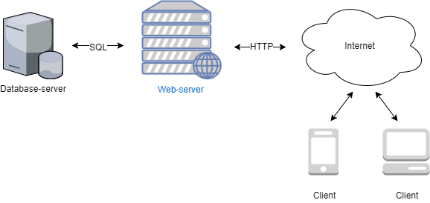
Clients should be able to use a smartphone, tablet or computer to access the web shop. The web server communicates with the database server to allow for storage and use of data.

The customer would like to be able to migrate the system to a cloud based solution in the future.

The customer has accumulated data to be used in the new system. The data is provided in different files including text files and spreadsheets.

