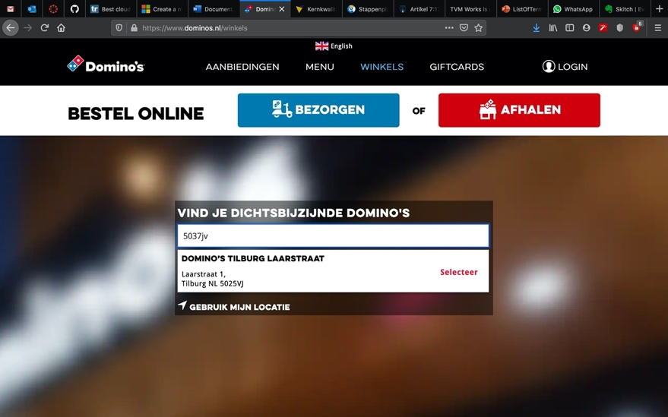
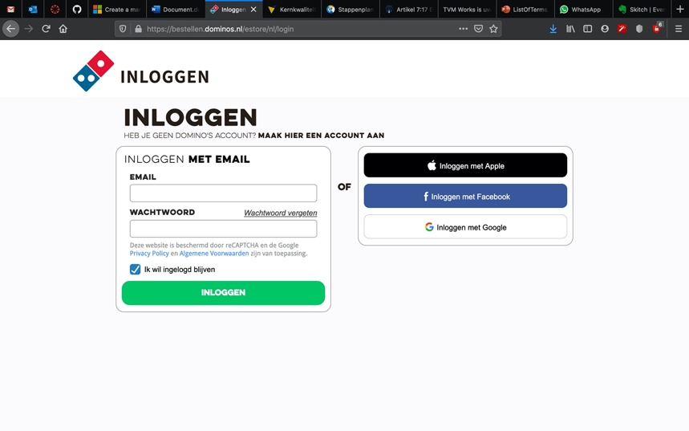
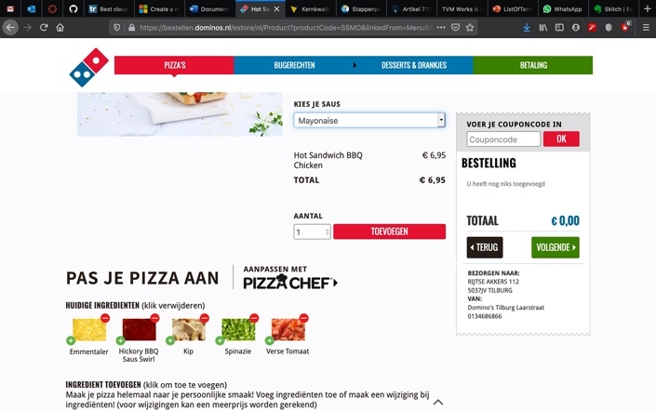
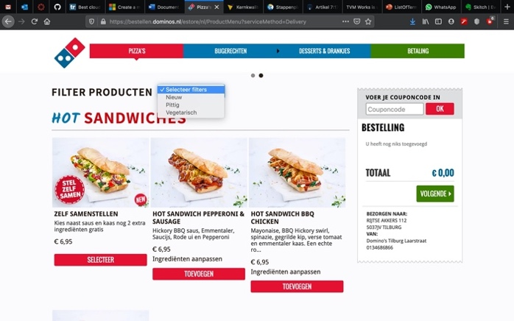
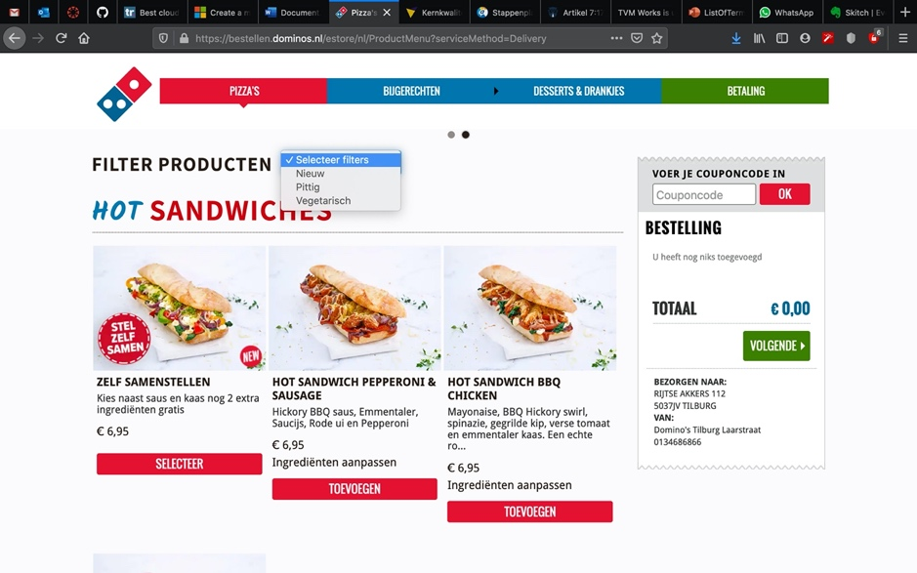
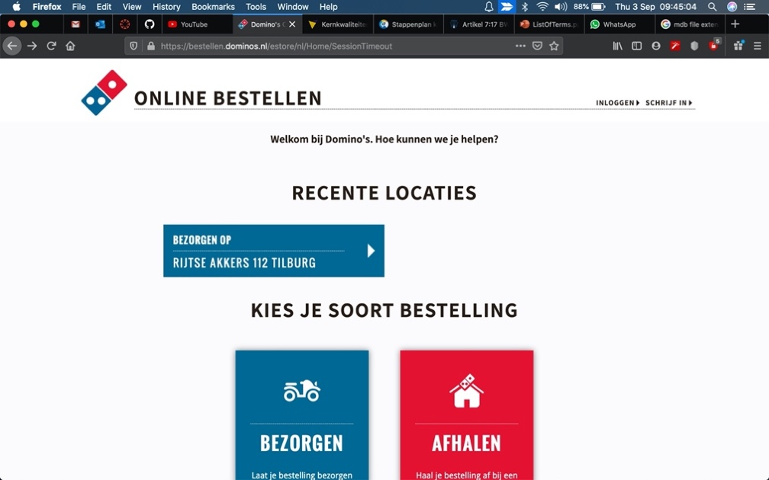
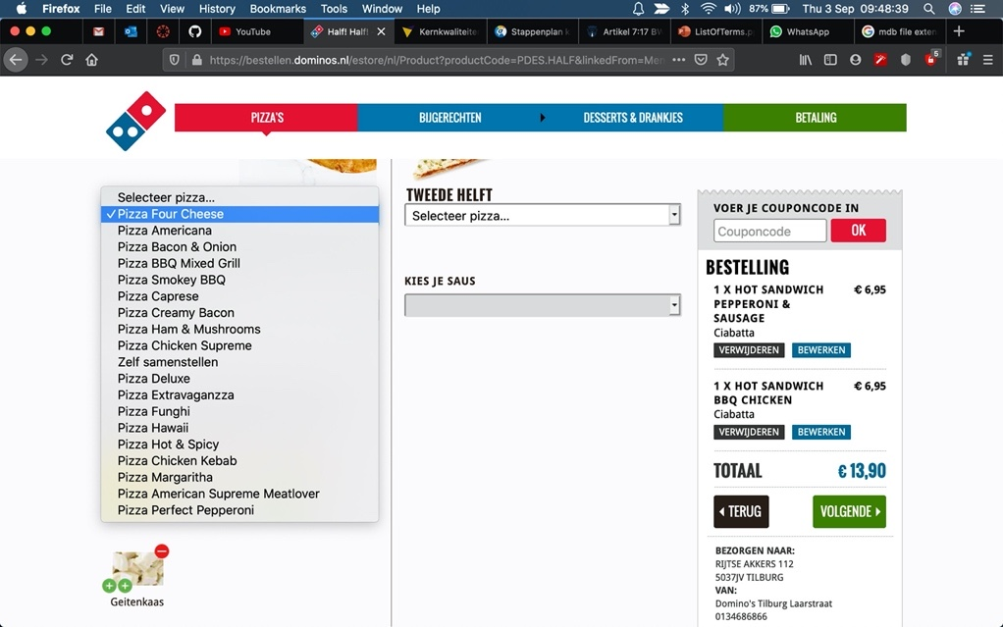
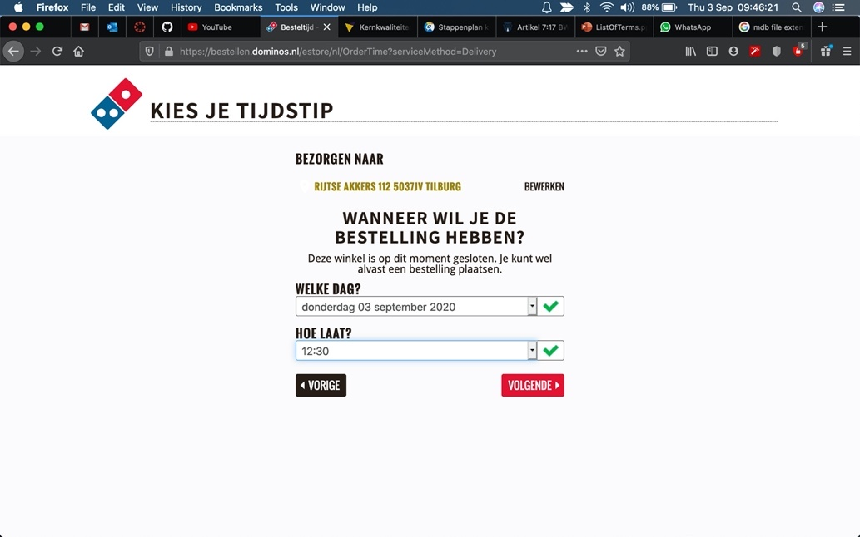
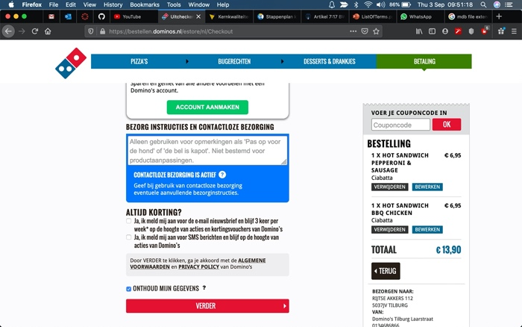
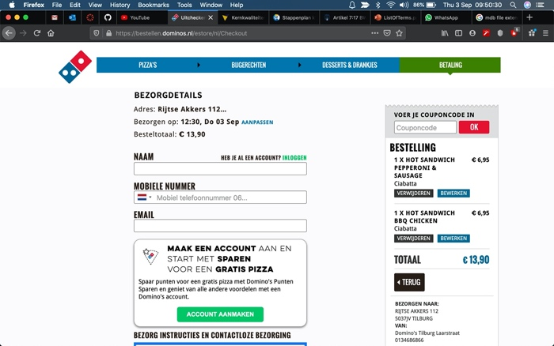
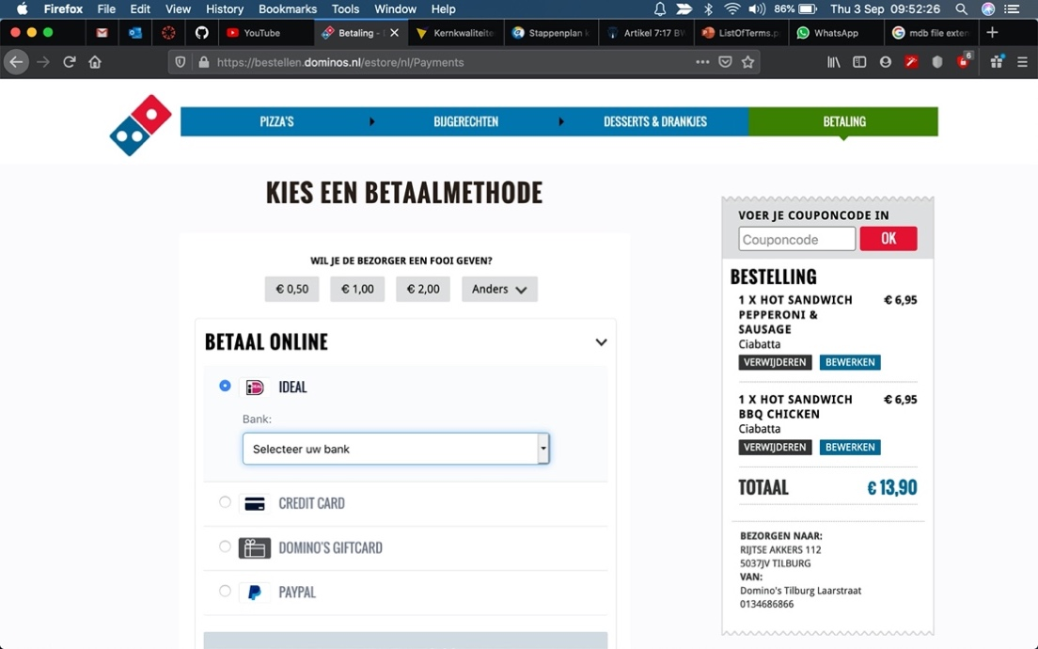

Table of Contents
Introduction 3
Domino’s website analysis 4
Mario Pizzerias data types 9
Extra ingredienten.csv 10
MarioOrderData01_10000.csv - MarioOrderData04_10000.csv 10
Overige producten.xlsx 10
pizza_ingredienten.xlsx 11
pizzabodems.xlsx 11
Winkels Mario.txt 11
Postcode tabel.mdb 12

Introduction

This document concerns the analysis of the Super Mario Pizzeria casus. At first, we’re going to analyze the Domino’s website with its functionality concerning the use of (dynamic) data fetched from databases. Screenshots will be used as a means of help in visualizing the layout and actions taking place on the site.
In the next step we will analyze the data files available as part of the current Super Mario Pizzeria operation. Those files are in several different database formats and the data contained will have to be cleaned up and transferred to a new all-encompassing database of our own design.

Domino’s website analysis
Website in question can be found under this link:
https://www.dominos.nl/

Typing in postcode automatically suggest a list of nearby pizza shops:

Login possibility to trace orders and recall address. Orders are being stored on the account for further use, like ordering the same meals etc.:

Menu display + option to Add product to the order. Order details like price, qty, products to buy etc. are dynamically updated in a sidebar:

Products can be filtered by selecting a specific filtering option:

The site keeps recently used addresses in cache for convenience even without the use of an account:

Selecting specific ingredients is realized by using drop down lists and the fee is being calculated dynamically as the user selects given ingredients:

If selected by the user pizza shop is closed at the moment it is still possible to place an order on a specified date and time:

Checkout requires consent to store the user data and lets the user use the option to leave a notice to the delivery person:

At checkout payment method can be selected. It is possible to tip the delivery person at this point and the specified tip is added to the total cost:

Mario Pizzerias data types

There are different data file types used in the Mario Pizzerias current system. The files use different formats and are organized in different ways. This presents a challenge in aligning the databases with one another. There’s also a problem with typing errors present in the data.
Below is a list of provided files with a short description of the contents and possible obstacles.

Extra ingredienten.csv
Contains a list of ingredients (like: ananas, bacon, salami etc.) in one column and price in second column. While the cost of ingredients seems to be correct the currency symbol used seems to be a corrupted one.
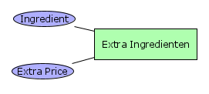

MarioOrderData01_10000.csv - MarioOrderData04_10000.csv
Those 4 files contain a list of orders placed by clients. A complete orders history is stored here. Fields used:
Winkelnaam, Klantnaam, TelefoonNr, Email, Adres, Woonplaats, Besteldatum, AfleverType, AfleverDatum, AfleverMoment, Product, PizzaBodem, PizzaSaus, Prijs, Bezorgkosten, Aantal, Extra Ingredi√´nten, Prijs Extra Ingredi√´nten, Regelprijs, Totaalprijs, Gebruikte Coupon, Coupon Korting, Te Betalen.
Note that some names seem to be corrupted. Each order consists of as many rows as there are products/ingredients in the order and each order is separated by an empty row.
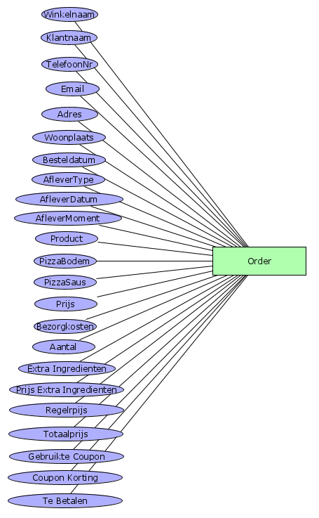

Overige producten.xlsx
Contains a list of products other than pizzas (ie. desserts). Field names:
categorie, subcategorie, productnaam, productomschrijving, prijs, spicy, vegetarisch
Not all products have a description (empty productomschrijving field). Last 2 columns are binary values. Row 23 seems to be overlapping two different categories of products (corrupted).
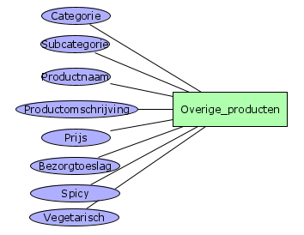

pizza_ingredienten.xlsx
This file contains all the pizza ingredients found on any particular pizza (similarly to a recipe). One type of pizza takes as many rows as there are ingredients on it. Fields:
categorie, subcategorie, productnaam, productomschrijving, prijs, bezorgtoeslag, spicy, vegetarisch, beschikbaar, aantalkeer_ingredient, ingredientnaam, pizzasaus_standaard

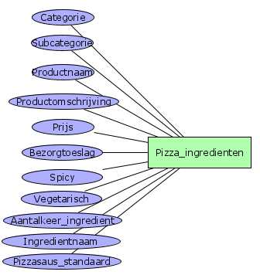
pizzabodems.xlsx
A list of available pizza bottoms. Fields:
naam, diameter, omschrijving, toeslag, beschikbaar
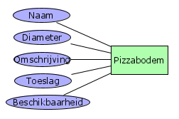

Winkels Mario.txt
This file contains a list of all the shops. Shops are separated by an empty line. The data seems to be organized in the following manner (top to bottom for a shop):
- Place (this can be a city or district, it’s inconsistent)
- Street
- House number
- City
- Country code
- Post code
- Phone number
As this document has been typed in by an employee there are some typing errors etc. which would need cleaning up.
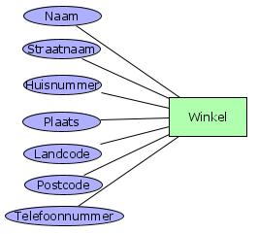

Postcode tabel.mdb
This database consists of all the postcodes and corresponding address breakdown in POSTCODES table; and municipality data in GEMEENTEN table. On this basis an address can be deducted from the postcode alone. It has the following fields:
POSTCODES table:
A13_POSTCODE, A13_REEKSIND, A13_BREEKPUNT_VAN, A13_WOONPLAATS, A13_STRAATNAAM, A13_GEMEENTECODE
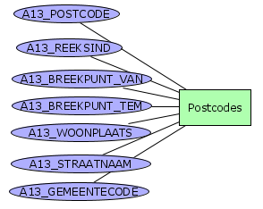

GEMEENTEN table:
N42_GEM_KODE, N42_GEM_NAAM
