**The Requirements Specification Document:**

* A complete requirements document will contain:
  + Needs, Objectives, and Background **(See Chapter 2).**
  + Requirements
  + Marketing requirements
    - **Look at case studies starting on page 9 of this document.**
  + Engineering requirements
    - Should be abstract, verifiable, and traceable. **Starts on page 2 of this document.**
    - Some may be constraints. **Pg. 4 of this document.**
    - Some may be standards. **Pg. 6 of this document.**
  + Advanced Analysis
    - **Starts on page 10 of this document.**
    - Engineering-marketing tradeoffs.
    - Engineering-engineering tradeoffs.
    - Benchmarks.

**Marketing Requirements:**

* Statements of the customer’s needs.

**Engineering Requirements:**

* Short statements that address a technical need of the design.
  + *Ex. System should be able to supply 30W power.*
* Initiated by the marketing requirements to satisfy customer needs.

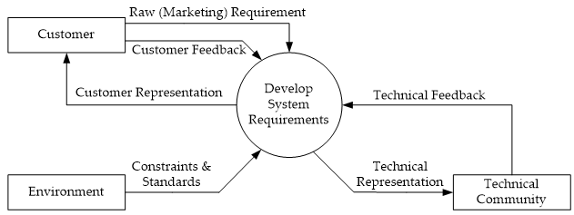

* Identifying Engineering Requirements.
  + Structured workshops and brainstorming
  + Interviews and surveys
  + Observation of processes and devices in use
  + Benchmarking and market analysis
  + Prototyping and simulation
  + Research survey
* Engineering Requirements – Categories
  + Performance
  + Functionality
  + Economic
  + Energy
  + Environmental
  + Safety
  + Usability
  + Legal
  + Maintenance
  + Operational
  + Manufacturability
  + Political
  + Reliability and availability
  + Social and cultural
* Engineering requirement properties.
  + Abstract
    - Description of capabilities and conditions; should be numerical.
    - Explains what it does **not** how it does it.
  + Verifiable
    - There are ways to **measure and demonstrate** that it meets the needs.
    - Requirements must be written so that they can be objectively verified.
    - **Imprecise Engineering Requirement Example:**
      * “The system should be easy to use by experienced controllers and should be organized in such a way that user errors are minimized.”
      * Terms like “easy to use” and “errors shall be minimized” are useless as specifications.
    - **Verifiable Engineering Requirement Example:**
      * “Experienced controllers should be able to use all the system functions after a total of two hours training. After this training, the average number of errors made by experienced users should not exceed two per day.”
  + Unambiguous
    - Short and **clear**
    - A one-sentence description of the requirement.

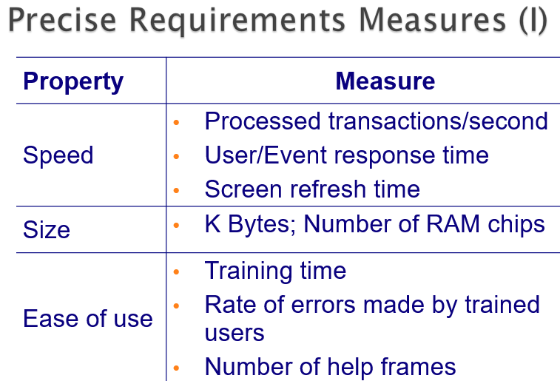

* + Traceable
    - It can be **traced** to the original customer need.
    - To protect against changes, you should be able to trace back from every system component to the original requirement that caused its presence.
  + Realistic
    - Must have **benchmark(s) and realizable.**
    - Realistic targets – tolerance (e.g.,+/- to ppm)
    - IMPORTANT – Your requirements for your project must also be REALISTIC!
      * You need to demonstrate that the target you have selected is technically feasible.
      * How are you going to do this?
      * Benchmarks may serve as points of reference.
      * Prototypes may be employed.
      * A solution may be assumed (although violates the abstractness property)

**Requirements Specification:**

* Collection of marketing and engineering requirements that a system must satisfy in order to satisfy the needs of a customer or end user.

**Types of Requirements:**

* Functional.
  + Describe system services and functions.
  + Compute sales tax on a purchase.
  + Update the database on the sever…
* Non-functional
  + Constraints on the system or the development process.
  + More critical than functional requirements.
  + If these are not met, the system might turn out to be not much of use.
  + Constraint: design decision imposed by the environment or a stakeholder that impacts or limits the design.
    - Example constraint: *The system must use a PIC18F52 microcontroller to implement processing functions.*

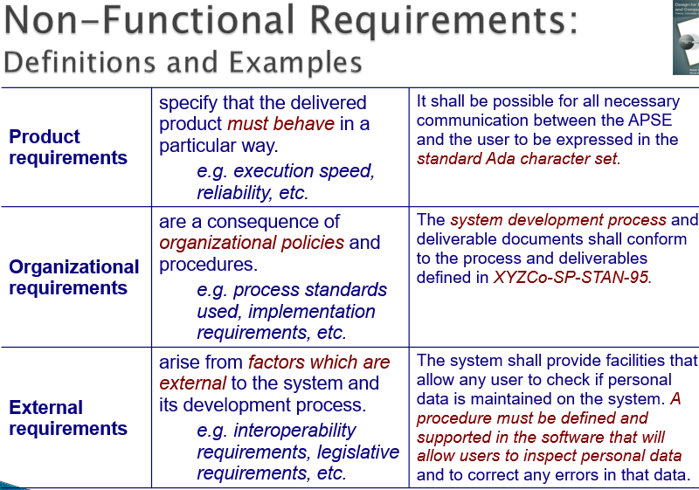

**Engineering Requirement Examples:**

* Performance.
  + system should detect 90% of all human faces in an image.
  + amplifier will have a total harmonic distortion less than 1%.
* Reliability & Availability.
  + system will have a reliability of 95% in five years.
  + system will be operational from 4AM to 10PM, 365 days a year.
* Energy.
  + system will operate for a minimum of three hours without needing recharge.
* Environmental.
  + system should be able to operate in the temperature range of 0°C to 75°C.
  + system must be waterproof and operate while submersed in water.
* More examples in book.

**Requirement Specifications- Characteristics of Properties:**

* Normalized (orthogonal) set.
  + No overlapping or redundancy between requirements
  + Analogy in Vector Calculus: projection of one requirement onto another is zero (dot product).
* Complete set
  + Contains all requirements.
* Consistent
  + No conflicting requirement
* Bounded
  + Contain minimum acceptable bounds for targets.
* Modifiable
  + Requirements must be evolutionary.
  + Benchmarked against the baseline requirements.

**Validation:**

* Answers the question “Am I building the right product?” by checking a work product against higher-level work products or authorities that frame this particular product.
  + Requirements are validated by stakeholders.
* How do you VALIDATE requirements?
  + Ask the customer if the requirements meet their needs.
  + Usually done in teams.
  + For each engineering requirement
    - Traceable?
    - Verifiable?
    - Realistic & technical feasible?
  + For the complete Requirements Specification
    - Orthogonal?
    - Complete?
    - Consistent?

**Verification:**

* answers the question “Am I building the product right?” by checking a work product against some standards and conditions imposed on this type of product and the process of its development.
  + Requirements are verified by the analysts mainly.

**Standards:**

* What standards are relevant to your project and how do you use them?
* Different levels of usage
  + User
  + Implementation
  + Developer
* The term "standard," or "technical standard" as cited in the [National Technology Transfer and Advancement Act](http://www.nist.gov/standardsgov/nttaa-act.cfm) (NTTAA), includes all of the following:
  + Common and repeated use of rules, conditions, guidelines or characteristics for products or related processes and production methods, and related management systems practices.
  + The definition of terms; classification of components; delineation of procedures; specification of dimensions, materials, performance, designs, or operations; measurement of quality and quantity in describing materials, processes, products, systems, services, or practices; test methods and sampling procedures; or descriptions of fit and measurements of size or strength.
* Types: safety, testing, reliability, communication, data, documentation, design,….
  + Standards can be differentiated based on purpose.
    - A **basic standard** has a broad ranging effect in a particular field, such as a standard for metal which affects a range of products from cars down to screws.
    - **Terminology standards** (or standardized nomenclature) define words permitting representatives of an industry or parties to a transaction to use a common, clearly understood language.
    - **Test and measurement standards** define the methods to be used to assess the performance or other characteristics of a product or process.
    - **Product standards** establish qualities or requirements for a product (or related group of products) to assure that it will serve its purpose effectively.
    - **Process standards** specify requirements to be met by a process, such as an assembly line operation, in order to function effectively.
    - **Service standards**, such as for repairing a car, establish requirements to be met in order to achieve the designated purpose effectively.
    - **Interface standards**, such as the point of connection between a telephone and a computer terminal, are concerned with the compatibility of products.
    - **Standards on data** to be provided contain lists of characteristics for which values or other data are to be stated for specifying the product, process or service.
    - **International Standards** have been developed through a process that is open to participation by representatives of all interested countries, transparent, consensus-based, and subject to due process.
      * The existence of non-harmonized standards for similar products, processes, and services in different countries or regions can create barriers to trade.
      * Therefore, export-minded countries and industries have recognized the need for internationally accepted standards to help rationalize the international trading process.
  + Standards may also be classified by the intended user group.
    - **Company standards** are meant for use by a single industrial organization and usually are developed internally.
    - **International standards** are developed and promulgated by international governmental and non-governmental organizations, such as the [North Atlantic Treaty Organization](http://www.nato.int/cps/en/natolive/index.htm) (NATO) or the [International Organization for Standardization](http://www.iso.org/iso/home) (ISO).
    - **Harmonized standards** can be either an attempt by a country to make its standard compatible with an international, regional or other standard or it can be an agreement by two or more nations on the content and application of a standard, the latter of which tends to be mandatory.
    - **Industry standards** are developed and promulgated by an industry for materials and products related to that industry.
    - **Government standards** are developed and promulgated by Federal, State, and local agencies to address needs or applications peculiar to their missions and functions.
  + Another distinction among standards is the manner in which they specify requirements.
    - **Performance standards** describe how a product is supposed to function.
      * A performance standard for water pipe might set requirements for the pressure per square inch that a pipe must withstand, along with a test method to determine if a specimen meets the requirement.
    - **Design standards** define characteristics or how the product is to be built.
      * The specification that a pipe be made of a given gage of copper would characterize a design standard.

**Case Study: Car Audio Amplifier**

* **Marketing Requirements**
  + The system should have excellent sound quality.
  + The system should have high output power.
  + The system should be easy to install.
  + The system should have low cost.
* **Engineering Requirements**

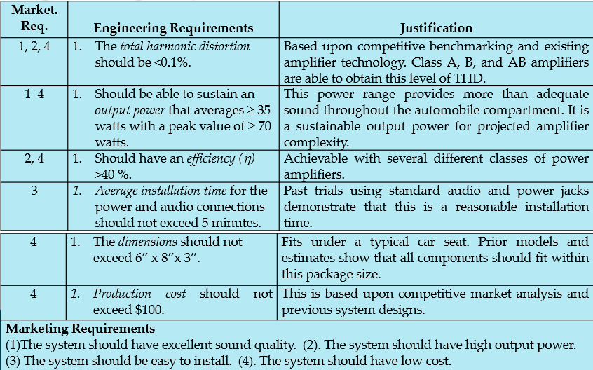

**Case Study: iPod™ Hands-Free**

* **Marketing Requirements**
  + Should not minimize or slow down the functional quality of the iPod.
  + User should be able to search for songs and artists and receive feedback on selection.
  + System should provide clear understandable speech.
  + System should be able to understand voice commands from user.
  + Should be able to fit and operate in an automobile.
  + Should be easy to use.
  + Should be portable.
* **Engineering Requirements**

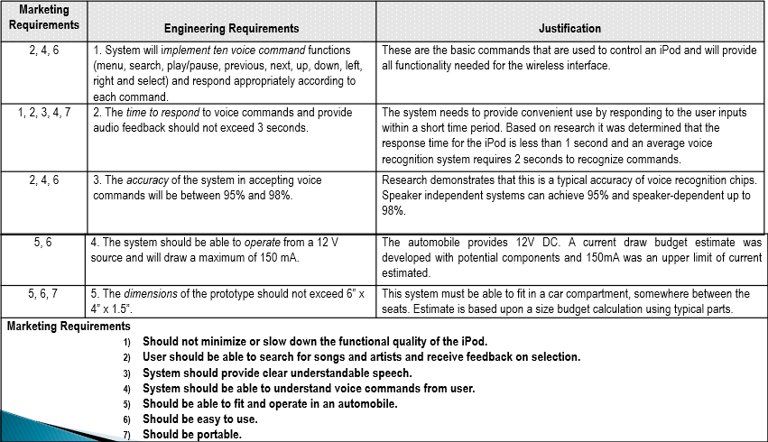

**Advanced Requirements Analysis:**

* Understanding the tradeoffs between different conflicting requirements
* Identifying engineering and marketing requirements

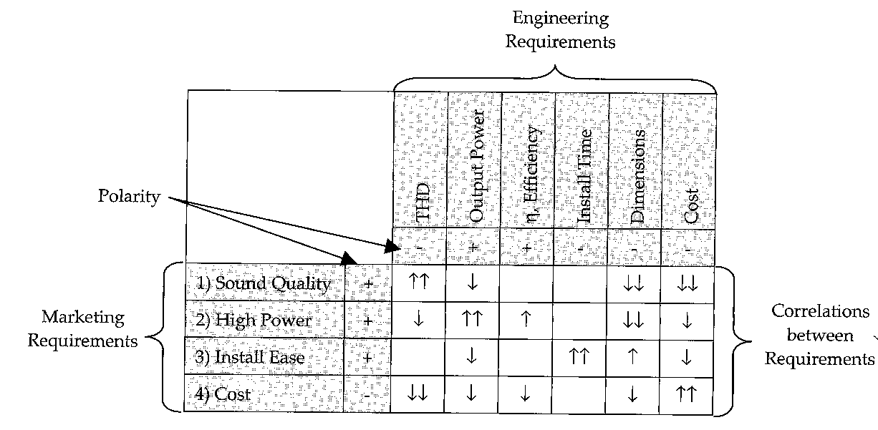

* Requirement correlations
  + Up Arrow: Positive correlation; Both goals can be simultaneously met.
  + Down Arrow: Negative correlation; Improving one will compromise the other.
* Polarity
  + (+) indicates desirability.
  + (-) indicates non-desirability.

