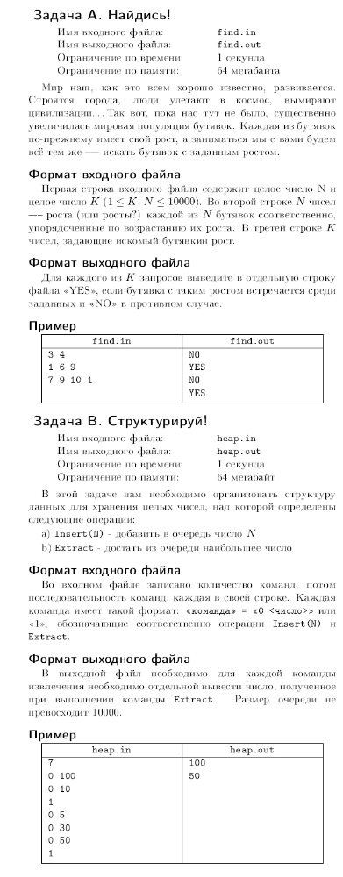
C. Euclid.

Given two numbers a, b such that a, b >= 0.
First of all you should find gcd(a, b) = d;
It means: biggest d such that d divides both a, b;

Then two integers x, y such that a*x + b*y = d;

Input 1;

0 1

Output 1;

0
0 0

Input 2;
10 25

Output 2;
5
-2 1

