TASK1-PTICE
Input File: ptice.in
Output File: ptice.out
Adrian, Bruno and Goran wanted to join the bird lovers' club. However, they did not know that all
applicants must pass an entrance exam. The exam consists of N questions, each with three possible
answers: A, B and C.
Unfortunately, they couldn't tell a bird from a whale so they are trying to guess the correct answers.
Each of the three boys has a theory of what set of answers will work best:
Adrian claims that the best sequence is: A, B, C, A, B, C, A, B, C, A, B, C ...
Bruno is convinced that this is better: B, A, B, C, B, A, B, C, B, A, B, C ...
Goran laughs at them and will use this sequence: C, C, A, A, B, B, C, C, A, A, B, B ...
Write a program that, given the correct answers to the exam, determines who of the three was right –
whose sequence contains the most correct answers.
INPUT
The first line contains an integer N (1 ≤ N ≤ 100), the number of questions on the exam.
The second line contains a string of N letters 'A', 'B' and 'C'. These are, in order, the correct answers to the questions in the exam.
OUTPUT
On the first line, output M, the largest number of correct answers one of the three boys gets.
After that, output the names of the boys (in alphabetical order) whose sequences result in M correct
answers.
EXAMPLES
input
5
BAACC
output
3
Bruno

input
9
AAAABBBBB
output
4
Adrian
Bruno
Goran

TASK2-MRAVOJED
Input File: mravojed.in
Output File: mravojed.out
Archeologists recently found the remains of Greco-Roman architecture. The location can be modeled as a grid of R・C square cells. For each of the cells, archeologists have determined if some building was there or if the cell has always been empty.
After examining the artifacts in detail, they concluded that the location contains two buildings from different periods in time, and that the floor plans of both buildings are of square shape. Because the buildings were from different periods in time, it is possible that their floor plans overlap. Determine the possible location and size (length of the side of the square occupied by the floor plan) for each building.
INPUT
The first line contains two integers R (1 ≤ R ≤ 100) and C (1 ≤ C ≤ 100), the size of the location.
Each of the next R lines contains a strong of C characters '.' (dot) or 'x' (lowercase letter). The character '.' means that nothing was found in that cell, while 'x' indicates that there was a building there.
OUTPUT
For each of the two buildings, output on a single line the row and column of its upper left corner, and the size of the building.
Note: The test data will guarantee that a solution always exists, although it may not necessarily be
unique.
EXAMPLES
input
3 3
xx.
xxx
...
output
1 1 2
2 3 1
input
4 6
xx....
xx.xxx
...xxx
...xxx
output
1 1 2
2 4 3
input
5 5
.....
xxx..
xxxx.
xxxx.
.xxx.
output
2 1 3
3 2 3

TASK3-JEZ
Input File:Jez.in
Output File:Jez.out
Luka found a very unusual game board in his attic. Surprisingly, it consists of R・C square cells. The
rows are numbered 0 to R−1 top to bottom and the columns 0 to C−1 left to right.
What makes the board unusual is the way in which the cells are coloured. Each cell is either grey or
white:
• white, if the row and column numbers of the cell, when represented in binary, have at least one
digit 1 in the same position. For example, the cell (4, 5) would be white.
• grey, otherwise. For example, the cell (2, 5) would be grey.
The following image shows a board of size 10・10.

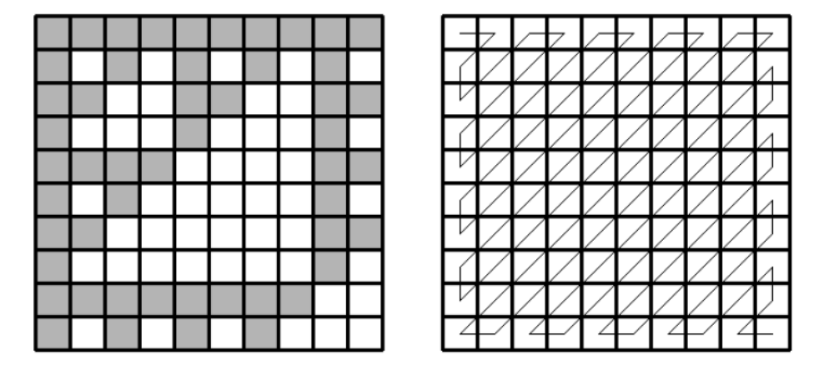
Luka's hedgehog likes walking on this unusual board and does it in an unusual way. The hedgehog
starts his walk in the cell (0, 0) and continues in the zig-zag pattern as in the second image above. While the hedgehog is walking, Luka counts how many grey squares it visited.
After visiting K squares, the hedgehog gets tired and falls asleep. Luka then goes to bed too, happy that he was able count the grey squares.
Knowing the dimensions of the board and the number K beforehand, however, it is possible to write a program that calculates the result faster. This is your task.
INPUT
The first line contains two integers R (1 ≤ R ≤ 1 000 000) and C (1 ≤ C ≤ 1 000 000), the dimensions of the board.
The second line contains the integer K (1 ≤ K ≤ R・C), the total number of squares the hedgehog visits. Note that this number may not fit in a 32-bit integer.
OUTPUT
Output the number of grey cells the hedgehog visits.
GRADING
In test cases worth 50% of points, K will be less than 1 000 000.

EXAMPLES
input
10 10
6
output
5
input
3 5
11
output
8
input
10 10
100
output
51

