Задача A. Beer Problem

Имя входного файла: beer.in
Имя выходного файла: beer.out
Ограничение по времени: 2 секунды
Ограничение по памяти: 64 мегабайта

Everyone knows that World Finals of ACM ICPC 2004 were held in Prague. Besides its greatest architecture and culture, Prague is world famous for its beer. Though drinking too much is probably not good for contestants, many teams took advantage of tasting greatest beer for really low prices.

A new beer producing company Drink Anywhere is planning to distribute its product in several of the n European cities. The brewery is located near Prague, that we would certainly call city number 1. For delivering beer to other cities, the company is planning to use logistics
company Drive Anywhere that provides m routes for carrying goods. Each route is described by the cities it connects (products can be transported in either direction), its capacity --- the number of barrels of beer that can be transported along this route each day, and the cost of transporting one barrel of beer along it. To deliver beer to some city it may be necessary (or advantageous) to use several routes consequently, and maybe even deliver beer using several different paths.

Each city is in turn characterized by the price that local pubs and restaurants are ready to pay for one barrel of beer. You may assume that demand for beer is essentially unlimited in each city, since this is the product that will always find its consumer.

Drink Anywhere is not planning to distribute its beer in Prague for a while, because of
the high competition there, so it is just planning to provide beer to other cities for now. Help it to find out, what is the maximal income per day it can get.

Input File

The first line of the input file contains n and m --- the number of cities in Europe we consider and the number of delivery routes respectively (2 <= n <= 100, 1 <= m <= 2000). The next line contains n – 1 integer numbers --- prices of a barrel of beer in European cities 2, 3 ..., n respectively (prices are positive integers and do not exceeded 1000).

The following m lines contain four integer numbers each and describe delivery routes. Each route is specified by the numbers of cities it connects, its capacity, and the price of transporting one barrel
of beer along it (the capacity and the price are positive integers, they do not exceed 1000).

Output File

Output the maximal income the company can get each day.

Example

beer.in
4 4
80 50 130
1 2 80 50
2 4 40 90
3 1 40 60
3 4 30 50

beer.out
3000

Задача G. Evacuation Plan

Имя входного файла: evacuate.in
Имя выходного файла: evacuate.out
Ограничение по времени: 2 секунды
Ограничение по памяти: 64 мегабайта

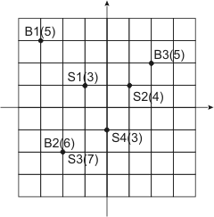
The City has a number of municipal buildings and a number of fallout shelters that were build specially to hide municipal workers in case of a nuclear war. Each fallout shelter has a limited capacity in terms of a number of people it can accommodate, and there's almost no excess capacity in The City's fallout shelters. Ideally, all workers from a given municipal building shall run to the nearest fallout shelter. However, this will lead to overcrowding of some fallout shelters, while others will be half-empty at the same time.

To address this problem, The City Council has developed a special evacuation plan. Instead of assigning every worker to a fallout shelter individually (which will be a huge amount of information to keep), they allocated fallout shelters to municipal buildings, listing the number of workers from every building that shall use a given fallout shelter, and left the task of individual assignments to the buildings' management. The plan takes into account a number of workers in every building - all of them are assigned to fallout shelters, and a limited capacity of each fallout shelter - every fallout shelter is assigned to no more workers then it can accommodate, though some fallout shelters may be not used completely.

The City Council claims that their evacuation plan is optimal, in the sense that it minimizes the total time to reach fallout shelters for all workers in The City, which is the sum for all workers of the time to go from the worker's municipal building to the fallout shelter assigned to this worker.

The City Mayor, well known for his constant confrontation with The City Council, does not buy their claim and hires you as an independent consultant to verify the evacuation plan. Your task is to either ensure that the evacuation plan is indeed optimal, or to prove otherwise by presenting another evacuation plan with the smaller total time to reach fallout shelters, thus clearly exposing The City Council's incompetence.

During initial requirements gathering phase of your project, you have found that The City is represented by a rectangular grid. The location of municipal buildings and fallout shelters is specified by two integer numbers and the time to go between municipal building at the location (Xi, Yi) and the fallout shelter at the location (Pj, Qj) is Di,j = |Xi - Pj| + |Yi - Qj| + 1 minutes.

Input

The input file consists of The City description and the evacuation plan description. The first line of the input file consists of two numbers N and M separated by a space. N (1 ≤ N ≤ 100) is a number of municipal buildings in The City (all municipal buildings are numbered from 1 to N). M (1 ≤ M ≤ 100) is a number of fallout shelters in The City (all fallout shelters are numbered from 1 to M).

The following N lines describe municipal buildings. Each line contains there integer numbers Xi, Yi, and Bi separated by spaces, where Xi, Yi (-1000 ≤ Xi, Yi ≤ 1000) are the coordinates of the building, and Bi (1 ≤ Bi ≤ 1000) is the number of workers in this building.

The description of municipal buildings is followed by M lines that describe fallout shelters. Each line contains three integer numbers Pj, Qj, and Cj separated by spaces, where Pi, Qi (-1000 ≤ Pj, Qj ≤ 1000) are the coordinates of the fallout shelter, and Cj (1 ≤ Cj ≤ 1000) is the capacity of this shelter.

The description of The City Council's evacuation plan follows on the next N lines. Each line represents an evacuation plan for a single building (in the order they are given in The City description). The evacuation plan of ith municipal building consists of M integer numbers Ei,j separated by spaces. Ei,j (0 ≤ Ei,j ≤ 1000) is a number of workers that shall evacuate from the ith municipal building to the jth fallout shelter.

The plan in the input file is guaranteed to be valid. Namely, it calls for an evacuation of the exact number of workers that are actually working in any given municipal building according to The City description and does not exceed the capacity of any given fallout shelter.

Output

If The City Council's plan is optimal, then write to the output file the single word OPTIMAL. Otherwise, write the word SUBOPTIMAL on the first line, followed by N lines that describe your plan in the same format as in the input file. Your plan need not be optimal itself, but must be valid and better than The City Council's one.

Sample inputs and outputs

These are sample inputs and outputs that correspond to the city plan that is shown on the picture - buildings are denoted with Bx, shelters are denoted with Sx. Number of working people and capacities are shown in parentheses. The first sample is suboptimal, but the proposed alternative plan turns out to be optimal as shown in the second sample.

evacuate.in
3 4
-3 3 5
-2 -2 6
2 2 5
-1 1 3
1 1 4
-2 -2 7
0 -1 3
3 1 1 0
0 0 6 0
0 3 0 2

evacuate.out
SUBOPTIMAL
3 0 1 1
0 0 6 0
0 4 0 1

evacuate.in
3 4
-3 3 5
-2 -2 6
2 2 5
-1 1 3
1 1 4
-2 -2 7
0 -1 3
3 0 1 1
0 0 6 0
0 4 0 1

evacuate.out
OPTIMAL

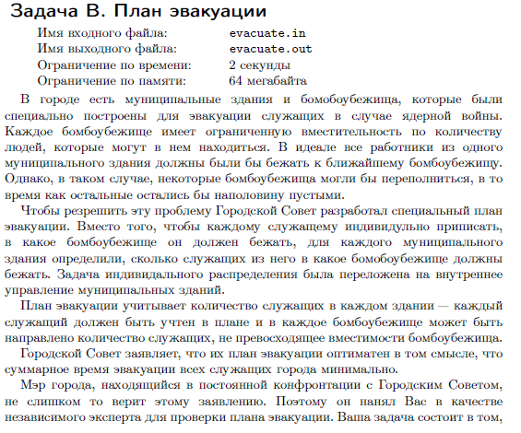
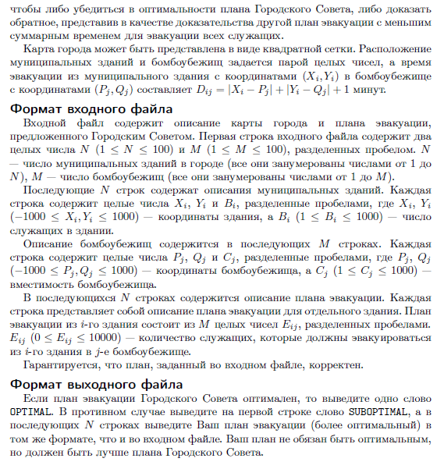
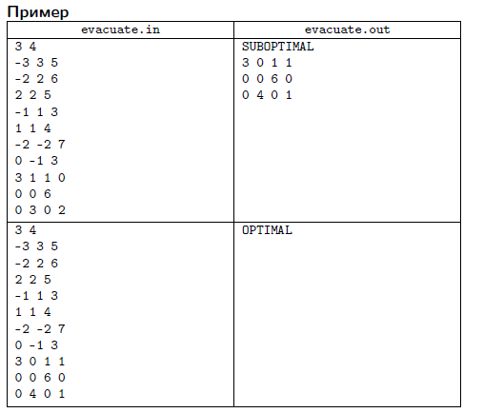
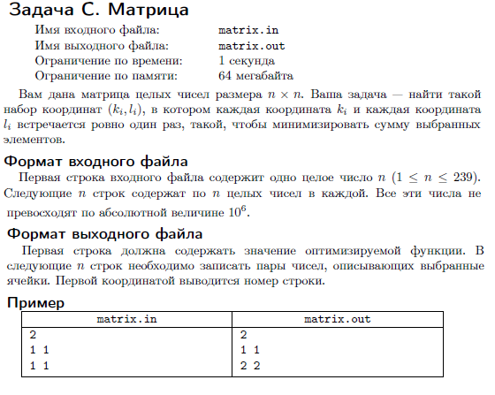
Задача D. Bring Them There

Имя входного файла: bring.in
Имя выходного файла: bring.out
Ограничение по времени: 2 секунды
Ограничение по памяти: 64 мегабайта

By the year 3141, the human civilization has spread all over the galaxy. The special hypertunnels are used to travel from one star system to another. To use the hypertunnel, you fly to a special location near the source star using your spaceship, activate the hyperjumper, fly through the hypertunnel, get out near your destination star and fly to the planet you need. The whole process takes exactly one day. A small drawback of the system is that for each tunnel every day only one spaceship can travel using this tunnel.

You are working in the transportation department of the ``Intergalaxy Business Machines'' company. This morning your boss has assigned a new task to you. To run the programming contest IBM needs to deliver K supercomputers from Earth where the company headquarters are located to the planet Eisiem. Since supercomputers are very large, one needs the whole spaceship to carry each supercomputer. You are asked to find a plan to deliver the supercomputers that takes as few days as possible. Since IBM is a very powerful corporation, you may assume that any time you need some tunnel for hyperjump, it is at your service. However, you still can use each tunnel only once a day.

Input File

The first line of the input file contains N --- the number of star systems in the galaxy, M --- the number of tunnels, K --- the number of supercomputers to be delivered, S --- the number of the solar system (the system where planet Earth is) and T --- the number of the star system where planet Eisiem is (2 <= N <= 50, 1 <= M <= 200, 1 <= K <= 50, 1 <= S, T <= N, S <> T).

Next M lines contain two different integer numbers each and describe tunnels. For each tunnel the numbers of star systems that it connects are given. The tunnel can be traveled in both directions, but remember that each day only one ship can travel through it, in particular, two ships cannot simultaneously travel through the same tunnel in opposite directions. No tunnel connects a star to itself and any two stars are connected by at most one tunnel.

Output File

On the first line of the output file print L --- the fewest number of days needed to deliver K supercomputers from star system S to star system T using hypertunnels. Next L lines must describe the process. Each line must start with C_i --- the number of ships that travel from one system to another this day. C_i pairs of integer numbers must follow, pair A, B means that the ship number A travels from its current star system to star system B.

It is guaranteed that there is a way to travel from star system S to star system T.

Example

bring.in
6 7 4 1 6
1 2
2 3
3 5
5 6
1 4
4 6
4 3

bring.out
4
2 1 2 2 4
3 1 3 2 6 3 4
3 1 5 3 6 4 4
2 1 6 4 6

Задача E. Cubes

Имя входного файла: cubes.in
Имя выходного файла: cubes.out
Ограничение по времени: 1 секунда
Ограничение по памяти: 64 мегабайта

Consider a wall built up of cubes of the same size: it can be represented by a sequence of n stacks numbered from 1 to n constructed of these cubes. The total number of cubes s is divisible by n. An example can be seen at the picture:

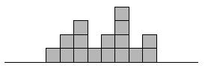

Let us define an elementary operation as follows: take up the topmost cube in the stack i (1 <= i <= n) and put it atop the stack j (1 <= j <= n). The cost of such an operation equals g[i,j]. You task is to find out what is the minimum total cost of an elementary operation sequence that makes the wall even, i.e. such that in every stack there are exactly s / n cubes.

Input File

In the first line of the input file you will find an integer n (1 <= n <= 100). The next line contains n integer numbers which correspond to the heights of the stacks of the wall (1st number --- the height of the 1st stack, 2nd number --- the height of the 2nd stack etc.) provided that 1 <= s <= 10^7. The following n lines contain n numbers each: j-th number in the (i + 2)-th line equals g[i,j] (0 <= g[i,j] <= 100).

Output File

Output the answer for the problem in the first line.

Example

cubes.in
4
1 3 2 2
1 1 1 1
1 1 2 4
1 2 3 4
2 3 4 5

cubes.out
1

Задача F. Distincter

Имя входного файла: distincter.in
Имя выходного файла: distincter.out
Ограничение по времени: 2 секунды
Ограничение по памяти: 64 мегабайта

We are given a sequence containing a sequence of numbers. In a single operation, we can either increment or decrement the value of a single element by 1. Determine the minimum number of operations we must perform before the sequence contains at least K distinct elements.

Note that we can create negative elements during the process.

Constraints
- sequence will contain between 1 and 50 elements, inclusive.
- Each element in sequence will be between 1 and 1000, inclusive.
- K will be between 1 and the number of elements in sequence, inclusive.

See input file format in examples.

Examples

distincter.in
{5, 1, 3}, 2

distincter.out
0

The sequence already has two distinct elements.

distincter.in
{1, 1, 1, 1, 1, 1, 1}, 5

distincter.out
6

Some elements can become negative.

distincter.in
{1, 1, 1, 1, 1, 2, 3}, 6
distincter.out
6

distincter.in
{8, 9, 7, 8, 7, 9, 7}, 7
distincter.out
7

distincter.in
{1, 2, 3, 4, 4, 5, 7, 7, 8}, 9
distincter.out
4

The optimal way to make 9 distinct elements is to increase one of the 4s two times and increase one of the 7s two times.

distincter.in
{576, 571, 571, 572, 575, 572, 571, 568, 573, 572, 569, 572}, 11
distincter.out
12

Задача G. Детский отдых

Имя входного файла: rest.in
Имя выходного файла: rest.out
Ограничение по времени: 2 секунды
Ограничение по памяти: 64 мегабайта

Ежегодно сотни детей со всех населенных пунктов Республики отправляются отдыхать в M летних лагерей. В каждом из N городов проживает определенное количество ребят. Естественно, лагеря не могут принять всех желающих, потому что у любого из них свой предел на количество мест. Стоимость летнего отдыха ребенка зависит от конкретного лагеря плюс дорожные расходы. Большинство родителей не в состоянии оплачивать отдых своих детей, нет денег. Правительство Республики решило сделать ребятам подарок, и, сократив расходы на чиновников, изыскало средства для отправки школьников в лагеря.

Руководители проекта, занимаясь распределением путевок, должны определить такую схему распределения ребят по лагерям и бюджетных средств, чтобы за летний период отдохнуло как можно больше детей за меньшие деньги.

Input File

В первой строке входного файла два числа N и M (1 <= N, M <= 100). Вторая строка содержит количества детей в городах. В третьей строке задается число мест в лагерях. Далее следуют N строк по M чисел --- стоимости путевок.

Output File

В выходной файл выведите одно число - стоимость всех распределенных путевок.

Example

rest.in
4 8
14 78 16 50
34 63 96 87 66 35 50 42
11 85 86 85 5 88 45 36
11 45 66 19 81 80 1 67
91 43 94 9 39 15 32 73
80 19 47 91 42 72 28 3

rest.out
850

Задача H. В поисках невест.

Имя входного файла: brides.in
Имя выходного файла: brides.out
Ограничение по времени: 2 секунды
Ограничение по памяти: 64 мегабайта

Однажды король Флатландии решил отправить k своих сыновей на поиски невест. Всем известно, что во Флатландии n городов, некоторые из которых соединены дорогами. Король живет в столице, которая имеет номер 1 а город с номером n знаменит своими невестами. Итак, король повелел, чтобы каждый из его сыновей добрался по дорогам из города 1 в город n. Поскольку, несмотря на обилие невест в городе n, красивых среди них не так много, сыновья опасаются друг друга. Поэтому они хотят добраться до цели таким образом, чтобы никакие два сына не проходили по одной и той же дороге (даже в разное время). Так как король любит своих сыновей, он хочет, чтобы среднее время сына в пути до города назначения было минимально.

Формат входных данных

В первой строке входного файла находятся числа n, m и k - количество городов и дорог во Флатландии и сыновей короля, соответственно (2 ≤ n ≤ 200, 1 ≤ m ≤ 2000, 1 ≤ k ≤ 100). Следующие строки содержат 3*m целых положительных числа. каждая тройка чисел - города, которые соединяет соответствующая дорога и время, которое требуется для ее прохождения (время не превышает 10^6). По дороге можно перемещаться в любом из двух направлений, два города могут быть соединены несколькими дорогами.

Формат выходных данных

Если выполнить повеление короля невозможно, выведите на первой строкечисло -1. В противном случае выведите на первой строке минимальное возможное среднее время (с точностью 5 знаков после десятичной точки), которое требуется сыновьям, чтобы добраться до города назначения, не менее чем с пятью знаками после десятичной точки. В следующих k строках выведите пути сыновей, сначала число дорог в пути и затем номера дорог в пути в том порядке, в котором их следует проходить. Дороги нумеруются, начиная с единицы, в том порядке, в котором они заданы во входном файле.

Примеры

brides.in
5 8 2
1 2 1 1 3 1 1 4 3
2 5 5 2 3 1 3 5 1
3 4 1 5 4 1

brides.out
3.00000
3 1 5 6
3 2 7 8

