Overview

Day 1

Problem  Settings |  | Candies drawing | Sports day | Carrot drought | Video service
Input file name |  | input.txt | input.txt | input.txt | input.txt
Output file name |  | output.txt | output.txt | output.txt | output.txt
Time limit |  | 1 sec | 1 sec | 1 sec | 1.5 sec
Memory limit |  | 128 Mb | 128 Mb | 128 Mb | 128 Mb
Source code size limit |  | 64 Kb | 64 Kb | 64 Kb | 64 Kb
Compilation options | С++ | -O2 | -O2 | -O2 | -O2
Compilation options | Pascal | -O2 | -O2 | -O2 | -O2
Number of tests |  | 20 | 20 | 20 | 20
Number of points for the problem |  | 100 | 100 | 100 | 100
Submit for testing | С++ | Source file with cpp extension | Source file with cpp extension | Source file with cpp extension | Source file with cpp extension
Submit for testing | Pascal | Source file with pas extension | Source file with pas extension | Source file with pas extension | Source file with pas extension
Graduation |  | N ≤ 10 – no less than 30 points | N ≤ 60 – no less than35 points | W, H, N + M ≤ 100 - no less than 40 points | K ≤ 2 – no less than 15 points
 |  | N ≤ 20 – no less than 50 points | N ≤ 300 – no less than 50 points | W, H, N + M ≤ 1000 - no less than 55 points | N^{K} ≤ 10⁶ – no less than 30 points
 |  | N ≤ 20 – no less than 50 points | N ≤ 2000 – no less than 65 points | N, M ≤ 1000 - no less than 75 points | N ≤ 50 – no less than 45 points
 |  | N ≤ 20 – no less than 50 points | N ≤ 2000 – no less than 65 points | K1 = 0 – no less than 75 points | N ≤ 300 – no less than 60 points

Solutions testing process will be executed on a computer with no less than 2 GHz CPU, and no less than 512 Mb RAM.

Candies drawing
Day I, task 1

A matinee is held in the kindergarten. Educators invented new game for children called candies drawing.
There are N balls placed in a bag. On each ball some integer A_{i} is written. Numbers, written on the balls are distinct.
N-1 children take part in the game. All N-1 children one after another go to the host and take two balls. Of two chosen balls each child saves the ball with greater number on it and puts the ball with smaller number back into the bag. Obviously, when each child chooses a ball, there will be exactly one ball left in the bag.
A final part of matinee is candies distribution. Each child receives candies. The number of candies received corresponds to the number written on the ball saved by child.
However, educators faced a complicated task – how many candies are needed for matinee? Your task is to help educators to calculate the biggest possible number of candies that can be won by all the children.
Input data

The first line of input file contains one integer N – number of balls (2 ≤ N ≤ 100).

The second line contains N distinct integers A_{i} (1 ≤ A_{i} ≤ 32767). The numbers are separated by single spaces.

Output data

Output file must contain one integer – the biggest possible number of candies that can be won by all the children in “Candies drawing” game.

input.txt | output.txt
2  1 100 | 100
4  4 2 5 7 | 16
7  9 12 8 10 11 20 15 | 77

Sports day
Day I, task 2

A sports day for schools of Brest city will be held soon. Each school of the city is to present a team of three persons. A sports day schedule includes following kinds of exercises: catching up on a crossbeam, squatting and pushing up on the floor. Sports day consists of three rounds: in the first round participants catch up on a crossbeam, in second round they push up on the floor, and in the third round they squat.
The judges of sports day decided to use rating system for judging. After each round an intermediate rating of a team is calculated, which is determined by sum of scores, got by three members of the team in this discipline. After holding three rounds of sports day, judges calculate final rating of the team that is sum of intermediate ratings of the team in each of three rounds. A team with biggest final rating is announced as sports day winner.
Because not all kinds of exercises are equivalent, the results of each of them are scored by judges in a special way. For each catching up participants receives X points, for each pushing up – Y points, for each squatting – Z points. There criteria show exercises difficulty evenly enough.
However, while forming a team administration of secondary school № 14 of Brest city faced some difficulties. There are N pupils in the school, sports data of each is known: A_{i} – number of catching up on a crossbeam, B_{i} – number of pushing up on the floor and C_{i} – number of squatting. But even with such a data about each pupil it’s rather complicated to choose a team. The reason is that some pupils catch up on crossbeam well but push up badly, and the reverse may be true. Your task is to help secondary school administration to form a team of three persons to maximize final rating of the team.
Input data
The first line of input file contains three integers X, Y and Z (1 ≤ X, Y, Z ≤ 10⁴), separated by single spaces.
The second line contains an integer N (3 ≤ N ≤10⁵) – number of pupils in the school.
Each of the following N lines describes sports data of each pupil and contains three integers A_{i}, B_{i} and C_{i} (1 ≤ A_{i}, B_{i}, C_{i} ≤ 10⁴), separated by single spaces.
Output data
An output file must contain three integers, separated by singles spaces – numbers of pupils that are to be members of a team. The pupils are numbered consequently, starting from one in order of input of their sports data. If there are several solutions, output any of them.

input.txt | output.txt | Explanations
10 10 10  4  1 1 1  10 1 1  1 10 1  1 1 10 | 2 3 4 | Final rating 360
2 3 2  6  3 1 4  5 1 1  2 3 2  3 2 3  2 3 2  1 4 1 | 3 5 4 | Final rating 52
5 3 4  7  2 7 12  13 10 5  6 7 5  1 1 20  8 2 14  3 21 4  7 9 8 | 7 2 5 | Final rating 311

Carrot drought
Day 1, task 3

Carrot is a very popular forage crops in Byteland, so the Government has recently approved the proposal to cultivate it in especially large amounts. It was decided to sow a single field to test the proposed solutions.
Carrot field can be represented by a rectangle H meters tall W meters wide. The field is divided into WxH beds with the help of H+1 horizontal and W+1 vertical furrows. Each bed is matched to a 1x1 metre square. Horizontal furrows are numbered top to bottom starting with zero, vertical furrows are numbered left to right starting with zero. Obviously, horizontal furrows with numbers 0 and H and vertical furrows with numbers 0 and W represent the boundaries of the field. We can think that a furrow is a line segment connecting two points on the boundaries of the field, and all horizontal or vertical furrows are parallel to their respective neighbours. Furrow is so thin that we can effectively assume its thickness to be zero.
Artificial irrigation system functions is such that N horizontal and M vertical furrows have constant water flow in them. Such furrows are called irrigated. It's also known that boundary furrows are always irrigated.
This irrigation system has a provably bad performance - not all beds are irrigated the same. Byteland scientists assume the special drought coefficient to be equal to the minimal distance between the bed and some irrigateed furrow. The bed whose drought coefficient belongs to the range [K_{1,} K₂] is potentially safe. Your task is to help agricultural officials of Byteland to determine the number of potentially safe beds on the carrot field.
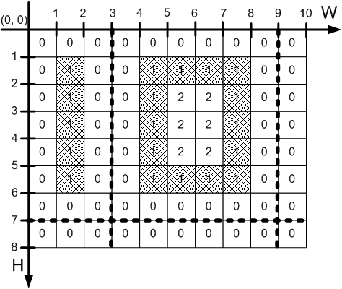
Example test case №2, W = 10, H = 8, N = 1, M = 2, K₁ = K₂ = 1.
Potentially safe beds are hatched on the picture. The numbers in the centers of the squares are the drought coefficients of the corresponding beds on the field.
Input data
First line of the input contains two integers W and H
(1 ≤ W, H ≤ 10⁹), separated by a single space.
Second line contains two integers K₁ and K₂ (0 ≤ K₁ ≤ K₂ ≤ 10⁵), separated by a single space.
Third line contains two integers N and M (0 ≤ N, M ≤ 10⁵), separated by a single space.
Fourth line contains N integers A_{i} (1 ≤ A_{i} < H) – the numbers of the horizontal irrigated furrows. A_{i} < A_{j} for all i < j.
Fifth line contains M integers B_{i} (1 ≤ B_{i} < W) – the numbers of vertical irrigated furrows. B_{i} < B_{j} for all i < j.
Output data
The only line of output contains a single integer - the number of potentially safe beds on the carrot field.

input.txt | output.txt
4 4  0 3  0 0 | 16
10 8  1 1  1 2  7  3 9 | 19
42 37  3 5  2 3  11 29  9 22 37 | 337

Video service
Day 1, task 4

It's known for a long time that the 2114 Ice Hockey World Cup will be held in Byteland. Organizers need to fulfill some of the International Ice Hockey Federation (IIHF) requirements to make the event organization considered successful. Hockey matches are to be held in the cities of Ivanovo and Slavino, directly connected by a high-speed motorway.
IIHF chairman noted that none of the N campings along the Ivanovo-Slavino motorway has a video-cafe. Video-cafe is a road service element practically indistinguishable from a usual drive-through cafe, that has everything set up for the appreciation of sport events by means of video. IIHF had stated before, that for the certification to succeed K out of N existing campings should have a video-cafe build on site. IIHF also specified some additional requirements for the placement of each video-cafe:

- The distance from a current video-cafe to the previous one (considered as if going from Ivanovo to Slavino, if such a cafe exists) should be not less than A kilometer and not greater than B kilometers.

- The distance from a current video-cafe to the next one (considered as if going from Ivanovo to Slavino, if such a cafe exists) should be not less than A kilometer and not greater than B kilometers.

- The distance between the city of Slavino or Ivanovo to the nearest video-cafe should be not less than A kilometers and not more than B kilometers.
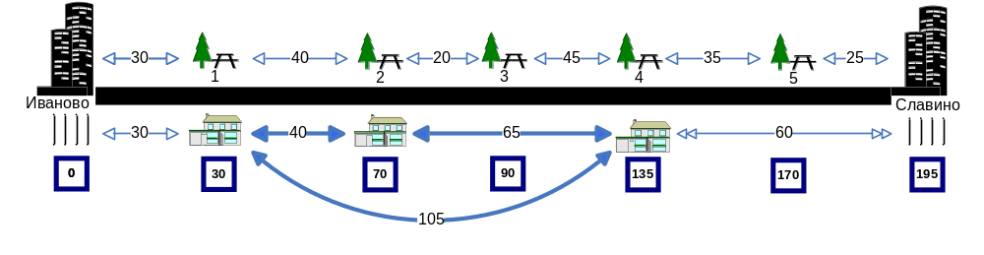
Example test case №1: N = 5, K =3, A = 20, B = 70:
For i-th built video-cafe we denote by Z_{i} the sum of the distances between that cafe and all other cafes. IIHF had noted that the more the sum of Z_{i,} for all the cafes, the better is the coverage of sport events for motorway travellers.
Your task is to determine the maximum value of the sum of Z_{i} that can be achieved by building K video-cafes meeting all the requirements of the IIHF. Each camping can have at most one video-cafe on site.
Input data
First line of input contains two integers separated by a single space – N and K (1 ≤ K ≤ N ≤ 1000) respectively.
Second line contains integers A and B (1 ≤ A < B ≤ 10⁹) separated by a single space.
Third line contains a single integer S (1 ≤ S ≤ 10⁹) – the distance between Ivanovo and Slavino.
Fourth line contains N integers C_{i} (0 < C_{i} < S, C_{i} < C_{j} for all i < j) –the distance between i-th camping and Ivanovo. All the numbers are single-space-separated.
Output data
Output should contain the only integer – the maximal value of the sum of Z_{i} for K built video-cafe. The value is always defined.

input.txt | output.txt | Comments
5 3  20 70  195  30 70 90 135 170 | 420 | Campings  {1, 2, 4}
10 4  10 28  100  10 19 23 32 47 51 62 74 82 89 | 474 | Campings  {2, 5, 8, 10}

