12/7/2015

**Procedure to burn new dongles**

Written by: Tanya Birger, Giga Ltd.

1. Install **Sentinel License Manager:**

Run from command line “haspdinst –I”

1. Apply **new firmware:**

run FirmwareUpdate.exe and click to “Apply Update” button:

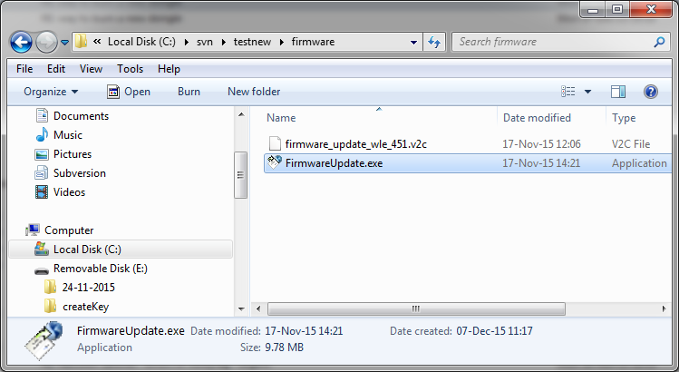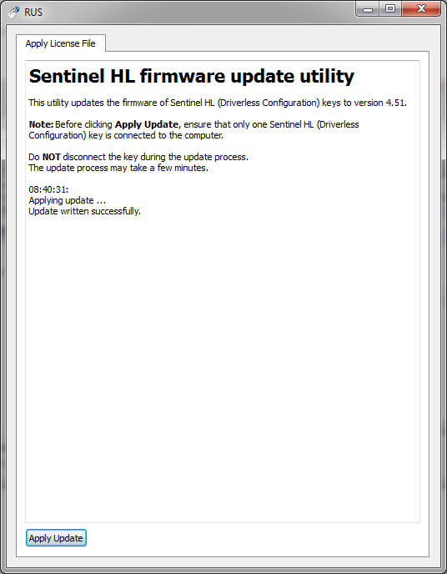

1. Apply **new REDApp:**

RedApp image file – is a template file with name REDApp_lic_tmpl.xml

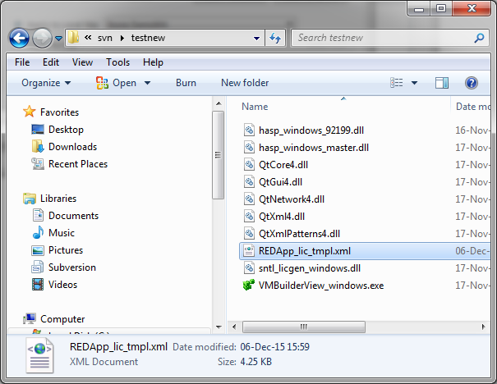

1. Run C:\svn\testnew\VMBuilderView_windows.exe and click Apply button:

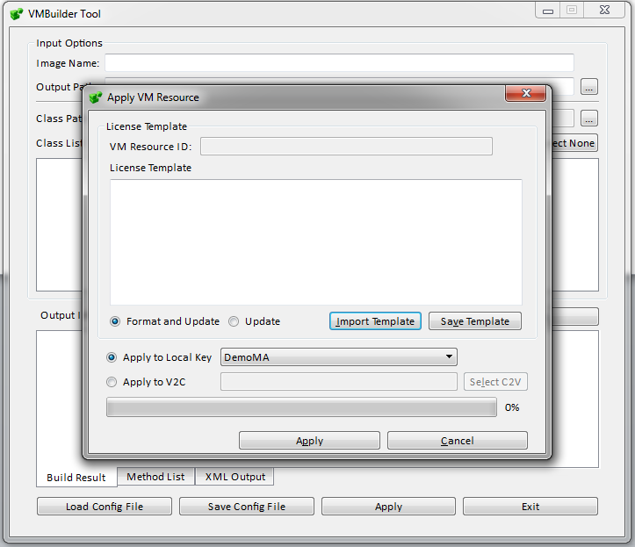

1. Click on “ Import Template” button:

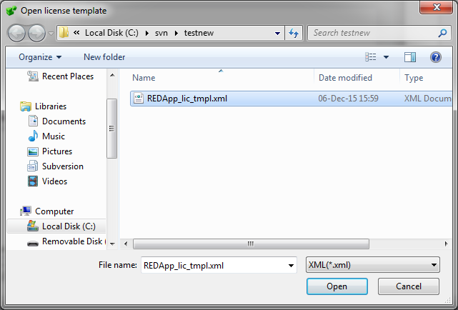

1. Select REDApp_lic_tmpl.xml file and click “Open”

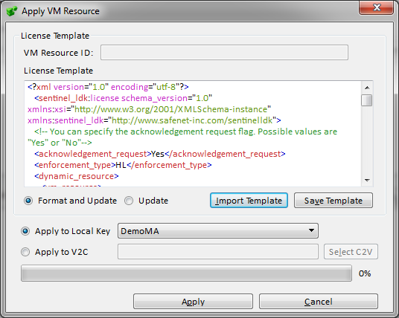

1. Change type local key to “Non DemoMA” and click Apply:

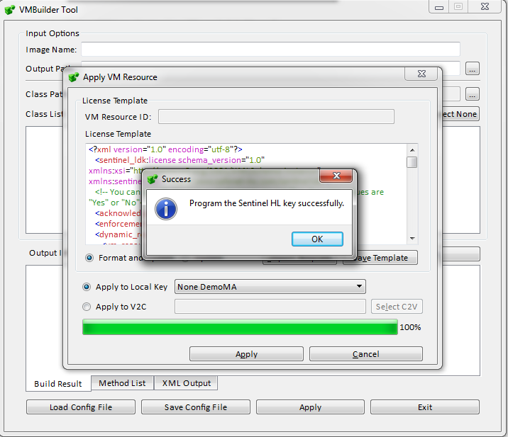

1. You shall get ‘Success’ – burning operation completed!!