Changes in BIT (Triplex machine)

Description:

The main idea is to gather all checks like Door is open, Tray is clear etc... at the beginning of the BIT.

Changes:

The location of changes is in BITViewerDlg .
- New functions :
There is new function - bool PrepareForBit(TTestAttributes TestAttributes);
This function will check all attributes and will show new dialog that will describe what kind of things user need to check.

- New classes
PrepareForBitDlg

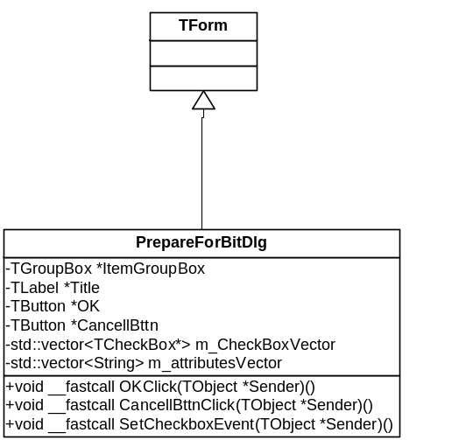

- New Logic :

Parameter | Description | Need to be checked at the beginning of the BIT
taTrayInsert | Verify that the tray is inserted | Yes
taDoorLock | Close the door | Yes
taHomeAxes | Axes homing  If axes movement is required - ask the user about a clean tray  If the tray is not empty - do not perform the test | Yes
taHeadsHeating | Heads should be hot | No
taTrayHeating | Tray should be hot | No
taHeadsFilling | Heads filling | No

New dialog screen:
