Load Cell Calibration

Machine: Triplex.
SRS: Load cells calibration SRS

- Overview.
This document defines the changes in source code according to required adaptations for the Triplex load cells calibration wizard.
In Triplex there are 8 cartridges comparing to 4 cartridges in most Eden’s and Connex’s, and since it is confusing to detect the cartridges only by the naming convention, we will visually guide the user for the correct cartridge location. As well, all the calibrations will appear in only one combined wizard screen in order to avoid monotone work load during the process.
All modifications need to be backward compatible.
- Current Implementation

The current process is sequential and performing 8 sequential operations might be too much and annoying.
- New Implementation
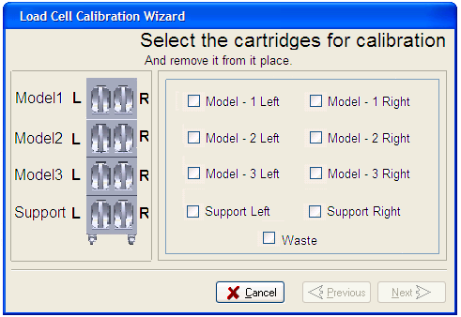

The user needs to select the required load cell/s he would like to calibrate.

- Class Diagram.

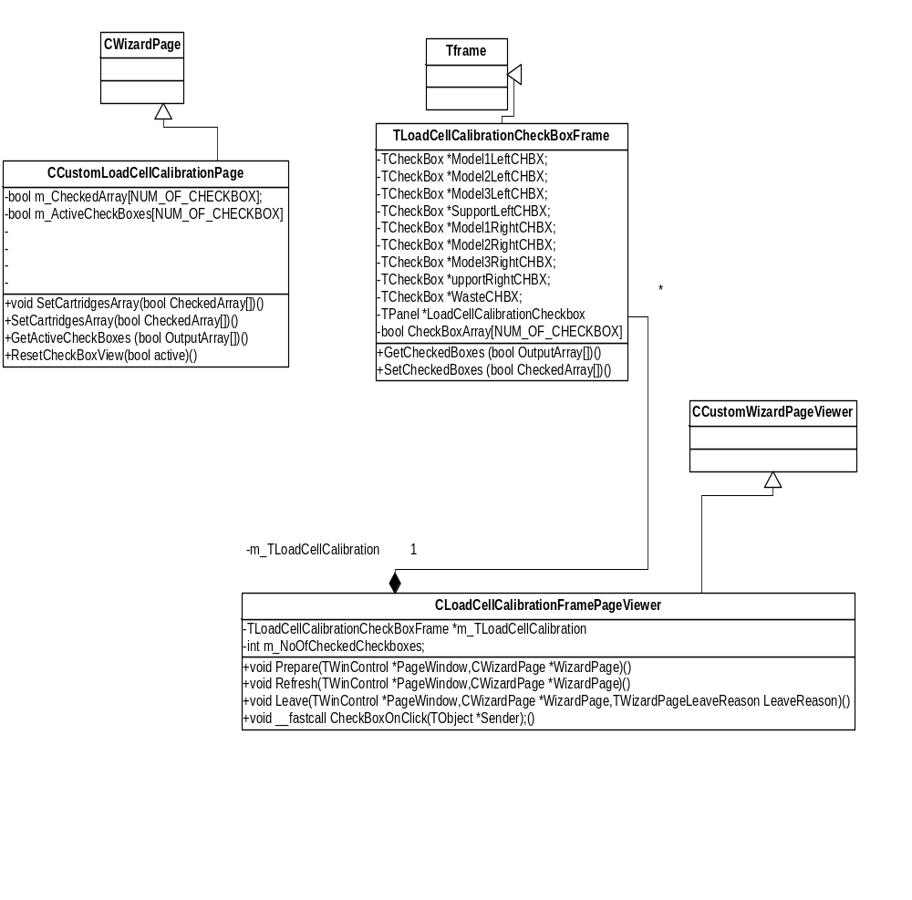

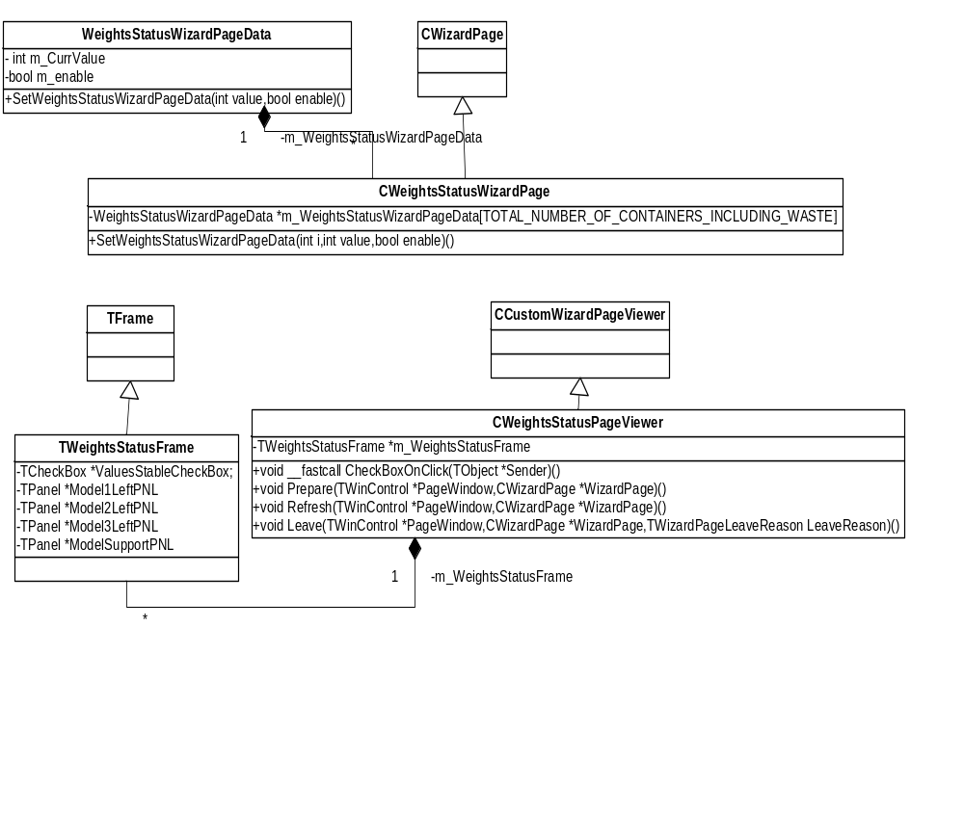

- Sequence diagram.
