

SOFTWARE REQUIREMENTS SPECIFICATION

EDEN 500 / Lite -Printer States, Sequences and Wizards SRS
Software Requirements Specification
for the Eden Printer States,
Sequences and Wizards

MAY 2005

Objet Geometries Ltd.
2 Holzman St., Science Park,
P.O. Box 2496, Rehovot 76124, Israel
Tel +972-8-9314314, Fax +972-8-9314315
E-mail: info@2objet.com
Web: www.2objet.com
REV. No. | DATE | C.P. No. | AFFECTED PAGES | APPROVED BY:
1.0 | 04/05/2005

 | NAME & SIGNATURE | DATE
PREPARED BY: | NAME: Chaim Kleinhendler  SIGN:
CHECKED BY: | NAME:  SIGN:
APPROVED BY: | NAME:  SIGN:
QUALITY ASSURANCE | NAME:  SIGN:
PROJECT MANAGER | NAME:  SIGN:
CONFIGURATION MANAGER: | NAME:  SIGN:

LIST OF EFFECTIVE PAGES

Insert latest changed pages. Dispose of superseded pages according to applicable regulations.

Pages | Change No. (*)
Title | 0
A to C | 0
i to iii | 0
1 to 20 | 0
 | 0
 | 0
 | 0
 | 0

* Zero indicates an original page.

Copy _______ of ________

List of Abbreviations and Acronyms
AGC | - | Automatic Gain Control
BIT | - | Built In Test
CAP | - | Capability
CSCI | - | Computer Software Configuration Item
DOC | - | Document
ICD | - | Interface Control Document
RAM | - | Random access memory
TBD | - | To Be Defined

Table of Contents
1 Machine States and Modes 4
1.1 Power Up activities 8
1.2 Idle activities 8
1.3 Pre Print activities 8
1.4 Printing activities 9
1.5 Stopping activities 10
1.6 Stopped activities 10
1.7 Pausing activities 10
1.8 Paused activities 10
1.9 Stanby 1 10
1.10 Standby 2 11
1.11 Maintenance 11
2 Printer Sequences 12
2.1 Goto Purge Position 12
2.2 Purge 12
2.3 FireAll 12
2.4 Test Pattern 13
2.5 Goto Tray Removal Position 13
2.6 Wipe 13
2.7 Test 14
3 Printer Wizards 15
3.1 Clean Wiper 15
3.2 Clean Heads 15
3.3 Tray Points Calibration 16
3.4 Heads Filling Calibration 16
3.5 Roller Tilt Calibration 17
3.6 Resin Replacement 17
3.7 Head Replacement 17
3.8 UV calibration 17
3.9 Shut Down 17

List of Figures
Figure 1 - System States and Modes 4

List of Tables
Table 1 System States and Modes 5
Table 2 Printer Sequences 6
Table 3 - Printer Wizards 7

Machine States and Modes

The EDEN_SW states and modes are described in the following figure:
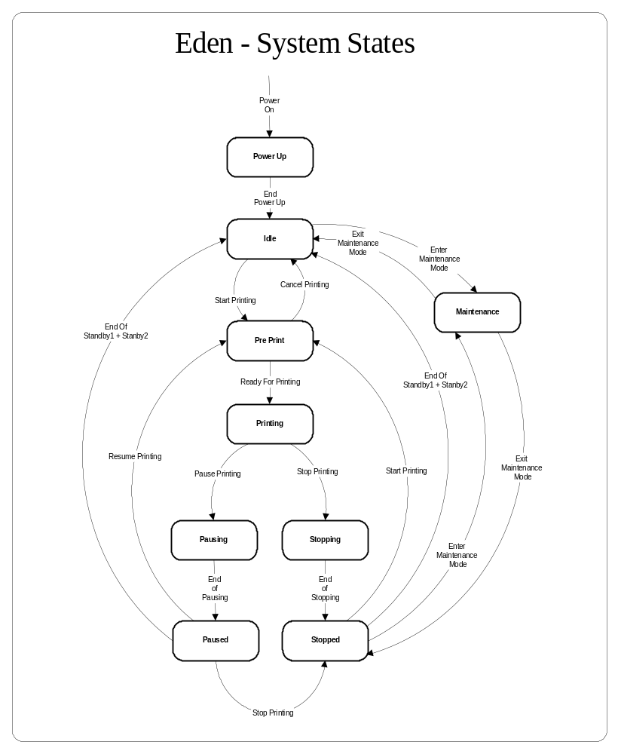
Figure 1 - System States and Modes
The EDEN printer of which the EDEN_SW makes part can operate in the following states and modes:
ID | Mode Name | Mode Description
1 | OFF | Power OFF mode, no power is supplied to the system the software is not operational.
2 | Power Up | When power is supplied to the system, the processor enters the Power Up sequence and the operating system is loaded and starts running the Eden software
3 | Idle | At the end of Power Up the system enters this state and stays in this state until a print request is issued.
4 | Pre Print | This state is a transitional state where the printing process begins, and the software makes all the preparations for printing
5 | Printing | This is the main printing state. In this state the machine is requesting slices from the host machine and prints the model
6 | Pausing | In this state the movement of the printing head stops and the machine is doing all the necessary activities to enter the Paused state
7 | Paused | In this state the printing sequence is frozen, and after a predefined time, all the print supporting activities are paused.
8 | Stopping | In this state the machine stops all printing activities and enters the Stopped state.
9 | Stopped | In this state the printer is stopped and only general maintenance processes are still active
10 | Terminating | When there is an abnormal stop of printing the printer enters the “Terminating” state
11 | Maintenance | In this state the printer is allowed to do maintenance sequences
Table 1 System States and Modes

The EDEN printer of which the EDEN_SW makes part includes the following
printer sequences:
ID | Mode Name | Mode Description
11.1 | Goto Purge Position | This sequence moves the head to the “Purge” position
11.2 | Purge | The printer performs a full purge sequence including movement to purge position, purging, and wiping
11.3 | Fire All | The printer moves the heads to “Purge” position and performs a “Fire All”
11.4 | Test Pattern | The printer moves the heads to “Test Pattern” position in X and Y axes, loads “Test Pattern” data to the heads, and prints the  “Test Pattern”
11.5 | Goto Tray Upper Position | The printer moves the Z axis to a position that is defined as the “Tray Upper Position”. In Eden 260 this position is the tray out position, In Eden 330/333 it should be the same as the Z start position.
11.6 | Wipe | The printer performs a “Wipe” sequence
11.7 | Test | The printer performs an internal sequence for testing purposes used for debugging

Table 2 Printer Sequences

The EDEN printer of which the EDEN_SW makes part includes the following
printer wizards:
12.1 | Clean Wiper | The printer performs the “Clean Wiper” wizard that instructs the user through the Wiper Cleaning process.
12.2 | Clean Heads | The printer performs the “Clean Heads” wizard that instructs the user through the Heads Cleaning process.
12.3 | Tray Points Calibration | The printer performs the “Tray Points Calibration” wizard that instructs the user through the process of leveling the Tray.
12.4 | Heads Filling Calibration | The printer performs the “Heads Filling Calibration” wizard that instructs the user through the process of calibrating the heads filling level thermistors.
12.5 | Roller Tilt Calibration | The printer performs the “Roller Tilt Calibration” wizard that instructs the user through the process of leveling the Roller against the Tray.
12.6 | Resin Replacement | The printer performs the “Resin Replacement” wizard that instructs the user through the process of replacing one printing resin with another.
12.7 | Head Replacement | The printer performs the “Head Replacement” wizard that instructs the user through the process of replacing and adjusting the jetting heads.
12.8 | Shut Down | The printer performs the “Shut Down” wizard that instructs the user through the process of preparing the printer for long term storage.

Table 3 - Printer Wizards

Power Up activities

The following activities take place after power is up:

- Check communication with OCB
- Turn peripherials power ON (Via OCB)
- Turn UV lamps OFF
- Turn Tray heating OFF
- Update Display with Liquid Tanks status
- Set hood fan to IDLE status
- Check communication with OHDB
- Set Head heating parameters – temperature - voltage
- Turn Heads heating On or OFF according to “KeepHeadsHeated” parameter
- Turn head Liquids monitoring OFF
- Set OHDB Vaccum parameters
- Turn Vacuum ON
- Turn Waste pump (Jiffa) valve OFF
- Turn Roller OFF
- Disable Bumper
- Set Bumper parameters (OHDB)
- Turn Material cooling FAN OFF
- Start OCB and Heads status threads
- Notify OCB of Debug mode
- Notify OHDB of Debug mode
- Check communication with MCB
- Initialize MCB parameters
- Disable motors
- Turn Interlock OFF
- Update display with printer status

Idle activities

The following activities take place during the Idle state:

- Open door

Pre Print activities

The following activities take place during the Pre Print state:

- Check validity of some system parameters
- Set active material tank (OCB)
- Check material tanks status
- Check ambient temperature
- Init Motors parameters
- Check that the Tray is inserted
- Lock Door
- Turn Tray heating ON using the pre print tray temperature value
- Turn Heads heating ON and wait for the heads to reach a predefined margine from the target temperature
- Turn UV lamps ON
- Wait for heads to get to the target temperature
- Turn Head liquids monitoring ON
- Wait for heads to be filled
- Turn Waste pump ON (Jiffa)
- Wait for tray temperature ok
- Send the T,Y,X,Z axes home, and go to the previous Z position when in recover mode, or Z start position in a new print job mode
- Activate a Purge and Wipe sequence
- Update OHDB and Printing card (PCI) preprint parameters
- Turn Roller ON
- Turn Fans ON
- Enable Bumper
- Update OCB Printing parameters
- Clear “KeepHeadsHeated” parameter

Printing activities

- When resuming print after pause

- Check if Model Support and Waste weights are OK for starting printing
- Check both tanks are inserted
- Check for tray existence
- Inteloock ON
- Set Tray heating ON
- Set Heads heating ON
- Wait for heads temperature start UV lamps margine
- Set UV lamps ON
- Wait for Heads start printing temperature
- Set Heads filling ON
- Wait for tray in temperature
- Set Waste pump ON
- Perform home T,Y,X
- Perform Purge/Fire all if needed
- Move to last Z position
- Update OHDB and Printing card (PCI) preprint parameters
- Turn Roller ON
- Turn Fans ON
- Enable Bumper
- Update OCB Printing parameters

- Enter the printing loop, and continue until the end of model or other interruption

- Check Cartridges status
- Ask for a new layer
- Update OHDB with next layer parameters
- Update OHDB with next “pass” parameters
- Move motors for printing “pass”
- Verify OCB and OHDB Status after each layer

Stopping activities

- Turn Roller OFF
- Make a scan sequence only when the UV lamps are ON and Turn UV lamps OFF
- Change Fans to IDLE velocity
- Do purge if needed
- Turn head filling OFF
- HOME YXT
- Send the Z axis to end print position
- Disable motors
- Disable Bumper

Stopped activities

- Turn UV lamps off if ON
- Open Door

Pausing activities

- Wait until end of current layer printing
- Roller OFF
- Do a scan sequence
- Material cooling fan OFF
- Goto Purge position
- Disable motors
- Disable Bumper
- Head Filling OFF

Paused activities

- Open Door

Stanby 1

- Set Tray Temperature to print temperature
- Turn Tray heating ON
- Set default heads voltages
- Set heads to working temperature
- Open door

At the end of Standby1 time goto Standby2 substate

Standby 2

- Open Door
- Trun Dirt Pump OFF
- Set Tray Temperature to printing temperature
- Set Heads temperature to “Standby Temperature”

At the end of Stanby2 time:

- Turn Dirt Pump off
- Turn Heads heating OFF if “KeepHeadsHeated” parameter is OFF
- Turn Tray OFF
- Open Door

Maintenance

The printer can enter “Maintenance” mode by user requests only from the “Idle” or “Stopped” state.
When in the “Maintenance” state the user can activate various printer sequences and wizards.

For a detailed description of the sequences and wizards, look at the “Printer Sequences” and “Printer Wizards” section of this document.

Printer Sequences

Goto Purge Position

- Close Door
- Enable motors
- Home T,Y,X axes if needed
- Goto Purge position and open Waste container door
- Disable T axis
- Open Door

Purge

- Close Door
- Activate Goto Purge position sequence
- Turn heads heating ON (excluding block heaters and preheater)
- Wait for heads temperature settling
- Turn heads filling ON
- Wait for heads full indication
- Activate Waste pump
- Activate Purge
- Wait for end of purge
- Wait for “Motor Post Purge Time Sec”
- Perform Wipe (“Wipes After Purge” times)
- Close Waste container door
- Disable T motor
- HOME YX
- Fill block
- Open Door

FireAll

- Close Door
- Turn heads heating ON
- Wait for heads temperature settling
- Turn head filling ON and wait for head filled indication
- Activate “Goto Purge position” sequence
- Activate “Fire All”
- Wait for end of “Fire All”
- Close Waste container door
- Disable T motor
- Head heating OFF
- Head Filling OFF
- Open Door

Test Pattern

- Check if Tray is inserted
- Close Door
- Ask user if he wants to perform “Test Pattern” from the current Z position
- Turn heads heating ON (excluding block heaters and preheater)
- Wait for heads temperature settling
- Turn heads filling ON
- Wait for heads full indication
- Turn Dirt Pump ON
- Turn UV lamp on if required
- Wait for lamps On
- Home TYX axes
- Home Z only when user selects not to perform Test Pattern from current Z position
- Move Z down according to “TestPatternZPozition”
- Move head to Test Pattern position
- Y moves according to “TestPatternYPosition”
- X moves to “TestPatternXPosition”
- Get Test Pattern layer from layer generator
- Initialize OHDB for pass printing
- Send Layer to PCI card with all relevant initializations
- If UV lamps were on
- Start scan sequence
- turn UV lamps OFF
- Go home X,Y,Z
- Turn heads heating OFF according to “KeepHeadsHeated” parameter
- Turn heads filling OFF
- Open Door
- Disable T axis

Goto Tray Removal Position

- Close Door
- Enable all Axes
- Home TYX
- Home Z if needed
- Move Z axis to “ZaxisEndPrintPosition”
- Diable All axes
- Open Door

Wipe

- Close door
- Enable T,Y,X
- Home T,Y,X axes if needed
- Start wipe sequence
- Open door

Test

For internal use only, sequence may vary according to debugging purposes.

Printer Wizards

Clean Wiper

- Welcome Page
- Close Door
- Turn Dirt pump ON
- Home T,Y,X,Z
- Goto “Z CleanWiperPosition”
- Goto “XcleanWiperPosition”
- Move T to Wiper Up Position
- Disable all axes
- Open Door
- User confirmation for wiper clean
- Close Door
- Enable axes
- Home T,Y,X,Z
- Disable all axes
- Turn Dirt pump OFF
- Open Door

Clean Heads

- Welcome Page
- Close Door
- Turn Dirt pump ON
- Home T,Y,X,Z
- Goto “Z,Y,X CleanHeadsPosition”
- Disable all axes
- Heat heads if required by “CH_HeatHeads”
- Open Door
- User confirmation for heads clean
- Close Door
- Enable all axes
- Home Y,X
- Goto Purge position
- Heads heating
- Heads filling
- Purge
- Wipe X2
- Home T,Y,X,Z
- Disable all axes
- Head Heaters OFF
- Head Filling OFF
- Turn Dirt pump OFF
- Open Door

Tray Points Calibration

- Welcome Page
- Check for tray inserted
- Enable all axes
- Home T,Y,X,Z
- Set X,Y lower velocities
- On Eden 260 ask user to open Z mechanism screws
- Adjust Z level Page (Interactive movements with arrows)
- Ask user to confirm that the indicator is in place
- Start looping through tray calibration points
- Exit loop when user pushes the done button
- Ask user to remove indicator
- On Eden 260 ask user to tighten screws
- Home all axes
- Restore X,Y velocities
- Disable all axes
- End Page

Heads Filling Calibration

- Welcome Page
- Close Door
- Enable T motor
- Heads heating
- Goto Purge Position
- Turn off head filling
- Turn Waste pump ON
- Open air valve
- Wait for “HF_DrainTime” seconds
- Close air valve
- Wipe *2
- Goto Purge position
- Fill block using actuators
- Turn off head filling
- Turn Waste pump ON
- Open air valve
- Wait for “HF_DrainTime” seconds
- Close air valve
- Wipe *2
- Wait for “HF_DrainTime” seconds
- Read current head filling thermistors values
- Calculate and set “ModelThermistorFullLowThreshold”, “ModelThermistorFullHighThreshold”, “SupportThermistorFullLowThreshold”, “SupportlThermistorFullHighThreshold”
- Head Heating OFF
- Waste pump OFF
- Move T axis to 0 position
- Disable XYT axes
- Open Door

Roller Tilt Calibration

- Welcome Page
- Close Door
- Enable X,Y,Z
- Home Y,X,Z
- Move Z down to allow placement of indicator
- Lower X,Y velocities
- Ask user for calibration or evaluation mode
- Loop through head positions and ask the user to position the indicator in the right position

At the end of the wizard :

- Home Y,X,Z
- Disable all axes
- Open Door

Resin Replacement

See Ref. Doc. 1

Head Replacement

See Ref. Doc. 2

UV calibration

See Ref. Doc. 3

Shut Down

- Waste Pump ON
- Home T,Y,X,Z
- Goto Z clean wiper position
- Heads heating ON
- Goto Purge position
- Head Filling ON
- Air Valve ON
- Wait for 3 minutes
- Air Valve OFF
- Wait for “MotorPostPurgeTime” seconds
- Wipe x2
- Home T,Y,X
- Terminate Application
- System Shutdown when required

