**ELLIPSIS TECH SERIES 2021**

**Proposal Submission Template**

**General Brief**

1. Fill in the Team Details table with your team’s information and use this document as a template to write your team’s proposal.
2. By submitting this proposal, all participants have acknowledged the terms stated in the Terms and Conditions document and the Code of Conduct document.
3. Rename the proposal submission document as “***ProposalSubmission_<TeamName>***”.
4. Submissions that do not follow the format of this document will be disqualified.
5. The text of this document should be font “**Arial**”, font size **11**, and line spacing of **1.5**.
6. Ensure you have filled up your team name and team member’s details.
7. Keep this proposal to a maximum of 10 pages only excluding the cover page, content outline, appendix, and references.
8. Submit your team’s proposal [here](https://smu.sg/TS2021ProposalSubmission) by 27th August 2021, 1400 Hrs.
   1. Only one submission is necessary per team.

**Team Details**

| **Team Name** | Var Co | | |
| --- | --- | --- | --- |
| **Team Members Details** | **Full Name** | **Email Address** | **Student ID** |
| **Member 1 (Team Leader)** | Vedant Mehrotra | vedantm.2018@scis.smu.edu.sg | 01334523 |
| **Member 2** | Amey Rathi | ameyrathi.2018@scis.smu.edu.sg | 01363734 |
| **Member 3** | Renata Dharma | renatad.2018@scis.smu.edu.sg | 01372220 |
| **Member 4** | Zheng Xinxin (Cindy) | xxzheng.2018@scis.smu.edu.sg | 01370466 |
| **Member 5 (if applicable)** | Ojus Sharma | ojus.sharma.2018@economics.smu.edu.sg | 01378420 |

**Content Outline**

|  | **Page Number(s)** |
| --- | --- |
| **1. Solution Outline** | 3-4 |
| **2. Deep Dive of Solution** | 4-5 |
| **3. Impact of Solution** | 5 |
| **4. Architecture of Solution** |  |
| **5. Going Ahead** |  |
| **6. Appendix** | 9 |
| **7. References** | 9 |

# 1. Solution Outline

* *Identify your Target Audience and explain your rationale for choosing them.*
* *What are some problems faced by the Target Audience in the context of financial inclusion and how does your team wish to address that through your solution?*

Our digital solution aims to target **budding entrepreneurs** in **developing countries** and give them both the operational and capital based assistance they need to not fall prey to the pitfalls faced by most small businesses.

In our preliminary research, we found that 70% of small businesses and startups around the world fail due to a lack of funding within 10 years and 20% within just the first year (McIntyre, 2020). It is evident that APAC is in dire need of financial inclusivity as 67% of all enterprises do not possess any direct line of credit from a financial institution (ADB,2015).

In addition, reasons for not being able to secure a loan include:

* Amount of risk involved in the business
* Business being non-profit in nature
* Business owners themselves do not have sufficient demographic information to earn enough credit score
* Lack of financial literacy and operative measures of the entrepreneurs

Using a crowdfunding approach, our solution involves anyone who could propose a new business plan or would like to donate to an approved business plan. The market for crowdfunding platforms is on the rise and expected to hit US$ 196.36bn by 2025 with a 13.86% YOY growth in 2021 (Technavio, 2021). A large part of this growth comes from the APAC region (62%) as well.

Goldman Sachs benefits through two ways: Firstly, employees who volunteer to look through the business plans can contribute to the firm’s CSR vision, thereby affirming and becoming exemplary of big bracket investment banks that large firms can achieve ambitious CSR goals. Secondly, small businesses who are successful in their crowdfunding campaigns may grow into potential clients for Goldman Sachs, thereby empowering these businesses and their owners through financial inclusion.

Therefore our target audience will be small businesses who are either just starting and require seed funding for capital or those who are in dire need of emergency financing to stay afloat amidst the pandemic.

# 2. Deep Dive of Solution

* *Please elaborate in detail on the features of your team’s solution and how your team. plans to build and implement the solution/prototype.*

User Journey for Applicants

* Login > Submit business proposal plans and state impact of business > wait for approval > once approved, crowdfunding begins
* Login > upload important documents for easy asset management

User Journey for Donors

* Browse through all/ interesting business plans > login > support a plan voluntarily

User Journey for Admin

* Login > review business plans voluntarily (approve/ reject) > watch for rising businesses and provided financial assistance

| **Features** | **Elaboration** |
| --- | --- |
| Submission of Business Plans | Applicants can submit their proposal in 2 ways: they can either fill in a form on the web, or speak into the form to fill in the various form fields. There will be carefully planned questionnaires to gauge their solutions.  This directly provides inclusion for applicants who may not know how to write but have brilliant and humble business plans.  On the backend, all applicant forms will be translated into English for the purpose of reviewing. This further includes people by removing any discrimination towards people of various languages. |
| Proposal Approval | GS Employees take turns to review the business plans as part of a CSR movement in the firm. Using the business plan’s keywords, employees can refer to integrated tools like Google Trends to determine the potential popularity of the business plan.  (UI for this is not in scope due to time constraints) |
| Crowdfunding | Applicants will set a monetary goal and pitch their plans on their business pages.  Donors who identify businesses that align with their interests and values can choose to donate any amount to the business. They can also view Google Trends of the business plan’s keywords to make informed decisions about directing their funds.  Once the monetary goal is reached, the business owners would begin their business journeys. |
| Asset Management for Business Owners | Business Owners who have successfully campaigned and raised funds can leverage on the web application’s cloud storage to facilitate asset management and the review of important documents for future development plans with Goldman Sachs |

# 3. Impact of Solution

* *How would your team’s solution stand out? What is the unique feature of your team’s solution?*
* *What are some success metrics for your solution?*

Social & Inclusivity

* Since we are targeting developing countries which might have language barriers, our solution will provide users a functionality of speaking into the application in their native language when filling up the application
* We would make use of AWS services such as Amazon Transcribe, Amazon Translate, and Amazon Comprehend to provide speech recognition, language translation and finally keyword extraction respectively.
* This way we negate language barriers which can prove to be a hurdle for many users from developing countries. Our user-friendly functionalities would definitely put them at ease and encourage them to share their ideas on our platform.

Success Metrics

* Proportion of users, if it is diverse then we have achieved inclusivity
* Approval rate of applications
* Retention rate of users
* Acquisition rate of users

# 4. Solution Architecture

* *Include Architecture Diagrams.*
* *How does your team plan to integrate the different services available on AWS and make use of their infrastructure?*

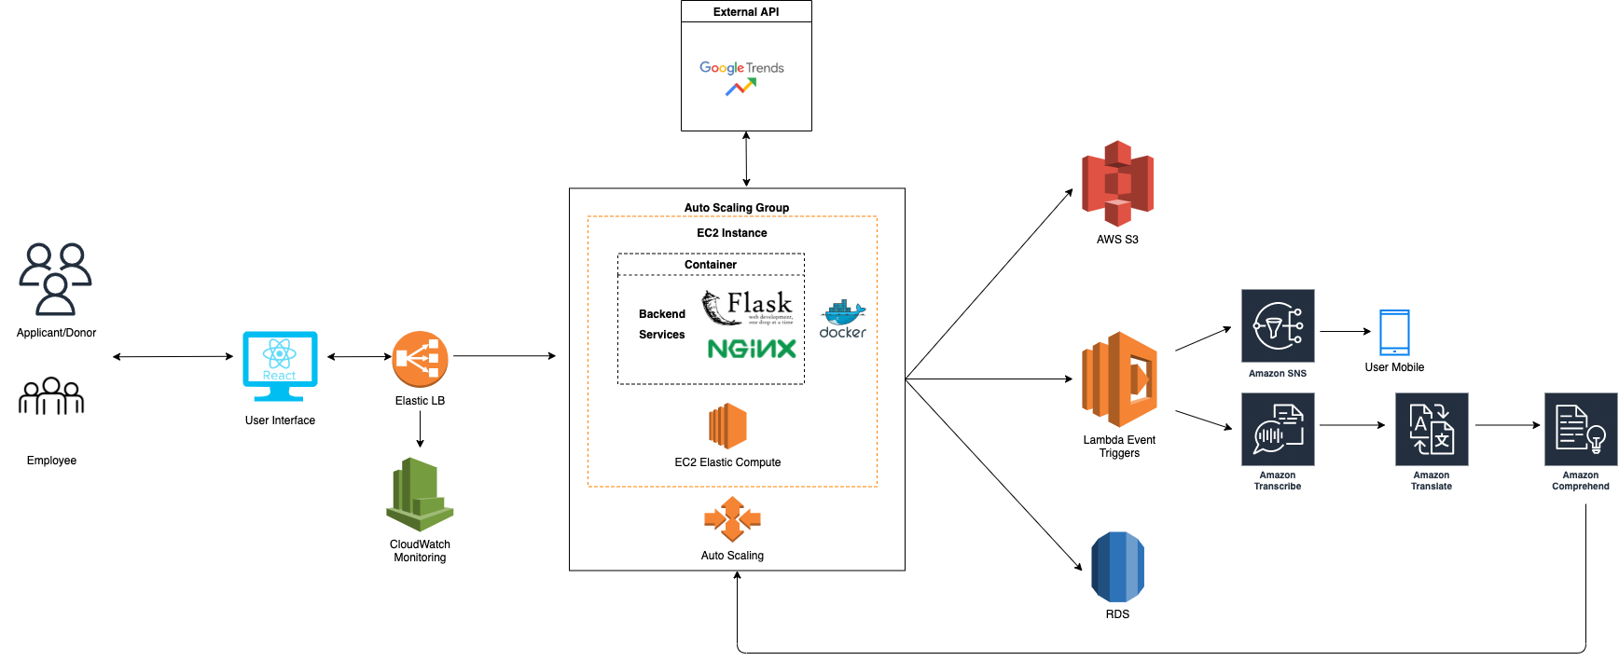

[SolutionArchitecture](https://drive.google.com/file/d/1LZFNTF5rx1ql4hzy427djRMwgCPiJtqv/view?usp=sharing)

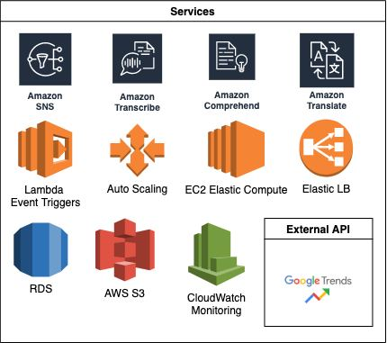

# 5. Moving Ahead

* *Should your team’s idea be chosen, how would you further develop the solution given sufficient resources?*
* *How scalable and viable is your team’s solution?*

1. Scalability
   1. We hope to expand our services to even more businesses and extend the opportunity for individuals with a dream.
2. Expanding on financial literacy
   1. Beyond Google Trends, we hope to provide more informational features relating to the business plans:
   2. Educational section to teach business owners and individuals important financial terms like Loans and Contract

# 6. Appendix

# 7. References

<https://www.fundera.com/blog/what-percentage-of-small-businesses-fail>

<https://www.prnewswire.com/news-releases/crowdfunding-market-to-grow-by-usd-196-36-billion-during-2021-2025--13-86-year-over-year-growth-in-2021--technavio-301249041.html>

<https://www.adb.org/publications/financial-inclusion-asia-overview>