ASG Airlines - Data Engineering Case Study

1. What I was asked to do
ASG Airlines collects flight data from a few different operational systems - booking platforms, scheduling, and airport logs. Because these systems don't talk to each other properly, the data that comes out has real problems - flight identifiers that don't match up cleanly, missing airline names, overnight flights that mess with duration calculations, and so on. The goal of this case study was to take that messy data, clean it, model it properly, and turn it into something a business analyst could actually use to look at flight operations, delays and route performance.
I did this fully locally (Python + pandas + Power BI Desktop) instead of Azure, since I didn't have working Azure access for this. The logic maps over 1-to-1 to a cloud setup if it was ever needed later - same cleaning rules, same star schema, just running on my own machine instead of ADF/Databricks.

2. The data I actually recieved
The workbook had 4 sheets, not just the flight fields mentioned in the brief. This mattered a lot because 3 of those sheets (bookings, passengers, payments) contain passenger PII that needed to be handled carefully.
- flights (1020 rows) - flight_id, airline, source, destination, departure_time, arrival_time, duration
- bookings (1000 rows) - booking_id, passenger_id, flight_id, status, passport_number, seat_number, emergency contact info
- payments (1000 rows) - payment_id, booking_id, amount, payment_method
- passengers (1039 rows) - passenger_id, name, age, gender, email, phone, aadhaar_id, date_of_birth
Because bookings/payments/passengers all link back to flights through IDs, I treated this as one connected dataset rather than 4 separate ones, and built a proper relational model out of it instead of just cleaning the flights sheet in isolation.

3. Problems I found in the data
Before writing any cleaning code I first just explored the raw data to see what was actually wrong with it (rather than guessing). Here's what came up, with real counts:
Duplicate flight rows (exact duplicates) | 15
Flights with missing/UNKNOWN airline | 72 (41 NaN + 31 'UNKNOWN')
Flights with negative duration (arrival before departure) | 1 (SJ192)
Legit overnight flights (arrival next day) | 124
Payment amounts that are NaN or the literal text 'INVALID' | 78 (48 NaN + 30 INVALID)
Duplicate passenger_id rows | 39
Bookings with missing status | 45
Bookings with status = 'INVALID' | 30
The flight_id field itself was actually fine - every single one matched the pattern of 2 letters + 3 digits (like SJ010, AI155). The 'corruption' mentioned in the brief turned out to be in the airline column, not the flight_id column - which makes sense once you notice the first two letters of every flight_id already tell you the airline (6F = IndiGo, AI = Air India, SJ = SpiceJet, UK = Vistara).
One thing I found that wasn't mentioned anywhere in the brief: the payments sheet has 1000 rows but only 637 unique booking_id values. That means 363 bookings have zero payment record at all, and on top of that, 267 bookings have more than one payment attempt logged against them (some up to 6 attempts, with different amounts and different payment methods each time). There's no success/fail flag on payments, so this looks like retried or duplicate charge attempts rather than one clean payment per booking. I go into why this matters in section 6 below - it was probably the most important thing I caught in the whole dataset.

4. How I cleaned it (the actual logic)

Flights
- Dropped 15 exact duplicate rows.
- Fixed missing/UNKNOWN airline by mapping the flight_id prefix (6F/AI/SJ/UK) to the airline name - this is deterministic, not a guess, since the prefix always matches the real airline in the rows that do have a valid airline.
- Calculated duration_minutes as (arrival_time - departure_time) in minutes, using full datetime values so overnight flights work correctly automatically - no special-casing needed, since arrival_time already carries the correct date (one day later for overnight flights).
- Flagged is_overnight = TRUE where arrival date is after departure date. 122 flights after cleaning (124 before dedup - 2 duplicates removed happened to be overnight ones).
- The one row with a negative duration (SJ192, arrival timestamp earlier than departure) was pulled out into a separate quarantine_flights table instead of being dropped silently or 'fixed' by guessing - so there's a full audit trail of what was removed and why.

Payments
- Converted amount to numeric, coercing 'INVALID' text and blanks to null (78 total).
- Imputed the nulls using the median amount for that specific payment_method (CARD / NETBANKING / UPI), so the imputed values stay realistic instead of using one global median.
- Added is_amount_imputed flag so anyone looking at revenue numbers later can tell which rows were guessed vs which were real.
- Added payment_attempt_count per booking, and kept only the highest payment_id per booking as the 'settled' payment (since payment_id order is the closest thing to a timestamp we have for payments).

Bookings
- Missing status filled as 'UNKNOWN' rather than guessing CONFIRMED/CANCELLED.
- 'INVALID' status kept as-is rather than overwritten, since silently changing a status could hide a real data quality problem from whoever reads the report later.
- passport_number masked to first letter + stars + last 2 digits (e.g. P*****87).
- emergency_contact_phone masked, keeping only last 4 digits.
- emergency_contact_name dropped entirely - it's a real person's name with no analytical value, so there's no reason to keep it around even masked.

Passengers
- Removed 39 duplicate passenger_id rows, keeping the first occurance.
- Missing last_name filled with 'N/A'.
- aadhaar_id masked to last 4 digits only (XXXXXXXX6001 style).
- phone masked to last 4 digits.
- email one-way hashed with SHA-256 (not reversible, but still usable to check if two rows belong to the same person).

5. Assumptions I made
A few decisions here were judgment calls, not something the data told me directly, so I'm writing them down explicitly:
- Payment_id order is used as a stand-in for time order, since payments has no timestamp column. I assumed the highest payment_id per booking = the most recent/settled attempt.
- A booking with zero payment rows is treated as 'no payment on file', not as revenue-zero or an error - it's just missing data, same as everything else in this dataset.
- I didn't try to guess which of the multiple payment attempts (if any) actually succeeded, since there's no status field for payments to confirm that. Revenue is reported 3 ways (naive/settled/confirmed-only) instead of picking one number and hiding the ambiguity.
- Duration anomaly threshold set at <30 min or >360 min based on eyeballing the distribution - turned out 0 flights hit this after cleaning (the shortest real flight is exactly 30 min).

6. The revenue overstatement issue (the important one)
This is the thing I want to call out clearly because I think it's easy to miss if you just write SUM(amount) without checking the data first. If you sum every single row in payments, you get a much bigger number than the airline actually recieved, because a lot of bookings show up multiple times with different amounts. Once I kept only one settled payment per booking, revenue dropped by 56.8%. That's not a small rounding thing - it's the difference between a report that overstates revenue by more than half, versus one that's actually usable for real business decisions.
Naive revenue (sum of every payment row) | Rs. 80,05,891.53
Settled revenue (1 payment per booking - the correct number) | Rs. 51,07,104.33
Revenue counting only CONFIRMED bookings | Rs. 16,98,568.58
Overstatement if you don't dedupe payments | 56.8%
Bookings with more than one payment attempt | 267
Bookings with zero payment record at all | 363

7. Data model
I organised the cleaned data into a small star schema so it's easy to filter/slice in Power BI:
- dim_airline - airline_key, airline name
- dim_route - route_key, source, destination, route_name
- dim_passenger - passenger_key, name, age, gender, masked contact info
- fact_flight_operations - one row per flight, links to dim_airline and dim_route, has duration/overnight/anomaly flags
- fact_booking_payments - one row per booking, links to flights and passengers, has the settled payment info and a payment_status flag (PAYMENT_RECORDED / NO_PAYMENT_RECORD)
- quarantine_flights - the one bad row, kept seperately with a reason column
- pipeline_summary - every cleaning metric (counts above) in one small table, so the dashboard's data-quality page reads real numbers instead of me typing them in by hand

8. The Power BI dashboard
3 pages, built off the star schema above. Screenshots below are straight from the actual file.

Page 1 - Executive Overview
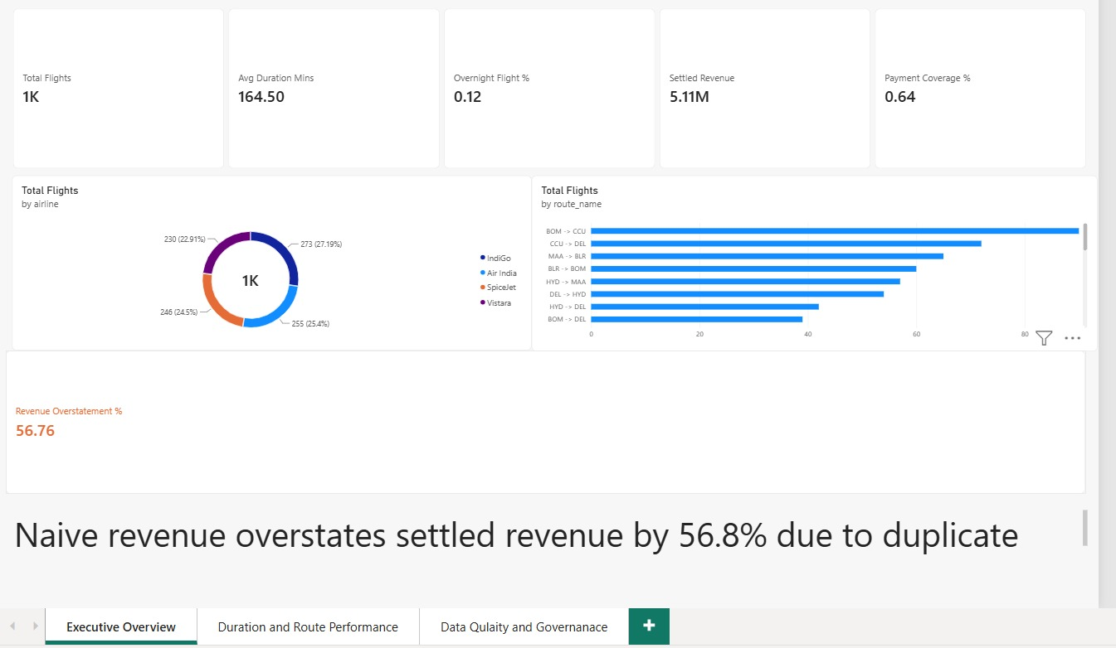
Page 1: KPI cards for total flights, avg duration, overnight %, settled revenue and payment coverage, plus airline share and top routes. The card at the bottom is the revenue overstatement catch called out above - I kept it seperate from the other KPI cards on purpose so it actually gets noticed.
Total flights sits at ~1K (1004 after cleaning), average duration works out to about 2h 45m, and roughly 12% of flights are overnight. Payment coverage of 0.64 means only 64% of bookings actually have a payment on record - the other 36% are the 'no payment record' bookings mentioned earlier.

Page 2 - Duration and Route Performance
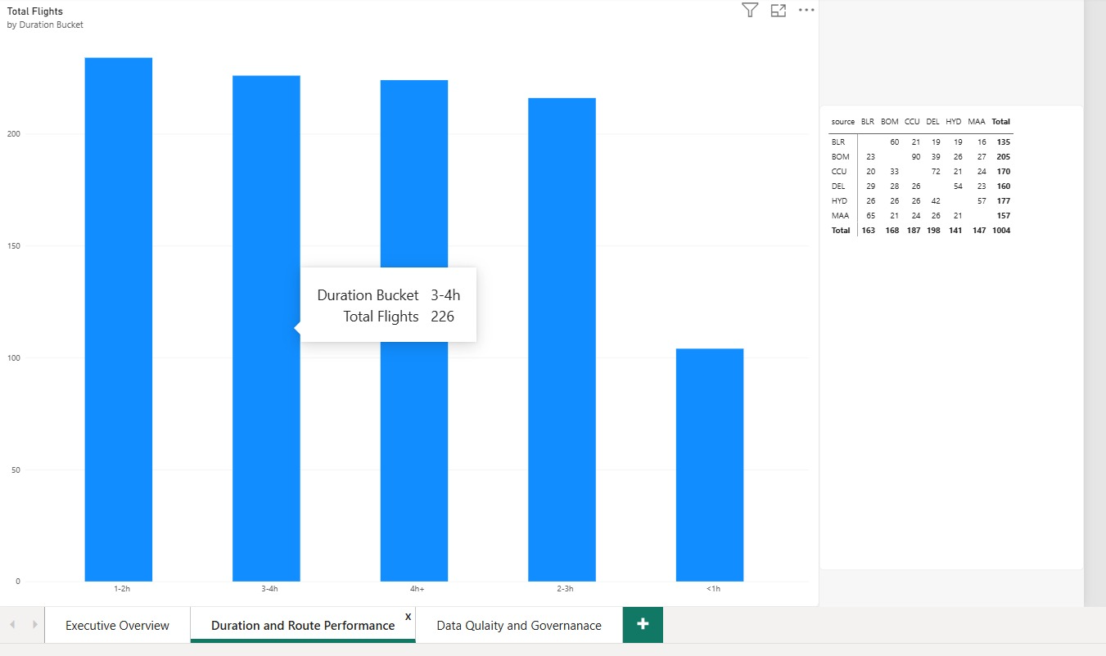
Page 2: flight duration split into buckets, and a source-to-destination matrix showing how busy each route pair is. BOM-CCU and CCU-DEL are the busiest single routes.
Durations are fairly evenly spread across the 1-4h+ buckets, nothing looks artificially clustered. The route matrix on the right makes it easy to see which airports are net senders vs net receivers of traffic - e.g. DEL receives a lot more flights (198) than it sends (163).

Page 3 - Data Quality and Governance
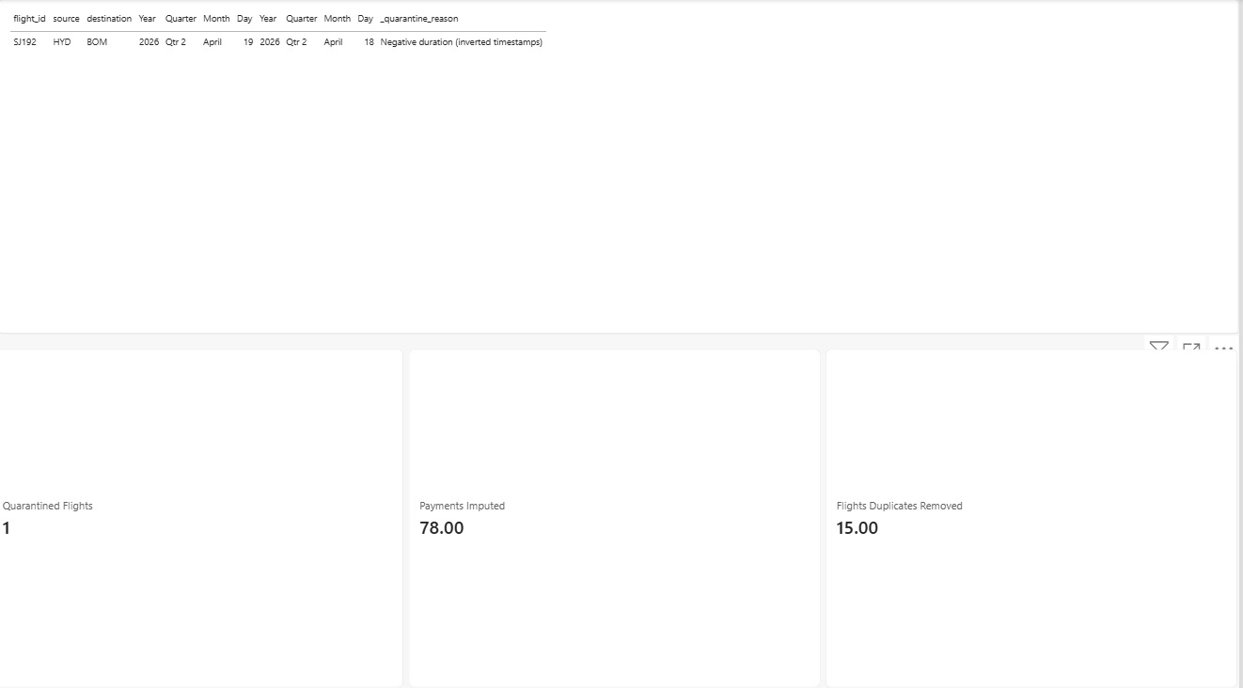
Page 3: the actual quarantined row (SJ192, negative duration), plus audit cards for how many records were fixed/removed during cleaning.
This page exists so the cleaning work isn't just something I claim happened in a document somewhere - the quarantined row is right there with its reason, and the imputation/dedup counts match exactly what's reported in sections 3 and 4 above.

9. Privacy and access control
Since bookings/passengers contain real PII (Aadhaar, passport, phone, email), a few things were done specifically for that:
- All PII is masked/hashed before it ever reaches the fact/dim tables used for reporting - nobody looking at the Power BI file or the gold/ csvs sees a real Aadhaar number, passport number or phone number.
- Email is hashed (SHA-256) rather than just masked, since hashing lets you still match 'is this the same person' across records without ever storing the real email.
- Raw unmasked data (the original Excel file) is not pushed to GitHub - only the cleaned/masked output tables are, which is why the repo is safe to make public.
- In a real production setup this would extend to row-level security in Power BI (so e.g. an IndiGo ops person can't see SpiceJet's routes/revenue) and role-based access on who can even query the raw bronze-layer data before masking - I didn't build this part out since it needs an actual Power BI Service tenant, but it's a straightforward next step.

10. Closing note
The biggest thing I'd want a reviewer to take away from this isn't the star schema or the dashboard pages - those are fairly standard. It's the payment-retry issue in section 6. A pipeline that just sums every row without checking for duplicate/retried payments would hand the business a revenue number that's wrong by more than half, and nothing in the raw data structure warns you about that unless you actually go looking. That's the kind of thing I tried to build this whole pipeline around - not just cleaning what's obviously broken, but checking assumptions before they turn into a wrong number on a dashboard.

