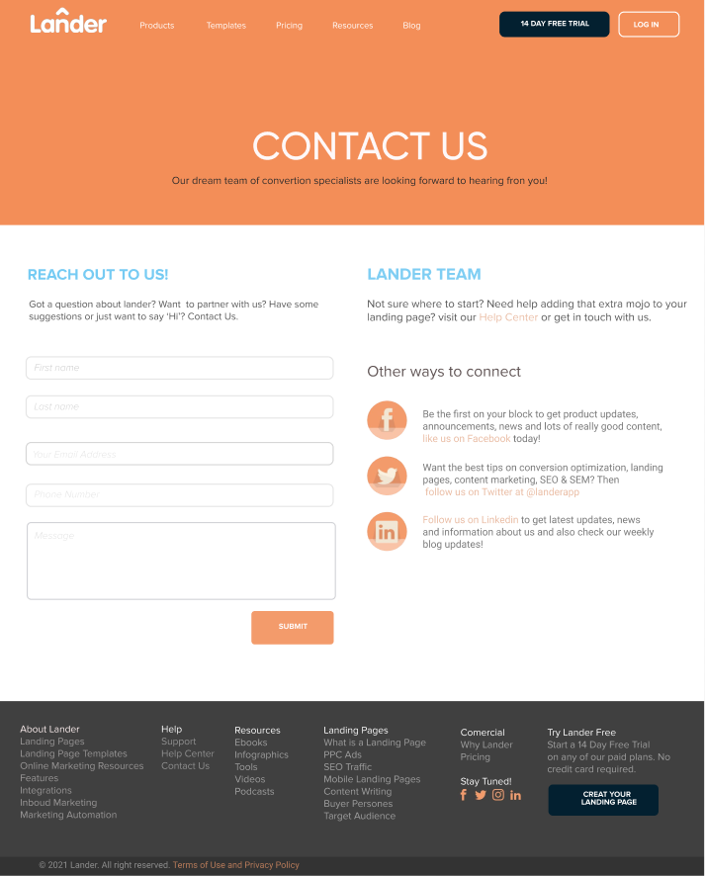
Nav
Header
container
Footer
Copyright
section

