# Homework 3. Continuum mechanics

1. Problem 1

A block slides along a rough surface at an angle 𝛼 with some constant velocity (Figure 1). Given

that the mass of the block 𝑚, the coefficient of friction between the block and the surface 𝑓 and the area of the block 𝑆, find the stress tensor describing the stresses on the bottom surface of the block.

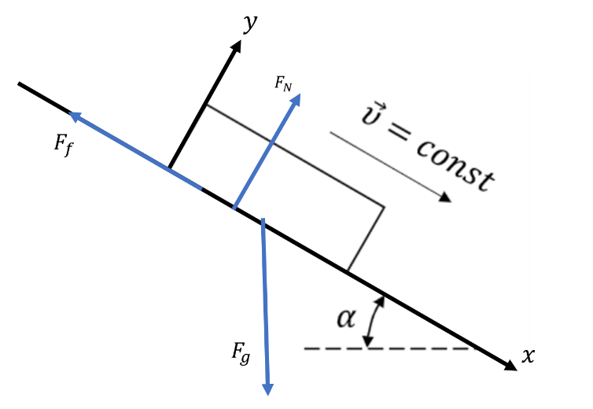

Third Newton’s Low:

$$F_{f}+F_{gx}=0$$

$$F_{N}+F_{gy}=0$$

Gravity:

$$F_{g}=mg, F_{gx}=mg\sin\left(α\right), F_{gy}=-mg\cos\left(α\right)$$

Consider bottom surface:

$$σ_{yy}=\frac{F_{gy}}{S}=-\frac{mg}{S}\cos\left(α\right)$$

$$σ_{yx}=\frac{F_{gx}}{S}=\frac{mg}{S}\sin\left(α\right)$$

$$σ_{yz}=0$$

1. Problem 2

At some point of the body in the Cartesian orthogonal coordinate system, the stress tensor is given

by its components:

$$S_{ij}=\left[\begin{matrix}150 & 45 & 180 \\ 45 & 0 & -120 \\ 180 & -120 & -60\end{matrix}\right]Pa$$

For an area with normal 𝑛1 =2/3,𝑛2 =2/3,𝑛3 =1/3, find the components of the vector 𝑝⃗𝑛

and the magnitudes of the shear and normal stresses. Find the angle between 𝑝⃗𝑛 and 𝑛⃗⃗.

$$p_{n}=Sn=\left[\begin{matrix}150 & 45 & 180 \\ 45 & 0 & -120 \\ 180 & -120 & -60\end{matrix}\right]\left[\begin{matrix}2 \\ 2 \\ 1\end{matrix}\right]\frac{1}{3} =\left[\begin{matrix}570 \\ -30 \\ 60\end{matrix}\right]\frac{1}{3}=\left[\begin{matrix}190 \\ -10 \\ 20\end{matrix}\right]=10\left[\begin{matrix}19 \\ -1 \\ 2\end{matrix}\right]$$

$$p_{nn}=n^{T}p_{n}=\frac{10}{3}{\left[\begin{matrix}2 \\ 2 \\ 1\end{matrix}\right]}^{T}\left[\begin{matrix}19 \\ -1 \\ 2\end{matrix}\right]=\frac{380}{3}Pa$$

$$p_{nτ}=\sqrt{p_{n}^{2}-p_{nn}^{2}}=\frac{50}{3}\sqrt{74}=143Pa$$

$$\cos\left(\hat{p_{n}n}\right)=\frac{p_{n}n}{\left|p_{n}\right|\left|n\right|}=\frac{p_{n}n}{\left|p_{n}\right|}=\frac{\frac{380}{3}}{10\sqrt{366}}=\frac{19\sqrt{366}}{549}$$

$$\hat{p_{n}n}=arcos\left(\frac{19\sqrt{366}}{549}\right)={49}^{0}$$

1. Problem 3

Given stress tensor:

$$S_{ij}=\left[\begin{matrix}σ_{11} & 0 & 0 \\ 0 & σ_{22} & 3 \\ 0 & 3 & 2\end{matrix}\right]MPa$$

Find $σ_{11}$ and $σ_{22}$, considering that the maximum shear stress is 8.5 MPa, the two non-maximum

principal stresses are −7 MPa and 3 MPa.

Let’s find coordinate system where S is dioganal. For this we need to find e-vals, they will be on the main diagonal.

$$\left|\left[\begin{matrix}σ_{11}-λ & 0 & 0 \\ 0 & σ_{22}-λ & 3 \\ 0 & 3 & 2-λ\end{matrix}\right]\right|=\left(σ_{11}-λ\right)\left(\left(σ_{22}-λ\right)\left(2-λ\right)-9\right)=0$$

$$λ_{1}=σ_{11}$$

$$\left(\left(σ_{22}-λ\right)\left(2-λ\right)-9\right)=2σ_{22}-λσ_{22}-2λ+λ^{2}-9=λ^{2}-λ\left(σ_{22}+2\right)+2σ_{22}-9=0$$

$$D=σ_{22}^{2}-4σ_{22}+40$$

$$λ_{2,3}=\frac{\left(σ_{22}+2\right)±\sqrt{D}}{2}=\frac{σ_{22}}{2}+1±\frac{\sqrt{D}}{2}$$

$$S_{ij}=\left[\begin{matrix}σ_{11} & 0 & 0 \\ 0 & σ_{22} & 3 \\ 0 & 3 & 2\end{matrix}\right]MPa=A\left[\begin{matrix}σ_{11} & 0 & 0 \\ 0 & \frac{σ_{22}}{2}+1+\frac{\sqrt{D}}{2} & 0 \\ 0 & 0 & \frac{σ_{22}}{2}+1-\frac{\sqrt{D}}{2}\end{matrix}\right]A^{*}Mpa=$$

Let $\frac{σ_{22}}{2}+1±\frac{\sqrt{D}}{2}=\left(3,-7\right)$

$$\frac{σ_{22}}{2}+1+\frac{\sqrt{D}}{2}=3$$

$$\frac{σ_{22}}{2}+1-\frac{\sqrt{D}}{2}=-7$$

Then $σ_{22}=-6$,=> $D=6^{2}-4\left(-6\right)+40=100={10}^{2}$

$$\frac{σ_{22}}{2}+1+\frac{\sqrt{D}}{2}=\frac{-6}{2}+1+\frac{10}{2}=3$$

$$\frac{σ_{22}}{2}+1-\frac{\sqrt{D}}{2}=\frac{-6}{2}+1-\frac{10}{2}=-7$$

The last $\frac{σ_{11}-\left(-7\right)}{2}=8.5=>σ_{11}=10$

Finally $σ_{22}=-6, σ_{11}=10$

1. Problem 4

In some plane parallel flow, the x-component of the velocity field is known:

$$υ_{x} =-A\frac{y}{r^{2}}, A=const, r=\sqrt{{(x}^{2} +y^{2})}.$$

Find y-component of the motion, if it is known that the fluid is incompressible (also 𝜐𝑦 →0 for 𝑦 →∞ for all x). Is the motion potential, if yes, is this statement satisfied for all points? Explain your answer.

As far as fluid is incompressible => $ρ$ is const.

Mass conservation low: $\frac{∂ρ}{∂t}+div\left(ρv\right)=0=>div\left(ρv\right)=0=>div\left(v\right)=0$

$$\frac{∂v_{x}}{∂x}+\frac{∂v_{y}}{∂y}+\frac{∂v_{z}}{∂z}$$

As far as In ou case it is parallel flow, Let’s chose coordinate system such that $v_{z}$ parallel to that flow. So $v_{z}=0$

$$\frac{∂v_{x}}{∂x}+\frac{∂v_{y}}{∂y}=0$$

$$\frac{∂v_{x}}{∂x}=-\frac{∂}{∂x}A\frac{y}{r^{2}}=-\frac{∂}{∂x}A\frac{y}{x^{2} +y^{2}}=A\frac{2xy}{{\left(x^{2} +y^{2}\right)}^{2}}$$

$$\frac{∂v_{x}}{∂x}+\frac{∂v_{y}}{∂y}=A\frac{2xy}{{\left(x^{2} +y^{2}\right)}^{2}}+\frac{∂v_{y}}{∂y}=0$$

$$\frac{∂v_{y}}{∂y}=A\frac{-2xy}{{\left(x^{2} +y^{2}\right)}^{2}}$$

$$v_{y}=\frac{Ax}{x^{2}+y^{2}}+C\left(x\right)=\frac{Ax}{r^{2}}+C\left(x\right)$$

For $y→∞,x$ is any: $$v_{y}=\frac{Ax}{r^{2}}+C\left(x\right)=C\left(x\right)$$

From the task condition $v_{y}$ must converge to 0 for any x, $y→∞=>C\left(x\right)=0$

$$v=\left(-\frac{Ay}{r^{2}},\frac{Ax}{r^{2}},0\right)=\frac{A}{r^{2}}\left(-y,x,0\right)$$

Flow is potential if $rot\left(v\right)=0$

$$rot\left(v\right)=\left|\begin{matrix}i & j & k \\ \frac{∂}{∂x} & \frac{∂}{∂y} & \frac{∂}{∂z} \\ v_{x} & v_{y} & v_{z}\end{matrix}\right|=i\left(\frac{∂v_{z}}{∂y}-\frac{∂v_{y}}{∂z}\right)-j\left(\frac{∂v_{z}}{∂x}-\frac{∂v_{x}}{∂z}\right)+k\left(\frac{∂v_{y}}{∂x}-\frac{∂v_{x}}{∂y}\right)=$$

$$i\left(0-0\right)-j\left(0-0\right)+k\left(\frac{∂v_{y}}{∂x}-\frac{∂v_{x}}{∂y}\right)=k\left(\frac{∂v_{y}}{∂x}-\frac{∂v_{x}}{∂y}\right)$$

$$\frac{∂v_{y}}{∂x}=\frac{∂}{∂x}\frac{Ax}{r^{2}}=\frac{A}{r^{2}}+x\frac{∂}{∂x}\frac{A}{r^{2}}=\frac{A}{r^{2}}+x\frac{∂}{∂x}\frac{A}{x^{2}+y^{2}}=\frac{A}{r^{2}}-x\frac{A2x}{{\left(x^{2}+y^{2}\right)}^{2}}=\frac{A}{r^{2}}-\frac{2Ax^{2}}{r^{4}}$$

$$\frac{∂v_{x}}{∂y}=-\frac{∂}{∂y}\frac{Ay}{r^{2}}=-\frac{A}{r^{2}}+\frac{2Ay^{2}}{r^{4}}$$

$$rot\left(v\right)=k\left(\frac{∂v_{y}}{∂x}-\frac{∂v_{x}}{∂y}\right)=k\left(\frac{A}{r^{2}}-\frac{2Ax^{2}}{r^{4}}+\frac{A}{r^{2}}-\frac{2Ay^{2}}{r^{4}}\right)=k\left(2\frac{A}{r^{2}}-\frac{2A\left(x^{2}+y^{2}\right)}{r^{4}}\right)= \\ k\left(2\frac{A}{r^{2}}-\frac{2A(x^{2}+y^{2})}{r^{4}}\right)=k\left(2\frac{A}{r^{2}}-\frac{2Ar^{2}}{r^{4}}\right)=0$$

Flow is potential

1. Stress field is described with the stress field:

$$S_{ij}=\left[\begin{matrix}pgx_{1} & 2γx_{2}x_{3} & -γx_{3}^{2} \\ 2γx_{2}x_{3} & \frac{βx_{2}}{x_{3}^{2}} & \frac{β}{x_{3}} \\ -γx_{3}^{2} & \frac{β}{x_{3}} & 0\end{matrix}\right]$$

Assume what forces act on continuum if it is in equilibrium at this moment.

$$\frac{dv}{dt}=0$$

$$ρ\frac{dv}{dt}=ρF+∇_{j}S^{ij}e_{i}=0$$

$$F=-\frac{1}{ρ}∇_{j}S^{ij}e_{i}$$

$$F_{1}=-\frac{1}{ρ}∇_{j}S^{1j}=-\frac{1}{ρ}\frac{∂}{∂x_{j}}S^{1j}=-\frac{1}{ρ}\left(\frac{∂}{∂x_{1}}pgx_{1}+\frac{∂}{∂x_{2}}2γx_{2}x_{3}-\frac{∂}{∂x_{3}}γx_{3}^{2}\right)= \\ -\frac{1}{ρ}\left(pg+2γx_{3}-2x_{3}γ\right)=-g$$

$$F_{2}=-\frac{1}{ρ}∇_{j}S^{2j}=-\frac{1}{ρ}\left(0+\frac{β}{x_{3}^{2}}-\frac{β}{x_{3}^{2}}\right)=0$$

$$F_{3}=-\frac{1}{ρ}∇_{j}S^{3j}=-\frac{1}{ρ}\left(0\right)=0$$

1. Problem 6 (additional: gives max +10% of your HW grade)

Two bodies A and B are stationary in a pipe through which a fluid flow. Let 𝑆1 and 𝑆2 be the cross sections of the pipe far ahead and behind bodies 𝐴 and 𝐵 (Figure 2), 𝑇 be the surface of the pipe walls between 𝑆1 and 𝑆2.

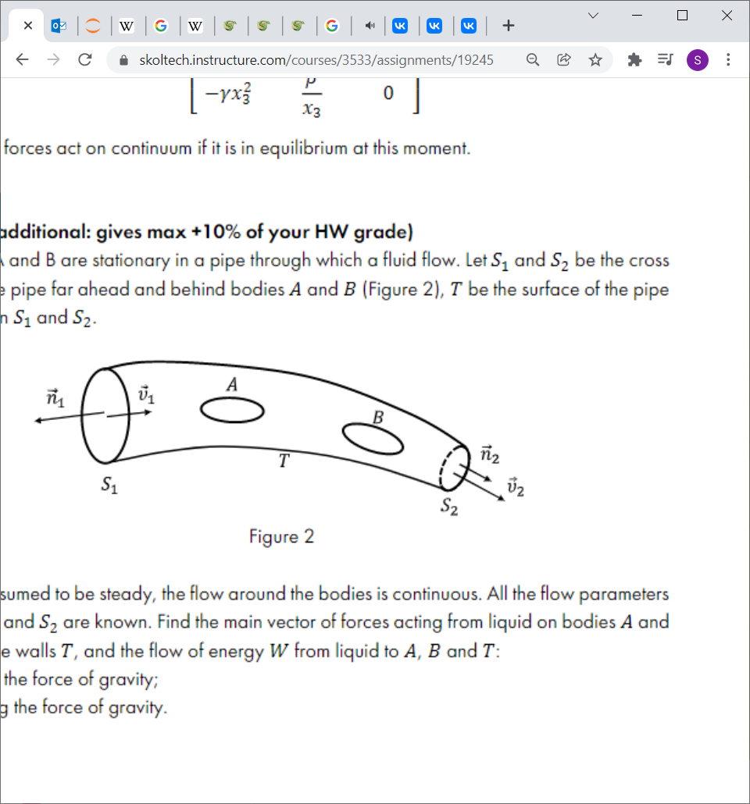

The flow is assumed to be steady, the flow around the bodies is continuous. All the flow parameters in sections 𝑆1 and 𝑆2 are known. Find the main vector of forces acting from liquid on bodies 𝐴 and 𝐵 and on pipe walls 𝑇, and the flow of energy 𝑊 from liquid to 𝐴, 𝐵 and 𝑇:

a) neglecting the force of gravity;

b) considering the force of gravity.

$$\frac{d}{dt}\int_{V}{ρvdV=\int_{S}{ρvv_{n}dS}=}\int_{V}{ρFdV}+\int_{S}{p_{f}ndS}$$

1. Suppose external mass forces are zero: F =0,

$$\int_{S}{ρvv_{n}dS}=\int_{S}{p_{f}ndS}$$

$S=S1+S2+A+B+T,$ but on the A,B,T surfaces $v_{n}=0$

Total force : $P=P_{n}-\int_{S}{p_{f}ndS},$ where $P_{n}$ external forces (normal components), $p_{f}$ is pressure of liquid.

$$P=P_{n}-\int_{S}{p_{f}ndS}=P_{n}-\int_{S1+S2}{ρvv_{n}dS}=\int_{S1+S2}{p_{n}-ρvv_{n}dS}$$

$p_{n }$ is external pressure in normal on S1,S2

Low of Energy conservation in our case:

$$\frac{d}{dt}\int_{V}{\left(\frac{v^{2}}{2}+u\right)ρdV}=\int_{S1+S2}{\left(\frac{v^{2}}{2}+u\right)ρv_{n}dS}= \\ =\int_{V}{ρ\left(Fv\right)dV+\int_{S1+S2}{p_{n}vdS}-\int_{S1+S2}{q_{n}dS}=}\int_{S1+S2}{(p_{n}v}-q_{n})dS=$$

Flow of energy :

$$W=\int_{S1+S2}{(p_{n}v}-q_{n})dS-\int_{S}{\left(\frac{v^{2}}{2}+u\right)ρv_{n}dS}=\int_{S1+S2}{( p_{n}v}-q_{n}-\left(\frac{v^{2}}{2}+u\right)ρv_{n})dS$$

1. considering the force of gravity

$$F=g$$

$$\int_{S}{ρvv_{n}dS}=\int_{V}{ρFdV}+\int_{S}{p_{f}ndS}=>$$

$$\int_{S}{p_{f}ndS}=\int_{S}{ρvv_{n}dS}-\int_{V}{ρgdV}=\int_{S}{ρvv_{n}dS}-mg$$

$$P=P_{n}-\int_{S}{p_{f}ndS}=\int_{S1+S2}{(p_{n}-ρvv_{n})dS} -mg$$

Low of Energy conservation in this case:

$$\int_{S1+S2}{\left(\frac{v^{2}}{2}+u\right)ρv_{n}dS}=\int_{V}{ρ\left(Fv\right)dV}+\int_{S1+S2}{(p_{n}v}-q_{n})dS$$

$$W=\int_{S1+S2}{( p_{n}v}-q_{n}-\left(\frac{v^{2}}{2}+u\right)ρv_{n})dS+\int_{V}{ρ\left(gv\right)dV}$$