# Numerical Methods in Engineering and Applied Science. Assignment 2.

Student: Vyacheslav Kovalev

$$\begin{aligned}u^{'}\left(x_{i}\right)≈\frac{1}{h}\left(\frac{1}{6}u_{i-2}-\frac{4}{3}u_{i-1}+\frac{11}{6}u_{i}-\frac{5}{3}u_{i+1}+\frac{4}{3}u_{i+2}-\frac{1}{3}u_{i+3}\right) \#\left(1\right)\end{aligned}$$

1. Is (1) a consistent approximation to the first derivative of u(x)?

Yes. Answer why in the next point.

1. Use the Taylor series expansion to find the order of this approximation.

$$u\left(x_{i}+sh\right)=u\left(x_{i}\right)+sh u^{'}\left(x_{i}\right)+\frac{{\left(sh\right)}^{2}}{2}u^{''}\left(x_{i}\right)+\frac{{\left(sh\right)}^{3}}{6}u^{'''}\left(x_{i}\right)+O\left(h^{4}\right)$$

Let’s consider coefficients at $u\left(x_{i}\right)$.

$$u^{'}\left(x_{i}\right)≈\frac{1}{h}\left(\frac{1}{6}u_{i-2}-\frac{4}{3}u_{i-1}+\frac{11}{6}u_{i}-\frac{5}{3}u_{i+1}+\frac{4}{3}u_{i+2}-\frac{1}{3}u_{i+3}\right)==\frac{1}{h}\left(\frac{1}{6}u\left(x_{i}\right)-\frac{4}{3}u\left(x_{i}\right)+\frac{11}{6}u\left(x_{i}\right)-\frac{5}{3}u\left(x_{i}\right)+\frac{4}{3}u\left(x_{i}\right)-\frac{1}{3}u\left(x_{i}\right)+O(h)\right)=\frac{1}{h}\left(O(h)\right)$$

Coefficient at $u\left(x_{i}\right)$ is zero.

Performing this procedure for other members in the Tailor series:

$$u^{'}\left(x_{i}\right)≈\frac{1}{h}\left(\frac{1}{6}u_{i-2}-\frac{4}{3}u_{i-1}+\frac{11}{6}u_{i}-\frac{5}{3}u_{i+1}+\frac{4}{3}u_{i+2}-\frac{1}{3}u_{i+3}\right)=u^{'}\left(x_{i}\right)+\frac{h^{3}u^{''''}\left(x_{i}\right)}{4}+O\left(h^{4}\right)$$

Therefore:

$$\frac{1}{h}\left(\frac{1}{6}u_{i-2}-\frac{4}{3}u_{i-1}+\frac{11}{6}u_{i}-\frac{5}{3}u_{i+1}+\frac{4}{3}u_{i+2}-\frac{1}{3}u_{i+3}\right)-u^{'}\left(x_{i}\right)=\frac{h^{3}u^{''''}\left(x_{i}\right)}{4}+O\left(h^{4}\right)$$

3rd order of approximation.

While $h$ is small then it is a consistent approximation.

$$u^{'}-\frac{\sin\left(x\right)}{3+\cos\left(x\right)}u=\frac{\cos\left(2x\right)+3\cos\left(x\right)}{3+\cos\left(x\right)}$$

Homogenous:

$$u^{'}-\frac{\sin\left(x\right)}{3+\cos\left(x\right)}u=0$$

$$\int{\frac{du}{u}}=\int{\frac{\sin\left(x\right)}{3+\cos\left(x\right)}dx}$$

$$\ln\left(u\right)=\left\{\frac{t= 3+\cos\left(x\right)}{dt=-\sin\left(x\right)dx} \right\}=\int{\frac{\sin\left(x\right)}{t} \frac{dt}{-\sin\left(x\right)} }=-\int{\frac{1}{t} dt }=-\ln\left(t\right)+\ln\left(C\right)=\ln\left(\frac{C}{t}\right)=\ln\left(\frac{C}{3+\cos\left(x\right)}\right)$$

$$u_{h}=\frac{C}{3+\cos\left(x\right)}$$

Particular solution of the equation.

$$u^{'}-\frac{\sin\left(x\right)}{3+\cos\left(x\right)}u=\frac{\cos\left(2x\right)+3\cos\left(x\right)}{3+\cos\left(x\right)}$$

Let $u=A\sin\left(x\right)+B cos⁡(x)$

$$u^{'}-\frac{\sin\left(x\right)}{3+\cos\left(x\right)}u=A\cos\left(x\right)-B\sin\left(x\right)-\frac{\sin\left(x\right)\left(A\sin\left(x\right)+B\cos\left(x\right)\right)}{3+\cos\left(x\right)}=\frac{3A\cos\left(x\right)-3B\sin\left(x\right)+A\cos^{2}\left(x\right)-B\sin\left(x\right)\cos\left(x\right)-\sin^{2}\left(x\right)A-\sin\left(x\right)B\cos\left(x\right)}{3+\cos\left(x\right)}=\frac{3A\cos\left(x\right)-3B\sin\left(x\right)+A\cos\left(2x\right)-2B\sin\left(2x\right)}{3+\cos\left(x\right)}=\frac{\cos\left(2x\right)+3\cos\left(x\right)}{3+\cos\left(x\right)}$$

get: $B=0, A=1$

$$u_{p}=sin⁡(x)$$

Summing up:

$$u=\frac{C}{3+\cos\left(x\right)}+sin⁡(x)$$

Periodic boundary conditions: $x∈\left[0,2π\right], u\left(0\right)=0$

$$u\left(0\right)=\frac{C}{3+\cos\left(0\right)}+\sin\left(0\right)=\frac{C}{3+1}=0=>C=0$$

Summing up:

$$u=\sin\left(x\right), x∈\left[0,2π\right]$$

1. Use the finite-difference approximation (1) to solve this problem numerically. Plot the exact and the approximate u(x) calculated on a uniform grid with step h = π/10 over the interval from 0 to 2π.

$$u^{'}-\frac{\sin\left(x\right)}{3+\cos\left(x\right)}u=\frac{\cos\left(2x\right)+3\cos\left(x\right)}{3+\cos\left(x\right)}$$

Represent as:

$$Au+Bu=F$$

$$u^{T}=\left[u_{1},u_{2},…, u_{N}\right], u_{0}=0$$

From the task:

$$h=\frac{2π}{N}=>N=\frac{2π}{h}=20$$

Keep in mind that $u_{0}=0$ and neglect every $u_{0}$.

$$A=\frac{1}{6h}\left[\begin{matrix}11 & -10 & 8 & -2 & 0 & … & 0 & 1 \\ -8 & 11 & -10 & 8 & -2 & 0 & … & 0 \\ 1 & -8 & 11 & -10 & 8 & -2 & 0… & 0 \\ 0 & 1 & -8 & 11 & -10 & 8 & -2 & …0 \\ … & … & … & … & … & … & … & … \\ 0… & 0 & 1 & -8 & 11 & -10 & 8 & -2 \\ 0 & … & 0 & 1 & -8 & 11 & -10 & 8 \\ -2 & 0 & … & 0 & 1 & -8 & 11 & -10 \\ 8 & -2 & 0 & … & 0 & 1 & -8 & 11\end{matrix}\right]$$

$$x_{i}=ih=> B=-\left[\begin{matrix}\frac{\sin\left(h\right)}{3+\cos\left(h\right)} & 0 & … & 0 \\ 0 & \frac{\sin\left(2h\right)}{3+\cos\left(2h\right)} & 0… & 0 \\ … & … & … & … \\ 0 & … & 0 & \frac{\sin\left(Nh\right)}{3+\cos\left(Nh\right)}\end{matrix}\right]$$

$$F=\left[\begin{matrix}\frac{\cos\left(2h\right)+3\cos\left(h\right)}{3+\cos\left(h\right)} \\ \frac{\cos\left(2*2h\right)+3\cos\left(2h\right)}{3+\cos\left(2h\right)} \\ … \\ \frac{\cos\left(2*Nh\right)+3\cos\left(Nh\right)}{3+\cos\left(Nh\right)}\end{matrix}\right]$$

Solve $\left(A+B\right)U=F:$

$$U_{approx}={\left(A+B\right)}^{-1}F$$

Plot the exact and the approximate u(x) calculated on a uniform grid with step h = π/10 over the interval from 0 to 2π.

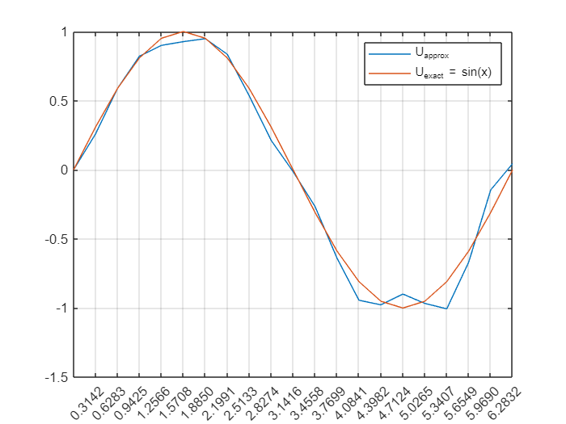

1. Vary h from a suitably small to a suitably large value to plot the convergence error norms (pointwise maximum and r.m.s.) as functions of h. Comment on the rate of convergence: compare your numerical observation with your theoretical result.

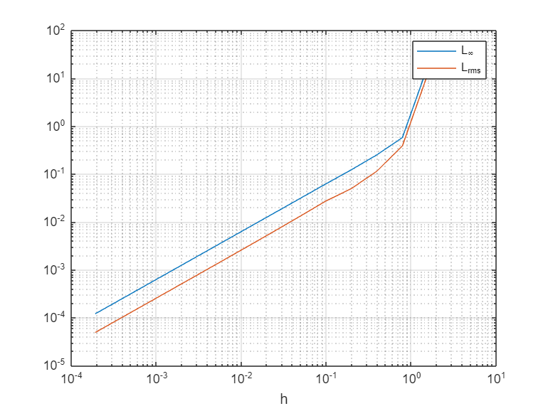

It is clear that $max\left|e_{k}\right|≈O\left(h\right), (\log\left(L_{∞}\right)≈\log\left(C\right)+p\log\left(h\right), where p=1⁡)$ So if we divide $h$ by 2, $max|e_{k}|$ becomes twice smaller.

The numerical result gives the same as theoretical.