# Numerical Methods in Engineering and Applied Science. Assignment 3.

Kovalev Vyacheslav

1. (max. 1 point) Find a quadratic polynomial p(t) that satisfies the following conditions:

$$\begin{aligned}p\left(t_{n}\right)= u_{n}, p^{'}\left(t_{n}\right)= f_{n}, p^{'}\left(t_{n+1 }\right)= f_{n+1} \#\left(1\right)\end{aligned}$$

Which time-stepping method do you obtain if you assign $u_{n+1} = p\left(t_{n+1}\right)$? Write a formula and name it.

$$p\left(t_{n}\right)=c+at_{n}+bt_{n}^{2}$$

$$p^{'}\left(t_{n}\right)= a+2bt_{n}=f_{n}$$

$$p^{'}\left(t_{n+1 }\right)=a+2bt_{n+1}=f_{n+1}$$

$$a=f_{n}-2bt_{n}$$

$$a+2bt_{n+1}=f_{n}-2bt_{n}+2bt_{n+1}=f_{n+1}$$

$$b=\frac{\left(f_{n+1 }-f_{n}\right)}{2t_{n+1}-2bt_{n}}=\frac{1}{2h}\left(f_{n+1 }-f_{n}\right)$$

$$a=f_{n}-2bt_{n}=f_{n}-\frac{1}{h}\left(f_{n+1 }-f_{n}\right)t_{n}=\frac{1}{h}\left(hf_{n}-f_{n+1 }t_{n}+f_{n}t_{n}\right)=\frac{1}{h}\left(f_{n}\left(h+t_{n}\right)-f_{n+1 }t_{n}\right)=\frac{1}{h}\left(f_{n}t_{n+1}-f_{n+1 }t_{n}\right)$$

$$u_{n}=p\left(t_{n}\right)=>c=u_{n}-at_{n}-bt_{n}^{2}$$

$$u_{n+1}=u_{n}-\frac{1}{h}\left(f_{n}t_{n+1}-f_{n+1 }t_{n}\right)t_{n}-\frac{1}{2h}\left(f_{n+1 }-f_{n}\right)t_{n}^{2}+ \frac{1}{h}\left(f_{n}t_{n+1}-f_{n+1 }t_{n}\right)t_{n+1}+\frac{1}{2h}\left(f_{n+1 }-f_{n}\right)t_{n+1}^{2}= \\ u_{n}-\frac{1}{2h}\left(f_{n+1 }-f_{n}\right)t_{n}^{2}+ \left(f_{n}t_{n+1}-f_{n+1 }t_{n}\right)+\frac{1}{2h}\left(f_{n+1 }-f_{n}\right)t_{n+1}^{2}= \\ u_{n}+ \left(f_{n}t_{n+1}-f_{n+1 }t_{n}\right)+\frac{1}{2h}\left(f_{n+1 }-f_{n}\right)\left(t_{n+1}^{2}-t_{n}^{2}\right)= \\ u_{n}+ \left(f_{n}t_{n+1}-f_{n+1 }t_{n}\right)+\frac{1}{2h}\left(f_{n+1 }-f_{n}\right)h\left(t_{n+1 }+t_{n}\right)= \\ u_{n}+ \left(f_{n}t_{n+1}-f_{n+1 }t_{n}\right)+\frac{1}{2}\left(f_{n+1 }t_{n+1 }-f_{n}t_{n+1 }+f_{n+1 }t_{n}-f_{n}t_{n}\right)= \\ u_{n}+\frac{1}{2}f_{n}t_{n+1}-\frac{1}{2}f_{n+1 }t_{n}+\frac{1}{2}\left(f_{n+1 }t_{n+1 }-f_{n}t_{n}\right)= \\ u_{n}+\frac{1}{2}f_{n}h+\frac{1}{2}f_{n+1 }h=u_{n}+\frac{h}{2}\left(f_{n}+f_{n+1 }\right)$$

It is the trapezoidal rule (order 2).

1. Consider a family of multi-step methods

$$u_{n+1} + \left(θ -2\right)u_{n} + \left(1 -θ\right)u_{n-1} =\frac{1}{4} h\left(\left(6 + θ\right)f_{n+1} + 3\left(θ -2\right)f_{n-1}\right)$$

where θ is a parameter.

1. Determine the order of consistency and the error constant of the method. Show that both do not depend on θ.

Let’s use Taylor expansion for $u_{n+1}, u_{n-1}, f_{n+1},f_{n-1}$, consider that $f_{n}={u'}_{n}$.

After that subtract the right-hand side from the left. (all calculations in the program)

$$u_{n+1} + \left(θ -2\right)u_{n} + \left(1 -θ\right)u_{n-1}-\frac{1}{4} h\left(\left(6 + θ\right)f_{n+1} + 3\left(θ -2\right)f_{n-1}\right)= \\ =-2h^{2}u_{n}^{''}-\frac{h^{3}}{3}u_{n}^{'''}θ$$

So, the order of consistency is 1. ( $-2h^{2}u_{n}^{''}-$ doesn’t depend on $θ$)

1. For which values of θ is the method convergent?

$$ρ\left(z\right)=z^{2}+\left(θ-2\right)z+\left(1-θ\right)=>z_{1,2}=\frac{1}{2}\left(-θ+2±θ\right)$$

$$z_{1}=1;z_{2}=1-θ$$

As far as $\left|z\right|≤1,$ and if $\left|z\right|=1$ it is simple: $θ∈[0,2]$ => method is zero stable +consistent =>it is convergent.

1. Using the explicit Euler method, calculate the time evolution of (xj,yj ) with t ∈ [0,1] and plot y1(x1), y2(x2). On a separate plot, show the convergence of the results of the calculations at t = 1 versus the discretization step h.

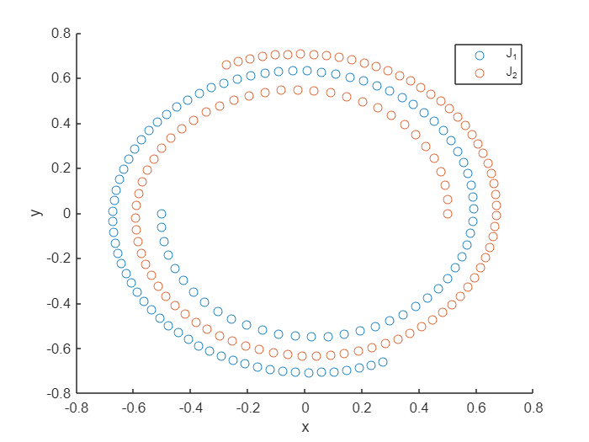

J1 is the first vortex, J2 is the second.

Solution must be periodic, therefore $Er_{j} =\left|J_{j}\left(1\right)- J_{j}\left(0\right)\right|=\sqrt{∆x^{2}-∆y^{2}}$.

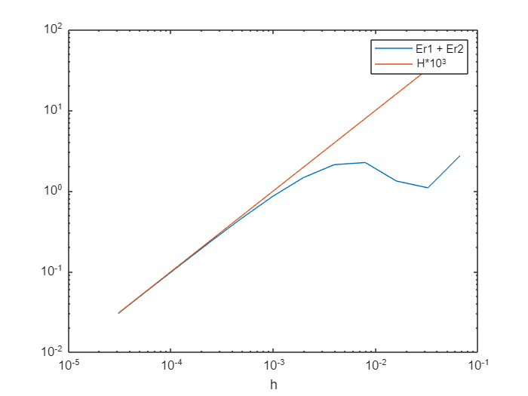

First order convergence.

1. Redo the same calculations using a third-order Runge–Kutta Method

Show the convergence plot with respect to h using the logarithmic scale and comment on the slope of the line that you obtain.

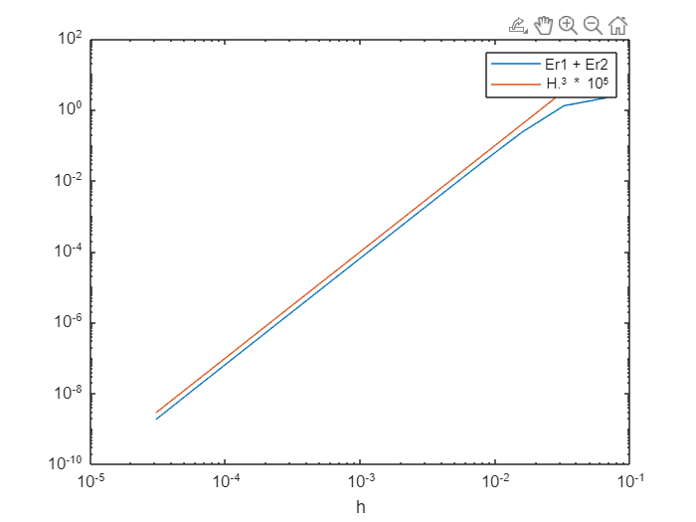

You can see 3rd order convergence. So, 3rd Runge-Kutta – 3rd order convergence.