Task#....

Construct boost converter with PI control.

$$V_{in}=10V, V_{out}=15V, I_{out}=1A, \frac{∆V_{out}}{V_{out}}=2\%$$

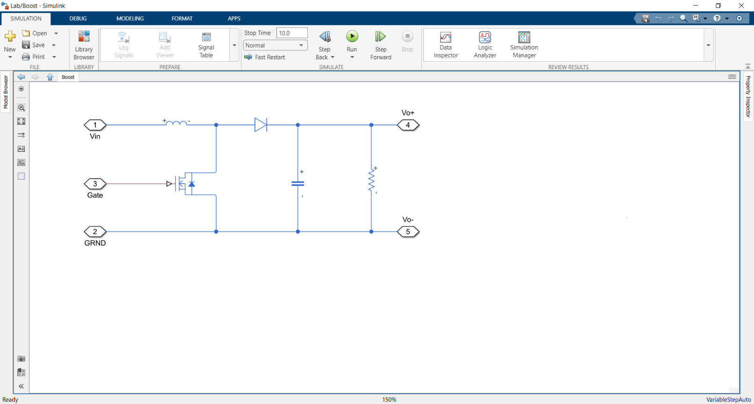Progress:

$$f=10 kHz, \frac{V_{0ut}}{V_{in}}=\frac{1}{1-D}=>D=66\%$$

$$R_{out}=\frac{V_{out}}{I_{out}}=15Ω, C=…, L_{min}=\frac{D{\left(1-D\right)}^{2}R}{2f}=…$$

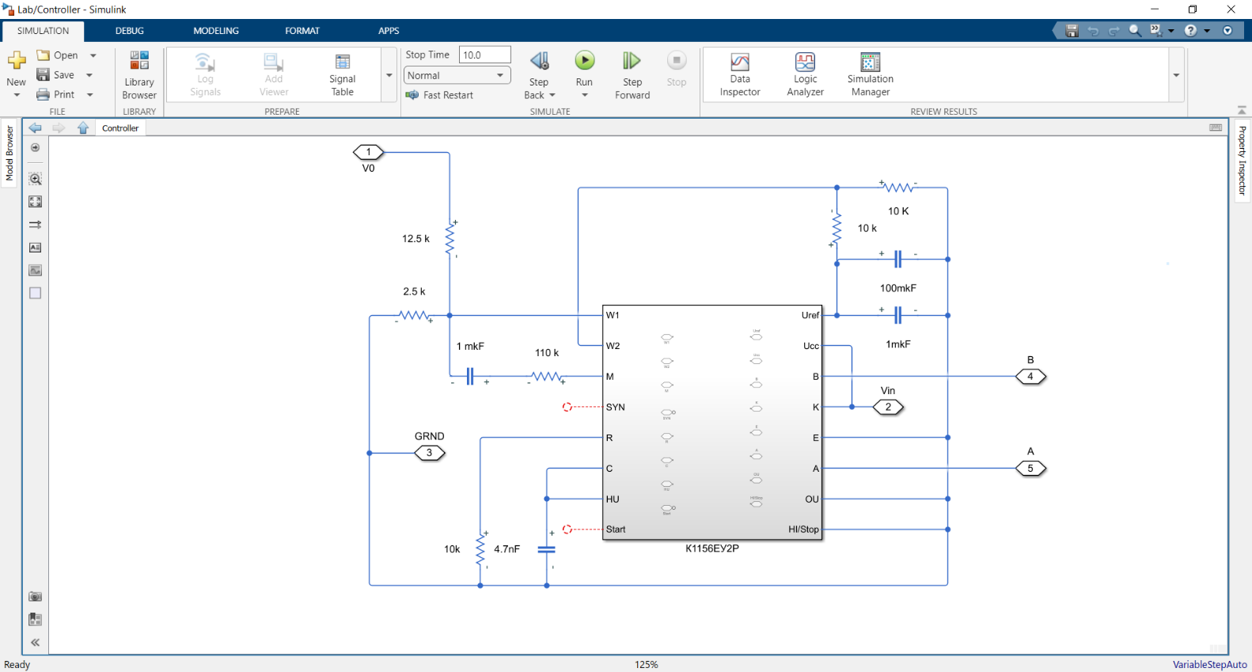*Construction of controller:*

*To control $f=10kHz$ R,C output of controller must be connected to $R=10kΩ,C=4.7nF$*

$V_{in}=15V$*is power supply of controller. $U_{ref}$ connects to $1mkF$ and $100mkF$ to filter signal.*

$U_{ref}=5V,$*so we divided it by 2 using two $10kΩ$ resistors. Our $V_{o}=15$ is boost result. In the resistor $2.5kΩ$ we expect 2.5V from $V_{o}$ and in the in the resistor 10k we expect 2.5V from $U_{ref}$ after that compare it in W1, W2.*

*Pi controller realized in RC circuit $(1mkF, 110kΩ)$ as a feedback of comparing.  
After that output goes to A and B (we need both because one has D max = 50% but we need 66%)*

*Driver:*

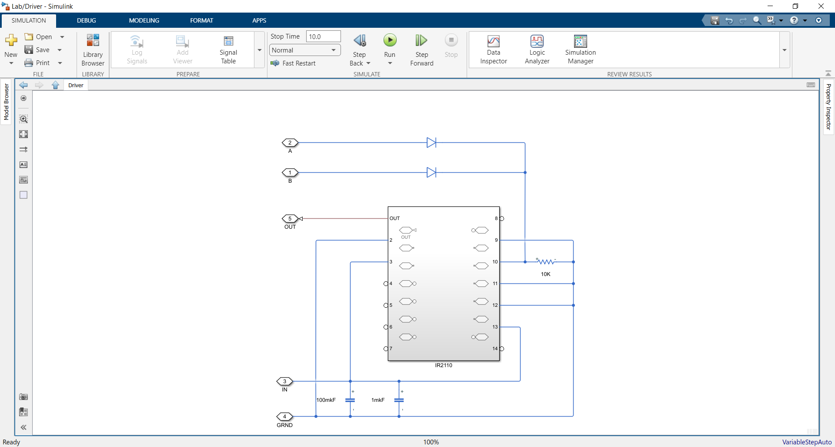*We sum our signals in 10 pin after that get result in first pin ($out)$. (we also filter input voltage using 2 capacitors)*

*Our out signal goes to gate of the boost coverter:*

*Full circuit:*

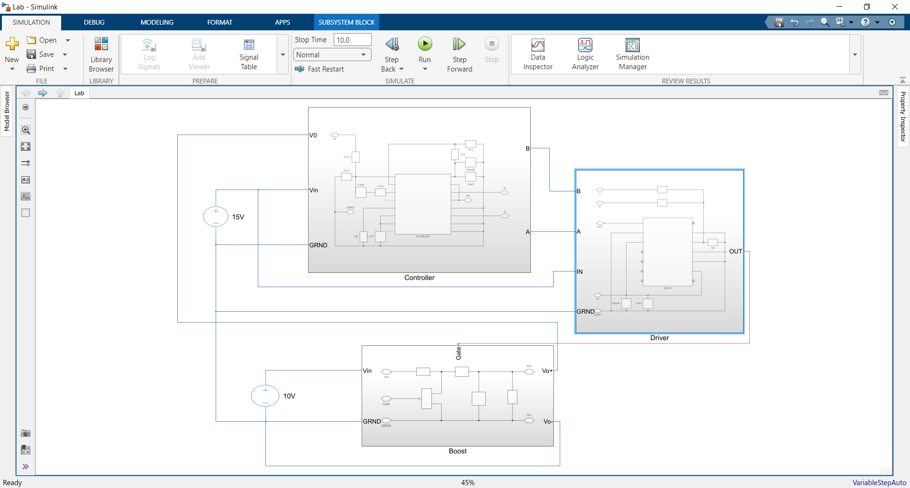

*We need two voltage sources for Boost (high power 10V) and for control-driver system(low power 15V).  
Because we comparing $Vo+≈15V$ we need to make our zero Voltage point common (on the picture it is $GRND)$*

*Results of system work:*

*PICTURES OF SCOP*

We expected $I=1A$ but our circuit works strange, so we obtain stable boost effect only with low power load $(I<1A, we changed resistance)$.

FROM THE PICTURE OBTAIN RIPPLE