Kovalev V.

Design of a boost converter of 24V to 80V using sliding mode technique.

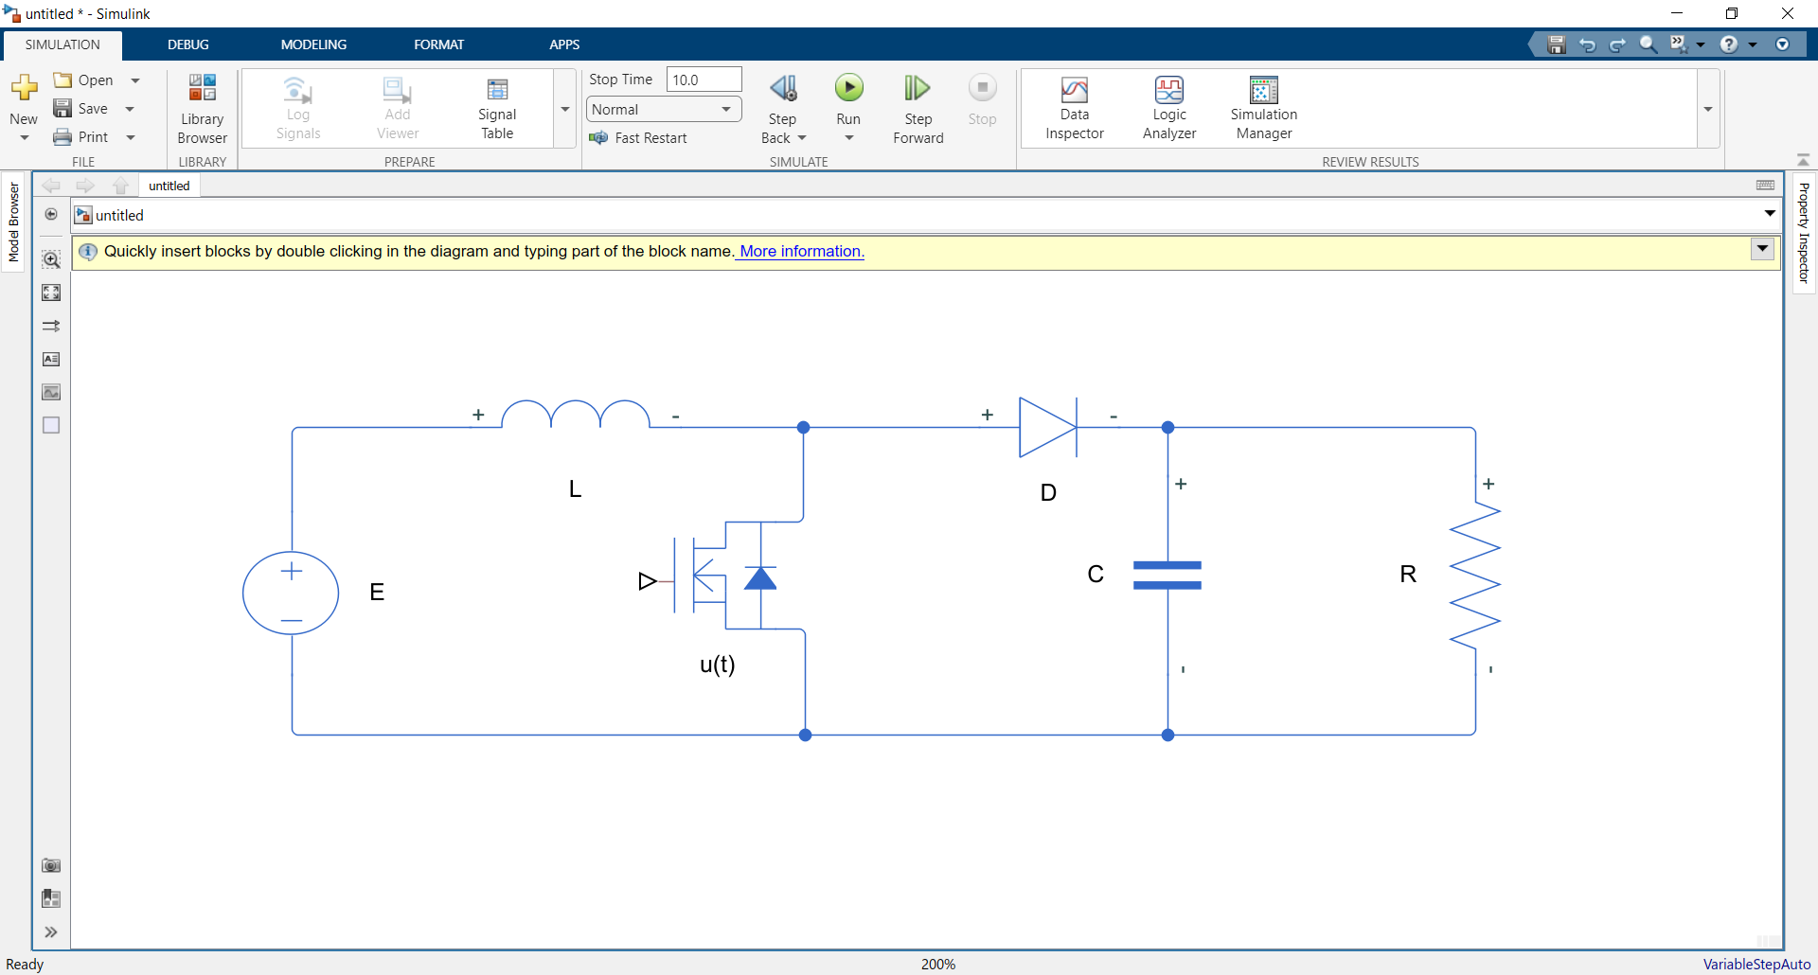

$$E =24V; V_{R}=80$$

Let’s power = 64W => $R =\frac{V_{R}^{2}}{P}=100 Ω$  
On the on state: $V_{c}=\frac{q}{C}=V_{R}=>∆V_{R}=\frac{1}{C}∆q=\frac{1}{C}\int^{DT}{\frac{V_{R}}{R}}=\frac{1}{CR}V_{R}DT (such as<i_{c}> =0=>∆q is equal to ∆q at off state)$

$$\frac{∆V_{R}}{V_{R}}=\frac{1}{CR}DT= \frac{D}{fCR}=>C=\frac{DV_{R}}{∆V_{R}}\frac{1}{fR}$$

Such as it is boost converter: $\frac{V_{R}}{E}=\frac{1}{1-D}=>D=\frac{V_{R}-E}{V_{R}}=0.7$. And let $f =100Hz$, $\frac{∆V_{R}}{V_{R}}=7\%$

$$C=\frac{DV_{R}}{∆V_{R}}\frac{1}{fR} =1mF$$

$$V_{L}=L\frac{∂I}{∂t}=E=>I=\frac{Et}{L}+I_{0}=>∆I=\frac{EDT}{L}$$

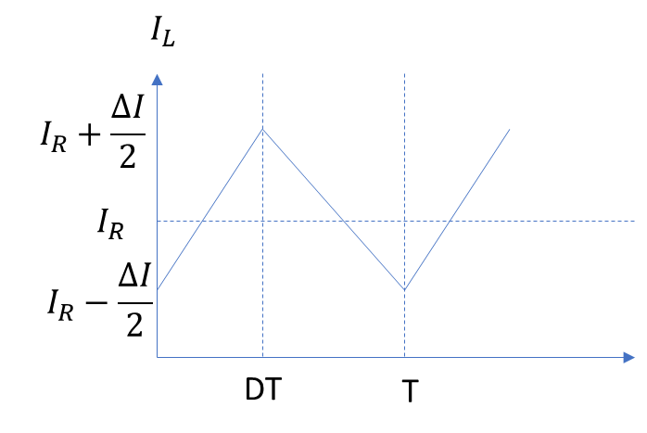We know that all DC current ideally goes to resistor => $I_{mean}=I_{R}$ $$I_{max}=I_{R}+\frac{∆I}{2}$$

$$I_{min}=I_{R}-\frac{∆I}{2}=\frac{V_{R}}{R}-\frac{EDT}{2L}$$

Considering continues mode: $$I_{min}>0=>\frac{EDT}{2L}<\frac{V_{R}}{R}=>$$

$$L>\frac{EDTR}{2V_{R}}=0.105H$$

Let’s $L=1H$

Summing up: $L=1H, C=1mF, R=100 Ω, f=100Hz, D=0.7,$

Simulation:

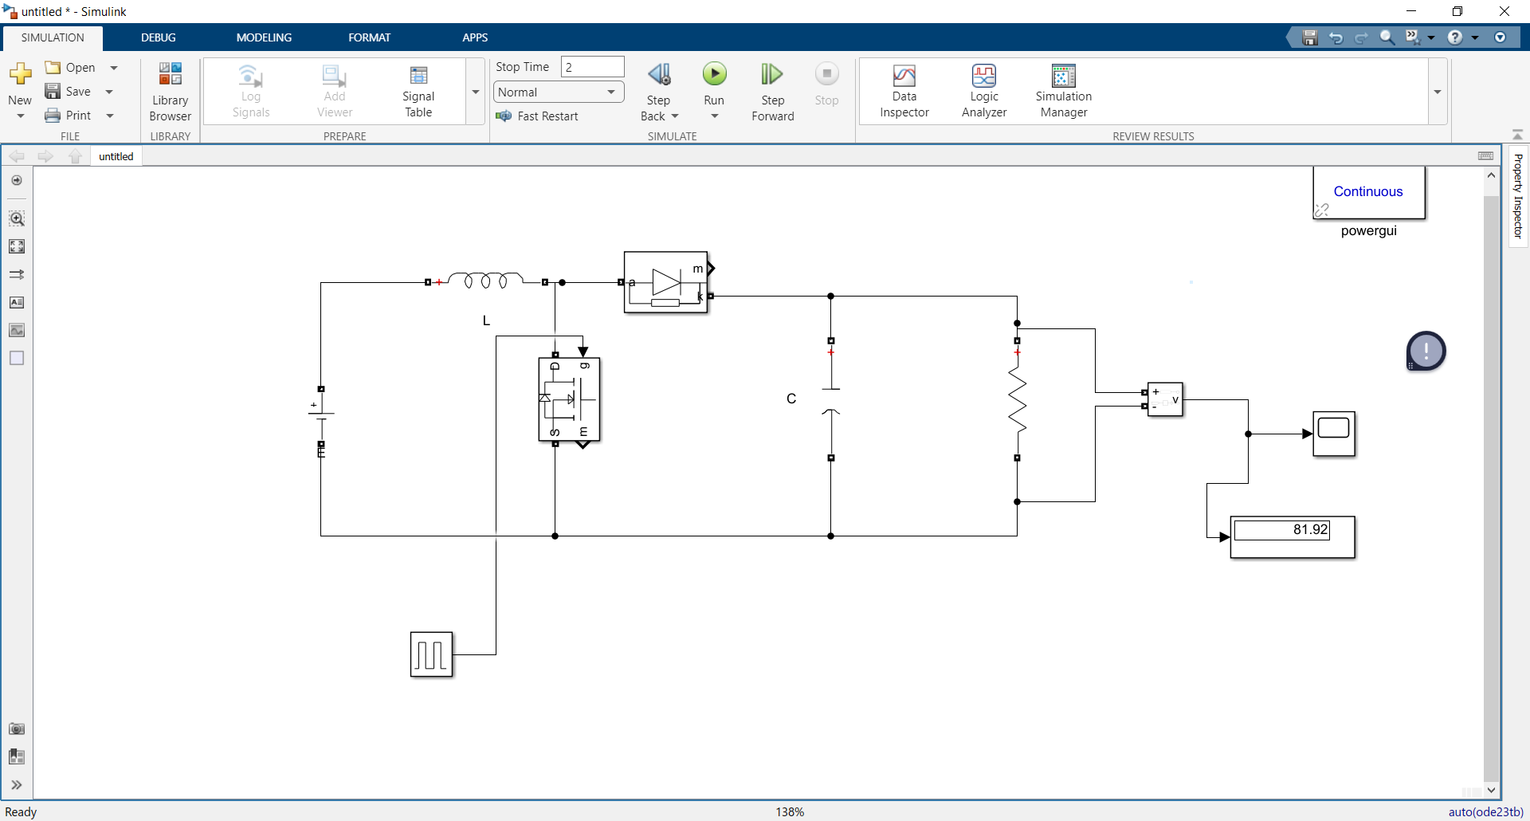

Result:

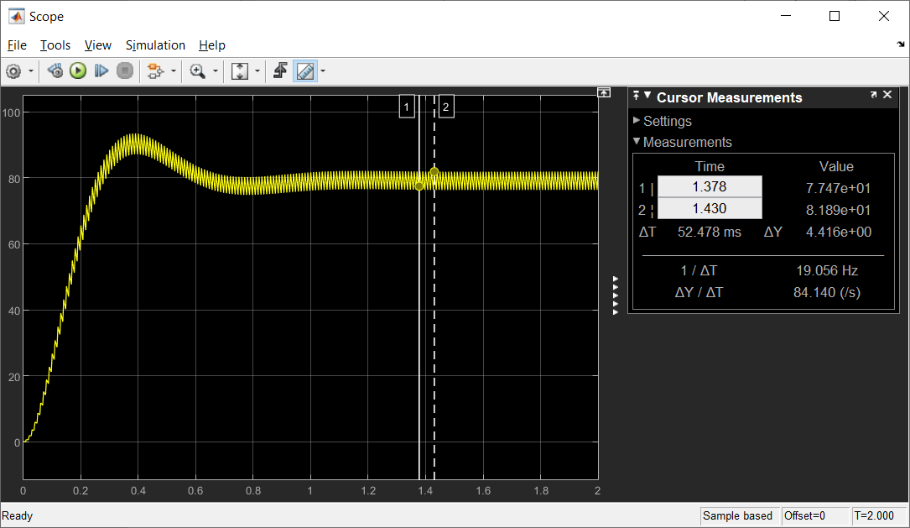

You can see reaple: $4.416/80 =5.5\%$ (I calculated 7%)

Construction of sliding mode technique:

On state:

$$\left\{\begin{aligned}E=L\frac{∂I}{∂t} \\ \frac{q}{C}=V_{R}\end{aligned}\right.=>\left\{\begin{aligned}\frac{∂I}{∂t}=\frac{E}{L} \\ \frac{{∂V}_{R}}{∂t}=\frac{V_{R}}{RC}\end{aligned}\right.$$

Off state

$$\left\{\begin{aligned}E=L\frac{∂I}{∂t}+V_{R} \\ \frac{q}{C}=V_{R}\end{aligned}\right.=>\left\{\begin{aligned}\frac{∂I}{∂t}=\frac{E-V_{R}}{L} \\ \frac{{∂V}_{R}}{∂t}=\frac{I_{C}}{C}\end{aligned}=>\right.\left\{\begin{aligned}\frac{∂I}{∂t}=\frac{E-V_{R}}{L} \\ \frac{{∂V}_{R}}{∂t}=\frac{I-\frac{V_{R}}{R}}{C}\end{aligned}=>\right.\left\{\begin{aligned}\frac{∂I}{∂t}=\frac{E-V_{R}}{L} \\ \frac{{∂V}_{R}}{∂t}=\frac{I}{C}-\frac{V_{R}}{RC}\end{aligned}\right.$$

Summing up

$$\left\{\begin{aligned}\frac{∂I}{∂t}=\frac{E}{L}-\left(1-u\right)\frac{V_{R}}{L} \\ \frac{{∂V}_{R}}{∂t}=\left(1-u\right)\frac{I}{C}-\frac{V_{R}}{RC}\end{aligned}\right.$$

Where $u$- switch function $u =[0,1]$– {off state, on state}

Substitute $I→x_{1},V_{R}→x_{2};$

$$\left[\begin{matrix}\dot{x_{1}} \\ \dot{x_{2}}\end{matrix}\right]=\left[\begin{matrix}0 & -\frac{\left(1-u\right)}{L} \\ \frac{\left(1-u\right)}{C} & -\frac{1}{RC}\end{matrix}\right]\left[\begin{matrix}x_{1} \\ x_{2}\end{matrix}\right]+\left[\begin{matrix}\frac{1}{L} \\ 0\end{matrix}\right]E$$

Consider:

$$S=x_{2}x_{1}-x_{1r}x_{2r}=0$$

$$\dot{S}=x_{2}\dot{x_{1}}+\dot{x_{2}}x_{1}=0;$$

$$x_{2}^{2}\left(-\frac{\left(1-u\right)}{L}\right)+\frac{E}{L}x_{2}+x_{1}^{2}\frac{\left(1-u\right)}{C}+x_{1}x_{2}\left(-\frac{1}{RC}\right)=-As-K*sign\left(s\right)$$

$$\left(1-u\right)\left(\frac{x_{1}^{2}}{C}-\frac{x_{2}^{2}}{L}\right)=-\left(\frac{E}{L}x_{2}+x_{1}x_{2}\left(-\frac{1}{RC}\right)\right)-As-K*sign\left(s\right)$$

$$\left(1-u\right)=\frac{1}{\left(\frac{x_{1}^{2}}{C}-\frac{x_{2}^{2}}{L}\right)}\left(\frac{x_{1}x_{2}}{RC}-\frac{E}{L}x_{2}-A*s-K*sign\left(s\right)\right)$$

$$u=1+\frac{1}{\left(\frac{x_{1}^{2}}{C}-\frac{x_{2}^{2}}{L}\right)}\left(-\frac{x_{1}x_{2}}{RC}+\frac{E}{L}x_{2}+A*s+K*sign\left(s\right)\right)$$

$$x_{1r}x_{2r}=80*\frac{P}{E}=80*\frac{64}{24}$$

Unfortunately I am not in electronic at all so I don’t know how to contract such scheme in electronic components so I constructed it schematically.

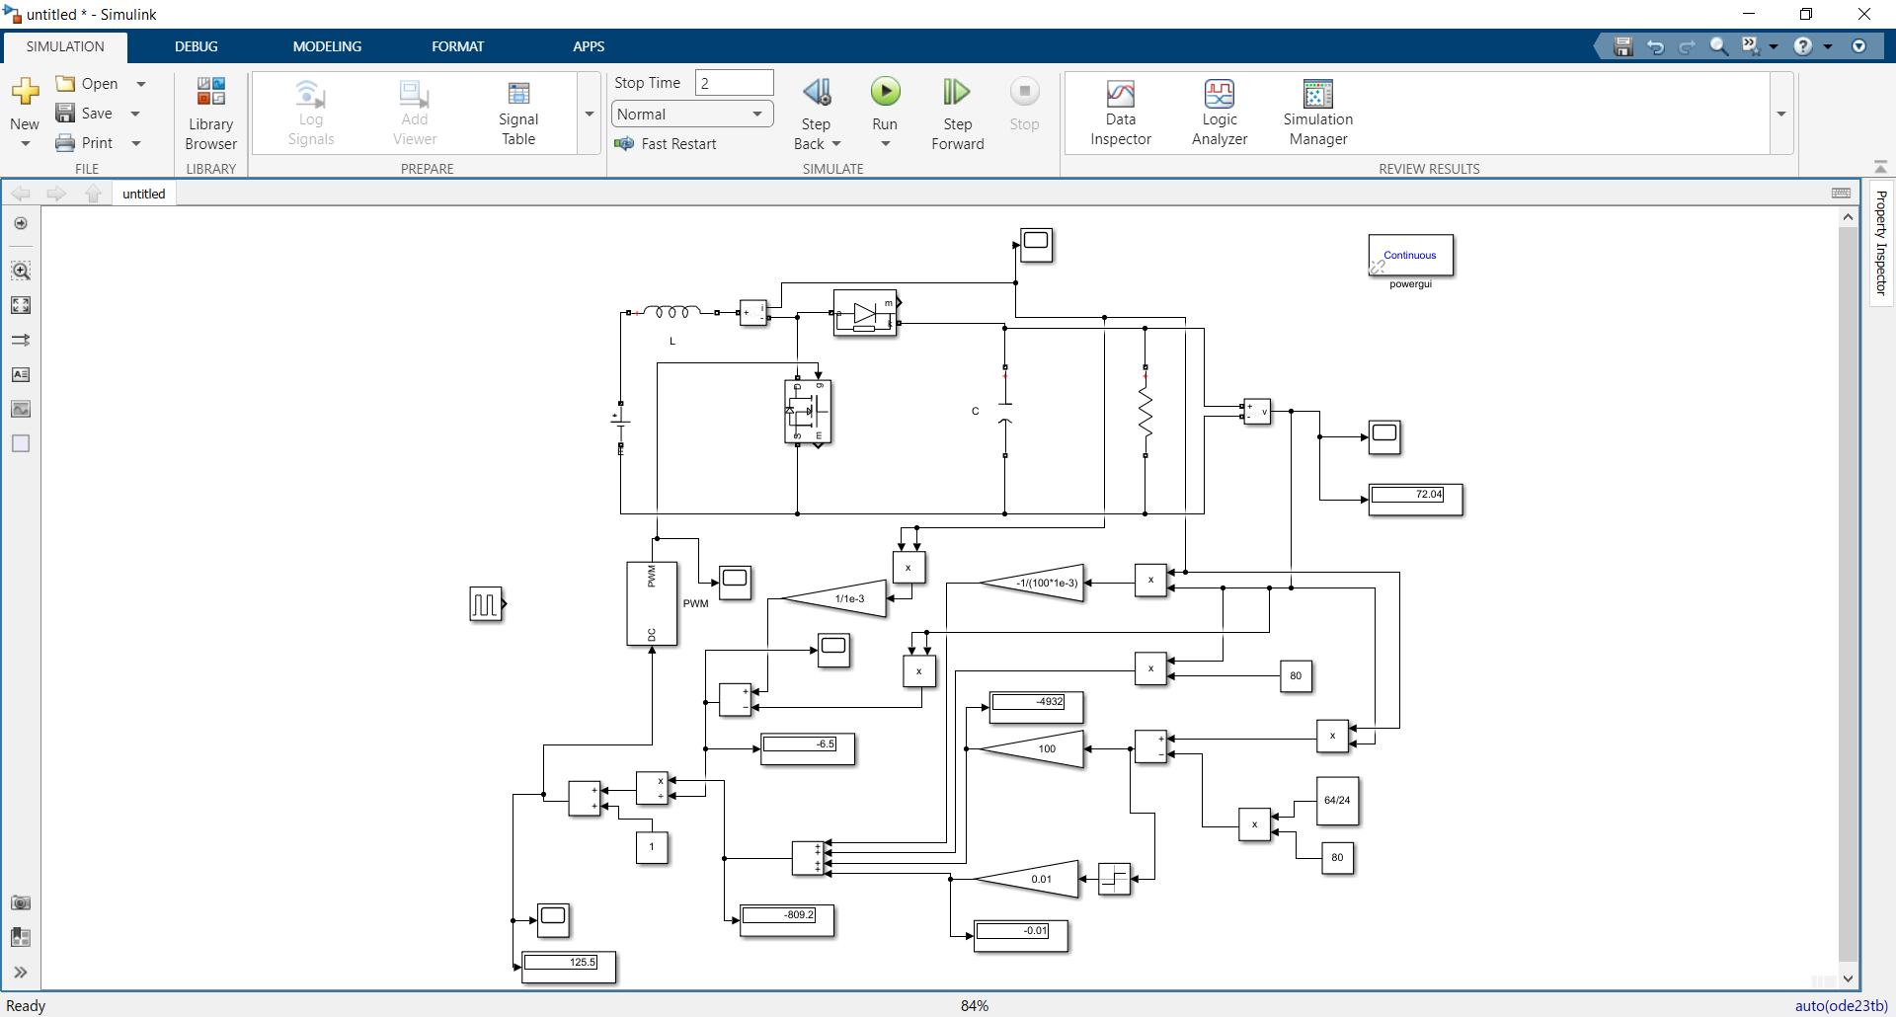

So $u\left(t\right)$ goes to PWM and controls transistor.($A=100(speed of convergence), K=0.01(for discontinuse mode)$)

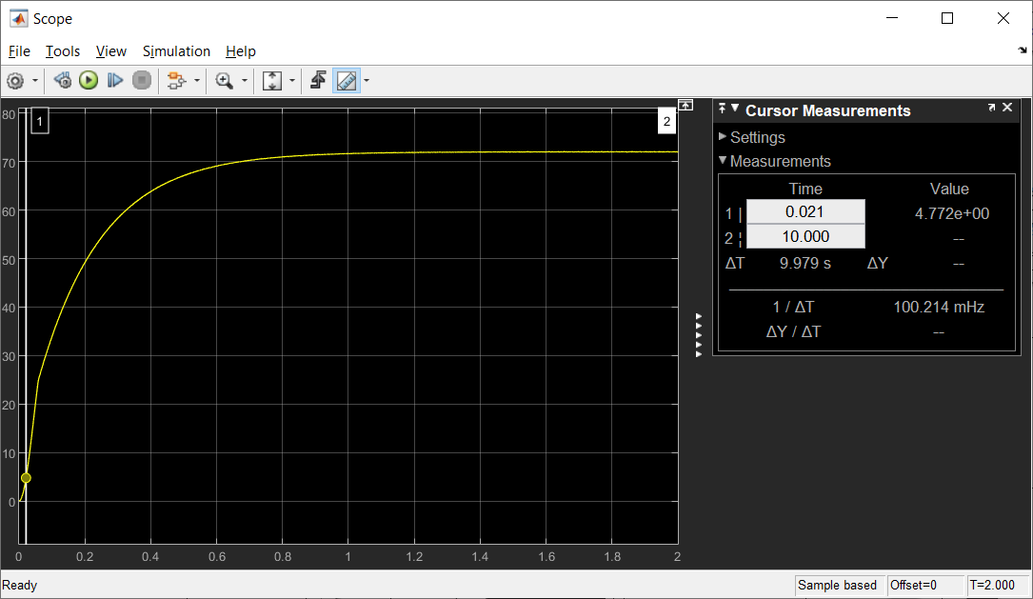

It is output voltage always goes to 72, but I need 80, don’t know where is the problem.

Bellow you can see $u(t)$  
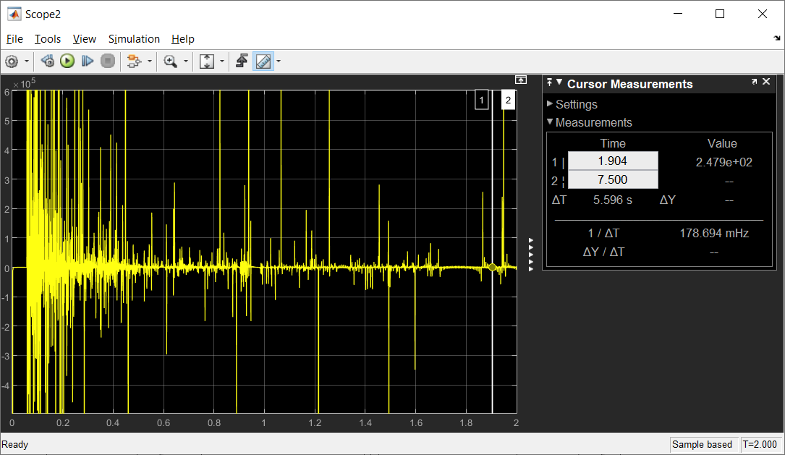

**Current($I_{L}$):** 