§16. Third Law of Thermodynamics
The third law of thermodynamics was established at the beginning of the 20th century in the works of Walther Nernst and Max Planck. This law, sometimes also called the Nernst theorem, is a generalization of experimental evidence for the case of temperatures approaching the absolute zero (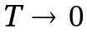 К).
Third law of thermodynamics is reduced to the following three statements.
- As the absolute temperature approaches zero, the entropy approaches a finite limiting value:
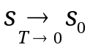. (5.16.1)
- All processes taking place when the absolute temperature approaches zero are asymptotically isentropic, i.e., the derivatives of the entropy with respect to any thermodynamic parameters 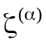 [see (5.1.2)] converge to zero:
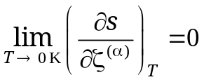 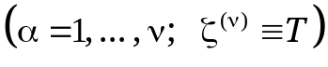. (5.16.2)
3. The absolute zero (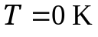) can not be reached in any finite process: it may only be approached asymptotically.

Consider Eq. (5.6.8) used to define the entropy, and select the state at zero temperature 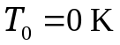 as a reference state:
s(ζ ⁽¹⁾, ζ⁽²⁾, ... , ζ^{(ν − 1)}, Т) = s(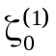,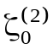, … , 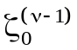, 0 ) + 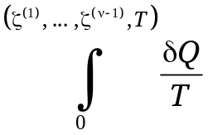, (5.16.3)
The temperature Т is in the denominator of the integrand. The first statement means that the integral is convergent, with the entropy 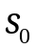 = s(,, … , , 0) at zero temperature () being a finite value. The second statement results that the entropy at zero temperature does not depend on the values of other thermodynamic parameters 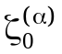 (α = 1, 2, ... , v − 1) which may include the specific volume, pressure, concentration of components, etc. Therefore,
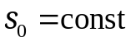. (5.16.4)
Max Plank has analyzed the third law of thermodynamics from the viewpoint of statistical physics where the entropy is defined in terms of thermodynamic probability (statistical sum) W of the system state, namely:
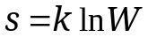 (k = const). (5.16.5)
At the temperature of absolute zero, the system is in its ground quantum state with a single micro-distribution, so 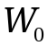 = 1, and thus:
= 0, (5.16.6)
corresponding to no heat motion of atoms and molecules.
In all actual measurements at temperatures close to the absolute zero, the entropy starts tending to zero long before the discreteness of quantum levels may come into play.
Thus, the third law of thermodynamics and the quantum statistical considerations lead to the following theorem.
Planck's theorem. At the temperature of absolute zero, the entropy is equal to zero.
A zero entropy value at the temperature of absolute zero () enables calculation of thermodynamic functions that contain the product 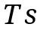. Such functions include the free energy F and the Gibbs chemical potential Ψ [see (5.7.13) and (5.7.14)]. They are used to evaluate chemical affinity which describes the capability of substances to enter chemical reactions with each other, and to calculate energy transitions in such reactions (see §13).
A logarithmic temperature scale Θ based on logarithms of the absolute temperature 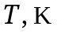 may be used for representation of the whole temperature range:
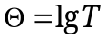. (5.16.7)
In this scale, the absolute zero and the infinitely large temperature are mapped to infinite logarithmic temperatures of different signs:
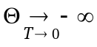, 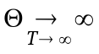, (5.16.8)
This is consonant with the idea that the realm of extra-low temperatures (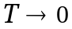 K) is as reach as the realm of extra-high ones (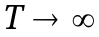 K).
The third law of thermodynamics or, more precisely, the convergence of the integral in (5.16.3), leads to the requirement that any heat capacities must vanish as 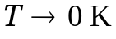:
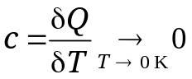, (5.16.9)
This, in particular, applies to heat capacities at constant pressure 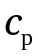 and at constant volume 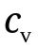, as well as to thermal expansion coefficients and a number of analogous quantities [see (5.7.30) and (5.7.31)].
It should be borne in mind that the approximation of constant and finite heat capacity accepted in the expressions for entropy of perfect gases (5.3.4) and incompressible liquids (5.2.17) no longer applies at very low temperatures because the heat capacities are vanishing as 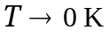. Thus, the expressions for entropy themselves are invalid for such temperatures.

