APPENDIX 2. GENERALIZED DIRAC δ-FUNCTION
Consider a discontinuous function δ(x, Δ) where Δ is a positive parameter:
δ(x, Δ) = 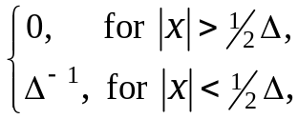 (Δ > 0). (A2.1)
This function is integrable over the whole х-axis for any Δ > 0, the integral over the whole х-axis being independent on Δ:
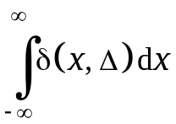 = 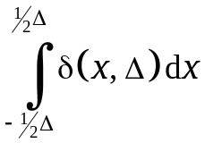 = 1. (A2.2)
Now consider the integral
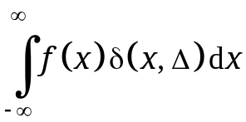 = 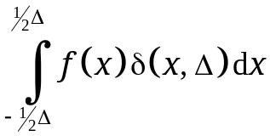,
where f(x) is the function continuous in the range − 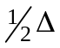 ≤ x ≤ . According to the mean value theorem, for each function continuous on the х–axis there exists a point x_{Δ} in the range − ≤ x ≤ such that the integral in question equals to the value of f at x_{Δ}:
= f(x_{Δ}), − < x_{Δ} < . (A2.3)
Let us consider the equalities (A2.2) and (A2.3) in the limit Δ → 0. The quantities and functions entering them have the following limits:
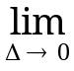δ(x, Δ) = 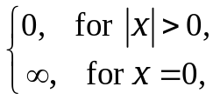
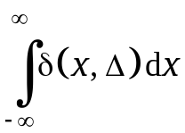 = 1.
x_{Δ} = 0, (A2.4)
f(x_{Δ}) = f(0),
= 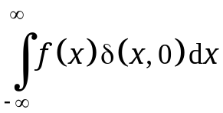 = f(0).
Based on the first limit, the notion of a function is generalized with respect to the limit δ(x, Δ) = δ(x, 0).
Definition. The limit of the function δ(x, Δ) as Δ → 0, denoted as δ(x, 0) ≡ δ(x):
δ(x) = 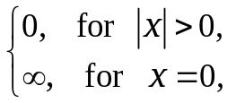 (A2.5)
is called the generalized Dirac δ-function.
The second and fifth limits in Eqs. (A2.4) result in the following integral properties of this generalized Dirac δ-function:
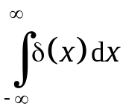 = 1, 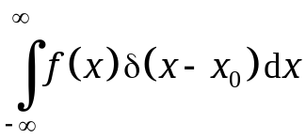 = 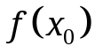. (A2.6)
It should be stressed that the Dirac δ-function is not a function in classical sense; this is the reason why it is called generalized. In functional analysis, the Dirac δ-function is defined as a continuous linear functional on the space of differentiable functions.

V.S. Vladimirov, "Generalized Functions in Mathematical Physics." – Moscow: Nauka, 1979.

