§11. Shock Adiabat (Hugoniot Adiabat)
The concept of shock adiabat, also known as Hugoniot adiabat, is widely used in physics because the change of state of a particle passing through a shock layer is usually adiabatic (see remark at the end of §10).
Definition. An equation that determines the state functions behind a shock when those ahead of the shock are given is called a shock adiabat, or a Hugoniot adiabat, or a shock Hugoniot; the corresponding graph is also referred to as a Hugoniot curve.
The Hugoniot adiabat for a perfect gas. Consider a one-dimensional normal shock in a perfect gas, whose state on both sides is characterized by the equations (see (4.2.6)–(4.2.8) below)
р = ρ R Т, u = c_{v} T = 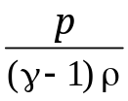 (R , c_{v} , γ - const). (3.11.1)
Suppose the effects of heat conduction (see (3.10.10)) and viscosity are negligible on both sides of the shock. The latter assumption implies that the stress tensor is isotropic and is determined by pressure:
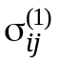 = − р⁽¹⁾δ_{ij}, 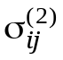= − р⁽²⁾δ_{ij}. (3.11.2)
The balance equations for mass (3.10.4), momentum (3.10.6), energy (3.10.7), and entropy (3.10.8) across a normal shock written in the shock-fixed coordinates (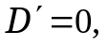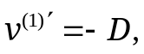 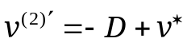) are similar to Eqs. (3.9.29)–(3.9.31) and (3.9.33):
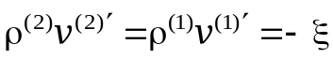, (3.11.3)
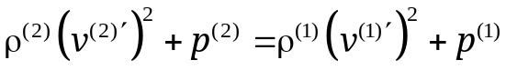, (3.11.4)
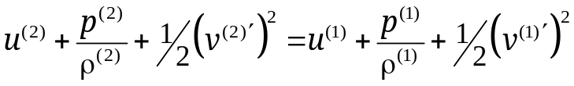, (3.11.5)
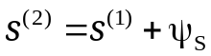, 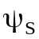 = 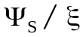 > 0. (3.11.6)
By eliminating velocities, the jump in internal energy across a normal shock is expressed as
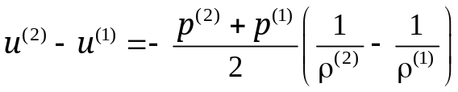. (3.11.7)
This equation, known as the Hugoniot equation, can be combined with the expression for internal energy u in (3.11.1) to relate the pressure and density ratios across the shock:
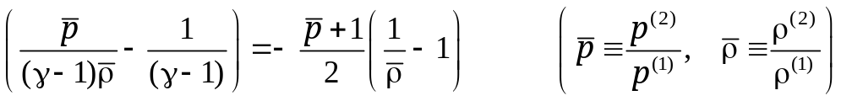.
Rewritten as density ratio expressed in terms of pressure ratio, or vice versa, this relation is the shock adiabat (shock Hugoniot) for a perfect gas:
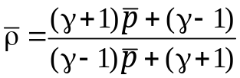 or 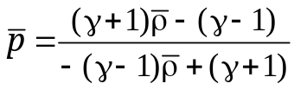 . (3.11.8)
The corresponding expression for shock propagation speed, derived from (3.11.3) and (3.11.4), is
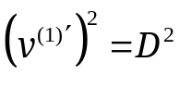 = −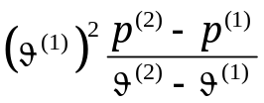 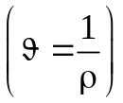. (3.11.9)
At point 1 (initial state), the Hugoniot curve defined by Eq. (3.11.8) is second-order tangent to the Poisson adiabat, or isentrope, also known as Poisson's law (see (5.3.6) below),
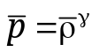; (3.11.10)
i.e., both 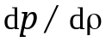 and 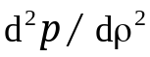 are equal for the curves. For a weak shock (with 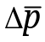 ≡ 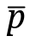 − 1 << 1), the density jump corresponds to Poisson's law
− 1 = 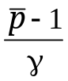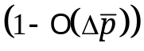, (3.11.11)
and the shock propagation speed is nearly equal to that of weak disturbances (sound) ahead of the shock wave (see Eq. (4.11.16) below):
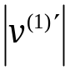 = 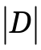 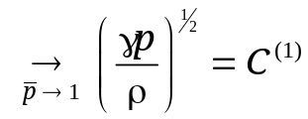 . (3.11.12)
An extremely strong compression shock (with 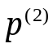>> 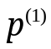, or 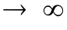) has the highest density ratio predicted by the Hugoniot equation for an adiabatic normal shock wave:
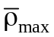= 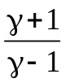 . (3.11.13)
For diatomic gases (e.g., air, which is a mixture of nitrogen N₂ and oxygen O₂), the adiabatic index is γ = 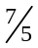 and = 6; for monatomic gases, γ = 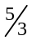 and = 4.
Note that the density ratio across a shock predicted by Hugoniot equation (3.11.8) is strictly limited, whereas as ≡ 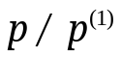 in quasi-static adiabatic (isentropic) compression in accordance with Poisson's law.
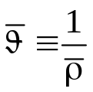
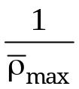
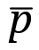

2

1
1

1

Fig. 3.11.1. Hugoniot curve (bold) and Poisson adiabat (thin curve) in the plane (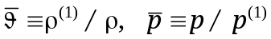). The circle represents initial state 1.
A convenient measure of the strength of a shock wave is the shock Mach number M defined as the ratio of shock propagation speed to the speed of sound ahead of the wave:
M = 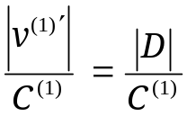. (3.11.14)
The shock Mach number is related to the pressure change across a shock wave as follows:
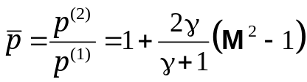, 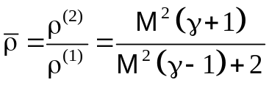. (3.11.15)
Note that temperature increases across a shock when 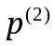>> 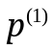 and 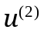 >> 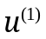. When it reaches Т ∼ 10³ K, the gas in the shock layer dissociates and ionizes. As a result, the adiabatic index 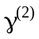 behind the shock increases, approaching γ = . It can be shown that should be used in (3.11.10) under these conditions, which would even further restrict the maximum density ratio across the shock.
In condensed matter, the maximum shock compression ratio is much lower than in gases because compression is counteracted by intermolecular repulsive forces (see Chapter 5, §9).
t
B
С₁
С₂
С₃
С_{n}
С_{n+1}
A₁
r
A
О

О
A
S

Fig. 3.11.2. Schematic of spherically symmetric shock compression of a gas in the (r, t) plane, where r is radius and t is time.
Although shock compression ratio is limited, a gas can be compressed by a factor of thousands by multiple shocks. Figure 3.11.2 schematizes such a shock-compression process in the volume bounded by sphere А centered at point О. The surrounding layer is driven inwards by acoustic or blast waves or by multiple laser pulses focused onto the sphere. The spherical boundary rapidly accelerates and acts as a piston pushing the gas ahead of it towards the center. As a result, a converging shock wave S is initiated inside the sphere. Its trajectory is represented by curve АС₁. The shock gains strength as it converges towards the center, bounces off the center at point С₁, propagates back outwards, and bounces off the boundary at point А₁. This sequence repeats itself so long as the inward-accelerated layer keeps acting as a piston and reflects shock waves. The waves pass through each particle of the gas many times, and the gas density increases several times with each shock passage.
At nuclear research centers in the USA (Livermore), France (Le Barp, near Bordeaux), and Russia (Sarov), ultrahigh-power laser pulses (with Е_{L} ∼ 10⁶ J per target in 10^{–8} s, i.e. power of 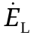 ∼ 10¹⁴ W) are projected to achieve a density of hydrogen isotopes (deuterium and tritium) as high as 10³ g/cm³ and temperatures of up to 10⁸ K for an initial density of ∼10⁻⁴ g/cm³, thereby initiating a thermonuclear reaction producing a huge energy release (∼10¹¹ J per gram of hydrogen isotopes). Spherical targets 5 mm diameter are to be used. The facility for converting electricity to laser light (with efficiency of around 3%) and laser drivers (approximately 200 in total), together with energy storage and conversion systems, occupy an area of about 10,000 m².
See also discussion of inertial collapse of a spherical gas bubble at the end of Chapter 4.
The Hugoniot curve lies above the Poisson adiabat (see Fig. 3.11.1) because part of the kinetic energy of the gas passing through the shock, equal to
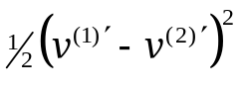, (3.11.16)
is converted into internal energy, causing an additional increase in temperature compared to isentropic compression. Combining expression (5.3.4) for the entropy of a perfect gas (see Chapter 5) with shock Hugoniot (3.11.8) or (3.11.15) yields
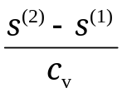 = ln 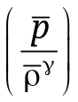 = 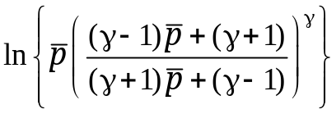
= 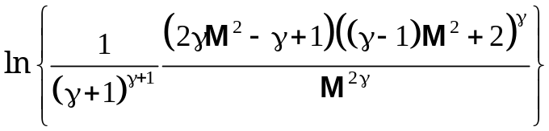. (3.11.17)
At points lying above the Poisson adiabat, including those on the Hugoniot curve, it holds that
> 1, 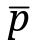 > 1, 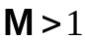 , (3.11.18)
and entropy increases across the shock (s⁽²⁾ > s⁽¹⁾) in accordance with entropy balance (3.11.6) when the shock is adiabatic (see (3.10.10)). Furthermore, it follows from (3.11.17) that the increase in entropy is a third-order quantity for a weak compression shock (with 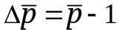 << 1), which propagates at the speed of sound according to (3.11.12):
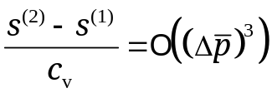. (3.11.19)
Thus, compression by a weak shock wave is a nearly isentropic process described by Poisson's law (3.11.11).
For a strong shock wave ( >> 1), with maximum compression ratio (3.11.13), it follows from (3.11.17) that the entropy increase asymptotically behaves as follows:
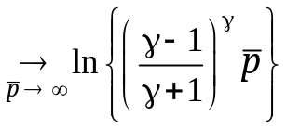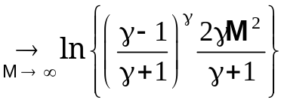. (3.11.20)
For a rarefaction shock,
< 1, < 1, 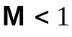, (3.11.21)
and (3.11.17) implies a decrease in entropy (s⁽²⁾ < s⁽¹⁾), which contradicts the second law of thermodynamics since entropy cannot decrease in an adiabatic process (see (3.11.6) and Chapter 5, §14). This leads to the following theorem.
Zemplén Theorem. In a perfect gas, compression shocks are possible and rarefaction shocks are impossible.
The part of the Hugoniot adiabat corresponding to (unphysical) rarefaction shocks is represented by a dashed curve in Fig. 3.11.1.
The theorem on the impossibility of rarefaction shocks applies to any medium for which isentropes s⁽²⁾ = const are concave in the (ϑ, p) plane:
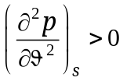 (3.11.22)
Convex isentropes (with 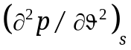 < 0), which make rarefaction shocks possible and compression shocks impossible, are characteristic of media undergoing phase transitions and of certain rubberlike materials.
Note the following essential difference between the Poisson and Hugoniot adiabats. A quasi-static isentropic compression or expansion is a change of state along the Poisson isentrope. The Hugoniot curve is the locus of all attainable final states, not the curve along which the system undergoing shock compression evolves from initial state 1 to final state 2. It can be shown that compression by a steady shock is a process where the state of the system follows the line connecting points 1 and 2 in the 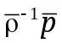 plane, referred to as the Mikhel'son line or the Rayleigh line (see Fig. 3.11.1).
Calculation of stress and density based on measurements of shock propagation speed and projectile velocity. According to (3.10.3), given the state (ρ⁽¹⁾, σ⁽¹⁾, u⁽¹⁾) ahead of a shock, the state (ρ⁽²⁾, σ⁽²⁾, u⁽²⁾) behind it can be determined by measuring kinematic quantities only: shock propagation speed D and post-shock material velocity v* in the laboratory frame (i.e., flow velocity behind the shock relative to the pre-shock medium). This possibility is very important because direct measurements of mechanical stress σ and internal energy u under rapidly changing conditions behind shock waves (the latter involving temperature measurement) are much more difficult to perform than velocity measurements.
t₃
t₁
t₂
t₄
δ_{D}
δ_{v}
v₀
v = 0
Fig. 3.11.3. Schematic of plate impact experiment to measure impactor velocity and shock propagation speed in the target.
As an example, consider Hugoniot measurement in solids under shock loading in a plate impact experiment (Fig. 3.11.3). An explosively driven flat plate (impactor) made of the material to be studied hits a stationary target plate at a projectile velocity v₀ (Fig. 3.11.4a). The velocity and pressure distributions along the impact direction at the instant of impact, t = 0, are shown Fig. 3.11.4b. Velocity is uniform within each plate, with a jump across the impact surface, while the pressure p_{x} = − σ_{x} (compressive traction) is uniform and equal to p₀ in both plates. A discontinuity surface of this kind, across which the jumps in velocity and stress do not satisfy balance equations (in particular, shock jump relations (3.10.3)), is called an arbitrary discontinuity. Immediately after the impact, the discontinuity breaks down into two outward shock waves propagating in opposite directions along the impact axis.
The process can be conveniently analyzed in a reference frame (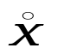, t) moving at velocity 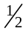v₀ relative to the target, where the target and the impactor approach each other at velocity v₀ (see velocities in the dashed-line box in Fig. 3.11.4a). When both plates are made of the same material, the process is symmetric about the impact plane (Fig. 3.11.4c). In this frame, the impact plane does not move (see Fig. 3.11.4d), the shock propagation speeds D are equal, and so are the velocity jumps (see AS and A′S′ in Fig. 3.11.4d):
[v] = 1/2 v₀.
Figure 3.11.4e shows the velocity distribution at t = after the impact ( > 0) in the laboratory frame (х, t), where х is a Lagrangian coordinate, v = 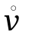 + 1/2 v₀, and the target is stationary before the impact. In this frame, the propagation speed of shock A′S′ is D, and the post-shock velocity of the target material is
v* ≡ v^{*(2)} = [v] = 1/2 v₀.

D – 1/2 v₀
− 1/2 v₀
0
= v − 1/2 v₀
D – 1/2 v₀
А′
S′
S
1/2 v₀
0
− 1/2 v₀
1/2 v₀
= v − 1/2 v₀
0
1/2 v₀
v p_{х}
x
v₀
р_{х}
v
v = 0
(a) t = 0
1/2 v₀
v₀
1/2 v₀
1/2 v₀
1/2 v₀
A
(b) t = 0
(c) t = 0

(d) 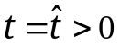

D – v₀
А′
v
v₀
0
S
D
A
x
S′
(e)

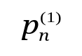
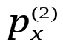
А′
A
S′
S
x
p
D
(f)
D – v₀
0
Fig. 3.11.4. Shock waves in impactor and target.
Fig. 3.11.4f shows the distribution of normal traction (p_{x} = −σ_{x}) at the same t = after the impact, where a constant compressive stress (p_{x} = 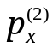) creates a "plug" between shocks АS (in target) and А′S′ (in impactor), which is at rest (= 0, ∂σ_{x}/∂x = 0) in the moving frame (, t).
The initial values of state functions (ρ⁽¹⁾, σ⁽¹⁾, u⁽¹⁾) can easily be determined before the experiment. Thus, to find their post-shock values of density ρ⁽²⁾, normal traction , and internal energy u⁽²⁾, one needs to measure the projectile velocity v₀ (which determines the velocity jump v* across the shock in the target) and the shock speed D in the target. The velocity v₀ and speed D can be found, respectively, by measuring the time τ_{v} required for the impactor to travel the distance δ_{v} between two arrival-time detectors in front of the target and the time τ_{D} for a shock to travel the distance δ_{D} between two arrival-time detectors embedded in the target (see Fig. 3.11.3). In experiments where electrical contactors (also called shorting pins) are used as detectors, an electrical circuit is closed at the instant any detector is hit by the impactor or a shock front, and the ensuing output current burst is recorded by an oscilloscope. The interval between the detected arrival times t₁ and t₂ is τ_{v}, and the interval between t₃ and t₄ is τ_{D}. Accordingly,
v₀ = 2v* = 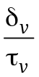, D = 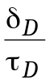.
Generally, δ_{v} ∼ δ = 5–8 mm, v₀ ∼ D ∼ (5–10)×10³ m/s, and τ_{v} ∼ τ_{D} ∼ 10⁻⁶ s ≡ 1 μs. Therefore, measurement of velocities on the order of 1 km/s requires time resolutions of about 1 μs.
D
C_{ac}
v∗
Fig. 3.11.5. Shock adiabat in the (D, v*) plane.

Thus, a shock Hugoniot can be obtained for any material of interest as a curve D(v*) of shock speed in the material versus velocity jump across the shock (see Fig. 3.11.5).
For condensed matter, the resulting curve is almost linear, with kinks usually appearing when physicochemical changes occur in the shock layer.
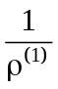
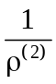
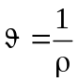
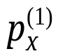
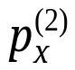
p_{x}
S
A
α

Fig. 3.11.6. Shock adiabat in the (р_{х}, ϑ) plane.

The propagation speed is D = C_{ac}, in the limiting case of zero shock strength ([v] ≡ v* → 0), which corresponds to acoustic (sound) waves (see Chapter 4, §11).
As is shown above, measured values of D and [v] ≡ v⁽²⁾ can be used to calculate the normal traction and density ρ⁽²⁾ behind the shock. Thus, the shock Hugoniot can be represented as a relation between normal traction and specific volume ϑ⁽²⁾ ≡ 1/ρ⁽²⁾ . A typical Hugoniot curve corresponding to compression shocks (ρ⁽²⁾ > ρ⁽¹⁾, > 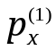> 0) has the shape shown in Fig. 3.10.6. Such concave Hugoniots cannot represent rarefaction shocks, and neither they can in the case of a perfect gas (see Fig. 3.11.1).
Combining the first two equations in (3.9.37), or (3.10.4) with (3.10.6), yields an expression for D in terms of pre- and post-shock values of σ and ϑ:
D = 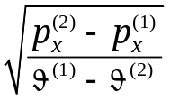, ϑ⁽¹⁾ = 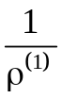, ϑ⁽²⁾ = 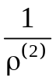.
It is clear that shock propagation speed D varies as 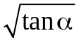, where α is the slope angle of the line connecting the Hugoniot points representing the pre- and post-shock states (ϑ⁽¹⁾, ) and (ϑ⁽²⁾, ).
Using the technique described above to measure kinematic quantities only, American and Russian research groups led by R.W. Goranson and L.V. Al'tshuler, respectively, pioneered Hugoniot measurements in solids at pressures of up to the order of 10⁶ bar = 10⁵ MPa as part of the nuclear weapons projects launched in the 1940s. Subsequently, the scope of these studies was extended to the development of civilian technologies.
To date, apart from pin contactors, electromagnetic particle velocity gauges and manganin piezoresistive gauges have been developed. The latter are used to record the pressure profile behind the shock front. Other diagnostics include flash X-ray techniques for visualizing fast-moving projectiles and laser interferometry for monitoring free-surface velocities of shock-loaded samples, commonly referred to as VISAR (Velocity Interferometer System for Any Reflector).

