§12. Nonclassical Discontinuities
In some areas of continuum mechanics and physics, nonclassical surfaces of discontinuity are used as generalizations of classical discontinuities.
In what follows, examples of nonclassical discontinuities are discussed where additivity conditions (3.9.5) are violated for at least one extensive quantity (mass, momentum, energy). Generalized additivity is introduced to take into account the surface densities of mass, momentum, and energy.
Sheet discontinuity. In mechanics of dispersed media, surfaces of discontinuity are considered where mass is concentrated and surface mass density R_{Σ} has the dimension of mass per area:
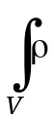 dV = 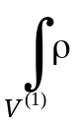 dV + 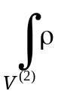 dV + 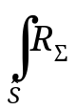ds. (3.12.1)
Surfaces of this kind are called material sheets.
ρ
ρ⁽²⁾
ρ⁽¹⁾
x
x_{Σ} + h
x_{Σ}
x_{Σ} – h
ρ⁽¹⁾(x)
ρ⁽²⁾(x)
Fig. 3.12.1. Density distribution around a material sheet.
Dotted curves in Fig. 3.12.1 exemplify a realistic one-dimensional distribution of volumetric mass density ρ in a continuum model with a finite surface density. Here, a layer around a surface element d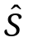 is shown whose thickness 2h is negligible compared to the length scale L of both the body and the process under study. Suppose, however, that the layer has a significant mass dm_{Σ}:
dm_{Σ} = d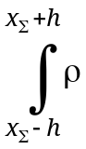 dx = R_{Σ} d. (3.12.2)
This singularity can be modeled as an idealized mass distribution with a jump at a surface of discontinuity (layer of zero thickness). In Fig. 3.11.1, the corresponding volumetric density distribution is shown by curves ρ⁽¹⁾(x) and ρ⁽²⁾(x). The "extra" mass is represented in terms of the surface density R_{Σ} at x = x_{Σ}. In other words, the distribution ρ(x) has a delta-function singularity at x = x_{Σ}:
ρ(x) = R_{Σ} ⋅ δ(x – x_{Σ}) + Н(x_{Σ} – x) ρ⁽¹⁾(x) + Н(x – x_{Σ}) ρ⁽²⁾(x); (3.12.3)
Н(ξ) = 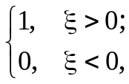 δ(ξ) = 0 at ξ > 0, ξ < 0; 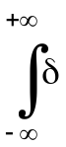(ξ) dξ = 1
(Н(ξ) is known as the Heaviside step function). The idealized distribution adequately represents the mass density outside a narrow layer of thickness 2h and gives the correct layer mass while representing it as localized on a discontinuity surface of zero thickness.
Analogous representations can be obtained by introducing surface momentum density I_{Σ}, surface energy density Е_{Σ}, and surface densities of other extensive variables:
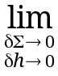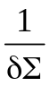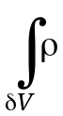 v dV = I_{Σ} ,
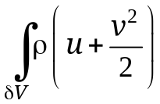dV = Е_{Σ}. (3.12.4)
Following the analysis leading to Eqs. (3.9.32), one can derive generalized balance equations across a sheet discontinuity:
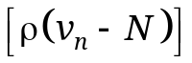 + 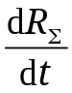 = 0,
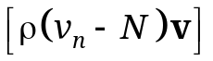 + 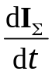 = 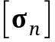, (3.12.5)
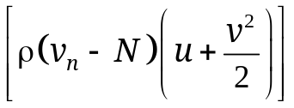 + 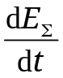 = 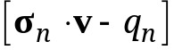.
Here, the time derivatives of 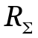, 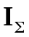, and 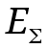 represent the rates of change in the surface densities of mass, momentum, and energy, respectively. Material sheets are used to describe processes in a "zero-pressure gas," such as a solid particulate phase dispersed in a gas.
Interface with surface tension. In two-phase systems, there exist discontinuity surfaces (interfaces) separating liquid and gas phases, liquid and solid phases, or two liquid phases. In an interfacial layer of thickness on the order of molecular interaction distance (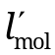∼ 10l_{mol} ∼ 10^{–9} m), molecules interact with those in both phases. Therefore, the material properties and behavior of the layer may differ significantly from the properties and behavior of the medium at distances from the interface much larger than , but still small compared to the macroscopic length scale L of the system. As suggested by J.W. Gibbs, an extremely thin interfacial layer between phases should be considered separately. Since the thickness of such a layer is much smaller than its extent in the other two dimensions, so are its volume and mass as compared to those of phase heterogeneities (droplets, bubbles, impurities, etc.). Furthermore, its momentum and kinetic energy are negligible because its velocity is comparable to the bulk velocity of the medium. However, its internal energy and the stress inside the layer should sometimes be taken into account.
These considerations lead to the concept of surface (or interfacial) phase, referred to as Σ-phase here, whose mass, momentum, and kinetic energy are negligible. A layer of thickness on the order of ∼ 10^{–9} m << L is treated as a distinct Σ-phase that has zero mass but a nonzero surface internal energy density U^{Σ} (defined per unit area). It is characterized by a surface (interfacial) tension force vector Σ and the rate of work 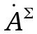 done by surface tension forces per unit length of the closed boundary L of an interface (see Fig. 3.9.2).
Accordingly, the additivity of mass, momentum, and bulk forces assumed in (3.9.5) holds, while the additivity of internal energy, surface forces, and the work done by them is generalized by taking into account U ^{Σ} , Σ, and :
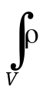dV = 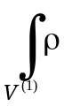 dV + 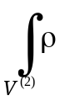 dV;
v dV = 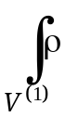v dV +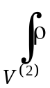v dV; 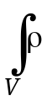F dV = F dV +F dV.
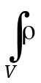u dV = 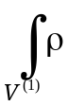u dV + 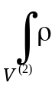u dV + 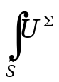dS; (3.12.6)
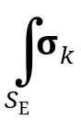n_{k} dS = 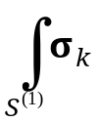n_{k} dS + 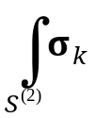n_{k} dS + 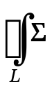dl;
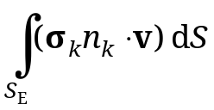 = 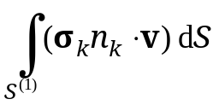 +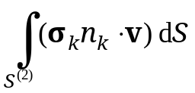 + 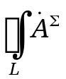dl.
The corresponding balance equations for momentum and energy in a volume V are written as
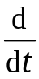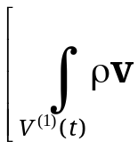 dV +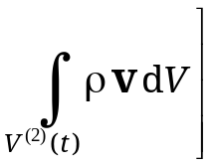 (3.12.7)
=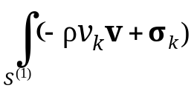n_{k} dS + 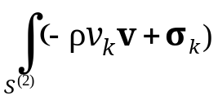n_{k} dS + 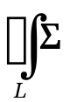dl
+ F dV +F dV,
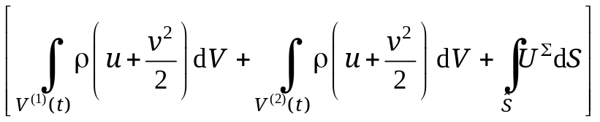
=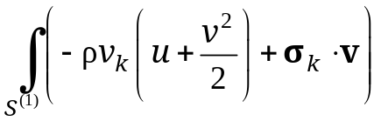n_{k} dS + 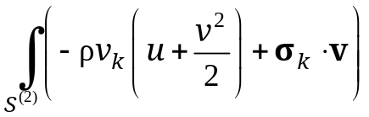n_{k} dS
+ 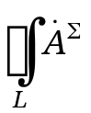dl + 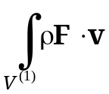dV +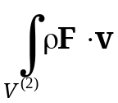dV. (3.12.8)
After rearrangements analogous to those performed to derive Eq. (3.9.17) for a classical discontinuity, the balance equations of mass, momentum, and energy across an interface with surface tension read
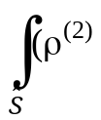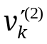– ρ⁽¹⁾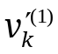)n_{k} dS = 0,
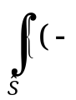ρ⁽²⁾ v⁽²⁾ + 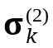) – (– ρ⁽¹⁾v⁽¹⁾ + 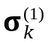)}n_{k} ds + 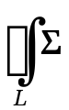dl = 0,
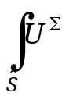dS = dl (3.12.9)
+ 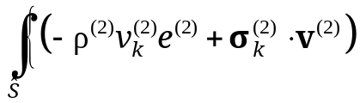 –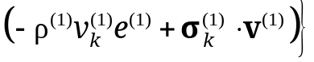n_{k} ds
(v′^{(α)} = v^{(α)} – Dn, e^{(α)} = u^{(α)} + 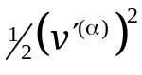, α = 1, 2).
Note that the first equation here is equivalent to (3.9.17) with f = 1, ψ_{k} = 0 (mass conservation equation), while the second and third equations differ from the momentum and energy equations in (3.9.17). Since these integral equations hold for any discontinuity and any portion thereof (including an infinitesimal surface element δ), the following local balance equations are obtained by shrinking the interface element δ bounded by a closed curve δL to a point:
− ρ⁽²⁾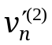= − ρ⁽¹⁾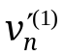 ≡ ξ,
ξ (v′⁽²⁾ – v′⁽¹⁾) = − (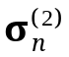– 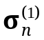) − 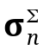,
ξ 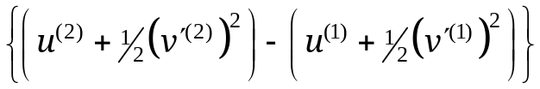 (3.12.10)
= − 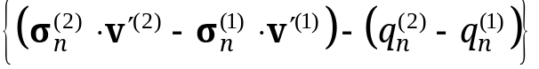−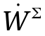 + 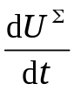,
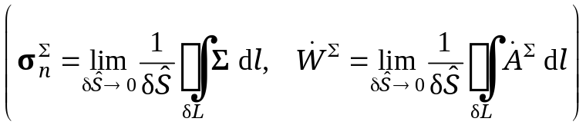.
Here, the time derivative of 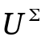 is the rate of change in surface internal energy. These equations are generalizations of (3.9.22)–(3.9.26) containing additional terms: the traction 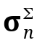 due to surface tension per unit length of δL (determined by the surface tension vector 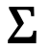) and the rate of work done by surface tension forces per unit area (determined by the rate of work per unit length of δL). They can also be represented as a generalization of (3.9.18):
ξ ( f⁽²⁾ – f⁽¹⁾) = − (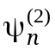 – 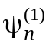) − 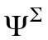, (3.12.11)
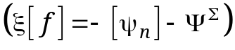,
F | v′ | u + ^{l}/₂(v′)²
ψ_{n} | σ_{n} | (σ_{n} · v′) – q_{n}
 | 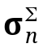 | − dU^{Σ}/dt
where v′ = v – Dn is the velocity of the medium in a discontinuity-fixed frame of reference.
When one of the phases is a liquid, the interface (surface phase) can be treated as a stretched thin elastic film where the surface tension force ΣdL on an arbitrary material line element dL lying in the interface acts tangentially along the unit normal to dL (see Fig. 3.12.2). The corresponding rate of work 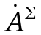 done by surface tension depends on the local velocity of the Σ-phase (displacement velocity of dL along ):
= Σ, = Σ v^{Σ}. (3.12.12)
L
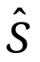
n
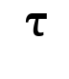
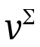
Fig. 3.12.2. Interface 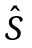 bounded by curve L:
n is normal to ; is normal to L in the local tangent plane to ; Σ is surface tension force.
The scalar quantity Σ, called surface tension, is specific to the pair of bulk phases separated by the interface and depends on state parameters, such as temperature and impurity concentration.
Consider an interface element 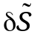 bounded by four line segments (Fig. 3.12.3):
δL = δL₍₁₎ + δL₍₂₎ + δL′₍₁₎ + δL′₍₂₎,
δL₍₁₎ = δL′₍₁₎ = 2а₍₁₎δθ₍₁₎ , δL₍₂₎ = δL′₍₂₎= 2а₍₂₎δθ₍₂₎. (3.12.13)
Let δ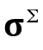 be the resultant surface tension force on the closed boundary δL of an interface element 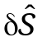. The component of δ along the interface normal n divided by the area of is called Laplace pressure:
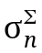=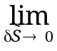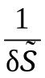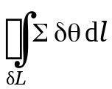
= 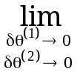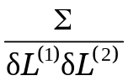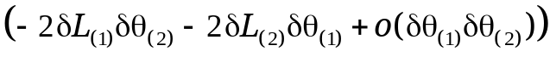= − 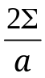; (3.12.14)
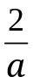 = 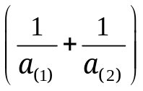.

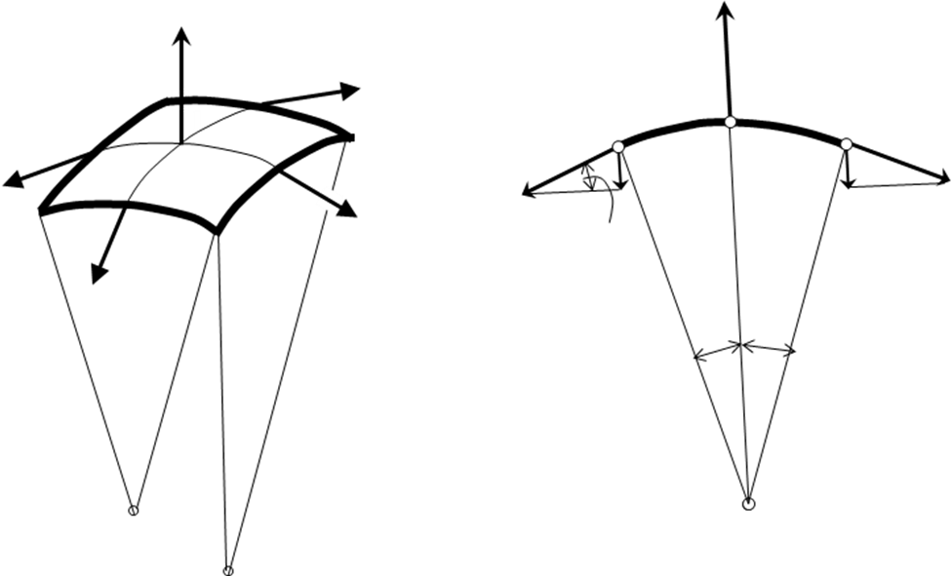

δθ
R
n
Σ^{τ} δL
Σ^{τ} δ

Σ δL
δθ
Σ δL′₍₁₎
P
δθ
R
Σ δL₍₂₎
Σ δL

δθ₍₁₎
δθ₍₂₎
δθ₍₁₎
Σ δL₍₁₎
O₍₂₎

δθ₍₂₎
Σ δL′₍₂₎

n

Fig. 3.12.3. Surface tension force acting on an infinitesimal interface element around point Р when one of the phases is liquid.
It is known from differential geometry of surfaces that the sum of curvatures the mean curvature 1/а ≡ ½(1/а₍₁₎ + 1/а₍₂₎) of a surface, where а₍₂₎ and а₍₁₎ are the respective curvatures of its mutually orthogonal sections, is invariant under #rotations.
The centers of curvature О₍₁₎ and О₍₂₎ lie "behind" the vector n in Fig. 3.12.3 but may have different relative positions with respect to the surface in the general case. Therefore, one should use unit vectors n₍₁₎ and n₍₂₎ pointing towards the interface from О₍₁₎ and О₍₂₎, respectively. Figure 3.12.3 illustrates the particular case of n₍₁₎ = n₍₂₎ = n. In the general case,
n = − 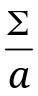 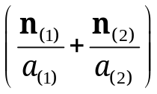. (3.12.15)
The component of δ tangential to an infinitesimal interface element divided by the area of is
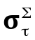=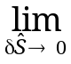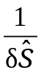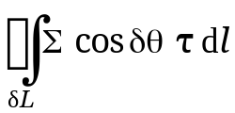= 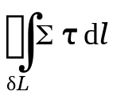
= 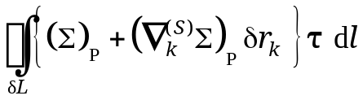
= 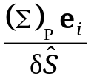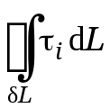 + 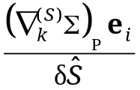 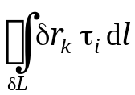. (3.12.16)
Here, the subscript Р denotes the values of Σ and 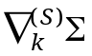 at point Р; the unit vector = τ_{i} е_{i} to the boundary curve δL lies in the tangent plane to the interface element , as do the unit vectors е_{i} (i = 1, 2); and 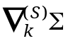 is the tangential gradient along the interface . The line integrals along δL can be calculated by applying the Gauss–Ostrogradsky theorem (3.1.25а) as surface integrals over , which approaches the tangent plane at point Р as → 0. Since the first integrand in the last expression in (3.12.16) corresponds to В_{i} = 1 in (3.1.25a), its divergence vanishes; i.e.,
= 0. (3.12.17)
The second integrand corresponds to В_{i} = δr_{k} in (3.1.25a). Therefore, #∇_{i}В_{i} = δ_{ik}, and the second integral along δL is
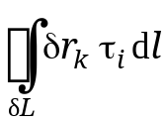 = 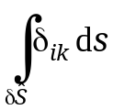= δ_{ik}. (3.12.18)
In summary,
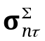= δ_{ik} = 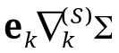. (3.12.19)
The stress due to a tangential surface tension gradient is called Marangoni stress or Marangoni force. Since surface tension is a function of temperature and impurity concentration, the Marangoni stress is determined by the tangential gradients of these parameters along the interface.
The resulting traction due to surface tension is
= 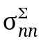n + = − + 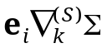, (3.12.20)
The rate of work done by surface tension forces on the closed boundary δL of the interface element divided by the area of is calculated analogously according to (3.12.10) and (3.12.11):
= 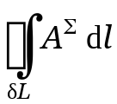 = 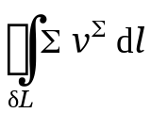. (3.12.21)
The mean-value theorem for integrals implies that a line integral along the boundary δL can be expressed in terms of a mean surface tension 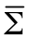 on δL. Noting that the velocity 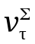 determines the rate of change in the area of , we write
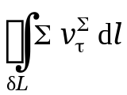 = 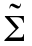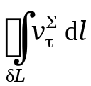 = 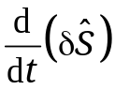 (3.12.22)
and use the fact that → Σ as → 0 to obtain an expression for the rate of work done by surface tension forces per unit area of the interface:
= Σ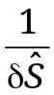. (3.12.23)
Equations (3.2.19) and (3.2.22) provide a closure to the balance equations across an interface with surface tension so that, given the values of state functions in region 1, one can calculate their values in region 2.
For a spherical bubble or droplet of radius а, the surface internal energy and Laplace pressure are
E ^{Σ}= 4πа² U^{Σ}, ⏐⏐ = . (3.12.24)
The internal energy of the gas in a bubble is
E^{G} = 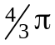a³ρc_{V}T, (3.12.25)
where ρ, c_{v}, and Т are the density, specific heat, and temperature of the gas, respectively. Consider the ratio between surface internal energy (3.12.24) and gas bubble energy (3.12.25) and the Laplace-to-ambient pressure ratio:
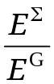 = 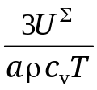, 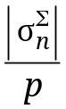 = 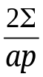. (3.12.26)
For an air bubble in water (а = 1 mm = 10⁻³ m) under standard conditions (p = 1 bar = 10⁵ Pa, Т = 300 K), the thermodynamic parameters in these expressions are as follows:
ρ = 1.19 kg/m³, c_{V} = 719 m²/(s² K), U^{Σ} ≈ Σ = 0.073 kg/s².
Then,
= 0.8 ⋅ 10⁻⁵, = 0.0015. (3.12.27)
It is clear from (3.12.26) that the effect of Laplace pressure is stronger for smaller droplets and bubbles (а ∼ 10 μm = 10⁻⁵ m) and at lower pressures and temperatures. The contribution to internal energy due to capillary effects becomes significant for even smaller radii (а ∼ 10⁻¹ μm = 10⁻⁷ m), as well as at lower pressures and temperatures.

Note the difference in meaning between n₍₁₎, n₍₂₎ and n⁽¹⁾, n⁽²⁾. The subscripts of the former pair of unit vectors refer to centers of curvature, whereas the superscripts of the latter refer to regions on opposite sides of the interface.
The analysis here is restricted to the tangent plane of the interface, and the Einstein summation а_{i} b_{i} ≡ a₁b₁ + a₂b₂ is employed.

