Chapter 4
CLASSICAL THEORIES IN MECHANICS OF FLUIDS AND DEFORMABLE SOLIDS
This chapter presents models (systems of equations) used to solve a broad class of problems that can be analyzed without invoking energy conservation and laws of thermodynamics.
§1. The System of Mass and Momentum Equations
Consider continuity equation (1.9.14) and momentum balance (2.3.9a) written in Eulerian coordinates:
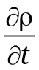 + ∇_{k}ρ v_{k} = 0, ρ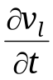 + ρv_{k}∇_{k} v_{l} = ∇_{k}σ_{kl} + ρF_{l} (l = 1, 2, 3). (4.1.1)
The body force per unit mass has the dimension of acceleration and is frequently represented as a function of coordinates, in particular in terms of a potential field,
F = − 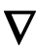U (F_{l} = − ∇_{l}U ), (4.1.2)
such as a gravitational field. For example, if the gravitational force of the Earth varies weakly across the region under study (the vertical extent h₃ of the region is much smaller than the Earth's radius R),
h₃ << R ≈ 6370 km, (4.1.3)
then the gravitational force per unit mass is a constant vector whose magnitude is equal to the standard acceleration due to gravity g:
F = ge₃, g = 9.81 m/s², (4.1.4)
where the unit vector e₃ points downwards.
The maximum depth of the ocean is 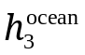≈ 11 km, and the troposphere extends to an altitude of approximately 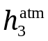= 20 km; i.e., condition (4.1.3) is satisfied. Therefore, the gravitational force per unit mass (acceleration of free fall) can be assumed constant in studies of ocean and atmosphere dynamics.
In a non-inertial frame of reference, inertial forces must be taken into account (see (3.3.3)). The total inertial force density а_{(in)} (inertial acceleration) is the sum of translational inertial force 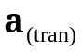, which is the negative of the translational acceleration of the non-inertial frame, and two inertial forces arising when the frame rotates with angular velocity  directed along the axis of rotation. The latter include centrifugal force 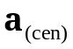, which is the negative of centripetal acceleration, and Coriolis force 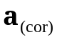, which is the negative of Coriolis acceleration:
а_{(in)} = + + , (4.1.5)
= Ω² r, = − 2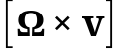,
where r is the position vector relative to the origin of the chosen coordinate system; v is the velocity of the particle being considered relative to the origin. In a reference frame rotating with the Earth, the angular velocity is Ω = 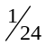 hour^{–1} = 0.1157⋅10^{–4} s^{–1}.
Finally, an electromagnetic (ponderomotive) force R depending on particle velocity v can be added to obtain
F = g′ + R, g′ = g + а_{(in)}. (4.1.6)
Electromagnetic effects can be described by invoking equations of electrodynamics.
Centrifugal force fields are potential (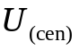 = − Ω²r²), whereas Coriolis force fields are not.
In the classical models discussed in this chapter, the body force F is assumed to be known.
When the motion in question involves high accelerations, external bulk forces (see (3.3.3)) can be much weaker than the inertial ones or the surface stress gradients:
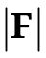 << 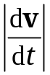 or ρ << 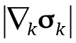 (F = g + а_{(in)} + R). (4.1.7)
Note that these conditions are equivalent: if the former is satisfied, then so is the latter, and vice versa. The corresponding momentum equation has the form
ρ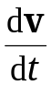 = 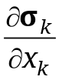. (4.1.8)
Note that even in a static system, where inertial forces vanish (dv/dt = 0), external bulk forces, such as gravity, are negligible when the system's size L (and therefore weight) is much lower than other forces acting on the system (see (4.6.10a)).
To close the set of Eqs. (4.1.1) and (4.1.2), constitutive equations are required, such as rheological ones #relating stress to strain and strain rate tensors as evidenced by experimental findings. Unlike continuity and momentum equations, they represent mechanical characteristics of the medium in question. More generally, constitutive equations reflect thermal, electromagnetic, and other physical and chemical processes. Accordingly, the construction of constitutive equations must not only employ basic principles of mathematics and physics and use experimental observations, but must also involve laws and equations of thermodynamics and electrodynamics.
This section discusses simpler, closed models of continuum mechanics, with constitutive equations based on intuitive reasoning, plain experimental facts, and generalizations using basic principles of mathematics and physics. No equations of thermodynamics or electrodynamics are employed, and neither phase change (e.g., evaporation and condensation) nor chemical reaction (e.g., combustion) is assumed to occur.
The continuity equation can be used to find an alternative expression for material derivative:
ρ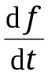 ≡ ρ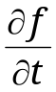 + ρv_{k}∇_{k} f = 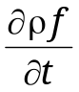 + ∇_{k}(ρv_{k} f). (4.1.9)
The latter representation is called divergence form or conservation form. To prove (4.1.9), apply the product rule to the partial time derivative and the divergence term,
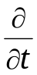ρ f + ∇_{k}(ρv_{k} f) = ρ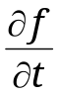 + f 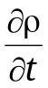 + f ∇_{k}(ρ v_{k}) + ρv_{k} ∇_{k} f =
= ρ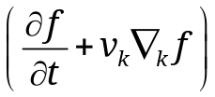 + f 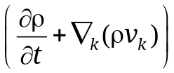, (4.1.9a)
and note that the expression in the latter parenthesis vanishes by the continuity equation.
As a corollary to (4.1.9), it follows that inertial acceleration (inertial force density) in the observer's frame can be expressed in divergence form as follows:
ρ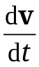 ≡ ρ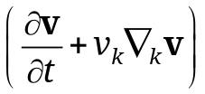 = 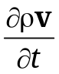 + ∇_{k}(ρv_{k}v). (4.1.10)
Acceleration represented in the Gromeka–Lamb form. Another remarkable and useful expression for the acceleration of a continuum particle,
≡ 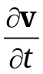 + v_{k}∇_{k} v = + 2[ω × v] + 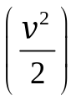, (4.1.11)
known as the Gromeka–Lamb form. To prove (4.1.11), add and subtract the same term, v_{k}∇_{l} v_{k}, in the expression for convective acceleration v_{k}∇_{k}v_{l},
v_{k}∇_{k}v_{l} = v_{k}∇_{k}v_{l} – v_{k}∇_{l} v_{k} + v_{k}∇_{l} v_{k} =
= v_{k}(∇_{k}v_{l} – ∇_{l} v_{k}) + 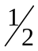∇_{l}(v_{k} v_{k}) = 2ω_{lk} v_{k} +∇_{l}(v²), (4.1.12)
and use the fact that ω_{lk} = – ε_{ilk}ω_{i} = ε_{lik} ω_{i} (see (1.8.13)). This yields
v_{k} ∇_{k}(v_{l}e_{l}) = 2ε_{lik} e_{l} ω_{i} v_{k} + e_{l}∇_{l}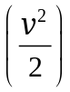 = 2[ω × v] + 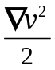, (4.1.13)
Q.E.D.
§2. Ideal Fluids
In aviation research, explosion science, and flow analysis in jet engine nozzles and compressor or turbine vane assemblies, wide use is made of a simplified model known as ideal fluid or perfect fluid.
Definition. Идеальной жидкостью (идеальным газом) A continuum is referred to as an ideal fluid if the following is true:
1. The stress tensor is spherical (isotropic): its Cartesian components at each point are expressed in terms of a single scalar variable p called pressure,
σ_{ij} = –pδ_{ij}, (4.2.1)
rather than six independent ones as in the general case. Equivalently, this definition implies that the traction on any surface with normal n is normal to the surface; i.e., 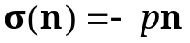.
2. The model is further specified by assumptions made about density:
- a fluid or flow is called incompressible if the fluid density is assumed to be constant,
ρ = const; (4.2.2a)
- a fluid or flow is called barotropic if the fluid density is a single-valued monotone increasing function of pressure р only:
ρ = ρ(p); (4.2.2b)
- generally, density depends on pressure p and temperature T, decreasing with increasing temperature at constant pressure, as well as on species concentrations с^{(k)} (k = 1, 2, … , K), which may change because of physicochemical #?#processes and species diffusion (see Chapter 5):
ρ = ρ(p, T, с⁽¹⁾, с⁽²⁾, … , с^{(K)}). (4.2.2c)
Expression (4.2.1) for an isotropic stress tensor means that all principal stresses are equal (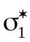 = 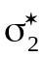 = 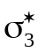 = –p) and the shear stresses vanish in any orthonormal coordinate system (see (A1.8.2)):
σ_{nτ} = 0, σ_{nn} = –p. (4.2.3)

The term rheology comes from the Greek verb rhéō (ῥέω), which means flow.
Writing conservation equations in divergence form improves computational efficiency since the conservation property is maintained on numerical grids.
An exception is water at temperatures between 0 and 4°C (see Fig. 4.6.2).

