Write up

Linux Fundamentals 1

Task 1: Introduction

In this task introduces the Linux as an operating system just like mac and windows.

Task 2: A Bit of Background on Linux

In this task showing what Linux good with like lightweight and critical infrastructure, Linux is also the big umbrella for many operating systems such like Ubuntu, Debian and Kali.

Task 3: Interacting With Your First Linux Machine

In this task showing for the first time the Linux machine to interact with it .

Task 4: Running Your First few Commands

In this task showing the terminal to practice the following commands:

1-“echo”: Output any text that we provide.

https://assets.tryhackme.com/additional/linux-fundamentals/part1/feedback/t42.png

2-“whoami”: Find out what user we're currently logged in as!.

https://assets.tryhackme.com/additional/linux-fundamentals/part1/feedback/t43.png

Task 5: Interacting With the File system!.

In this task practicing on the following commands:

1. Listing Files in our Directory (ls): by using “ls” command can list the files in the directory you are in it.

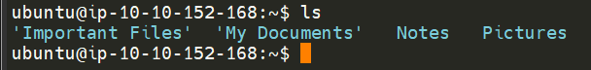

1. Changing Our Current Directory (cd): you can change directory by typing “cd “the new directory you want””.



1. Outputting the Contents of a File (cat): This command viewing the content of the folder.

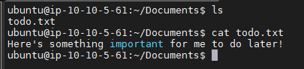

1. Finding out the full Path to our Current Working Directory (pwd): This stands for print working directory.

https://assets.tryhackme.com/additional/linux-fundamentals/part1/feedback/t52.png

Answer the questions below:

* On the Linux machine that you deploy, how many folders are there?

In order to solve this this question we need to use command “ls”, then we will see how many folders in the directory, which is 4 folders

* Which directory contains a file?

To find the directory that contains the file we need to do the following:

WE need to use the command “cd folder4”, then command “ls” we will find a .txt file.

* What is the contents of this file?

/home/tryhackme/folder4.

Task 6: Searching for Files

Using