A PROJECT REPORT ON E-COMMERCE PROSHOP
Submitted in partial fulfillment of the
Requirements for the award of
College name
College logo
Submitted By:
Name:
Roll No:

GLOBAL GROUP OF INSTITUTES, AMRITSAR

TABLE OF CONTENT
TITLE | PAGES
Declaration | 3
Certificate | 4
Acknowledgement | 5
Company Profile | 6
Chapter 1: Introduction to Project | 7-13
1.1 Project Aim & objectives | 7-11
1.2 Project Requirements | 11
1.3 Key Feature of project | 11
1.4 DFD | 12-13
Chapter 2: Software and Hardware Used | 14
2.1 Software Requirement | 14
2.2 Hardware Requirement | 14
Chapter 3: Results and Discussion | 15-19
3.1 Screenshots and its Description | 15-19
Chapter 3: Conclusion and Future Scope | 20-20
4.1 Conclusion | 20
4.2 Future scope | 20
Bibliography | 21

DECLARATION
name declare that we are undertaken 6 weeks Mern Stack Training at
Future Finders Pvt. Ltd. during a period from traning time in Partial fulfillment of requirements for the award of degree of college name. The work which is being presented in the training report submitted to Department of Global Institute College is an authentic record of training work.
Name of the candidate:
Roll No:
Examined By:
1) 2)
(Project Guide) (Head of Department)

CERTIFICATE

ACKNOWLEDGEMENT
I am highly grateful to the Ms./Mrs, HOD CSE/IT, college name for providing this opportunity to carry out the six weeks industrial training at Future Finders.

I would like to expresses my gratitude to other faculty members of Computer Science & Engineering department for providing academic inputs, guidance & encouragement throughout the training period.

The author would like to express a deep sense of gratitude and thankful to_DR.name Director/CEO of Company, without whose permission, wise counsel and able guidance, it would have not been possible to pursue my training in this manner.

The help rendered by Mr name for experimentation is greatly acknowledged.

Finally, I express my indebtedness to all who have directly or indirectly contributed to the successful completion of my industrial training.

COMPANY PROFILE
Future Finders is a ground-breaking platform that develops young Indian talent that is motivated to advance and forge successful careers in IT. We provide a variety of courses to help you launch your career and locate the employer that will assist you as you rise to the top. Our expertise with the latest tools and techniques, and the experience of our professional experts help us deliver high-end services to our esteemed clients. Future Finders educates students and developers about the most recent technologies that are now popular. We are working on distributing informational know-how and offering clients specialized services following global best practices. At Future Finders, we recognize your unrivalled skill and help you realize your creative ideas. Our sole goal is to provide students with cutting-edge practical skills that will enable them to swiftly and effectively adapt to the constantly evolving technologies found in the business world. At Future Finders, our goal is to raise educational standards via innovation in both quality and practical knowledge.

CHAPTER - 1 INTRODUCTION TO PROJECT
1. Project Title and Description:
Project Title: Online E-Commerce ProShop
Project Description:-

AIM:-
The purpose of Online E-commerce System is to automate the existing manual system by the help of computerized equipment ‘sand full-fledged computer software, fulfilling their requirements, so that their valuable data/information can be stored for a longer period with easy accessing and manipulation of the same. The required software and hardware are easily available and easy to work with.
The aim is to automate its existing manual system by the help of computerized equipment ‘sand full-fledged computer software, fulfilling their requirements, so that their valuable data/information can be stored for a longer period with easy accessing and manipulation of the same. Basically the project describes how to manage for good performance and better services for the clients.
Objective:-
- Manage Online Selling Costs in a strategic way
- Establish Deeper Business Relationships
- Provide a Unique Customer Experience
- Identify the right target audience
- Sell more
About the Project:-
In this MERN project, we will build an e-commerce website which is basically used for buying and selling of goods and services, or the transmitting of funds or data, over an electronic network, primarily the internet. These business transactions occur either as business-to-business, business-to-consumer, consumer-to-consumer or consumer-to-business

1.0 DEVELOPMENT TOOLS
Introduction to MERN:
MERN is one of several variations of the MEAN stack (Mongo DB Express Angular Node), where the traditional Angular.js frontend framework is replaced with React.js. Other variants include MEVN (Mongo DB, Express, Vue, Node), and really any frontend JavaScript framework can work. Torrent, Google App Engine, Eve Online, Maya and iRobot machines.
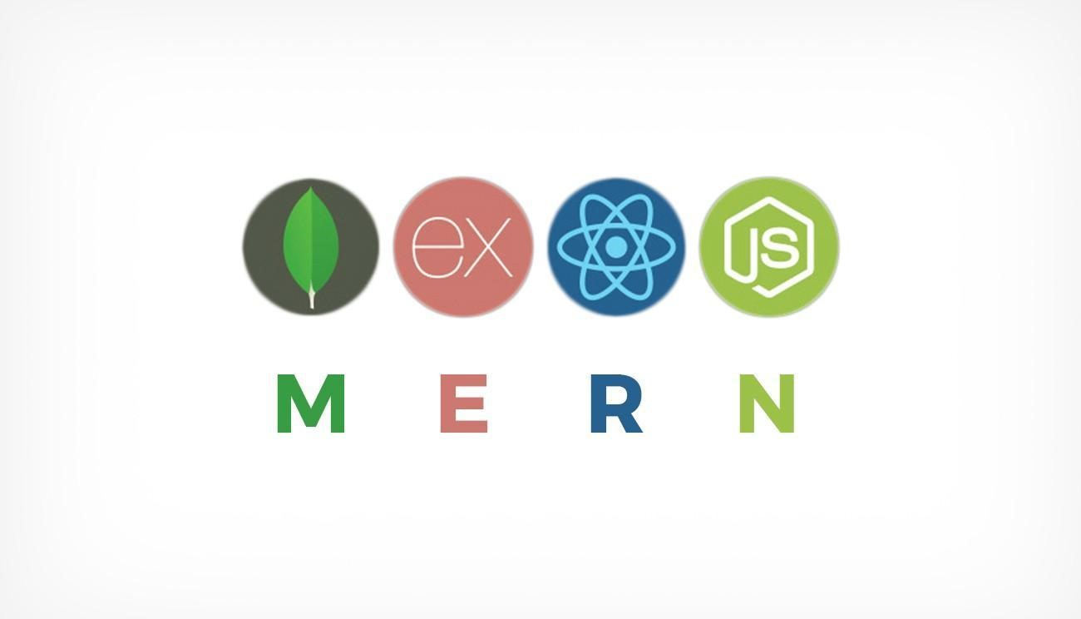
MERN Stack Benefits:-
- Open Source Technology− Startups prefer MERN because it’s an open-source code that’s constantly being improved upon by tech experts from around the world. All the components of the MERN stack are open source, and thus you can use it to create robust web apps.
- Free Templates are available online− Free templates are available online, which will save you tons of time. It would have taken me at least three times as long to customize a theme compared to downloading an off-the-shelf solution. You’ll also get help from experts if you run into any issues along the way.
- Allow you to build fast − The MERN stacks rely on open-source technologies that developers can use freely, which means you don’t have to build everything from scratch. For example, if you want a blogging platform, chances are someone has already developed a popular framework like Wordpress.
- Easy to Use − The underlying technology gets so well documented that you can deploy it with ease. It’s simple to understand and use, making it an ideal choice for beginners learning web development.
- Full-Stack Development − MERN’s full-stack development approach means
you’re responsible for building an application’s frontend and backend components. This approach draws on principles from both UI design and software engineering.
- Great Community Support − This set of technologies is backed by a solid community, making it easier to find answers to all sorts of technical
- questions that may come up. Thus when you’re unsure how something works or why there’s usually someone else who has already encountered (and fixed) similar problems.
- Offer Native Experience to the user −Native applications are more robust, secure and can provide a more compelling experience for users. So when
start-ups develop mobile apps, they usually build them on top of hybrid
frameworks like Ionic or React Native

Basic Concept of Mern :-
MERN Stack: MERN Stack is a Javascript Stack that is used for easier and faster deployment of full-stack web applications. MERN Stack comprises of 4 technologies namely: MongoDB, Express, React and Node.js. It is designed to make the development process smoother and easier.
Each of these 4 powerful technologies provides an end-to-end framework for the developers to work in and each of these technologies play a big part in the development of web applications.
Getting started: First, create a new project folder. Then go to the project folder in command prompt/terminal and type below command to initialize a package.json file. (Make sure npm is installed) npm init
A normal package.json file looks like this
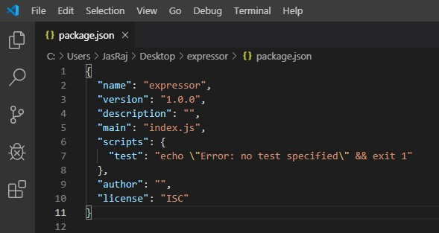

1. MongoDB: Cross-platform Document-Oriented Database
Mongo DB is a NoSQL database where each record is a document comprising of key-value pairs that is similar to JSON (JavaScript Object Notation) objects. MongoDB is flexible and allows its users to create schema, databases, tables, etc. Documents that are identifiable by a primary key make up the basic unit of MongoDB. Once MongoDB is installed, users can make use of Mongo shell as well. Mongo shell provides a JavaScript interface through which the users can interact and carry out operations (eg: querying, updating records, deleting records).
2. Express: Back-End Framework:
Express is a Node.js framework. Rather than writing the code using Node.js and creating loads of Node modules, Express makes it simpler and easier to write the back-end code. Express helps in designing great web applications and APIs. Express supports many middle wares which makes the code shorter and easier to write.

3. React: Front-End Library
React is a JavaScript library that is used for building user interfaces. React is used for the development of single-page applications and mobile applications because of its ability to handle rapidly changing data. React allows users to code in JavaScript and create UI components.

4. Node.js: JS Runtime Environment
Node.js provides a JavaScript Environment which allows the user to run their code on the server (outside the browser). Node pack manager i.e. npm allows the user to choose from thousands of free packages (node modules) to download.

1.2 Project Requirement
Traditionally, customers are used to buying the products at the real, in other words, factual shops or supermarkets. It needs the customers to show up in the shops in person, and walk around different shopping shelves, and it also needs the owners of shops to stock, exhibit, and transfer the products required by customers. It takes labor, time and space to process these operations. Furthermore, the spread of the Covid-19 pandemic has caused a lot of changes in our lifestyle, people fearing to get outside their homes, transportation almost shut down and social distancing becoming all the more important. Big to small scale business that relied on the traditional incur a lot of consequence due to the lockdown issues. Some tend to more towards using social media platforms like Facebook to sell their product. However, the social media platforms have been beneficial for marketing purposes alone but leaves the whole task of customer and massive order management via direct messaging (DM), which takes a lot of time to respond to all customers. In addition, everyone tends to use social media, posing a great challenge to differentiate between scammers (fraudsters) and legit sellers.

1.3 Key Feature of project
Proshop Store is an Online shopping system provides a solution to reduce and optimize these expenses. Authorized Customers do not need to go to the factual shops to choose, and bring the products they need by hands. They simply browse their Personal computers or cellphones to access shops, and evaluate the products description, pictures on the screen to choose products. In addition, the owners of the shop do not need to arrange or exhibit their stocks products. They just input the description, prices of products, and upload their pictures. Simply, both customers and shop owners do not need to touch the real products in the whole process of shopping, and management. In the end the logistic center will distribute the products required by customers, or products ordered by shop owners to their locations. The customers are able to track the status of their orders until delivery, after which they can leave a review of the type of service they received.
The payment and products’ quantity will be saved in database through the data flow.
These shopping, management and distribution processes greatly simplify and optimize the retail business.

1.4 DFD
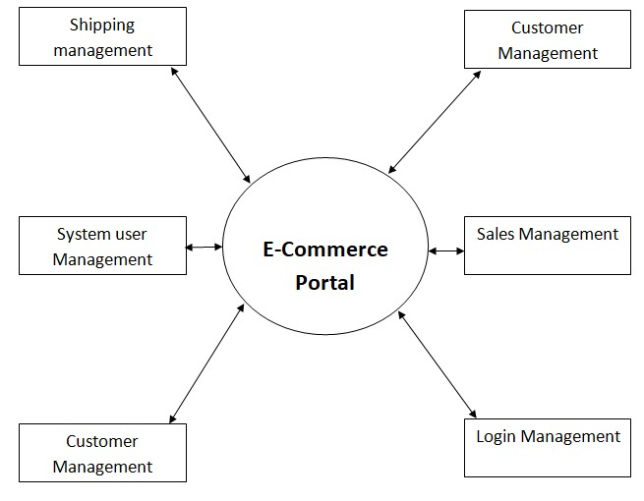

Functional Requirements
The following is the desired functionality of the new system. The proposed project would cover:

Customer Module
- Customer can view/search products without login.
- Customer can also add/remove product to cart without login (if customer try to add sameproduct in cart. It will add only one)
- When customer try to purchase product, then he/she must login to system.
- After creating account and login to system, he/she can place order.
- If customer click on pay button, then their payment will be successful and their order willbe placed.
- Customer can check their ordered details by clicking on orders button.
- Customer can see the order status (Pending, Confirmed, Delivered) for each order
- Customer can Download their order invoice for each order
- Customer can send feedback to admin (without login)

Admin Module
- Admin can provide username, email, password and your admin account will be created.
- After login, there is a dashboard where admin can see how many customers is registered,how many products are there for sale, how many orders placed.
- Admin can add/delete/view/edit the products.
- Admin can view/edit/delete customer details.
- Admin can view/delete orders.

CHAPTER - 2 SOFTWARE AND HARDWARE USED
2.1. Hardware Requirements:
Hardware is required to develop E-Pharma Website is listed below:
- X86 or 64-bit CPU (Intel / AMD architecture)
- 4 GB RAM
- 5 GB free disk space
2.2. Software Requirements:
Software is required to develop E-Pharma Website is listed below:
1. Modern Operating System:
- Windows 8.1 or 10
- Mac OS X 10.11 or higher, 64-bit
2.HTML
3.CSS
4.JavaScript
- React
- Nodejs
- MongoDb
- VS code
CHAPTER 3
RESULT AND DISCUSSION
3.1 Screenshots and its Description
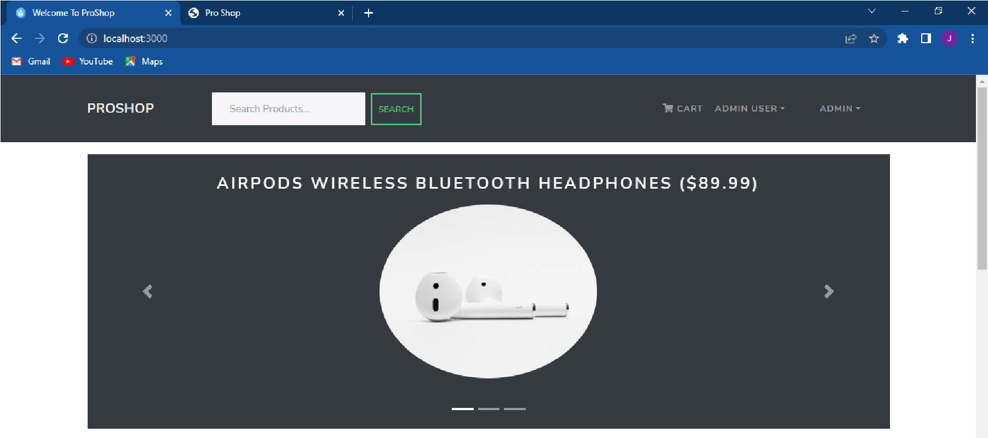

Fig 3.1.1 Home Screen
Figure 3.1.1 depicts the Home screen. Here we have an option for users to directly go to the product screen. User also have Direct Cart option to access his/her shopping cart.
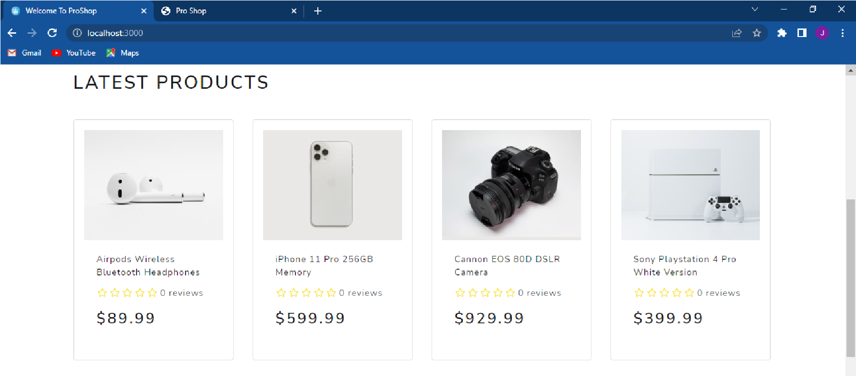

Fig 3.1.2 Product Category Screen
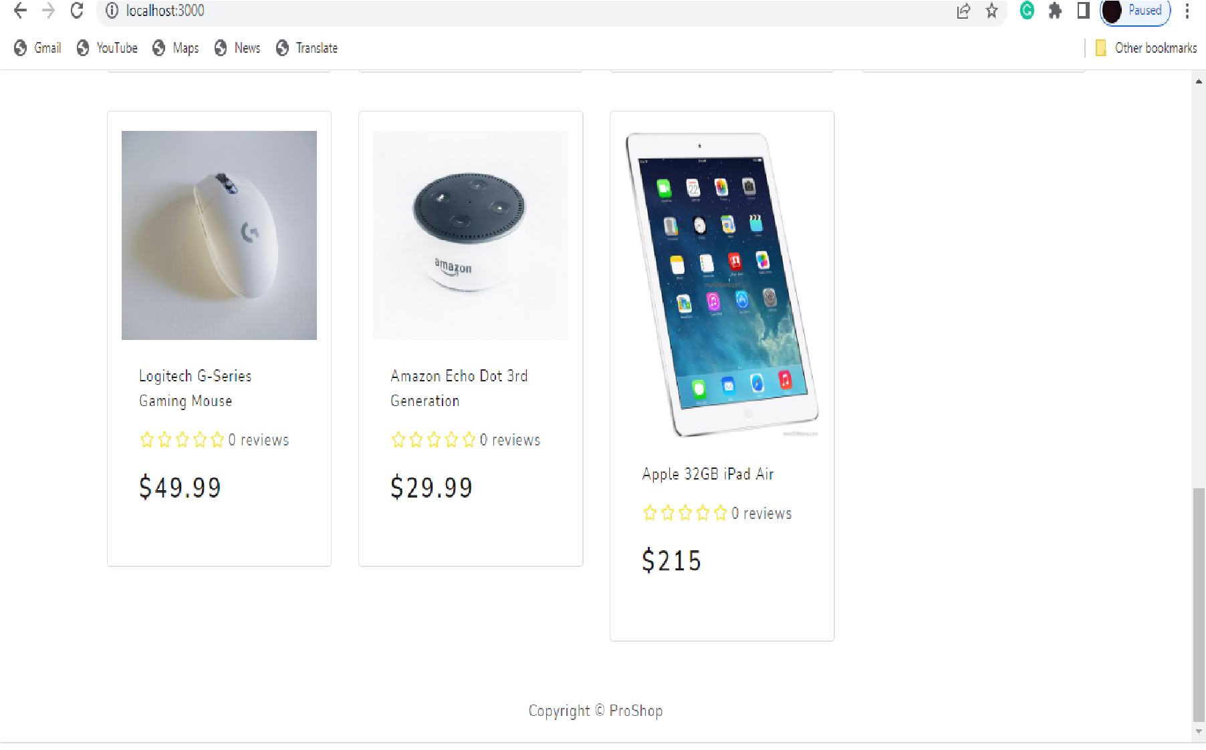

Fig 3.1.3 Product Category Screen
Figure 3.1.2&3.1.3 depicts the Product Category screen.Here viewer can get access to different categories to get prescribed product.
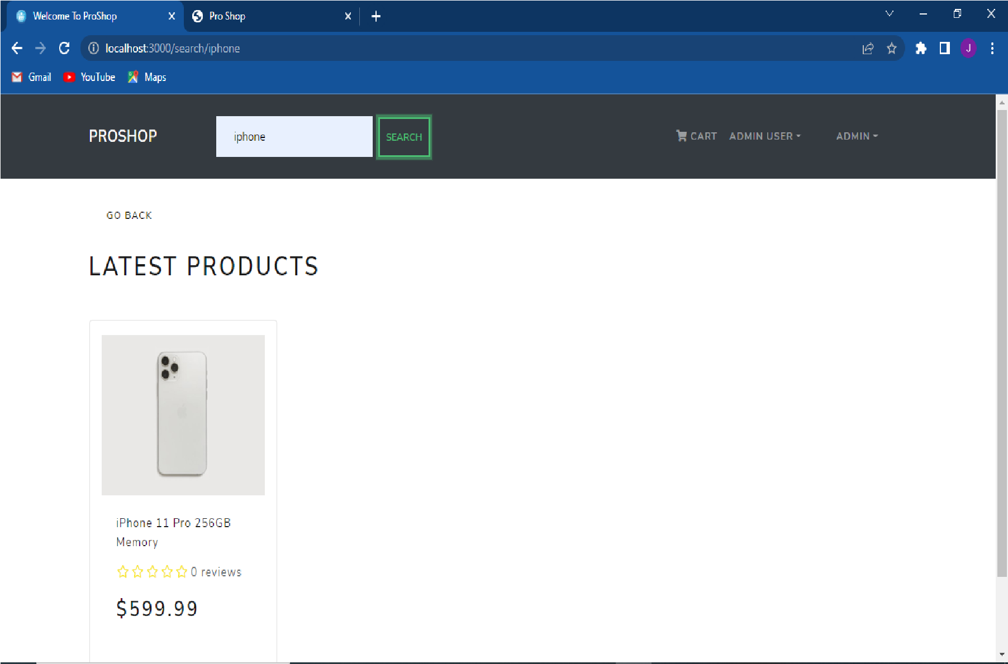

Fig 3.1.4 Search Bar
Fig 3.1.4 depicts that with the help of search bar we can search the product easily.
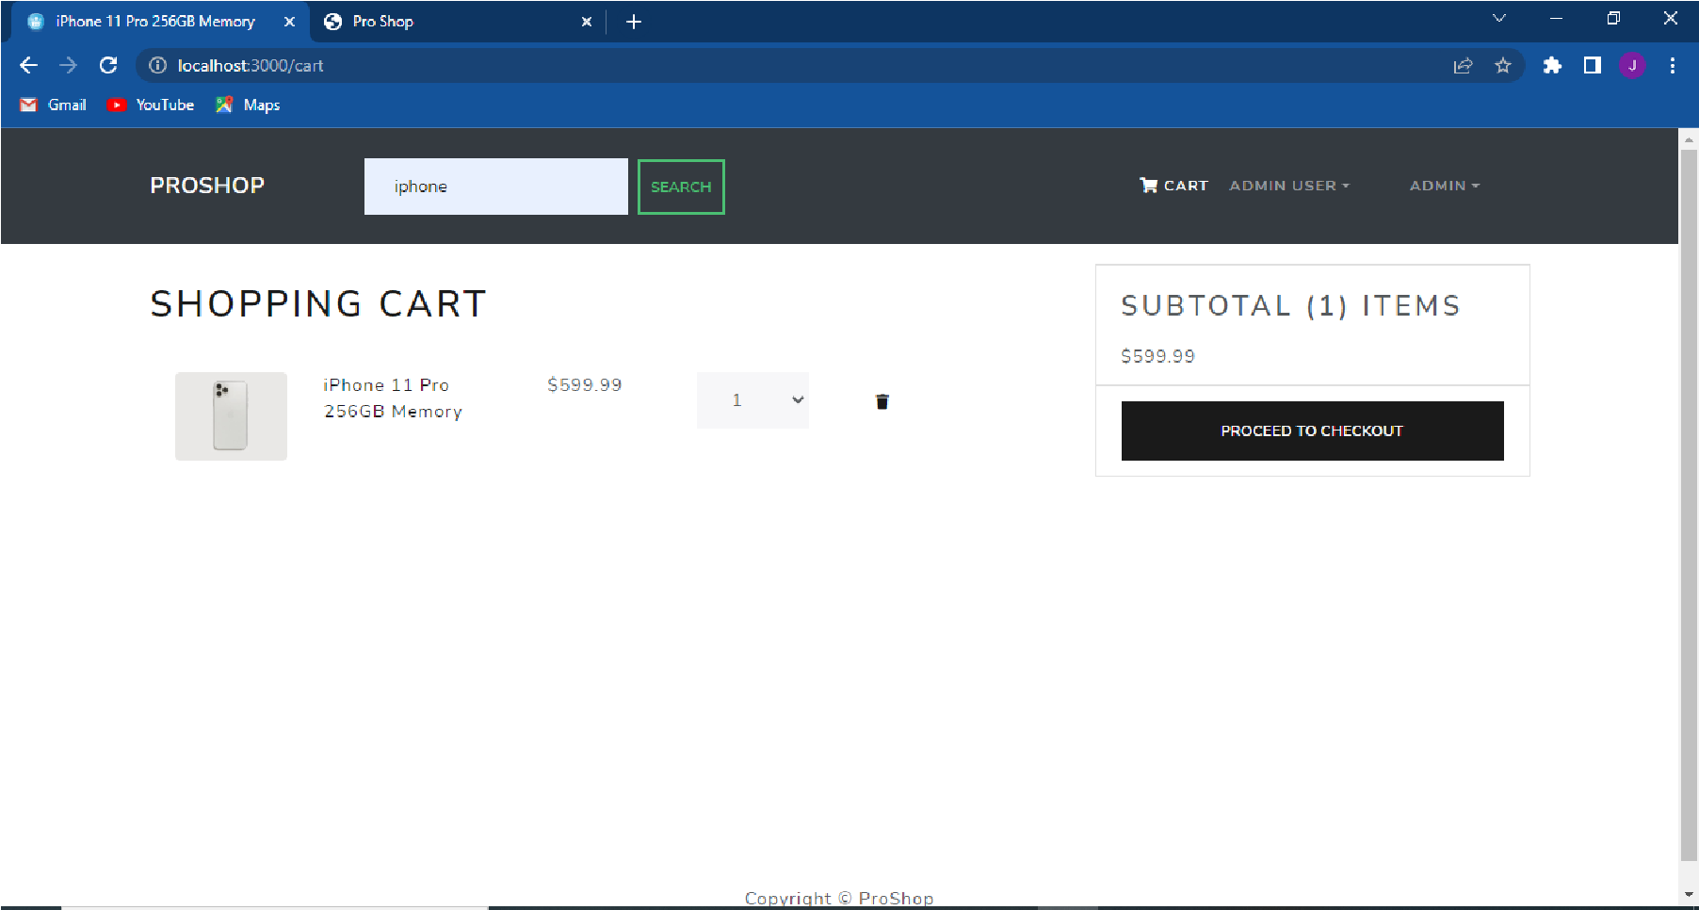

Fig 3.1.5 Shopping Cart
Figure 3.1.5 depicts the Shopping Cart & Payment option.Here viewer can access the shopping cart and Payable amount of products
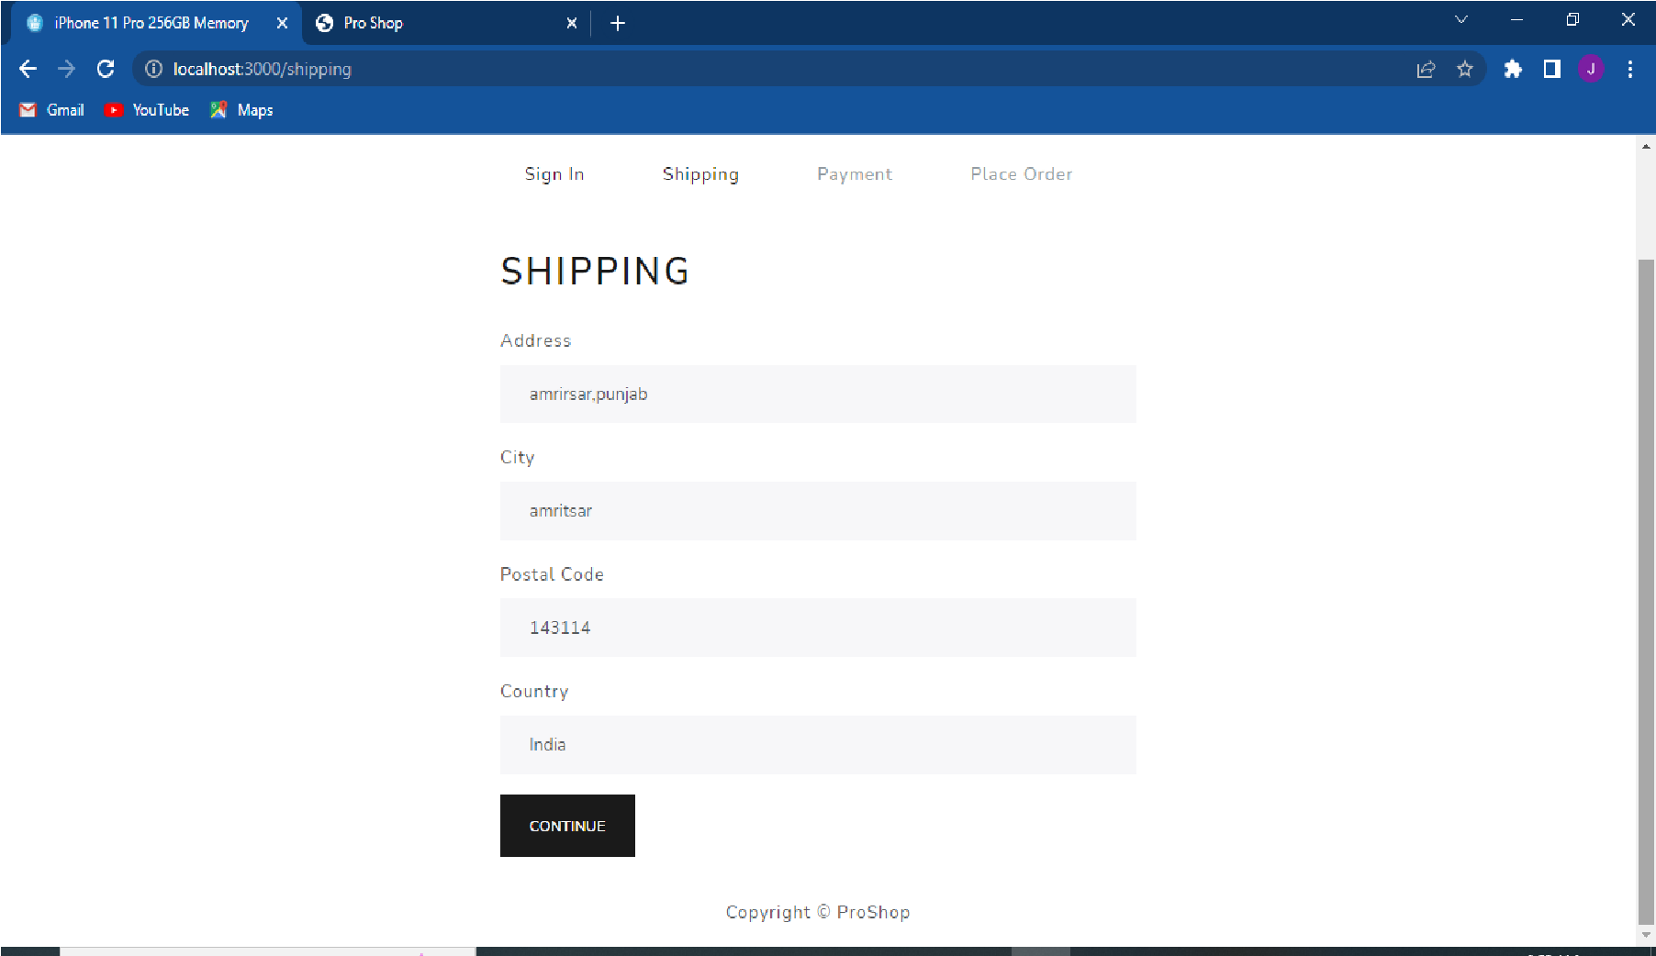

Fig 3.1.6 :Shipping Details
Figure 3.1.6 depicts the Buy Product option for getting the detail of buyer.Here buyer can fill the basic detail about the delivery location and Mail for Ebill.
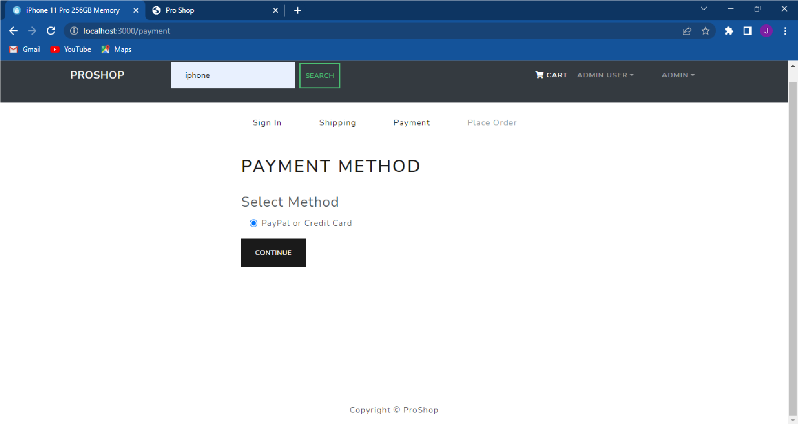

Fig 3.1.7: Payment Method
Fig 3.1.7 depicts that we can choose a payment method from Paypal or Credit Card.
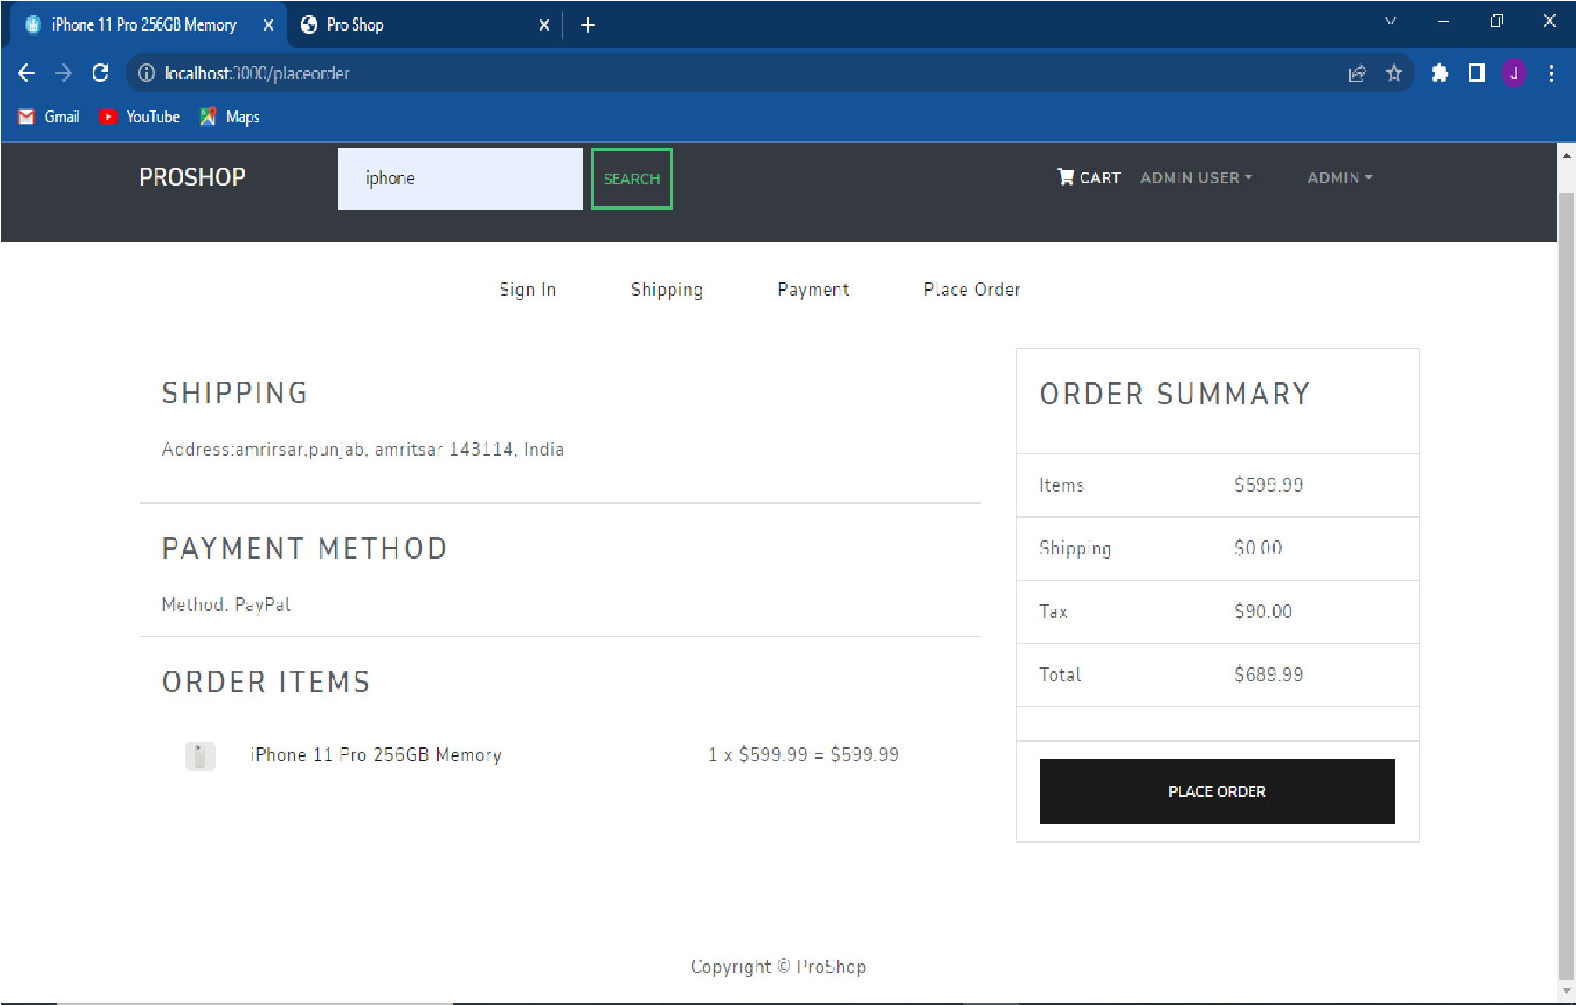

Fig3.1.8 :Order Summary
Fig 3.1.8 depicts that the amount of items, shipping charges, tax and total amount.
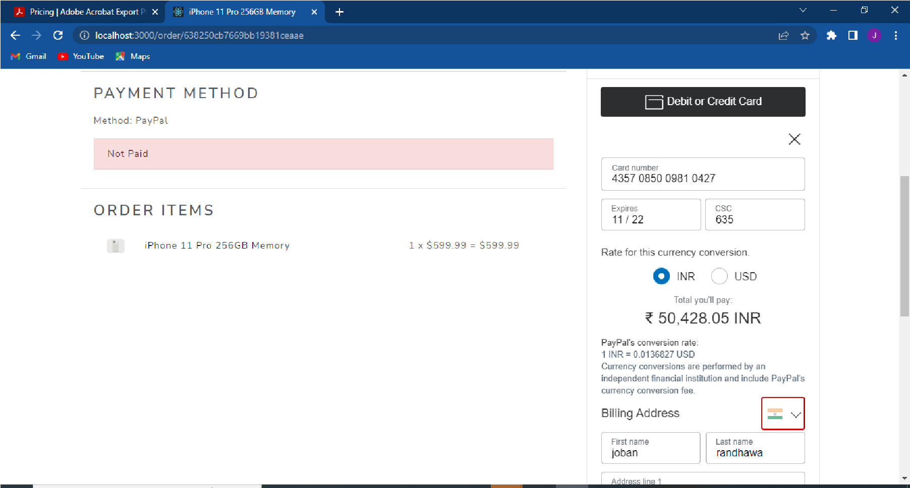
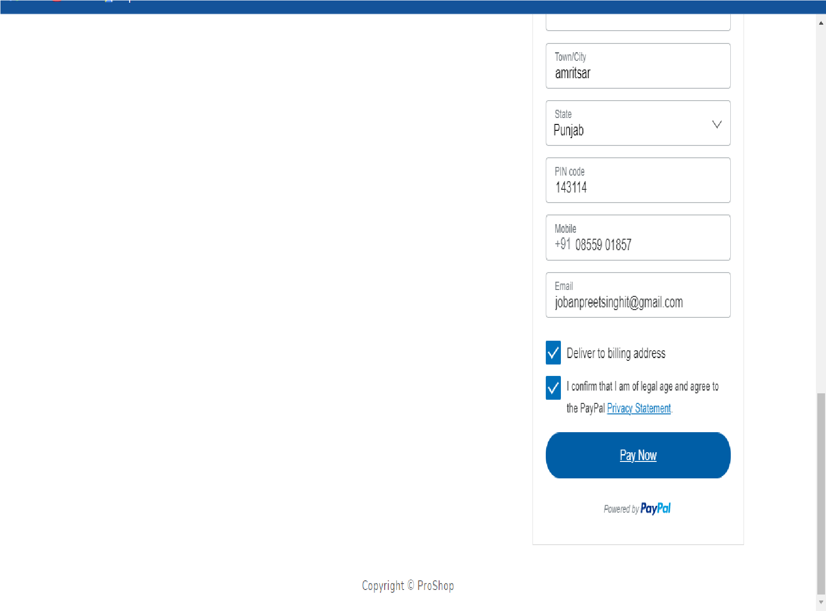

Figure 3.1.9: Payment
Figure 3.1.8 depicts the Payment Details.Here customer have to add card details for proceed payment
CHAPTER 4
CONCLUSION AND FUTURE SCOPE
CONCLUSION:
It is concluded that the website is working and all its core function are also working. Any bug that I was able to get, I removed it and will keep trying to improve this application.
Making this project is one of the challenging works, which I did as Good I can and this website will keep getting better with future updates.
Future Scope:
Future scope of this project is great as there are many things that can be added to this website that can make this application better than it already is. Future update also ensures that user is getting free user experience.
Updating website for latest features in code is also a task that must be done.

BIBLIOGRAPHY
https://reactjs.org/ https://nodejs.org https://www.w3school.com https://www.mongodb.com/ https://expressjs.com

