To explore , you may log in with the dummy user accounts (Management level officer) and (Operational level officer). Password .
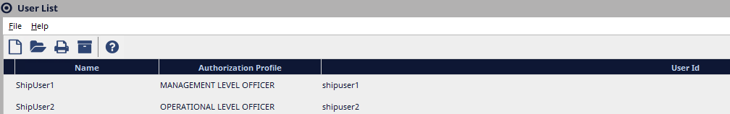
Accessing eLogs: This can be done in 2 ways.
- Open the UAT RD Web page.
- Click on the NSA-E log remote app to launch the app.
- For purposes of this guide we will use the first option with following steps:
- 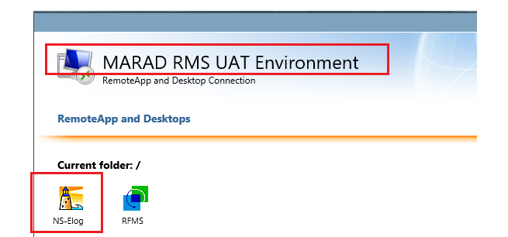
- Login to the NSE instance using your NS Account credentials.
- Click on the Module to open the module.
- 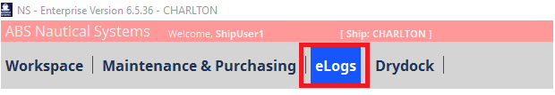
- That will open the module on MS Edge browser. is a web-based module and it will be accessed from a browser only.
The other option to access is by directly opening the URL from a browser. The URLs are different for each site since the host’s name is part of the URL. For testing, access by opening the URL: http://marhsawas908:7071/#/login from a browser. ( works better if the Chrome browser is used). Once at the login page, use your NSE Credentials to log in.
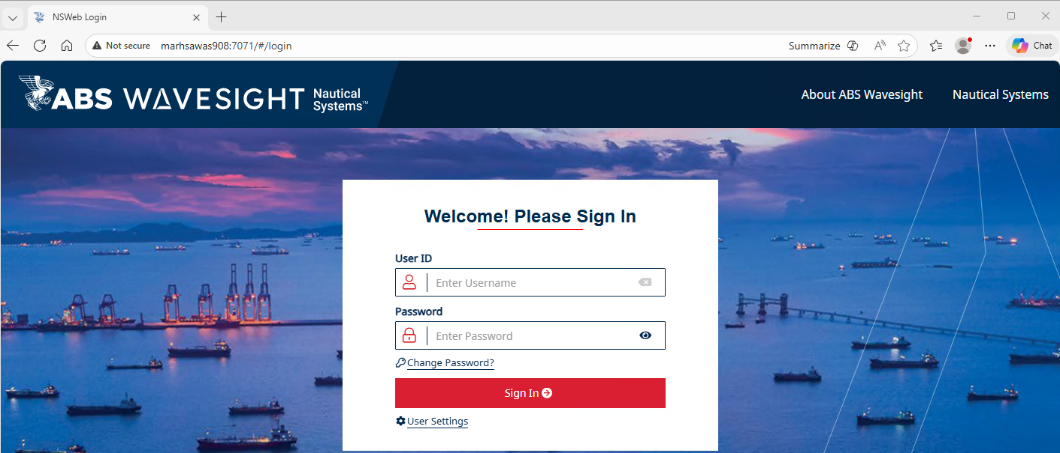
After login, the user selects and creates a signature.
If a signature is not saved, the user will need to create the signature each time, submitting an update. We are using test account or and password to capture the process of creating/resetting a PIN and Signature.
- After login to , click on located at the top-right of the page:
- 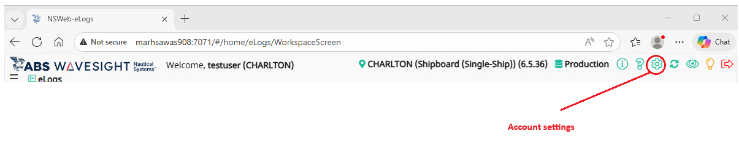
- On the user account settings page, click the button and update your user PIN and Signature
- 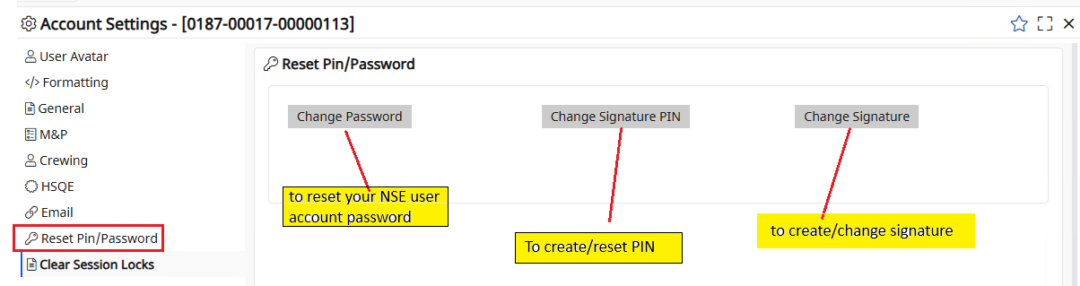
- If the user has an existing PIN (this applies recently created NSE accounts), the system will prompt the users to enter the , , and . If the user does not have an existing PIN (this applies for older NSE accounts), the system will prompt users to enter a and . Type the new PIN, Confirm the new PIN, and to apply the change.
- 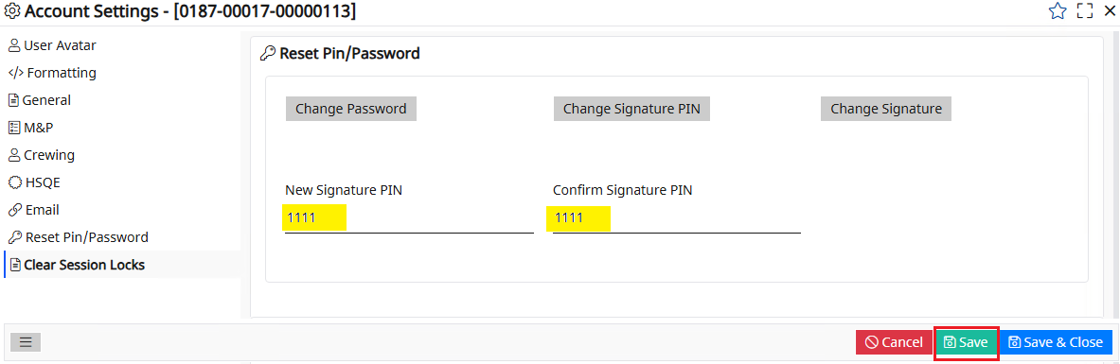
- Log out of to apply the PIN update.
- After login to , go to Accounts Settings. Select / to create your signature. At this point the system will prompt the user to enter the PIN number. Enter the PIN created and click .
- A box will open for the user to upload or sign a signature. Click the option to use an existing signature that is saved locally on your computer. Use the mouse to create your signature and click to apply the update. The option is to delete an existing signature.
- 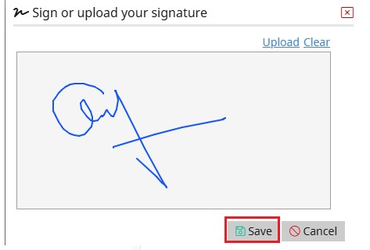
- Click on to close Account Settings.
- Saving the Signature is important, or the user will need to sign the signature each time submitting a record update. Below is an example: when the user clicks on the signature window with an already existing signature will open. Enter the PIN and click to complete submitting the record update.
- 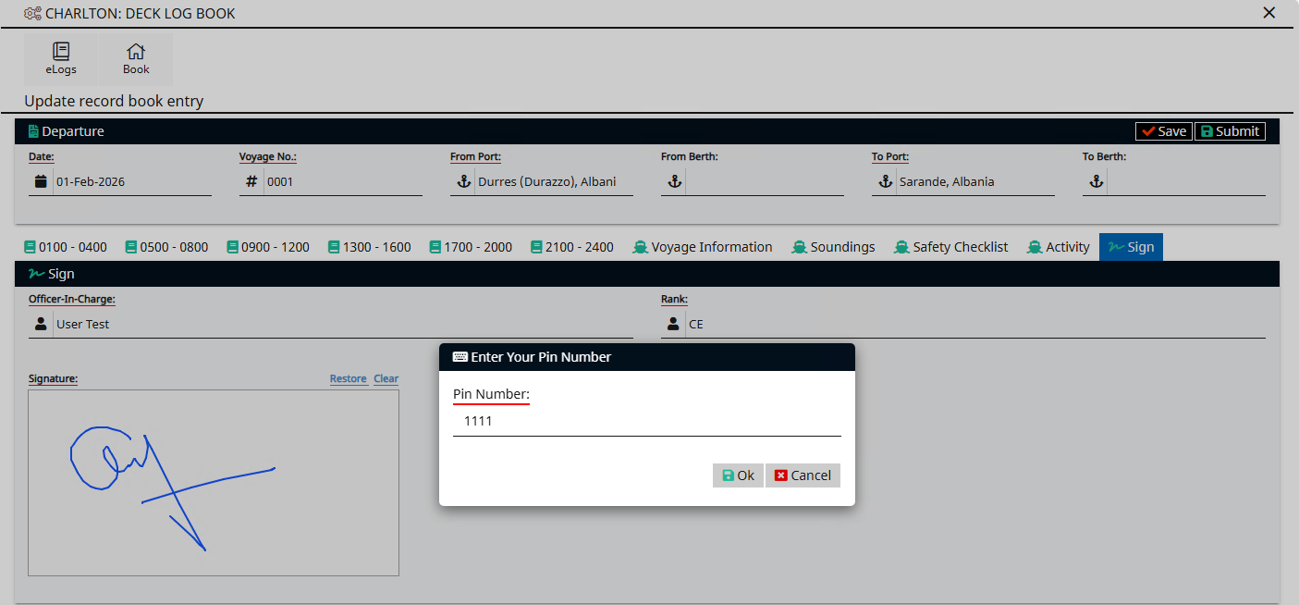
- This is number 9 E-log dashboard MARPOL BOOKS:
- 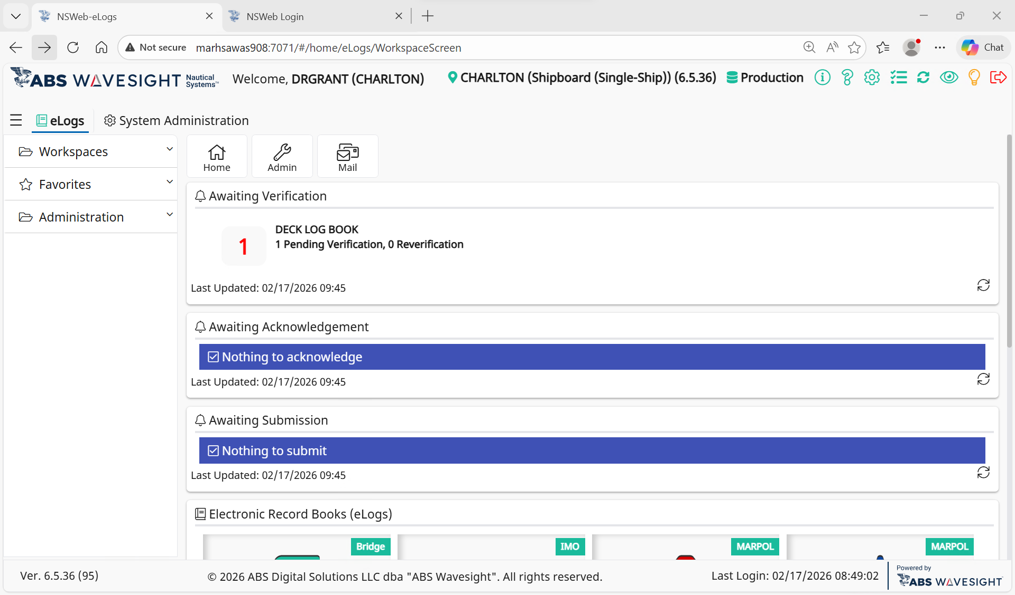
- This is the oil record book dashboard. The icons are active, you click on them to make log entries as needed.
- This is the Input Data Selection page/action operation page.
- From the dashboard page please select the OIL RECORD BOOK PART 1:
- 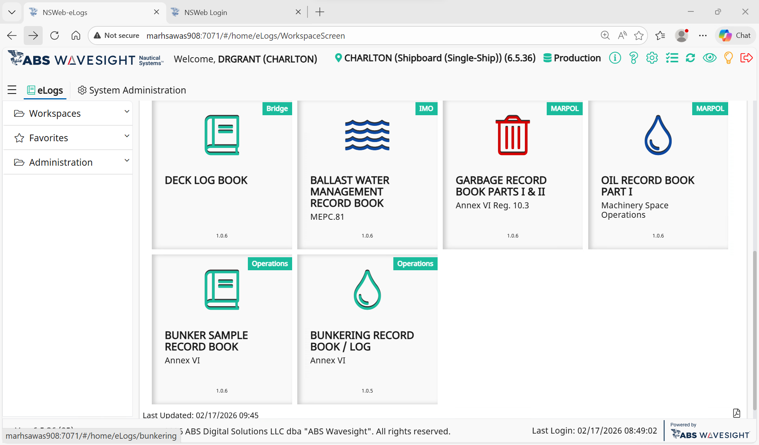
- Click on the button to record your daily entries.
- 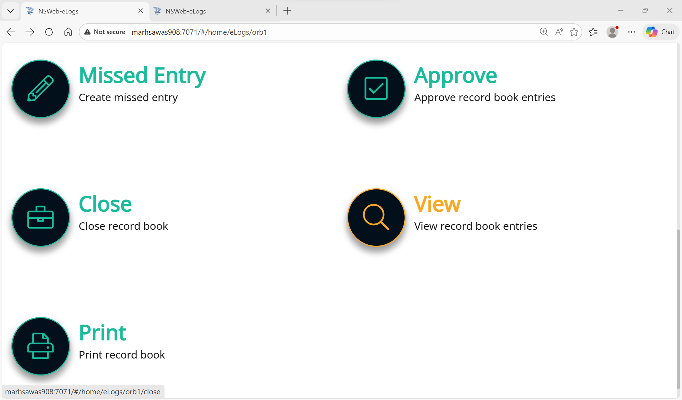
- Clicking on the button will take you here to this page, to the Oil record book template. Entries that are underlined in red are mandatory and must has to be completed for submission of the record.
- From the Electronic Record Books () screen (ship level), select the .
- On the record book menu, select the button. The record book’s screen displays.
- Select the appropriate and . The form will populate with additional sections for data entry.
- uses Greenwich Mean Time (GMT) and Local Time (LT) in record detail. The time is entered using military time format. Time entries display in the , in the exported file and can be found in the print out of the record.
- Enter the appropriate information in all required fields. Required fields are underlined in .
- Optional. For , there are three options that can be selected where ballasting was performed: , , .
- To view the , click the button located to the top right of the screen just above the button. The dialog will be opened. Click either or for details.
- This feature can be used on a rig or offshore vessel to view the time and location of the vessel when the logbook is accessed.
- To create a record for ballast or cleaning water discharge from oil fuel tanks, navigate to
- For the Category, select .
- To create a record for weekly update of residues, navigate to
- For the Category, select . Then select .
- To create a record for non-automatic water discharge, navigate to
- For the Category, select .
- To create a record for automatic water discharge, navigate to
- For the Category, select .
- To create a record for oil filtering equipment condition, navigate to
- For the Category, select .
- To create a record for oil discharges, navigate to
- For the Category, select .
- You need to enter either a port location or a latitude/longitude coordinate pair.
- To create a record for bunkering of fuel/lubricating oil, navigate to
- For the Category, select .
- The final category is for remarks or operations that do not have their own structured format.
- For the Category, select .
- For all Categories: to add attachments, click the browse to upload hyperlink located in the section and select the appropriate file. File types that can be attached include , , , , , , and .
- Optional. To save the record book entry as a draft rather than submitting it for approval, in the section, click the button. Once a record is saved as a draft, the button will appear in the section.
- In the section, enter the , , and signature.
- From the section, click the button. An dialog displays.
- Enter the appropriate Pin Number and then click .

