I have created users accounts shipuser1 (Management level officer) and shipuser2 (Operational level officer) for testing. Password marad1234
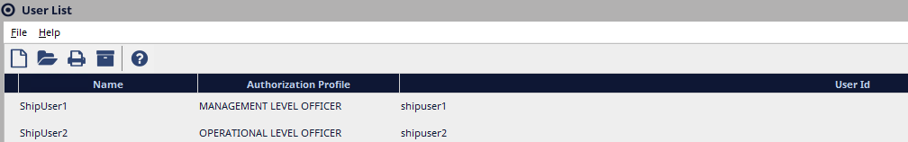

Accessing eLogs: this can be done in 2 ways:

- Open the UAT RD Web page : https://marhsawas908.ad.dot.gov/RDWeb/Pages/en-US/Default.aspx
- click on the NS-E log remote app to launch the app.
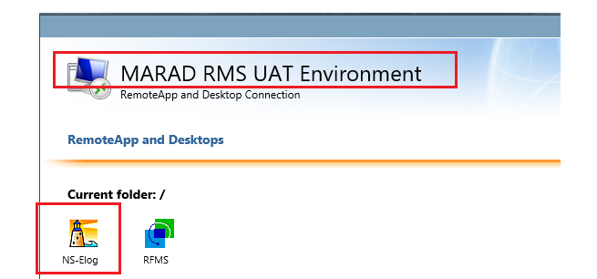
- login to the NSE instance using your NS Account credentials.
- Click on the eLogs Module to open the module.
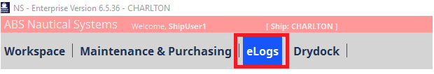
- That will open the eLogs module on MS Edge browser. eLogs is a web-based module and it will be accessed from a browser only.

The other option to access eLogs is by directly opening the eLogs URL from a browser. The URLs are different for each site since the host’s name is part of the URL. For testing access eLogs by opening the URL: http://marhsawas908:7071/#/login from a browser.( eLogs works better if Chrome browser is used). Once at the login page, use your NSE Credentials to log in.

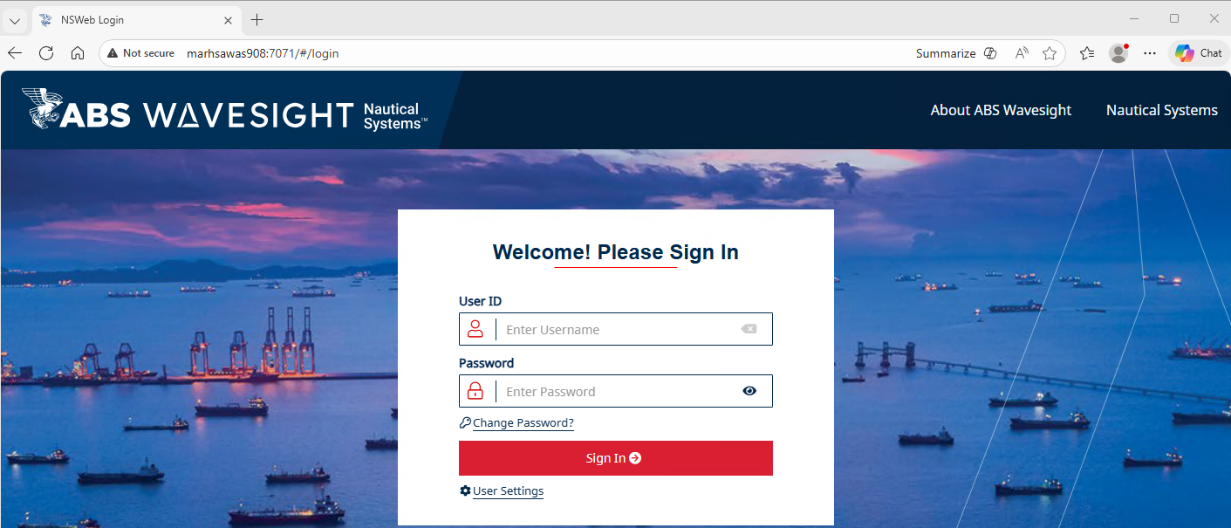

After inital login, the user selects change/Create PIN and create signature as well.
If a signature is not saved , the user will need to create the signature each time submitting an update. We are using test account test user 1 or test user 2 and password marad1234 capturing the process creating/resetting PIN and Signature.

- After login to eLogs click on Account settings located at the top-right of the page
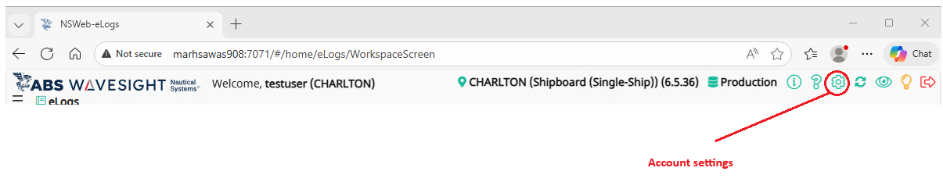
- On the user account settings page, click the Reset Pin/Password button and update your user PIN and Signature.?
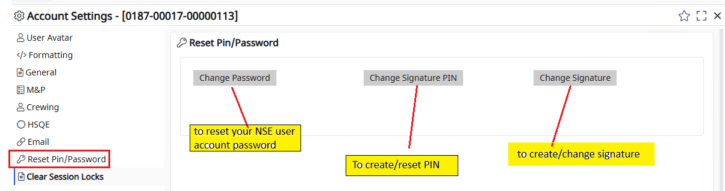

- If the user has an existing PIN (this applies recently created NSE accounts), the system will prompt the users to enter the current Signature PIN, New Signature PIN, and Confirm Signature PIN . If the user does not have an existing PIN (this applies for older NSE accounts), the system will prompt the users to enter the New Signature PIN, and Confirm Signature PIN. Type the new PIN, Confirm the new PIN, and Save to apply the change.

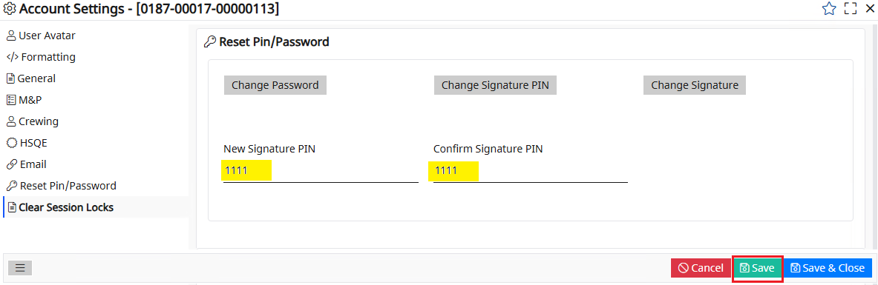
- Log out of eLogs to apply the PIN update.
- After login to eLogs, go to Accounts Settings select Reset Pin/Password Change Signature to create your signature. At this point the system will prompt the user to enter the PIN number. Enter the PIN created and click ok.
- A box will open for the user to upload or sign a signature. Click the Upload option to use an existing signature that is saved locally on your computer. Use the mouse to create your signature and click save to apply the update. The clear option is to delete an existing signature.
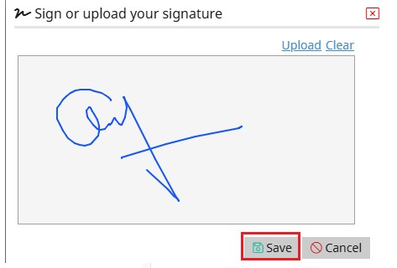

- Click on Save & Close to close Account Settings.
- Saving the Signature is important, or the user will need to sign the signature each time submitting a record update. Below is an example, when the user clicks on Sign the signature window with an existing signature. Enter the PIN and click OK to complete submitting the record update.

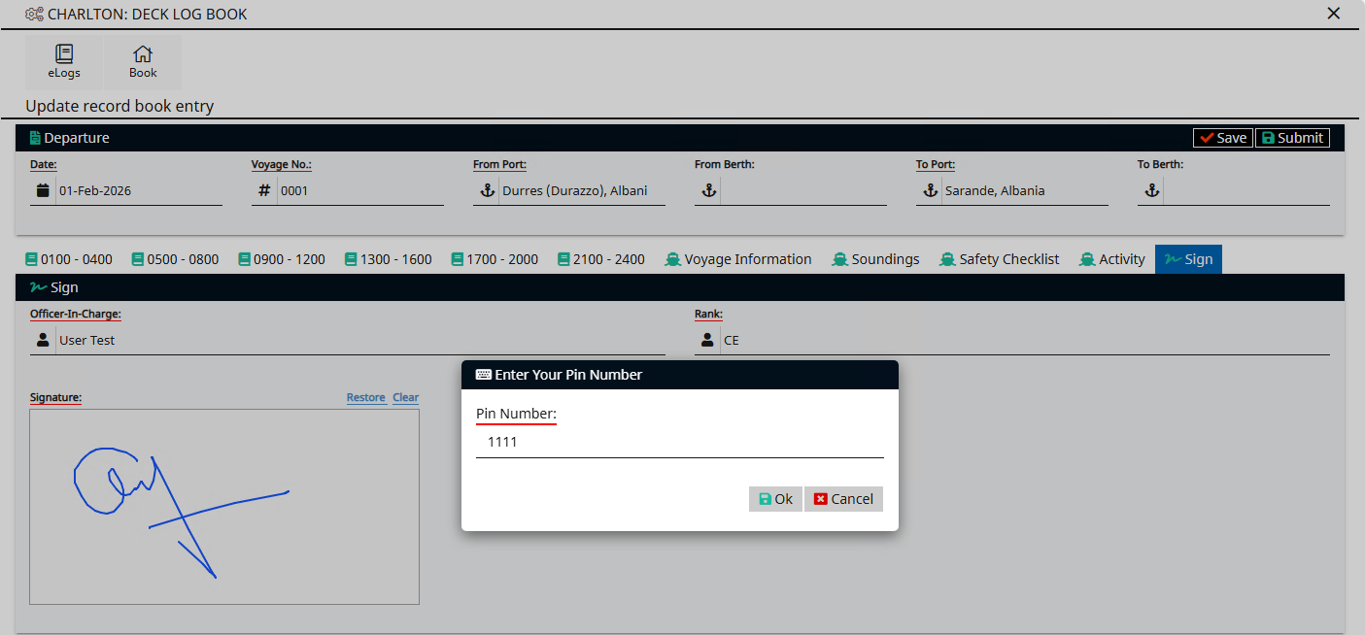
- This is number 9 E-log dashboard MARPOL BOOKS
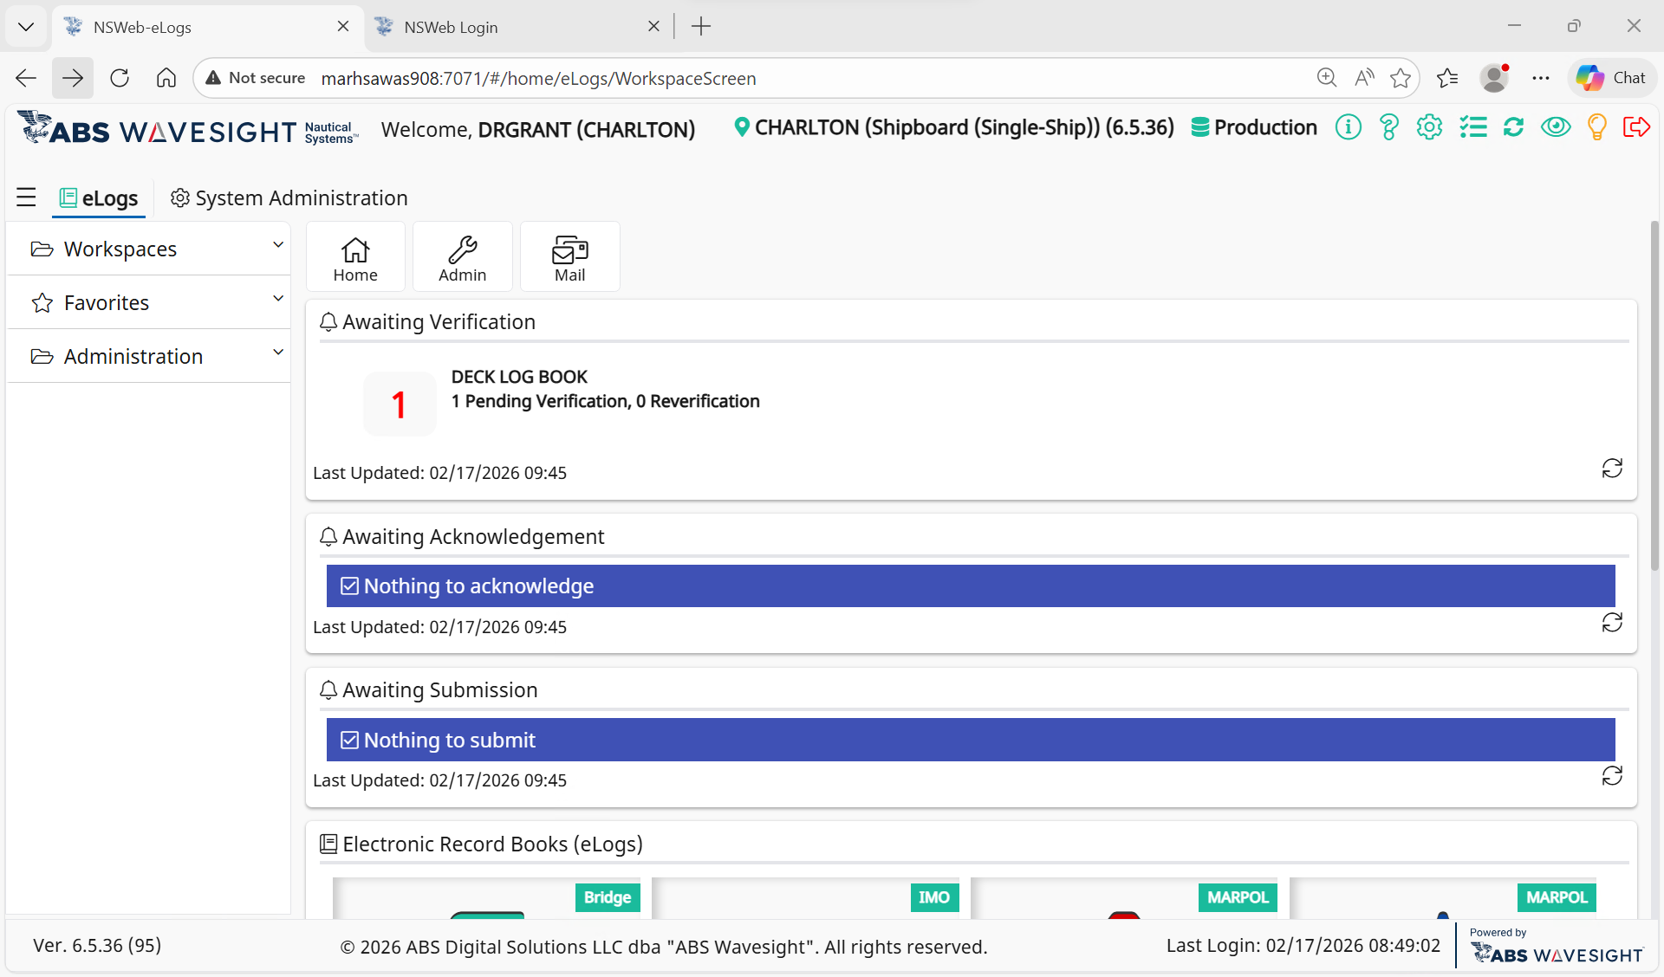

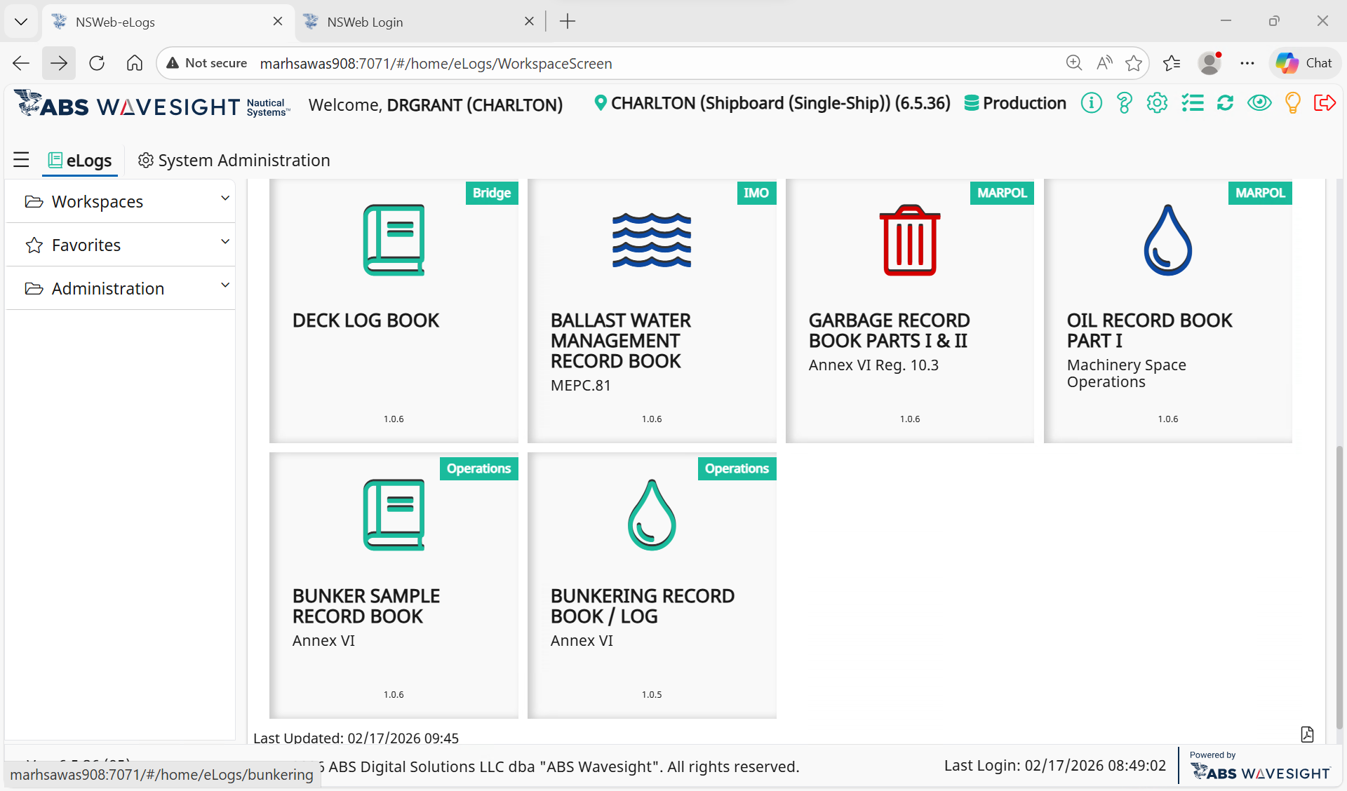

- This is the Input Data Selection page/action operation page
- From the dashboard page please select the OIL RECORD BOOK PART1

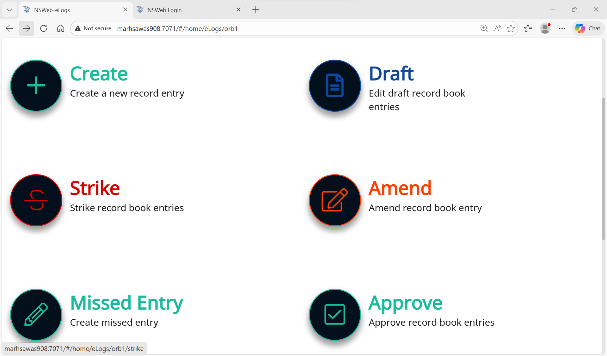
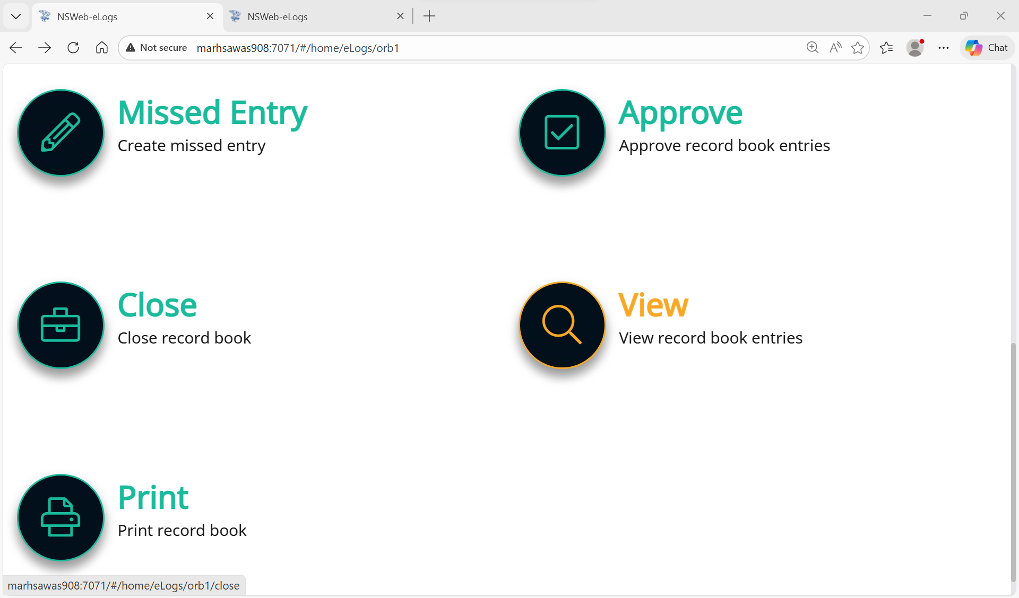

- This is the oil record book dashboard. The icons are active, you click on them for making log entries as needed.
Click on the create + button to record your daily entries.
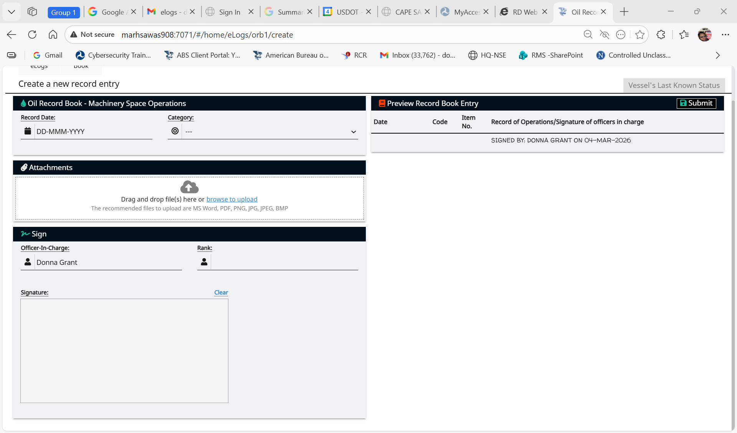
- Clicking on the create + button will take you here to this page, the Oil record book template: Entries underlined in red are mandatory and must be completed for submission of the E Log record..

Machinery Space Operations
Create

1. From the Electronic Record Books ( eLogs ) screen (ship level), select the Oil Record Book Part I – Machinery Space Operations Operations.

2. On the record book menu, select the Create button. The record book’s screen displays.

3. Select the appropriate Record Date and Category. The form will populate with additional sections for data entry.

Tip! eLogs uses Greenwich Mean Time (GMT) and Local Time (LT) in record detail. The time is entered using military time format. Time entries display in the Preview Record Book Entry, in the exported file and can be found in the print out of the record.

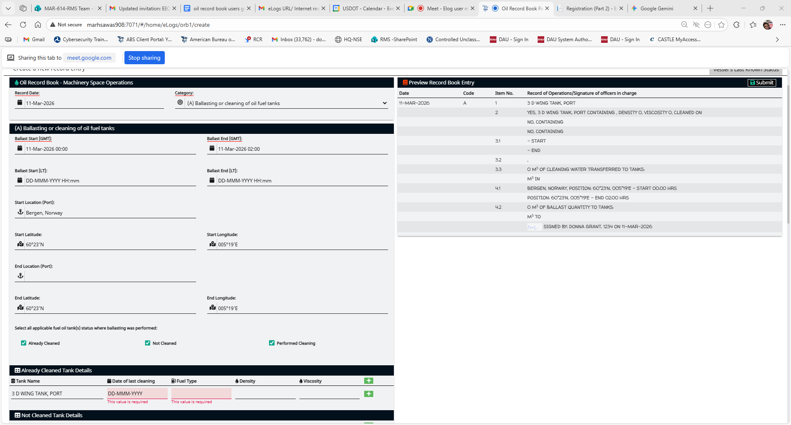

4. Enter the appropriate information in all required fields. Required fields are underlined in red.
5. Optional. For Tank Details, there are three options that can be selected where ballasting was performed: Already Cleaned, Not Cleaned, Performed Cleaning
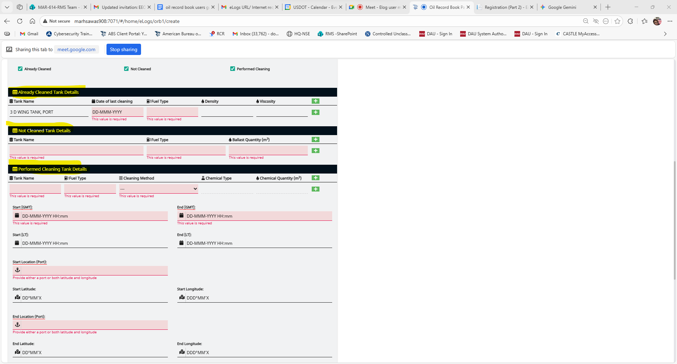

• To view the Vessel’s Last Known Status, click the button located to the top right of the screen just above the Save As Draft button. The Vessel’s Last Known Status dialog will be opened. Click either Vessel’s Operational Status or Engine Status for details.
Tip! This feature can be used on a rig or offshore vessel to view the time and location of the vessel when the logbook is accessed.

To create a record for ballast or cleaning water discharge from oil fuel tanks, navigate to ”Oil Record Book Part I – Machinery Space Operations”
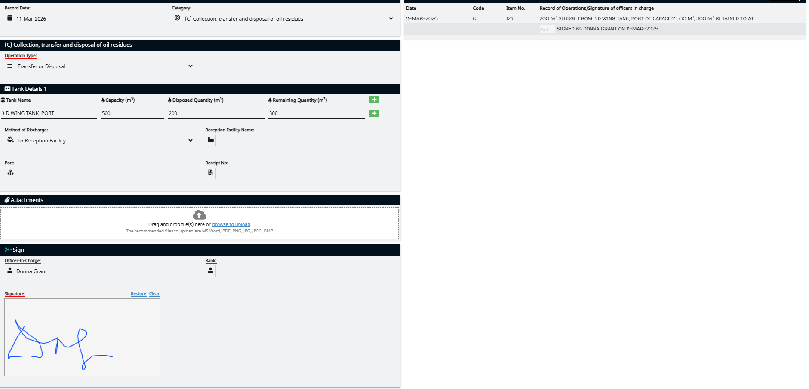
For the Category, select “ (B) Discharge of dirty ballast or cleaning water from oil fuel referred to under section (A) ”.

To create a record for weekly update of residues, navigate to “Oil Record Book Part I –Machinery Space Operations”

For the Category, select “(C) Collections, transfer, and disposal of oil residues ”. Then select “Weekly Update of Oil Residues”.

To create a record for non-automatic water discharge, navigate to “Oil Record Book Part I – Machinery Space Operations”
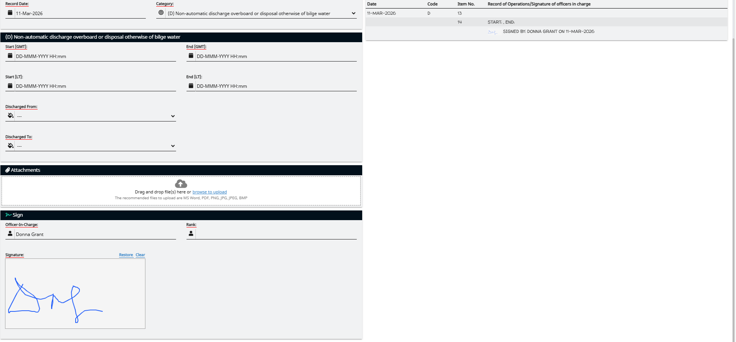
For the Category, select “(D) Non-automatic discharge overboard or disposal otherwise of bilge water”.

To create a record for automatic water discharge, navigate to “Oil Record Book Part I – Machinery Space Operations”
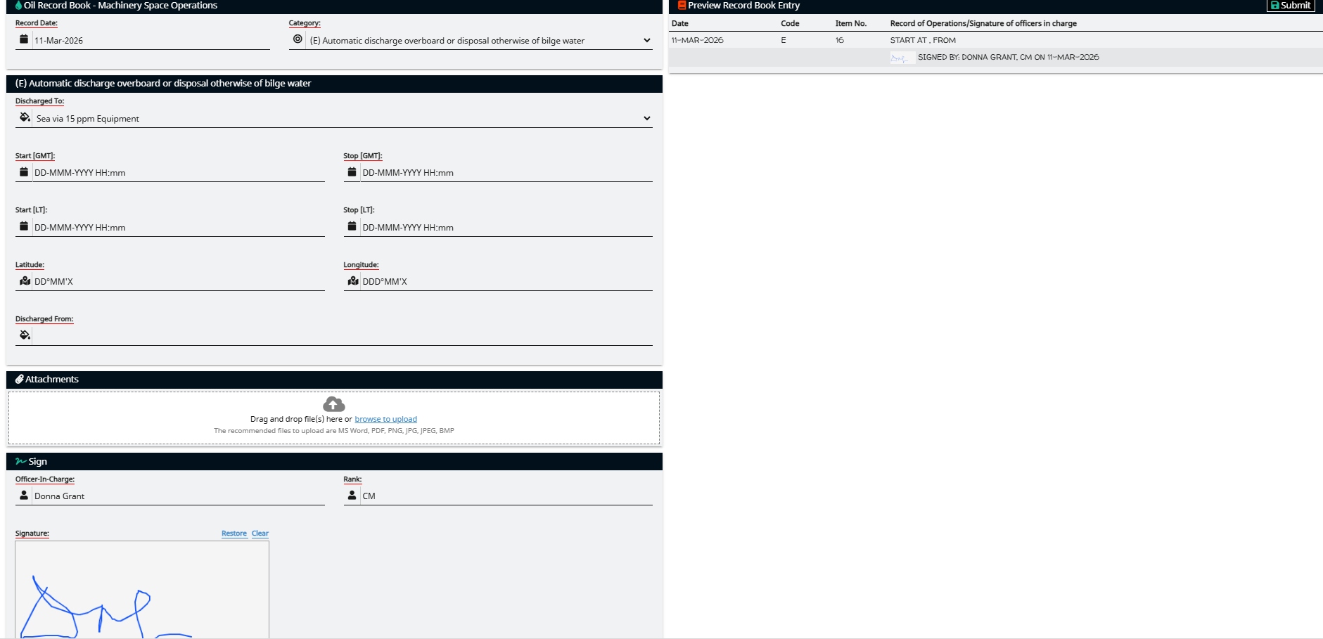
For the Category, select “(E) Automatic discharge overboard or disposal otherwise of bilge water”.

To create a record for oil filtering equipment condition, navigate to “Oil Record Book Part I – Machinery Space Operations”
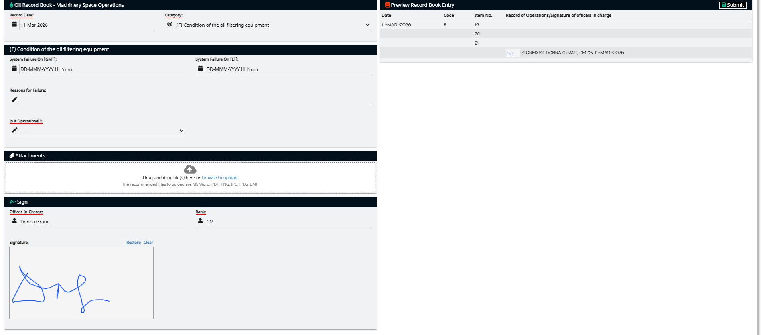
For the Category, select “(F) Condition of the oil filtering equipment”.

To create a record for oil discharges, navigate to “Oil Record Book Part I – MachinerySpace Operations”
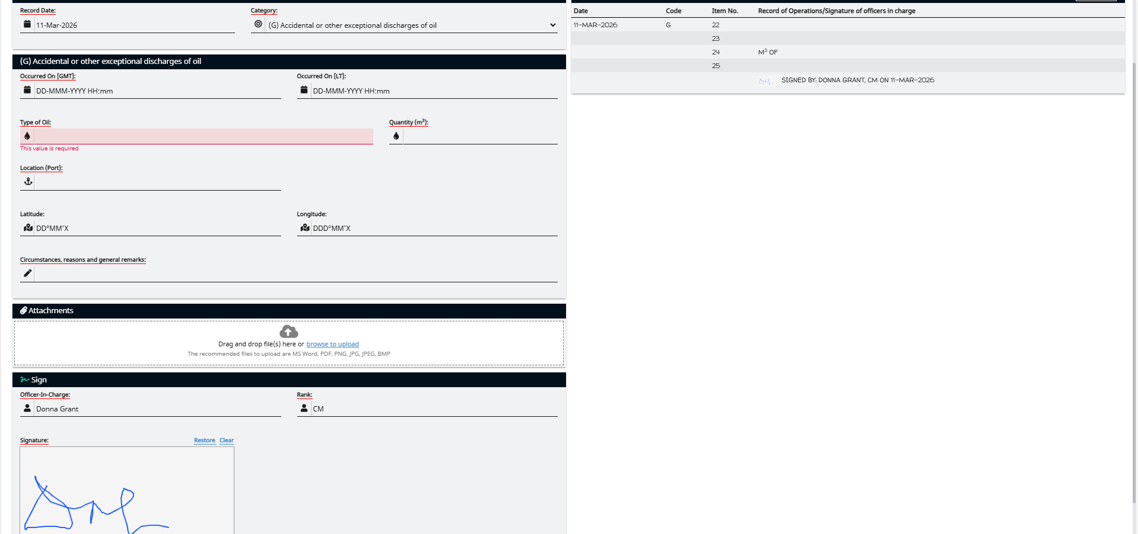
For the Category, select “(G) Accidental or other exceptional discharges of oil”.
Tip ! You need to enter either a port location or a latitude/longitude coordinate pair.

To create a record for bunkering of fuel/lubricating oil, navigate to “Oil Record Book Part I – Machinery Space Operations”
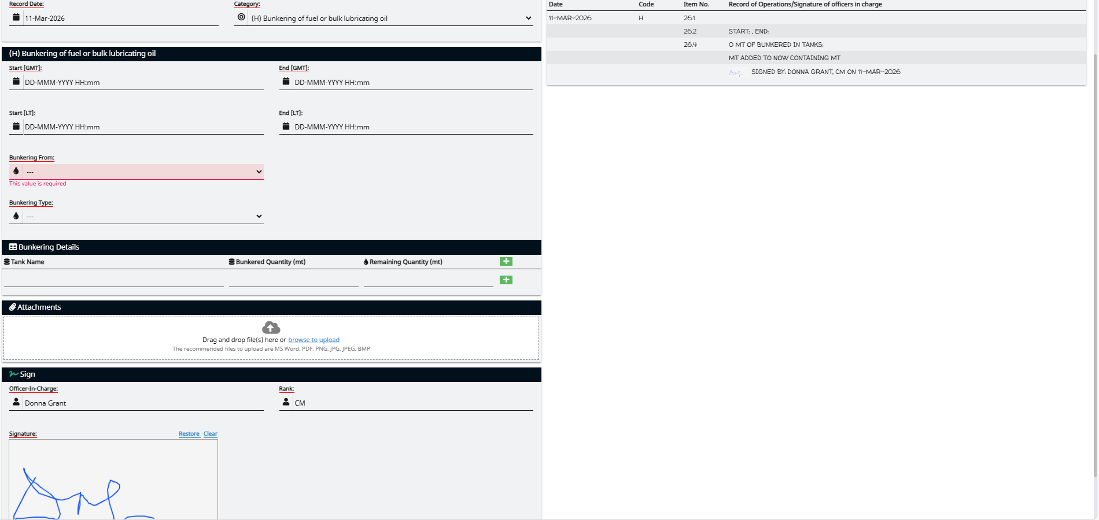
For the Category, select “(H) Bunkering of fuel or bulk lubricating oil”.
The final category is for remarks or operations that do not have their own structured format.
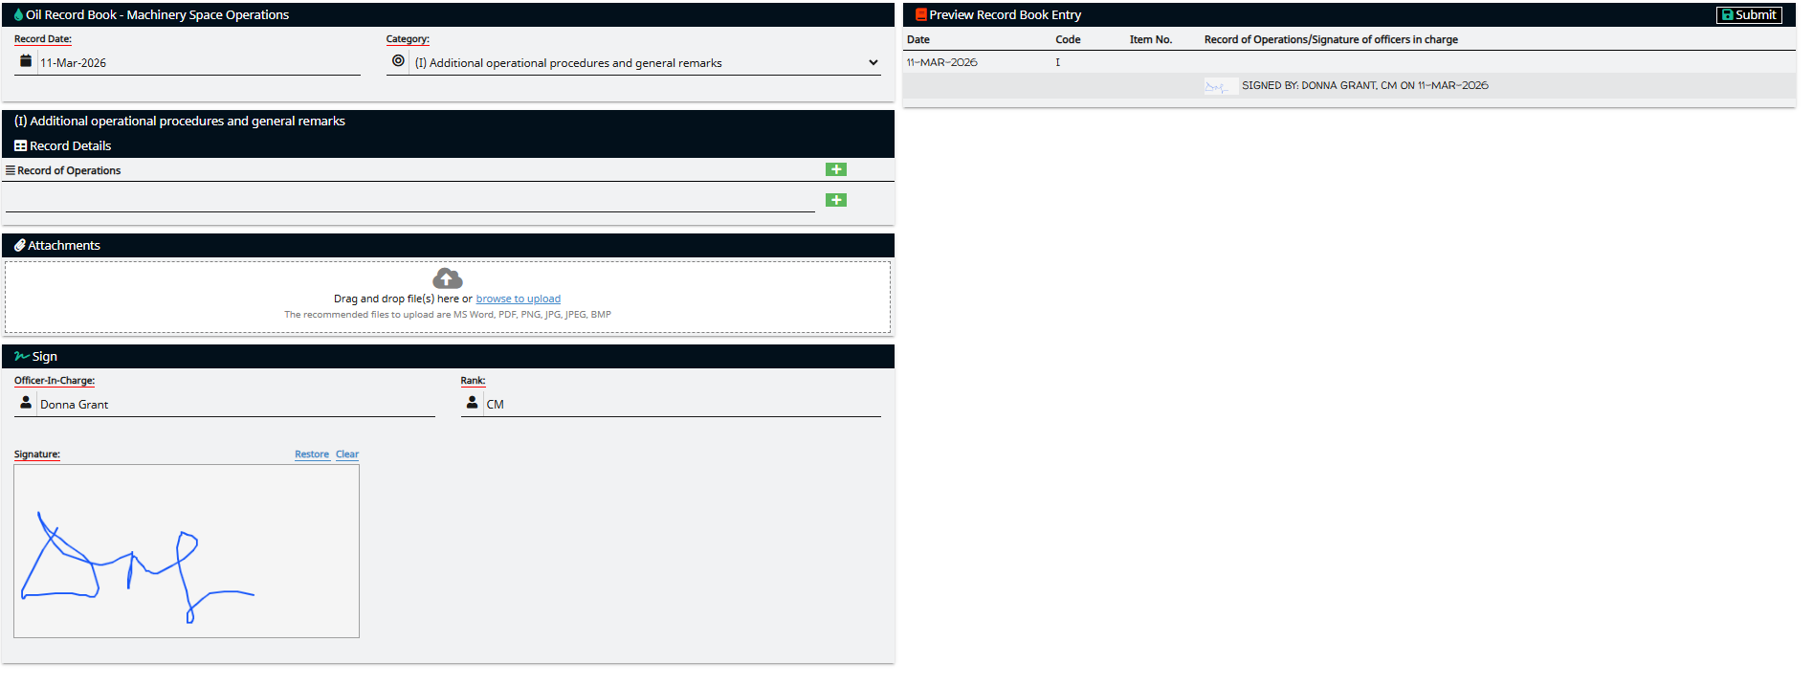
For the Category, select “ (I) Additional operating procedures and general remarks ”.

6. For all Categories: to add attachments, click the browse to upload hyperlink located in the Attachments section and select the appropriate file. File types that can be attached include PDF , DOCX , XLSX , PNG , JPG , GIF , and BMP .
7. Optional. To save the record book entry as a draft rather than submitting it for approval, in the Preview Record Book Entry section, click the Save as Draft button. Once a record is saved as a draft, the Delete button will appear in the Preview Record Book Entry section.
8. In the Sign section, enter the Officer-In-Charge, Rank, and signature.


9. From the Preview Record Book Entry section, click the Submit button. An “Enter Your PIN Number” dialog displays.
10. Enter the appropriate Pin Number and then click “Ok”.

