原题：
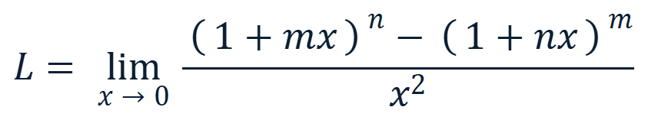

来源：
来 源
《工科数学分析习题册（第二版）》，第 6 题（据用户提供的书影）。
题面中的 m, n 限定为正整数；这一条件保证二项式展开与逐次求导在 x = 0 的邻域内均合法。
ANSWER / 答案
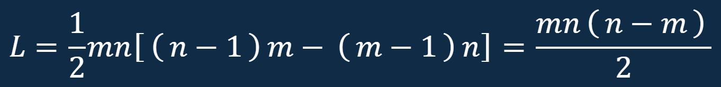
当 n > m 时 L > 0；当 n < m 时 L < 0；当 n = m 时 L = 0。

提示词：这题来源是工科数学分析习题册（第二版），请以多种做题方法解答并给出解题过程，把过程和结果整理成一份逻辑清晰、原理正确且美观大方的PPT。 提交内容：原题及来源、提示词、代码、PPT。

代码：
PYTHON 3 · STANDARD LIBRARY ONLY
1 #!/usr/bin/env python3
2 # -*- coding: utf-8 -*-
3 """
4 工科数学分析习题册（第二版）· 第 6 题
5 极限的精确推导与数值验证（仅使用 Python 标准库）
6 题目：
7 L = lim_{x->0} [ (1 + m x)^n - (1 + n x)^m ] / x^2,
8 m, n in N+.
9 结论：
10 L = m n (n - m) / 2.
11 """
12 from decimal import Decimal, getcontext
13 from fractions import Fraction
14 from math import comb
15 def expand_power(a: int, b: int, n: int) -> list[Fraction]:
16 """Return coefficients of (a + b*x)^n, from x^0 to x^n."""
17 return [Fraction(comb(n, k)) * (a ** (n - k)) * (b ** k)
18 for k in range(n + 1)]
19 def subtract(p: list[Fraction], q: list[Fraction]) -> list[Fraction]:
20 """Subtract two polynomials represented by coefficient lists."""
21 size = max(len(p), len(q))
22 p = p + [Fraction(0)] * (size - len(p))
23 q = q + [Fraction(0)] * (size - len(q))
24 return [a - b for a, b in zip(p, q)]
25 def coefficient_by_expansion(m: int, n: int) -> Fraction:
26 """Coefficient of x^2 in (1+mx)^n - (1+nx)^m."""
27 p = expand_power(1, m, n)
28 q = expand_power(1, n, m)
29 diff = subtract(p, q)
30 # The constant and linear terms must cancel exactly.
31 assert diff[0] == 0, "constant term should vanish"
32 assert diff[1] == 0, "linear term should vanish"
33 return diff[2] if len(diff) > 2 else Fraction(0)
34 def closed_form(m: int, n: int) -> Fraction:
35 """The closed-form limit value."""
36 return Fraction(m * n * (n - m), 2)
37 def numeric_value(m: int, n: int, x: Decimal) -> Decimal:
38 """Evaluate the quotient at a nonzero x with high precision."""
39 one = Decimal(1)
40 return ((one + m * x) ** n - (one + n * x) ** m) / (x * x)
41 def main() -> None:
42 getcontext().prec = 60
43 print("=" * 72)
44 print("Part 1. Exact coefficient by binomial expansion")
45 print("=" * 72)
46 print(f"{'m':>3} {'n':>3} {'coefficient of x^2':>22} {'mn(n-m)/2':>14}")
47 for m, n in [(1, 2), (2, 5), (3, 3), (4, 1), (5, 2), (7, 9)]:
48 exact = coefficient_by_expansion(m, n)
49 formula = closed_form(m, n)
50 assert exact == formula
51 print(f"{m:>3} {n:>3} {str(exact):>22} {str(formula):>14}")
52 # Exhaustive exact check for 1 <= m, n <= 20.
53 for m in range(1, 21):
54 for n in range(1, 21):
55 assert coefficient_by_expansion(m, n) == closed_form(m, n)
56 print("\n[OK] Exact identity verified for all 1 <= m, n <= 20.")
57 print("\n" + "=" * 72)
58 print("Part 2. Numerical convergence of the original quotient")
59 print("=" * 72)
60 print("x = 10^-k, computed with 60 decimal digits\n")
61 print(f"{'m':>2} {'n':>2} {'k':>2} {'quotient':>24} {'limit':>12} {'error':>12}")
62 for m, n in [(2, 5), (5, 2), (3, 3), (4, 1)]:
63 limit = Decimal(closed_form(m, n).numerator) / Decimal(closed_form(m, n).denominator)
64 for k in range(1, 8):
65 x = Decimal(10) ** (-k)
66 q = numeric_value(m, n, x)
67 error = abs(q - limit)
68 error_text = "0" if error == 0 else f"{error:.2e}"
69 print(f"{m:>2} {n:>2} {k:>2} {q:>24.15f} {limit:>12.6f} {error_text:>12}")
70 print("-" * 72)
71 print("\n[OK] All numerical results approach mn(n-m)/2.")
72 if __name__ == "__main__":
73 main()

