高等数学极限题的解答与提交材料
经典教材习题改编的极限问题
本文件按顺序整理原题及来源、最终答案与验证过程、本次实际使用的提示词，以及生成六页课件的完整 Python 代码。题目来自经典教材习题，具体题号需人工按教材核对。

1 原题及来源

1.1 原题
求下列极限：
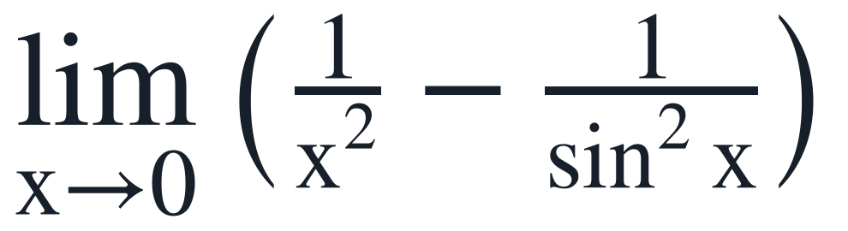

1.2 来源
经典教材习题改编。
同济大学《高等数学》第七版上册，极限与泰勒公式部分；也常见于考研数学复习资料。
具体题号需人工按教材核对。

1.3 最终答案
最终答案：−1/3
泰勒主法先通分，确认分母为四阶；再把正弦函数展开到足以产生四阶分子的项，平方并取倒数后与原式相减。常数项为负三分之一，其余项的极限为零。交叉检查把原式分解为三个标准极限的乘积，三个因子的极限依次为六分之一、二和一，再带上负号，结果同为负三分之一。

1.4 逐步解法与验证
第一步，通分。两个分式相减先化为一个分式，便于比较分子与分母的阶数。
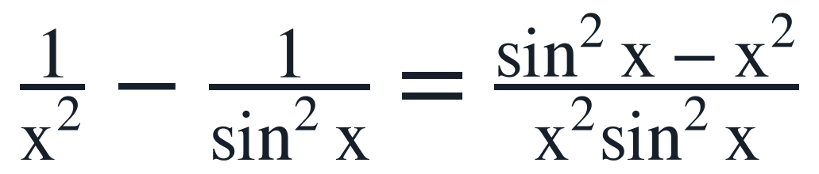
当 x 趋于零时，分母中的两个因子各自与 x 的二阶量等价，因此整个分母为四阶。分子不能只保留二阶主项，否则会完全抵消。
第二步，展开正弦函数。正弦函数展开到五阶，平方后保留到六阶，才能稳定得到分子中的四阶项。
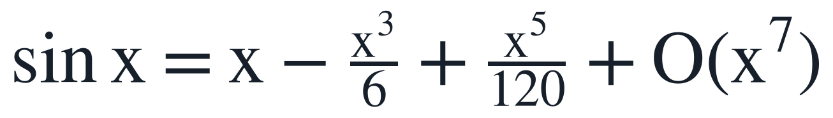
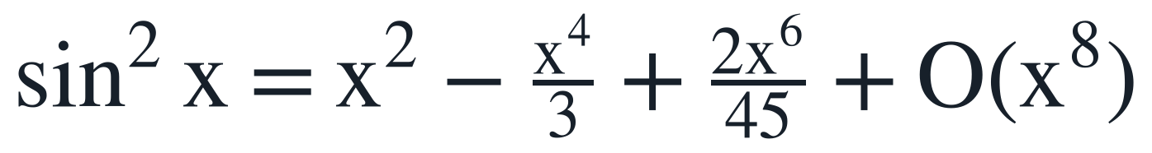
平方后，二次项保留，四次项来自两个展开项的一次交叉乘积，六次项来自三次项的平方。更高阶项统一并入余项。
第三步，取倒数并比较阶数。把正弦平方的展开式整体除以 x 的二次幂，得到倒数表达式。
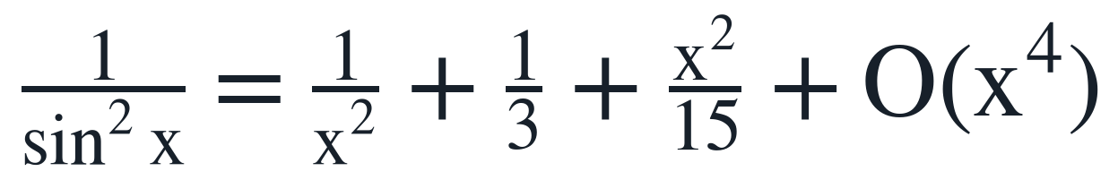
倒数展开中出现了与 x 的二次幂相消的主项，同时留下常数项和二阶项。与原式中的平方倒数相减后，常数项不再抵消。
第四步，取极限。将倒数展开代回原式，只剩常数项和趋于零的余项。
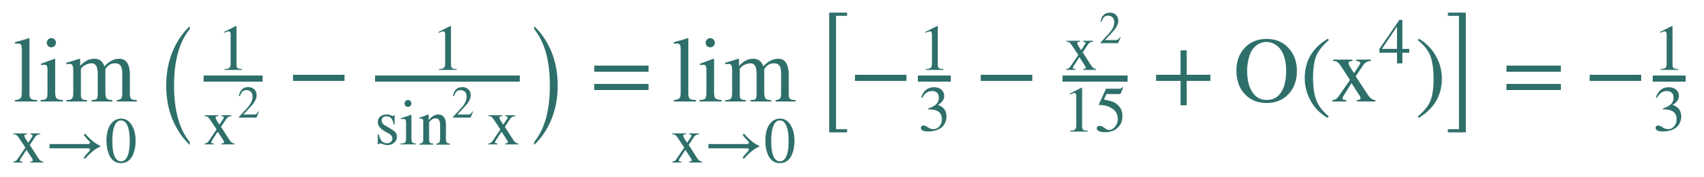
因此原极限为负三分之一。
交叉检查。将原式写成分式后分解为三个标准极限的乘积，可绕开高阶展开再次核对符号与系数。
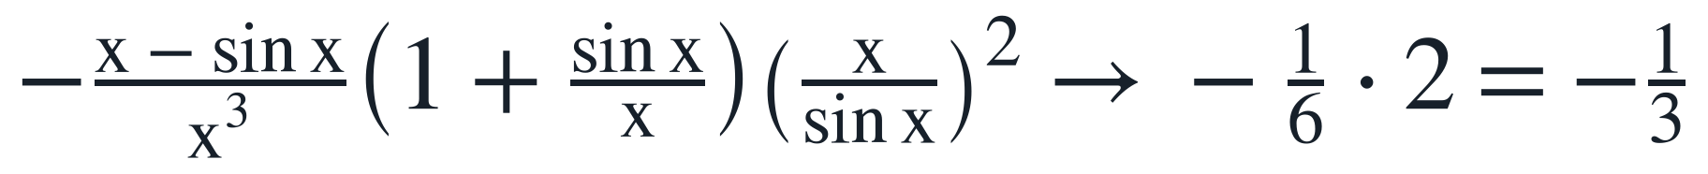
其中正弦差与三次幂的比值趋于六分之一，这一标准极限可由两次洛必达得到。其余两个因子分别趋于二和一，整体带上负号后仍为负三分之一。

1.5 常见错误
直接代入。原式是无穷减无穷的未定结构，不能分别求极限后相减。
展开阶数不够。只保留正弦的一次项时，分子主项完全抵消，无法得到负三分之一。
分母等价替换不完整。分母可看作四阶，但分子仍需保留首个未抵消项；只替换一部分会丢失信息。
多次洛必达。直接连续求导容易混淆乘积与链式结构，应先通分再决定是否使用。
忽略高阶项。平方和取倒数时须控制余项阶数，否则会误判常数项或丢掉非零项。

2 提示词
以下为本次实际使用的完整提示词原文。
你现在是数学助教+PPT设计师+文档整理助手，请直接在dsh环境中执行，不要只告诉我步骤。本次任务对应“第一次Demo实践”：用DeepSeek Harness完成一道高等数学题，并提交：原题及来源、提示词、代码、PPT。其中“原题及来源、提示词、代码”必须整理进同一个docx；PPT只呈现题目、解题过程和结果，不要放提示词和代码。

【固定题目，不要换题】
求极限：lim_{x→0} (1/x^2 - 1/sin^2 x)。

【来源标注】
经典高等数学极限题，教材习题改编（同济大学《高等数学》第七版上册，极限与泰勒公式部分）；也常见于考研数学复习资料。注意：若你不能联网核验具体题号/页码，不要编造，来源就写“经典教材习题改编”，并在docx中注明“具体题号需人工按教材核对”。

【任务一：解题与验证】
1. 给出最终答案，并用两种方法验证：泰勒展开法为主，另用等价无穷小/洛必达思路做交叉检查。
2. 输出逐步解法：通分、sin x的泰勒展开、sin^2 x展开、分子分母阶数比较、取极限。每一步写清原理。
3. 列出常见错误：多次洛必达易错、分母等价替换不完整、展开阶数不够、忽略高阶项等。
4. 数学正确性优先；若发现错误自行修正后再输出最终版。

【任务二：生成PPT（只放题目、过程、结果）】
1. 编写完整Python脚本 math_demo_solution.py，使用python-pptx生成 math_demo_final.pptx，共6页：P1封面（题目主题）；P2原题及来源；P3思路拆解（通分+泰勒）；P4关键展开；P5求极限与验证；P6方法总结与常见错误。
2. PPT中不要出现提示词、代码、dsh操作说明；只呈现数学题目、解题过程、结果、验证和方法总结。
3. 所有数学公式用matplotlib mathtext渲染为PNG（300dpi）放入 assets/ 后插入PPT；中文使用系统中文字体，确保不乱码。
4. 版式要求：逻辑清晰、原理正确、美观大方；统一字体和配色，颜色不超过3种；标题层级明确；留白充足；每页文字少；不要堆圆角卡片、装饰圆、渐变色、三栏小卡片等AI风。
5. 封面要有标题层次和明确主题；公式图大小合适，不遮挡文字；每页只突出一个核心信息。
6. 直接运行脚本，保存PPT；打印输出文件路径、页数、每页shape数量。
7. 自检：用shape的left/top/width/height检查是否超出页面边界、是否相互重叠；检查公式图是否过小、文字是否可能溢出；若发现问题自动调整后重新运行。
8. 不要覆盖已有文件；若 math_demo_final.pptx 已存在，另存为 math_demo_final_v2.pptx。

【任务三：整理提交docx】
1. 使用python-docx生成 math_demo_submission.docx，必须包含以下三部分，按顺序：
（1）原题及来源：原题、来源标注、最终答案、简要验证说明；
（2）提示词：本次实际发给dsh的完整提示词原文；
（3）代码：math_demo_solution.py 的完整代码，用等宽字体或代码样式排版，保证可复制。
2. docx排版要求：标题层级清楚、段落整洁、代码部分不要乱换行；中文正常显示；页边距合理。
3. docx中不要放PPT截图，不要放与提交无关的内容。
4. 将本次实际使用的提示词同时保存为 prompts.md，便于核对。
5. 最后打印完整提交清单及路径：
- math_demo_submission.docx（含原题及来源、提示词、代码）
- math_demo_solution.py
- math_demo_final.pptx（只含题目、过程、结果）
- prompts.md
- assets/（公式图片）
并打印PPT页数、每页shape数量、docx包含的章节标题。
6. 若缺少python-docx，请先安装再生成；不要只给代码不运行。

3 代码
以下为 math_demo_solution.py 的完整代码，保持原始缩进与换行。
#!/usr/bin/env python3
# -*- coding: utf-8 -*-
"""Generate a six-slide mathematics presentation with python-pptx.

The limit is

lim_{x -> 0} (1/x^2 - 1/sin^2(x)) = -1/3.

Every displayed formula is rendered by matplotlib mathtext at 300 dpi and
inserted as a PNG. The script refuses to overwrite an existing PPTX.
"""

from __future__ import annotations

import os
import tempfile
from pathlib import Path

BASE_DIR = Path(__file__).resolve().parent
ASSETS_DIR = BASE_DIR / "assets"
MPL_CACHE_DIR = Path(tempfile.gettempdir()) / "math_demo_mpl_cache"
MPL_CACHE_DIR.mkdir(parents=True, exist_ok=True)
os.environ.setdefault("MPLCONFIGDIR", str(MPL_CACHE_DIR))

try:
import matplotlib

matplotlib.use("Agg")
import matplotlib.pyplot as plt
from PIL import Image, ImageFont
from pptx import Presentation
from pptx.dml.color import RGBColor
from pptx.enum.text import MSO_ANCHOR, PP_ALIGN
from pptx.oxml.ns import qn
from pptx.util import Inches, Pt
except ModuleNotFoundError as exc: # pragma: no cover - user-facing setup help
raise SystemExit(
"Missing dependency: "
f"{exc.name}. Install it with: python -m pip install "
"python-pptx matplotlib pillow"
) from exc

SLIDE_W = 13.333
SLIDE_H = 7.5
DPI = 300

BG_HEX = "#F7F4EC"
INK_HEX = "#17202A"
ACCENT_HEX = "#2E6F6A"

BG = RGBColor.from_string(BG_HEX.lstrip("#"))
INK = RGBColor.from_string(INK_HEX.lstrip("#"))
ACCENT = RGBColor.from_string(ACCENT_HEX.lstrip("#"))

FONT_CN = "Microsoft YaHei"
FONT_FALLBACK = "Microsoft YaHei UI"
YAHEI_REGULAR = Path(r"C:\Windows\Fonts\msyh.ttc")
YAHEI_BOLD = Path(r"C:\Windows\Fonts\msyhbd.ttc")

FORMULAS = {
"cover_limit": (
r"\lim_{x\to 0}\left(\frac{1}{x^2}-\frac{1}{\sin^2 x}\right)=?",
34,
INK_HEX,
),
"original_limit": (
r"\lim_{x\to 0}\left(\frac{1}{x^2}-\frac{1}{\sin^2 x}\right)",
38,
INK_HEX,
),
"common_denominator": (
r"\frac{1}{x^2}-\frac{1}{\sin^2 x}"
r"=\frac{\sin^2 x-x^2}{x^2\sin^2 x}",
31,
INK_HEX,
),
"denominator_order": (
r"x^2\sin^2 x\sim x^4\quad(x\to 0)",
25,
ACCENT_HEX,
),
"sin_expansion": (
r"\sin x=x-\frac{x^3}{6}+\frac{x^5}{120}+O(x^7)",
28,
INK_HEX,
),
"sin_squared_expansion": (
r"\sin^2 x=x^2-\frac{x^4}{3}+\frac{2x^6}{45}+O(x^8)",
28,
INK_HEX,
),
"reciprocal_expansion": (
r"\frac{1}{\sin^2 x}"
r"=\frac{1}{x^2}+\frac{1}{3}+\frac{x^2}{15}+O(x^4)",
28,
INK_HEX,
),
"final_limit": (
r"\lim_{x\to 0}\left(\frac{1}{x^2}-\frac{1}{\sin^2 x}\right)"
r"=\lim_{x\to 0}\left[-\frac{1}{3}-\frac{x^2}{15}+O(x^4)\right]"
r"=-\frac{1}{3}",
29,
ACCENT_HEX,
),
"cross_check": (
r"-\frac{x-\sin x}{x^3}\left(1+\frac{\sin x}{x}\right)"
r"\left(\frac{x}{\sin x}\right)^2"
r"\to-\frac{1}{6}\cdot 2=-\frac{1}{3}",
27,
INK_HEX,
),
"standard_limit": (
r"\frac{x-\sin x}{x^3}\to\frac{1}{6}",
23,
INK_HEX,
),
}

def configure_matplotlib() -> None:
"""Set a stable serif math style that matches the editorial layout."""

plt.rcParams.update(
{
"mathtext.fontset": "stix",
"mathtext.default": "regular",
"font.family": "serif",
"font.serif": ["STIXGeneral", "DejaVu Serif"],
"axes.linewidth": 0,
}
)

def render_formulas() -> dict[str, Path]:
"""Render every display formula to a tightly cropped transparent PNG."""

configure_matplotlib()
ASSETS_DIR.mkdir(parents=True, exist_ok=True)
paths: dict[str, Path] = {}

for name, (latex, fontsize, color) in FORMULAS.items():
path = ASSETS_DIR / f"{name}.png"
fig = plt.figure(figsize=(14, 3.2), dpi=DPI)
fig.patch.set_alpha(0)
fig.text(
0.5,
0.5,
f"${latex}$",
ha="center",
va="center",
fontsize=fontsize,
color=color,
)
fig.savefig(
path,
dpi=DPI,
transparent=True,
facecolor="none",
bbox_inches="tight",
pad_inches=0.055,
)
plt.close(fig)
paths[name] = path

return paths

def set_run_font(run, font_name: str = FONT_CN) -> None:
"""Apply one typeface to Latin, East Asian, and complex-script runs."""

run.font.name = font_name
rpr = run._r.get_or_add_rPr()
for tag in ("a:ea", "a:cs"):
node = rpr.find(qn(tag))
if node is None:
node = rpr.makeelement(qn(tag), {})
rpr.append(node)
node.set("typeface", font_name)

def add_text(
slide,
x: float,
y: float,
w: float,
h: float,
text: str,
size: float,
*,
color: RGBColor = INK,
bold: bool = False,
align=PP_ALIGN.LEFT,
valign=MSO_ANCHOR.TOP,
line_spacing: float = 1.12,
margin: float = 0.025,
):
"""Add a simple text box without cards, fills, or decorative borders."""

shape = slide.shapes.add_textbox(Inches(x), Inches(y), Inches(w), Inches(h))
tf = shape.text_frame
tf.clear()
tf.word_wrap = True
tf.auto_size = None
tf.margin_left = Inches(margin)
tf.margin_right = Inches(margin)
tf.margin_top = Inches(margin)
tf.margin_bottom = Inches(margin)
tf.vertical_anchor = valign

lines = text.split("\n")
for index, line in enumerate(lines):
paragraph = tf.paragraphs[0] if index == 0 else tf.add_paragraph()
paragraph.alignment = align
paragraph.line_spacing = line_spacing
paragraph.space_before = Pt(0)
paragraph.space_after = Pt(0)
run = paragraph.add_run()
run.text = line
run.font.size = Pt(size)
run.font.bold = bold
run.font.color.rgb = color
set_run_font(run)

return shape

def add_page_number(slide, number: int) -> None:
add_text(
slide,
11.95,
7.12,
0.72,
0.22,
f"{number:02d} / 06",
9,
color=ACCENT,
align=PP_ALIGN.RIGHT,
valign=MSO_ANCHOR.MIDDLE,
margin=0,
)

def add_formula(
slide,
path: Path,
x: float,
y: float,
w: float,
h: float,
*,
align: str = "center",
valign: str = "middle",
):
"""Fit a formula PNG inside a box without distorting its aspect ratio."""

with Image.open(path) as image:
px_w, px_h = image.size
native_w = px_w / DPI
native_h = px_h / DPI
scale = min(w / native_w, h / native_h)
draw_w = native_w * scale
draw_h = native_h * scale

if align == "left":
left = x
elif align == "right":
left = x + w - draw_w
else:
left = x + (w - draw_w) / 2

if valign == "top":
top = y
elif valign == "bottom":
top = y + h - draw_h
else:
top = y + (h - draw_h) / 2

return slide.shapes.add_picture(
str(path),
Inches(left),
Inches(top),
width=Inches(draw_w),
height=Inches(draw_h),
)

def set_background(slide) -> None:
fill = slide.background.fill
fill.solid()
fill.fore_color.rgb = BG

def content_slide(prs: Presentation, number: int, kicker: str, title: str):
slide = prs.slides.add_slide(prs.slide_layouts[6])
set_background(slide)
add_text(
slide,
0.88,
0.52,
3.0,
0.28,
kicker,
11.5,
color=ACCENT,
bold=True,
valign=MSO_ANCHOR.MIDDLE,
margin=0,
)
add_text(
slide,
0.88,
0.88,
10.9,
0.66,
title,
31,
bold=True,
valign=MSO_ANCHOR.MIDDLE,
margin=0,
)
add_page_number(slide, number)
return slide

def build_presentation(formula_paths: dict[str, Path]) -> tuple[Presentation, list[str]]:
prs = Presentation()
prs.slide_width = Inches(SLIDE_W)
prs.slide_height = Inches(SLIDE_H)
prs.core_properties.title = "高阶抵消型极限"
prs.core_properties.subject = "高等数学极限题的分步解答"
prs.core_properties.author = "数学助教"
warnings: list[str] = []

# P1 cover
slide = prs.slides.add_slide(prs.slide_layouts[6])
set_background(slide)
add_text(
slide,
0.92,
0.82,
3.8,
0.32,
"高等数学 · 极限",
12.5,
color=ACCENT,
bold=True,
valign=MSO_ANCHOR.MIDDLE,
margin=0,
)
add_text(
slide,
0.92,
1.34,
8.7,
1.0,
"高阶抵消型极限",
41,
bold=True,
valign=MSO_ANCHOR.MIDDLE,
margin=0,
)
add_text(
slide,
0.94,
2.45,
7.4,
0.52,
"通分、泰勒展开与阶数比较",
21,
color=ACCENT,
valign=MSO_ANCHOR.MIDDLE,
margin=0,
)
add_formula(
slide,
formula_paths["cover_limit"],
0.92,
3.48,
9.4,
1.55,
align="left",
)
add_text(
slide,
0.94,
6.42,
4.8,
0.32,
"经典教材习题改编",
12,
color=ACCENT,
valign=MSO_ANCHOR.MIDDLE,
margin=0,
)
add_page_number(slide, 1)

# P2 original problem and source
slide = content_slide(prs, 2, "01 原题", "原题与来源")
add_formula(slide, formula_paths["original_limit"], 1.12, 1.62, 11.1, 2.25)
add_text(
slide,
0.92,
4.48,
8.6,
0.38,
"来源：经典教材习题改编",
18,
bold=True,
valign=MSO_ANCHOR.MIDDLE,
margin=0,
)
add_text(
slide,
0.92,
4.96,
10.6,
1.0,
"同济大学《高等数学》第七版上册，极限与泰勒公式部分。\n"
"也常见于考研数学复习资料。",
15.5,
line_spacing=1.28,
)
add_text(
slide,
0.92,
6.18,
8.2,
0.34,
"具体题号需人工按教材核对。",
12.5,
color=ACCENT,
valign=MSO_ANCHOR.MIDDLE,
margin=0,
)

# P3 route
slide = content_slide(prs, 3, "02 思路", "先通分，再比较阶数")
add_text(
slide,
0.9,
1.74,
0.48,
0.35,
"01",
13,
color=ACCENT,
bold=True,
valign=MSO_ANCHOR.MIDDLE,
margin=0,
)
add_text(
slide,
1.42,
1.69,
4.2,
0.45,
"通分",
20,
bold=True,
valign=MSO_ANCHOR.MIDDLE,
margin=0,
)
add_text(
slide,
1.42,
2.21,
4.7,
0.8,
"先通分，把两个分式的差化成单一分式。",
16.5,
line_spacing=1.25,
)
add_text(
slide,
0.9,
3.2,
0.48,
0.35,
"02",
13,
color=ACCENT,
bold=True,
valign=MSO_ANCHOR.MIDDLE,
margin=0,
)
add_text(
slide,
1.42,
3.15,
4.2,
0.45,
"展开",
20,
bold=True,
valign=MSO_ANCHOR.MIDDLE,
margin=0,
)
add_text(
slide,
1.42,
3.67,
4.7,
0.9,
"分子保留到首个未抵消项；\n四阶项决定答案。",
16.5,
line_spacing=1.25,
)
add_text(
slide,
0.9,
4.78,
0.48,
0.35,
"03",
13,
color=ACCENT,
bold=True,
valign=MSO_ANCHOR.MIDDLE,
margin=0,
)
add_text(
slide,
1.42,
4.73,
4.2,
0.45,
"比较",
20,
bold=True,
valign=MSO_ANCHOR.MIDDLE,
margin=0,
)
add_text(
slide,
1.42,
5.25,
4.7,
0.8,
"分母整体为四阶；分子与它同阶后，\n常数项才会留下。",
16.5,
line_spacing=1.25,
)
add_formula(
slide,
formula_paths["common_denominator"],
6.55,
1.72,
5.9,
1.25,
)
add_formula(
slide,
formula_paths["denominator_order"],
6.62,
3.28,
5.5,
0.72,
)
add_text(
slide,
6.58,
4.26,
5.55,
0.72,
"先定分母阶数，再决定分子要展开到哪一项。",
15,
color=ACCENT,
align=PP_ALIGN.CENTER,
line_spacing=1.2,
)

# P4 key expansions
slide = content_slide(prs, 4, "03 关键展开", "展开到四阶，抵消才会显形")
add_text(
slide,
0.9,
1.64,
1.8,
0.3,
"展开正弦",
12,
color=ACCENT,
bold=True,
valign=MSO_ANCHOR.MIDDLE,
margin=0,
)
add_formula(slide, formula_paths["sin_expansion"], 0.9, 2.0, 11.4, 0.78, align="left")
add_text(
slide,
0.9,
2.9,
1.8,
0.3,
"平方以后",
12,
color=ACCENT,
bold=True,
valign=MSO_ANCHOR.MIDDLE,
margin=0,
)
add_formula(
slide,
formula_paths["sin_squared_expansion"],
0.9,
3.28,
11.4,
0.82,
align="left",
)
add_text(
slide,
0.9,
4.35,
1.8,
0.3,
"取倒数",
12,
color=ACCENT,
bold=True,
valign=MSO_ANCHOR.MIDDLE,
margin=0,
)
add_formula(
slide,
formula_paths["reciprocal_expansion"],
0.9,
4.73,
11.4,
0.92,
align="left",
)
add_text(
slide,
0.92,
6.06,
9.8,
0.58,
"平方保留到四阶；取倒数后，常数项与二阶项同时显现。",
14.5,
color=ACCENT,
line_spacing=1.2,
)

# P5 result and cross-check
slide = content_slide(prs, 5, "04 结果", "求极限与验证")
add_text(
slide,
0.9,
1.7,
2.2,
0.3,
"主法 · 泰勒展开",
12,
color=ACCENT,
bold=True,
valign=MSO_ANCHOR.MIDDLE,
margin=0,
)
add_formula(slide, formula_paths["final_limit"], 0.9, 2.1, 11.55, 1.18, align="left")
add_text(
slide,
0.9,
3.68,
3.1,
0.3,
"交叉检查 · 标准极限分解",
12,
color=ACCENT,
bold=True,
valign=MSO_ANCHOR.MIDDLE,
margin=0,
)
add_formula(slide, formula_paths["cross_check"], 0.9, 4.07, 11.55, 1.05, align="left")
add_formula(slide, formula_paths["standard_limit"], 0.9, 5.51, 4.6, 0.74, align="left")
add_text(
slide,
5.28,
5.55,
6.45,
0.72,
"两次洛必达得到该标准极限，再与主法结果对照。",
14.5,
line_spacing=1.2,
valign=MSO_ANCHOR.MIDDLE,
)

# P6 summary and pitfalls
slide = content_slide(prs, 6, "05 总结", "方法与常见错误")
add_text(
slide,
0.9,
1.82,
4.7,
0.42,
"方法要点",
20,
bold=True,
valign=MSO_ANCHOR.MIDDLE,
margin=0,
)
add_text(
slide,
0.9,
2.38,
5.15,
3.85,
"1. 先通分，把差式化为单一分式。\n"
"2. 用抵消阶数决定展开深度。\n"
"3. 分母按整体等价无穷小定阶。\n"
"4. 用标准极限或洛必达交叉检查。",
17,
line_spacing=1.55,
)
add_text(
slide,
6.65,
1.82,
5.5,
0.42,
"常见错误",
20,
bold=True,
valign=MSO_ANCHOR.MIDDLE,
margin=0,
)
add_text(
slide,
6.65,
2.38,
5.55,
4.0,
"1. 直接以一次项代替正弦函数，忽略分子抵消。\n"
"2. 正弦平方只展开到二阶，展开深度不够。\n"
"3. 连续使用洛必达，却不先整理分式。\n"
"4. 丢掉高阶项，过早判断分子为零。",
16,
line_spacing=1.5,
)

# Conservative text-fit check based on the installed Chinese fonts.
warnings.extend(check_text_fit(prs))
return prs, warnings

def _greedy_line_count(text: str, font: ImageFont.FreeTypeFont, max_width: float) -> int:
if not text:
return 1
count = 1
current = ""
for char in text:
candidate = current + char
if font.getlength(candidate) <= max_width:
current = candidate
else:
count += 1
current = char
return count

def check_text_fit(prs: Presentation) -> list[str]:
"""Estimate wrapped text height and warn about likely overflow."""

warnings: list[str] = []
if not YAHEI_REGULAR.exists():
return ["Microsoft YaHei regular font file was not found; text fit not estimated."]

px_per_inch = 96.0
for slide_index, slide in enumerate(prs.slides, start=1):
for shape_index, shape in enumerate(slide.shapes, start=1):
if not shape.has_text_frame or not shape.text.strip():
continue
available_w = (shape.width / 914400 - 0.05) * px_per_inch
available_h = (shape.height / 914400 - 0.05) * px_per_inch
total_h = 0.0
for paragraph in shape.text_frame.paragraphs:
if not paragraph.runs:
continue
run = paragraph.runs[0]
size_pt = run.font.size.pt if run.font.size else 18
font_path = YAHEI_BOLD if run.font.bold and YAHEI_BOLD.exists() else YAHEI_REGULAR
font = ImageFont.truetype(str(font_path), max(8, round(size_pt * px_per_inch / 72)))
text = "".join(r.text for r in paragraph.runs)
line_count = _greedy_line_count(text, font, available_w)
spacing = paragraph.line_spacing or 1.12
total_h += line_count * size_pt * px_per_inch / 72 * spacing * 1.16
if total_h > available_h * 1.02:
warnings.append(
f"Slide {slide_index}, shape {shape_index}: estimated text height "
f"{total_h:.1f}px exceeds {available_h:.1f}px."
)
return warnings

def geometry_check(prs: Presentation) -> tuple[list[str], list[str]]:
"""Check slide bounds, pairwise overlap, and formula-image size."""

errors: list[str] = []
notes: list[str] = []
slide_w = int(prs.slide_width)
slide_h = int(prs.slide_height)
margin_emu = Inches(0.015)

for slide_index, slide in enumerate(prs.slides, start=1):
boxes: list[tuple[int, str, int, int, int, int]] = []
for shape_index, shape in enumerate(slide.shapes, start=1):
left, top = int(shape.left), int(shape.top)
width, height = int(shape.width), int(shape.height)
label = f"slide {slide_index} shape {shape_index} ({shape.shape_type})"
boxes.append((shape_index, str(shape.shape_type), left, top, width, height))

if (
left < -margin_emu
or top < -margin_emu
or left + width > slide_w + margin_emu
or top + height > slide_h + margin_emu
):
errors.append(f"{label} is outside the slide boundary.")

if shape.shape_type == 13: # Picture
width_in = width / 914400
height_in = height / 914400
if width_in < 1.15 or height_in < 0.55:
errors.append(
f"{label} formula image is too small: "
f"{width_in:.2f}in x {height_in:.2f}in."
)
notes.append(
f"Slide {slide_index}: formula image "
f"{width_in:.2f}in x {height_in:.2f}in"
)

for i in range(len(boxes)):
_, _, l1, t1, w1, h1 = boxes[i]
for j in range(i + 1, len(boxes)):
_, _, l2, t2, w2, h2 = boxes[j]
overlap_w = min(l1 + w1, l2 + w2) - max(l1, l2)
overlap_h = min(t1 + h1, t2 + h2) - max(t1, t2)
if overlap_w > Inches(0.01) and overlap_h > Inches(0.01):
errors.append(
f"Slide {slide_index} shapes {boxes[i][0]} and {boxes[j][0]} "
"overlap."
)
return errors, notes

def output_path() -> Path:
"""Return a non-existing PPTX path, using _v2, _v3, ... when needed."""

first = BASE_DIR / "math_demo_final.pptx"
if not first.exists():
return first
version = 2
while True:
candidate = BASE_DIR / f"math_demo_final_v{version}.pptx"
if not candidate.exists():
return candidate
version += 1

def main() -> None:
formula_paths = render_formulas()
prs, fit_warnings = build_presentation(formula_paths)
errors, notes = geometry_check(prs)

if errors:
raise SystemExit("Layout check failed:\n- " + "\n- ".join(errors))

destination = output_path()
prs.save(destination)

print(f"PPTX_PATH={destination.resolve()}")
print(f"SLIDE_SIZE={SLIDE_W:.3f}in x {SLIDE_H:.3f}in")
print(f"SLIDE_COUNT={len(prs.slides)}")
for index, slide in enumerate(prs.slides, start=1):
print(f"SLIDE_{index}_SHAPE_COUNT={len(slide.shapes)}")
print(f"ASSET_COUNT={len(formula_paths)}")
for name, path in formula_paths.items():
with Image.open(path) as image:
dpi = image.info.get("dpi", ("unknown", "unknown"))
print(f"ASSET={path.resolve()} SIZE={image.size} DPI={dpi}")
print(f"GEOMETRY_CHECK={'PASS' if not errors else 'FAIL'}")
print(f"OVERLAP_CHECK={'PASS' if not errors else 'FAIL'}")
if fit_warnings:
print("TEXT_FIT_WARNINGS")
for warning in fit_warnings:
print(f"- {warning}")
else:
print("TEXT_FIT_CHECK=PASS")
for note in notes:
print(f"NOTE={note}")

if __name__ == "__main__":
main()

